
GCSE Mathematics
Practice Tests: Set 3
Paper 3F (Calculator)
Time: 1 hour 30 minutes
You should have: Ruler graduated in centimetres and millimetres, protractor, pair of compasses, pen, HB pencil, eraser, calculator.

Instructions
- Use black ink or ball-point pen.
- Fill in the boxes at the top of this page with your name,
centre number and candidate number.
- Answer all questions.
- Answer the questions in the spaces provided
– there may be more space than you need.
- Calculators may be used.
- Diagrams are NOT accurately drawn, unless otherwise indicated.
- You must show all your working out.

Information
- The total mark for this paper is 80
- The marks for each question are shown in brackets
– use this as a guide as to how much time to spend on each question.

Advice
- Read each question carefully before you start to answer it.
- Keep an eye on the time.
- Try to answer every question.
- Check your answers if you have time at the end.

Answer ALL questions.
Write your answers in the spaces provided.
You must write down all the stages in your working.
1. Here is a list of numbers.

6 9 10 15 19 27

From the numbers in the list write down

(i) the square number,

.....................................

(ii) the prime number,

.....................................

(iii) the cube number,

.....................................
(Total 3 marks)
___________________________________________________________________________

2. Nathan thinks of a number.
He doubles the number.
He adds 5

His answer is 17

What number does Nathan think of?

.....................................
(Total 3 marks)
___________________________________________________________________________
3. Sally makes a fair 8-sided spinner for a game.
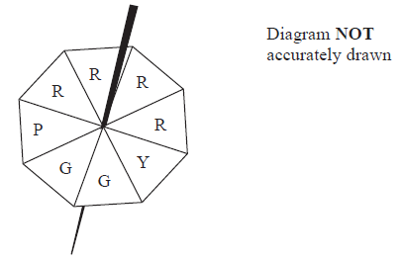

Sally is going to spin the spinner once.
The spinner will land on one of the letters shown in the diagram.
impossible unlikely evens likely certain

(a) From the list above, write down the word that best describes the likelihood
(i) that the spinner will land on the letter Y
.......................................

(ii) that the spinner will land on the letter R
.......................................

(iii) that the spinner will land on the letter T
.......................................
(3)
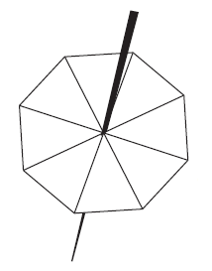
Sally makes a different fair 8-sided spinner.
The letters A, B, C and D will be on the spinner.
The probability that the spinner will land on A is twice the probability that the spinner will land on B.
The probability that the spinner will land on C is the same as the probability that the spinner will land on D.
(b) Use this information to complete the spinner.

(2)
(Total 5 marks)
___________________________________________________________________________
4.
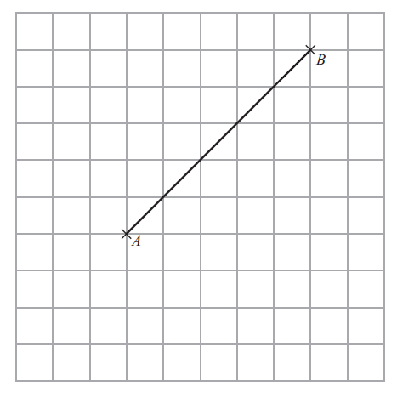

On the grid, draw a line that is both
parallel to the line AB
and the same length as the line AB.

(Total 2 mark)
___________________________________________________________________________
5. (a) Work out 40% of 20.

................................
(2)

Here are four numbers.

0.43 43.8%

(b) Write these numbers in order of size.
Start with the smallest number.

................................................................................................
(2)
(Total 4 mark)
___________________________________________________________________________
6. Sarah says,

"When square a prime number you always get an odd number."

(a) Write down one example to show that Sarah is wrong.

...............................................................................................................................................
(1)

Emily says,

"The lowest number that 3 and 6 both divide into exactly is 18"

(b) Is Emily correct?
You must give a reason for your answer.

...............................................................................................................................................

...............................................................................................................................................
(1)
(Total 2 mark)
___________________________________________________________________________

7 Batteries are sold in packets and in boxes.

There are 4 batteries in a packet.
There are 20 batteries in a box.

Derek buys one box of batteries.
He takes t batteries out of the box.

(a) Write down an expression, in terms of t, for the number of batteries left in the box.

.............................................
(1)

Sameena buys x packets of batteries and y boxes of batteries.

(b) Write down an expression, in terms of x and y, for the total number of batteries Sameena buys.

.............................................
(2)
(Total 3 marks)
___________________________________________________________________________
8 People can buy three types of plane tickets.

They can buy

an Economy ticket
a Premium ticket
or a Business ticket

200 people buy plane tickets.

92 males buy tickets
30 of the males buy Business tickets
62 females buy Economy tickets

A total of 44 people buy Business tickets.
A total of 60 people buy Premium tickets.

How many males buy Premium tickets?
You must show all your working.

...........................................
(Total 4 marks)
_______________________________________________________________________________
9 On the grid, draw the graph of y = x + 3 for values of x from –2 to 4.

(Total 3 marks)
__________________________________________________________________________
10 Here are the ingredients needed to make 10 pancakes.

Matthew makes 30 pancakes.

(a) Work out how much flour he uses.

.............................................. g
(2)
Tara makes some pancakes.
She uses 750 ml of milk.

(b) Work out how many pancakes she makes.

..............................................
(2)
(Total 4 mark)
___________________________________________________________________________
11. £360 is shared in the ratio 1 : 3 : 5

Work out the difference between the largest share and the smallest share.

£ .....................................
(Total 3 marks)
___________________________________________________________________________
12. (a) Work out the output for this number machine.

.......................................
(2)

(b) Work out the input for this number machine.

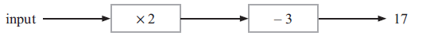

.......................................
(2)

(c) The input for this number machine is m.
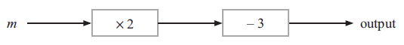

Find an expression, in terms of m, for the output.

.......................................
(2)

(d) The output for this number machine is n.

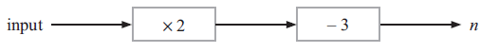

Find an expression, in terms of m, for the output.

.......................................
(2)
(Total 8 marks)
___________________________________________________________________________
13. Jenny wants to record 15 minutes of songs for a film.
The table shows the playing time of 3 songs she has recorded.

Song | Playing time
A | 4 minutes and 33 seconds
B | 3 minutes and 42 seconds
C | 3 minutes and 06 seconds

How much more time, in minutes and seconds, does she need to record?

................................ minutes ................................ seconds
(Total 4 marks)
___________________________________________________________________________
14. The table gives some information about the costs of posting large letters.

First Class Post – Delivery takes 1 to 2 days
Weight (g) | Cost
50 – 100 | 50p
101 – 250 | 72p
251 – 500 | £1.04
501 – 750 | £1.51

Second Class Post – Delivery takes 3 to 5 days
Weight (g) | Cost
50 – 100 | 40p
101 – 250 | 59p
251 – 500 | 85p
501 – 750 | £1.23

Leroy works for a company.
In January he sends some large letters by first class post.

The table gives information about numbers and weights of the large letters.

Weight (g) | Number of large letters
50 – 100 | 28
101 – 250 | 32
251 – 500 | 50
501 – 750 | 18

(a) Calculate the total cost of sending these large letters by first class post.

£ ................................
(3)

In February, Leroy is going to send some more large letters.

The table gives information about the weights and numbers of these large letters.
Weight (g) | Number of large letters
50 – 100 | 32
101 – 250 | 40
251 – 500 | 68
501 – 750 | 34

Leroy can use either first class post or second class post.
He thinks it will cost £20 less to send the letters by second class post.

(b) Is Leroy correct?
You must show your working.

(4)
(Total 7 marks)
___________________________________________________________________________
15. –2 < n ≤ 3
n is an integer.
(a) Write down all the possible values of n.

................................
(2)

x is a number.
Another number is 9 greater than x.
Both numbers are whole numbers.
The total of the two numbers is less than 60
(b) Find the greatest possible value of x.

................................
(3)
(Total 5 marks)
___________________________________________________________________________
16. The nth term of sequence A is 3n – 2
The nth term of sequence B is 10 – 2n

Sally says there is only one number that is in both sequence A and sequence B.

Is Sally right?
You must explain your answer.

(Total 2 marks)
___________________________________________________________________________
17.

Work out the value of x.
Give your answer correct to 3 significant figures.

x = ................................
(Total 3 marks)
___________________________________________________________________________
18. Here is a formula used to work out the speed, v mph, of a car making an emergency stop.
$$v=\sqrt{\text{21}d}$$
d feet is the length of the mark the car’s tyres make on the road when making an emergency stop.
A car makes an emergency stop.
The car’s tyres make a mark 90 feet long.
(a) Work out the speed of the car.
Give your answer correct to the nearest whole number.

................................ mph
(2)
A car made an emergency stop.
The car’s speed was 50 mph.
(b) Work out the length of the mark on the road.
Give your answer correct to the nearest whole number.

................................ feet
(3)
(Total 5 marks)
___________________________________________________________________________

19. Andy has some counters.
15% of the counters are red.
$\frac{2}{5}$of the counters are blue.
The rest of the counters are yellow.
There are 27 yellow counters.
How many blue counters are there?

................................
(Total 5 marks)
___________________________________________________________________________

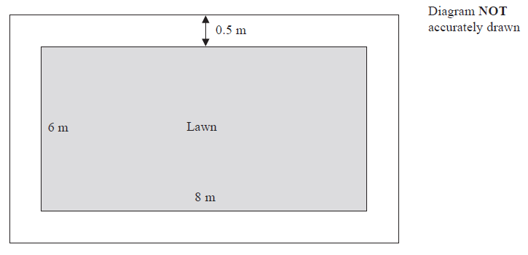
20. Here is a diagram of Gareth’s lawn.

The lawn is in the shape of a rectangle. The length of the lawn is 8 m.
The width of the lawn is 6 m.

There is a path all the way around the lawn. The path is made from paving slabs.
Each paving slab is a square 0.5 m by 0.5 m. The width of the path is 0.5 m.

Work out the number of paving slabs in the path.

................................
(Total 3 marks)
___________________________________________________________________________
21. The diagram shows an accurate scale drawing of part of the boundary of a field.
The complete boundary of the field is in the shape of a quadrilateral ABCD.

AB = 300 metres.
BC = 230 metres.
Point B is due north of point C.

The scale of the diagram is 1 cm to 50 metres.

The bearing of D from C is 260°.
AD = 480 metres.

Complete the scale drawing of the boundary of the field.
Mark the position of D.

(Total 2 marks)
___________________________________________________________________________

TOTAL FOR PAPER IS 80 MARKS

