
GCSE Mathematics
Practice Tests: Set 3
Paper 2F (Calculator)
Time: 1 hour 30 minutes
You should have: Ruler graduated in centimetres and millimetres, protractor, pair of compasses, pen, HB pencil, eraser, calculator.

Instructions
- Use black ink or ball-point pen.
- Fill in the boxes at the top of this page with your name,
centre number and candidate number.
- Answer all questions.
- Answer the questions in the spaces provided
– there may be more space than you need.
- Calculators may be used.
- Diagrams are NOT accurately drawn, unless otherwise indicated.
- You must show all your working out.

Information
- The total mark for this paper is 80
- The marks for each question are shown in brackets
– use this as a guide as to how much time to spend on each question.

Advice
- Read each question carefully before you start to answer it.
- Keep an eye on the time.
- Try to answer every question.
- Check your answers if you have time at the end.

Answer ALL questions.
Write your answers in the spaces provided.
You must write down all the stages in your working.

1. 5 pencils cost £1.85

Work out the cost of 9 of these pencils

£..........................................
(Total 2 mark)
___________________________________________________________________________
2. These two triangles are congruent.

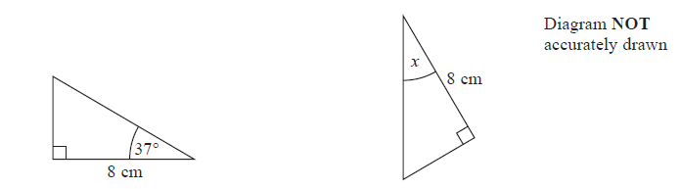
(a) Write down the size of the angle marked x.

..........................................°
(1)

These two quadrilaterals are congruent.

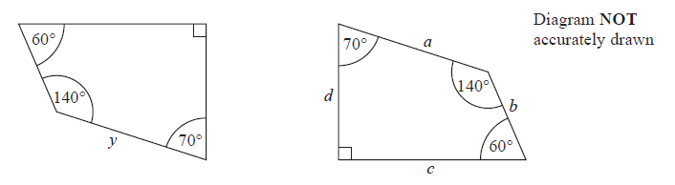
Side y is equal to one of the sides, a or b or c or d.

(b) Which side?

..........................................
(1)

(Total 2 mark)
___________________________________________________________________________
3.

(a) (i) Write down the coordinates of the point A.

( .............. , ..............)

(ii) Write down the coordinates of the point B.

( .............. , ..............)
(2)

(b) On the grid, plot the point (5, −1).
Label this point C.
(1)

(Total 3 mark)
___________________________________________________________________________
4. The scale shows the total weight of 3 boxes.
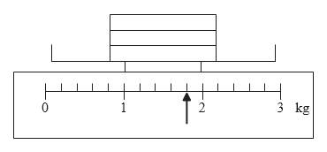

Each box is the same weight.
Work out the weight of one box.

.......................................... kg
(Total 3 mark)
___________________________________________________________________________

5. The table shows midday temperatures in four cities on one day in winter.

City | Midday temperature (°C)
Paris | 2
Cardiff | –5
London | –3
Edinburgh | –1

(a) Which city had the lowest midday temperature?
................................
(1)

By midnight, the temperature in London had fallen by 5°C.

(b) Work out the midnight temperature in London.

................................ °C
(2)
(Total 3 marks)
___________________________________________________________________________
6. Here is a café menu.
Menu
Cup of tea 75p
Cup of coffee 95p
Can of cola 80p
Beefburger £1.65
Hot dog £1.40

Kerry buys one beefburger and one can of cola.

(a) Work out the total cost.

£..........................................
(2)

Tyler wants to buy 2 hot dogs, a cup of tea and a can of cola. He has a £5 note.

(b) Does Tyler have enough money?
Give reasons for your answer.

(3)
(Total 5 marks)
___________________________________________________________________________
7. (a) Work out the number which is exactly halfway between 1.2 and 1.4

................................
(1)
(b) Change 0.4 kilograms to grams.

................................ grams
(1)
(c) Change 90 km/h into metres/second.

...................metres/second
(2)
(Total 4 marks)
___________________________________________________________________________
8. Here is a list of numbers.

4 8 5 9 10 5 6 3 4

(a) Work out the median.

..............................................
(2)

(b) Work out the mean.

..............................................
(2)
(Total 4 mark)
___________________________________________________________________________

9. There are 120 cars in a car park.
Colour of car | Frequency
Red | 40
Silver | 24
Blue | 19
Other | 37

Draw an accurate pie chart for this information.

(Total 3 marks)
___________________________________________________________________________

10. The cost of 1.5 kg of peaches is £0.84
The total cost of 3 kg of peaches and 2 kg of apples is £2.34
Work out the cost of 1 kg of apples.

..........................................
(Total 3 marks)
___________________________________________________________________________
11. Here is a rule for working out the volume of a pyramid.

Multiply the base area by the height and then divide by 3

A pyramid has a base area of 9 cm2 and a height of 4 cm.

(a) Use the rule to work out the volume of this pyramid.

.............................................. cm3
(2)

A different pyramid has a volume of 20 cm3.
The base area of this pyramid is 10 cm2.

(b) Work out the height of this pyramid.

.............................................. cm
(3)
(Total 5 marks)
___________________________________________________________________________
12. Brian wants to go on holiday.
He is going to take out a loan of £500 to help pay for the holiday.

Brian will have to pay back the £500 plus 20% interest over 12 months. He will pay back the same amount of money each month.

How much money will he pay back each month?

£..........................................
(Total 4 marks)
___________________________________________________________________________

13. (a) Work out of 72 kg.

.......................kg
(2)
(b) Show that

(2)
(Total 4 marks)
___________________________________________________________________________
14. The diagram shows part of the design of a stained glass window.
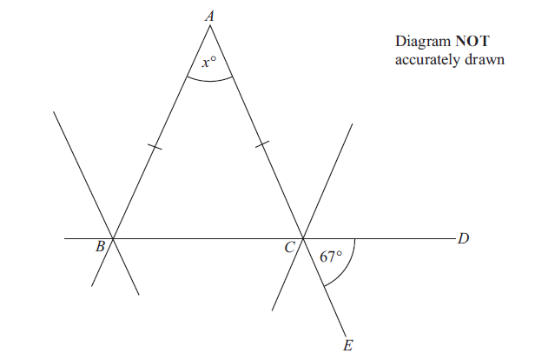

ABC is an isosceles triangle. BCD and ACE are straight lines. Angle DCE = 67°.

Work out the size of the angle marked x°. Give reasons for your answer.

(Total 4 marks)
___________________________________________________________________________
15.

Work out the value of x.
Give your answer correct to 1 decimal place.

x = ................................
(Total 3 marks)
___________________________________________________________________________
16. Nails of length 35 millimetres are sold in three sizes of packets.

There are 20 nails in a small packet, costing £1.36
There are 50 nails in a medium packet, costing £3.30
There are 90 nails in a large packet, costing £6.03

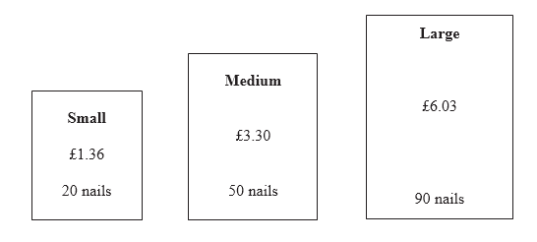

(a) Which size of packet is the best value for money?
You must show clearly how you got your answer.

(4)
Nails of different lengths are sold in mixed packets.

Here are the lengths, in millimetres, of the nails in a mixed packet.

20 | 35 | 49 | 30 | 45
40 | 50 | 25 | 39 | 30
30 | 37 | 47 | 55 | 28

(b) Draw an ordered stem and leaf diagram for this information.

(3)

(c) Find the median length.

.......................................... mm
(1)
(Total 8 marks)
___________________________________________________________________________

17. (a) Expand and simplify (x + 9)(x − 3)

...................................
(2)

(b) Make a the subject of the formula v = u + at

..................................
(2)
(Total 4 marks)
___________________________________________________________________________

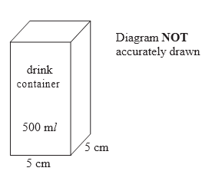
18. Suha Industries make drink containers.
They need to design a new container for 500 ml of drink.
The container has to be in the shape of a cuboid.
The base of the cuboid will be a square.
The square has sides of length 5 cm.

Work out the minimum height of the container.

.......................................... cm
(Total 3 marks)
___________________________________________________________________________

19. On July 1st 2004, Jack invested £2000 at 5% per annum compound interest.
Work out the value of Jack’s investment on July 1st 2006

£ ..........................................
(Total 3 marks)
___________________________________________________________________________
20.

The diagram shows a solid prism made from metal.
The cross-section of the prism is a trapezium.

The parallel sides of the trapezium are 8 cm and 12 cm.
The height of the trapezium is 6 cm.
The length of the prism is 20 cm.

The density of the metal is 5 g/cm³.

Calculate the mass of the prism.
Give your answer in kilograms.

................................ kg
(Total 5 marks)
___________________________________________________________________________
21. The diagram shows a triangle.

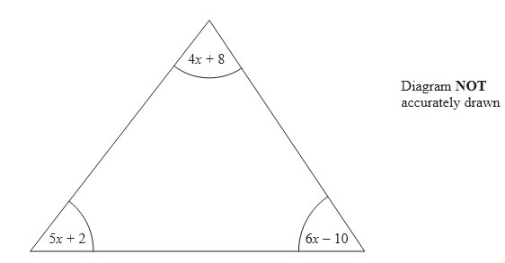

All the angles are measured in degrees.
Show that the triangle is isosceles.

(Total 5 marks)
___________________________________________________________________________

TOTAL FOR PAPER IS 80 MARKS

