Maths Emporium
Best Value
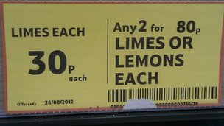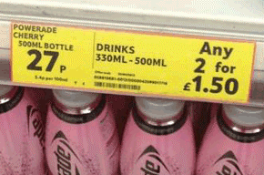

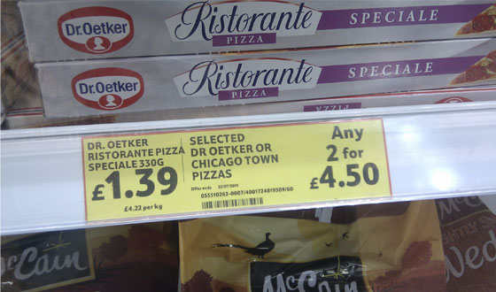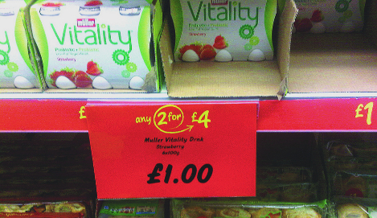

Introduction
Past papers aren’t just for practising your mathematics skills – they also useful for learning the basics you’ll need for all sorts of practical activities such as being able to work out the bargains when you go shopping. Supermarkets get it wrong from time to time – make sure that you don’t.

Information
The marks for individual questions are shown in round brackets: e.g. (2).
There are 17 questions in this booklet. The total mark is 70.
Questions marked with a * sign will require working to be shown.
Calculators may be used in all questions.

Advice
Show all stages in any calculations.
Work steadily through the paper. Do not spend too long on one recipe.
If you cannot answer a question, leave it and attempt the next one.
Return at the end to those you have left out.
Section A (35 marks)

*1. A shop sells coffee in 3 different sizes of jar.
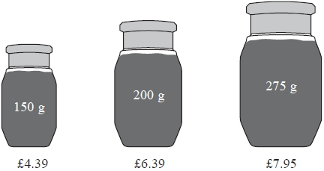
A 150 g jar of coffee costs £4.39
A 200 g jar of coffee costs £6.39
A 275 g jar of coffee costs £7.95
Which size of jar is the best value for money?
You must show all your working.

(Total 4 marks)
___________________________________________________________________________

*2. Tea bags are sold in three sizes of box.
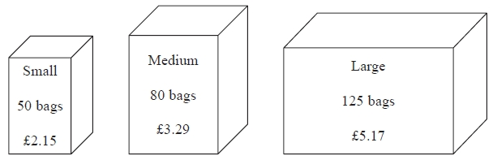

A small box of 50 tea bags costs £2.15
A medium box of 80 tea bags costs £3.29
A large box of 125 tea bags costs £5.17
Which size of box is the best value for money?
(Total 4 marks)
___________________________________________________________________________

*3. A shop sells toothpaste in 3 different sizes of tube.
A 70 ml tube of toothpaste costs £1.79
A 100 ml tube of toothpaste costs £2.75
A 150 ml tube of toothpaste costs £3.99
Which size of tube is the best value for money?
You must show all your working.
(Total 4 marks)
___________________________________________________________________________

*4. The same type of computer is sold in two shops.
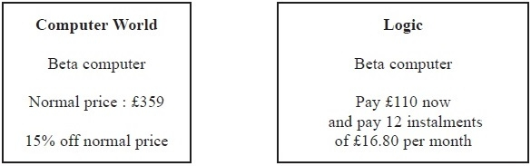
What is the difference in the cost of a Beta computer in Computer World and the cost of a Beta computer in Logic?
You must show all your working.
£ ...........................................................
(Total 5 marks)
___________________________________________________________________________

*5. Plants are sold in three different sizes of tray.
A small tray of 30 plants costs £6.50
A medium tray of 40 plants costs £8.95
A large tray of 50 plants costs £10.99
Kaz wants to buy the tray of plants that is the best value for money.
Which size tray of plants should she buy?
You must show all your working.
(Total 4 marks)
___________________________________________________________________________

*6. Milk is sold in two sizes of bottle.
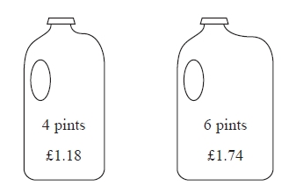
A 4 pint bottle of milk costs £1.18
A 6 pint bottle of milk costs £1.74
Which bottle of milk is the best value for money?
You must show all your working.
(Total 3 marks)
___________________________________________________________________________

*7. Ketchup is sold in three different sizes of bottle.
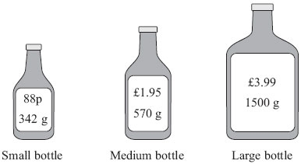

A small bottle contains 342 g of ketchup and costs 88p
A medium bottle contains 570 g of ketchup and costs £1.95
A large bottle contains 1500 g of ketchup and costs £3.99
Which bottle is the best value for money?
You must show your working.

(Total 4 marks)
___________________________________________________________________________

8.
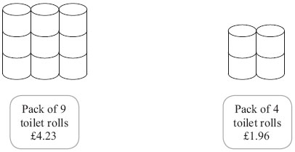
A pack of 9 toilet rolls costs £4.23
A pack of 4 toilet rolls costs £1.96
Which pack gives the better value for money?
You must show all your working.

...........................................................
(Total 3 marks)
___________________________________________________________________________

*9. Matches are sold in three sizes of box.
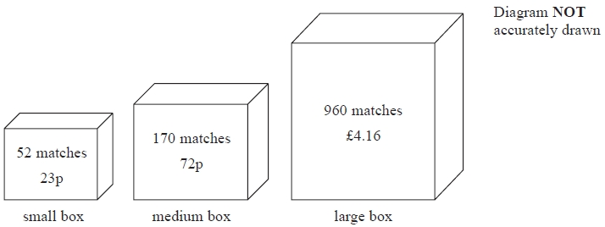
A small box contains 52 matches and costs 23p.
A medium box contains 170 matches and costs 72p.
A large box contains 960 matches and costs £4.16
Which size of box is the best value for money?
Show how you got your answer.

(Total 4 marks)
___________________________________________________________________________

Section B (35 marks)

*10. Brenda works in an office.
She finds out the prices of folders from two companies, Office Deals and Paper World.
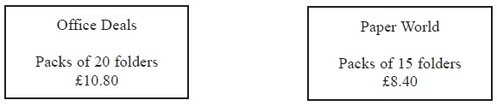
Brenda needs to buy exactly 60 folders.
She wants to buy the folders as cheaply as possible.
Which company should Brenda buy the folders from?
You must explain your answer.
(Total 4 marks)
___________________________________________________________________________

*11. Faiza wants to buy some plants.
She finds out the price of the plants from 2 shops.
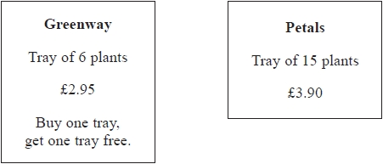
Faiza wants to buy exactly 60 plants.
She wants to buy the plants as cheaply as possible.
Which shop should Faiza buy the plants from?
You must show your working.

(Total 4 marks)
___________________________________________________________________________

*12. Here are the costs of pens in two shops.

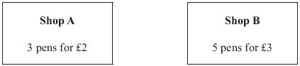
Mrs Evans wants to buy 30 pens for the cheapest possible cost.
Which shop should she buy the pens from?
You must show all your working.

(Total 4 marks)
___________________________________________________________________________

*13. Becky wants to buy a table and six chairs.
Three shops sell the same types of tables and chairs.

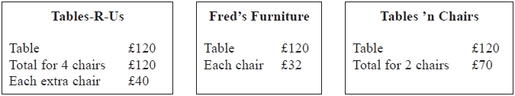
Becky wants to buy the table and six chairs from the same shop.
She wants to pay the lowest total price.
Which shop should Becky buy the table and six chairs from?
You must show all your working.

(Total 4 marks)
___________________________________________________________________________

14. George is going to buy exactly 10 ink cartridges.

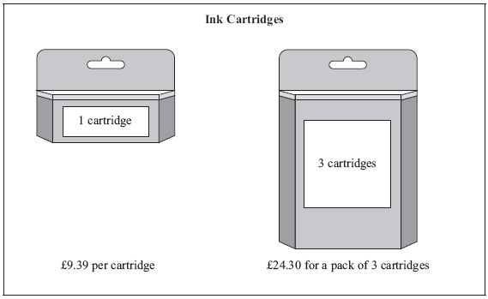
Find the difference in cost between the cheapest way and the most expensive way to buy the 10 ink cartridges.

……...............................................................................................................................................
(Total 5 marks)
___________________________________________________________________________

*15.
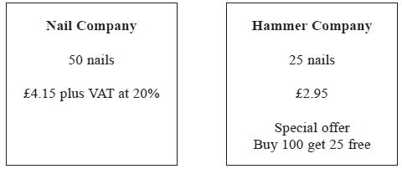
Barak is going to buy 550 nails from one of these companies.
He wants to buy the nails at the cheaper cost.

Where should he buy the nails, from the Nail Company or the Hammer Company?

(Total 5 marks)
___________________________________________________________________________

*16. Sam is going to paint his garden shed.
The paint is sold in two different shops.

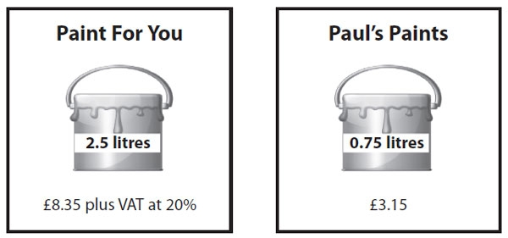

Sam needs 7.5 litres of paint.

Sam wants to buy the cheapest paint.
He is going to buy the paint from one of these shops.

Which shop should he buy the paint from?
You must show your working.

(Total 4 marks)
___________________________________________________________________________

*17. Tom is going to buy 25 plants to make a hedge.
Here is information about the cost of buying the plants.
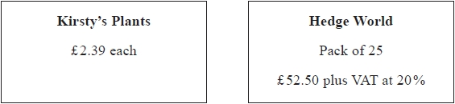
Tom wants to buy the 25 plants as cheaply as possible.
Should Tom buy the plants from Kirsty's Plants or from Hedge World?
You must show all your working.

(Total 5 marks)
___________________________________________________________________________
TOTAL FOR PAPER IS 70 MARKS

BLANK PAGE

