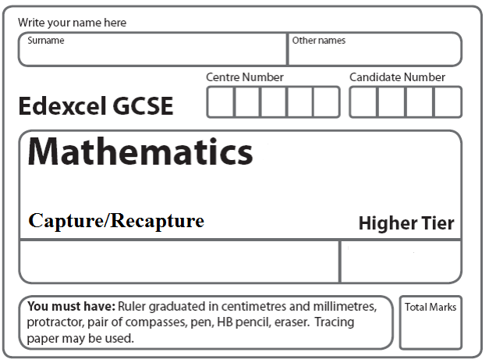
Instructions
- Use black ink or ball-point pen.
- Fill in the boxes at the top of this page with your name.
- Answer all questions.
- Answer the questions in the spaces provided
– there may be more space than you need.
- Calculators must not be used.

Information
- The total mark for this paper is 25.
- The marks for each question are shown in brackets
- use this as a guide as to how much time to spend on each question.
- Questions labelled with an asterisk (*) are ones where the quality of your written communication will be assessed.

Advice
- Read each question carefully before you start to answer it.
- Keep an eye on the time.
- Try to answer every question.
- Check your answers if you have time at the end.

A scientist wants to estimate the number of fish in a lake.

He catches 50 fish from the lake and marks them with a dye.
The fish are then returned to the lake.

The next day the scientist catches another 50 fish.
4 of these fish are marked with the dye.

Work out an estimate for the total number of fish in the lake.
You must write down any assumptions you have made.

........................................................................................................
(Total 4 marks)
______________________________________________________________________________
2. A farmer wants to estimate the number of rabbits on his farm.

On Monday he catches 120 rabbits.
He puts a tag on each rabbit.
He then lets the rabbits run away.

On Tuesday the farmer catches 70 rabbits.
15 of these rabbits have a tag on them.

Work out an estimate for the total number of rabbits on the farm.
You must write down any assumptions you have made.

........................................................................................................
(Total 4 marks)
______________________________________________________________________________
3. There are N beads in a jar.
40 of these beads are black.

Julie takes at random a sample of 50 beads from the jar.
5 of the beads in her sample are black.

Work out an estimate for the value of N.

..............................................................
(Total 2 marks)
______________________________________________________________________________

4. Clive wants to estimate the number of bees in a beehive.
Clive catches 50 bees from the beehive.

He marks each bee with a dye.
He then lets the bees go.

The next day, Clive catches 40 bees from the beehive.
8 of these bees have been marked with the dye.

(i) Work out an estimate for the number of bees in the beehive.

............................................. bees

(ii) Write down any assumptions you have made.

............................................................................................................................................................

............................................................................................................................................................

............................................................................................................................................................
(Total 4 marks)
______________________________________________________________________________
5. Toga wants to estimate the number of termites in a nest.
On Monday Toga catches 80 termites.

He puts a mark on each termite.
He then puts all 80 termites back in the nest.

On Tuesday Toga catches 60 termites.
12 of these termites have a mark on them.

Work out an estimate for the total number of termites in the nest.
You must write down any assumptions you have made.

(Total 4 marks)
______________________________________________________________________________

6. There are a large number of white beads in a bag.
There are only white beads in the bag.

Felicity wants to find an estimate for the number of beads in the bag.
Felicity replaces 30 of the white beads in the bag with 30 black beads.

She then takes 50 beads from the bag.
2 of the 50 beads are black.

Felicity then puts the 50 beads back in the bag.

(a) Work out an estimate for the number of beads in the bag.

......................................................
(2)

(b) Write down one assumption you have made.

............................................................................................................................................................

............................................................................................................................................................
(1)
(Total 3 marks)
______________________________________________________________________________

7. Alex wants to find out how many ducks there are in a park.

One day he puts a tag on each of 30 of the ducks.
The next day he catches 40 ducks.
8 of these ducks have tags on them.

(i) Work out an estimate for the number of ducks in the park.

.......................................................

Alex assumed that none of the tags fell off during the night.

(ii) If Alex’s assumption is wrong, explain how this could affect your answer to part (i).

......................................................................................................................................................

......................................................................................................................................................
(Total 4 marks)

TOTAL FOR PAPER IS 25 MARKS

