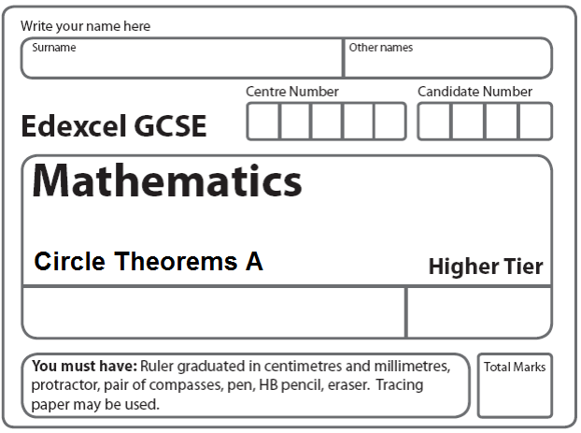
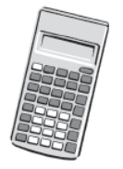
Instructions
- Use black ink or ball-point pen.
- Fill in the boxes at the top of this page with your name.
- Answer all questions.
- Answer the questions in the spaces provided
– there may be more space than you need.
- Calculators may be used.

Information
- The total mark for this paper is 40.
- The marks for each question are shown in brackets.
- use this as a guide as to how much time to spend on each question.
- Questions labelled with an asterisk (*) are ones where the quality of your written communication will be assessed.

Advice
- Read each question carefully before you start to answer it.
- Keep an eye on the time.
- Try to answer every question.
- Check your answers if you have time at the end.

1.
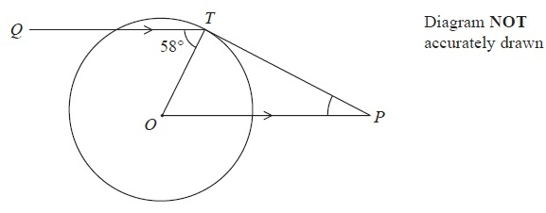
T is a point on a circle, centre O.
Q is a point such that angle QTO = 58°
P is the point such that OP is parallel to QT and PT is a tangent to the circle.
Work out the size of angle OPT.
...........................................................°
(Total 3 marks)
___________________________________________________________________________

2.
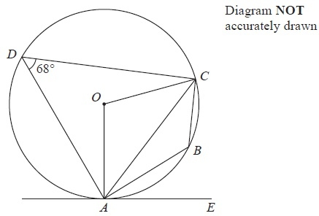

A, B, C and D are points on a circle, centre O.
AE is a tangent to the circle.
Angle ADC = 68°
(a) (i) Find the size of angle ABC.
........................................................... °
(ii) Give a reason for your answer.

................................................................................................................................................
(2)
(b) (i) Find the size of angle AOC.
........................................................... °
(ii) Give a reason for your answer.
...............................................................................................................................................
(2)
(c) Find the size of angle CAE.
........................................................... °
(1)
(Total 5 marks)
___________________________________________________________________________

3.
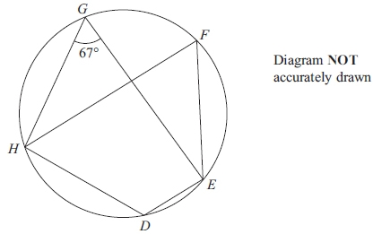

D, E, F, G and H are points on a circle.
Angle EGH = 67°

(a) Find the size of angle EFH.
...........................................................°
(1)
(b) Give a reason for your answer.

................................................................................................................................................

................................................................................................................................................
(2)
(Total 3 marks)
___________________________________________________________________________
4.
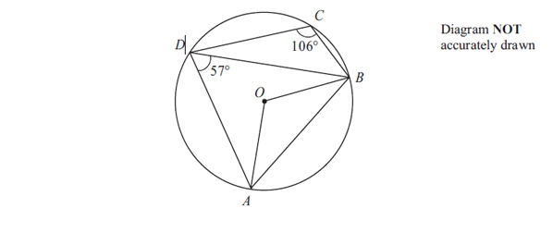
A, B, C and D are points on a circle, centre O.
Angle ADB = 57°.
Angle BCD = 106°.

(a) (i) Calculate the size of angle AOB.
...........................................................°
(ii) Give a reason for your answer.

...............................................................................................................................................

................................................................................................................................................
(2)

(b) Calculate the size of angle BAD.
...........................................................°
(1)
(Total 3 marks)
___________________________________________________________________________

5.
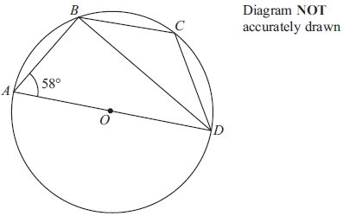

A, B, C and D are four points on a circle, centre O.
AD is a diameter of the circle.
Angle BAD = 58°

(a) Calculate the size of angle ADB.
...........................................................°
(2)

(b) (i) Calculate the size of angle BCD.
...........................................................°
(ii) Give a reason for your answer.

…............................................................................................................................................

................................................................................................................................................
(2)
(Total 4 marks)
___________________________________________________________________________
*6.
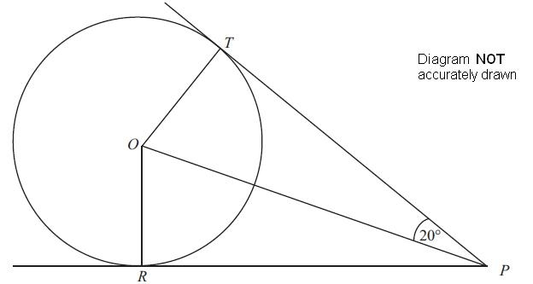

T and R are two points on a circle centre O.
PT and PR are the tangents to the circle from P.
Angle TPO = 20°.
Work out the size of angle TOR.
You must give reasons for each stage of your working.

(Total 4 marks)
___________________________________________________________________________

*7.
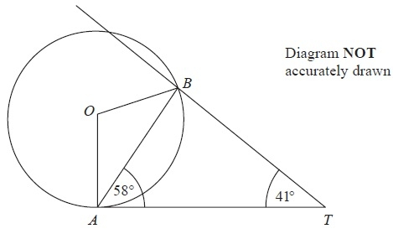
A and B are points on the circumference of a circle, centre O.
AT is a tangent to the circle.
Angle TAB = 58°.
Angle BTA = 41°.
Calculate the size of angle OBT.
You must give reasons at each stage of your working.
(Total 5 marks)
___________________________________________________________________________
8.
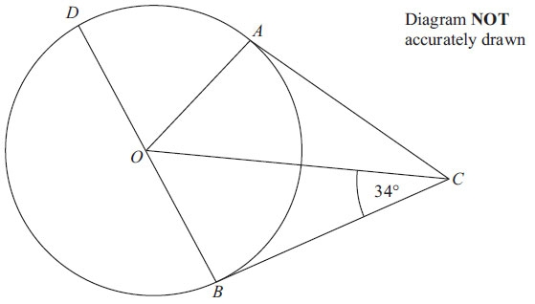

A, B and D are points on the circumference of a circle, centre O.
BOD is a diameter of the circle.
BC and AC are tangents to the circle.
Angle OCB = 34°.
Work out the size of angle DOA.

…. .................................................................................................................................................
(Total 3 marks)
___________________________________________________________________________

9.
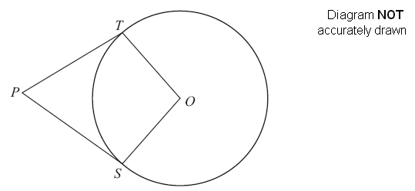
S and T are points on the circumference of a circle, centre O.
PT and PS are tangents.
Angle TPO = 24°.
Work out the size of angle SOT.

. . . . . . . . . . . . . . . . . . . . . .°
(Total 3 marks)
___________________________________________________________________________

10.
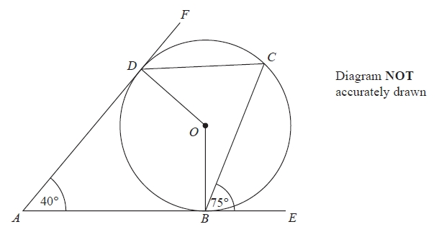
B, C and D are points on the circumference of a circle, centre O.
ABE and ADF are tangents to the circle.
Angle DAB = 40°
Angle CBE = 75°
Work out the size of angle ODC.

...........................................................°
(Total 3 marks)
___________________________________________________________________________

11.
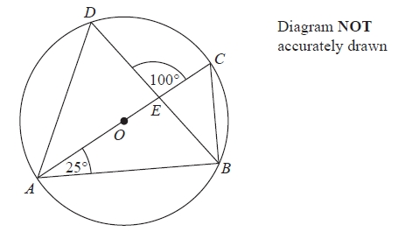
A, B, C and D are points on the circumference of a circle, centre O.
AC is a diameter of the circle.
AC and BD intersect at E.
Angle CAB = 25°
Angle DEC = 100°
Work out the size of angle DAC.
You must show all your working.
........................................................... °
(Total 4 marks)
___________________________________________________________________________
TOTAL FOR PAPER: 40 MARKS

