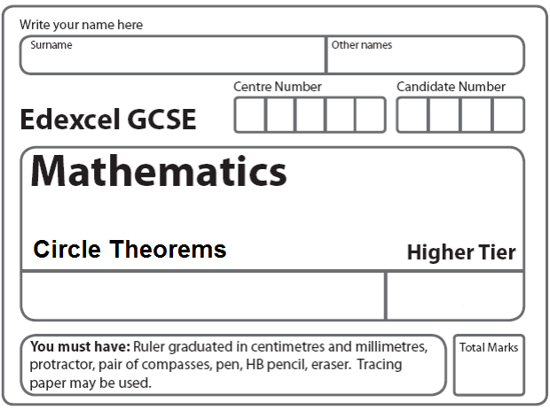
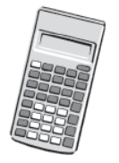
Instructions
- Use black ink or ball-point pen.
- Fill in the boxes at the top of this page with your name.
- Answer all questions.
- Answer the questions in the spaces provided
– there may be more space than you need.
- Calculators may be used.

Information
- The total mark for this paper is 80.
- The marks for each question are shown in brackets.
- use this as a guide as to how much time to spend on each question.
- Questions labelled with an asterisk (*) are ones where the quality of your written communication will be assessed.

Advice
- Read each question carefully before you start to answer it.
- Keep an eye on the time.
- Try to answer every question.
- Check your answers if you have time at the end.

1.
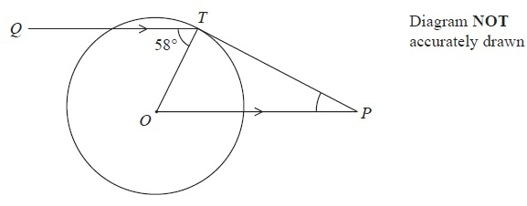
T is a point on a circle, centre O.
Q is a point such that angle QTO = 58°
P is the point such that OP is parallel to QT and PT is a tangent to the circle.
Work out the size of angle OPT.
...........................................................°
(Total 3 marks)
___________________________________________________________________________

2.
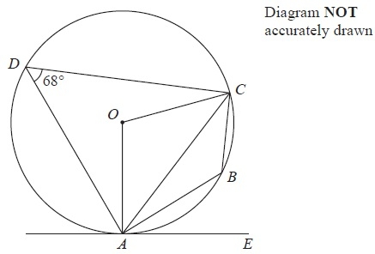

A, B, C and D are points on a circle, centre O.
AE is a tangent to the circle.
Angle ADC = 68°
(a) (i) Find the size of angle ABC.
........................................................... °
(ii) Give a reason for your answer.

................................................................................................................................................
(2)
(b) (i) Find the size of angle AOC.
........................................................... °
(ii) Give a reason for your answer.
...............................................................................................................................................
(2)
(c) Find the size of angle CAE.
........................................................... °
(1)
(Total 5 marks)
___________________________________________________________________________

3.
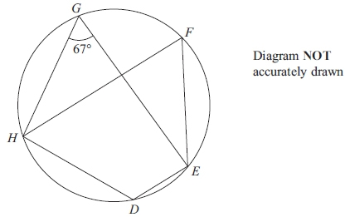

D, E, F, G and H are points on a circle.
Angle EGH = 67°

(a) Find the size of angle EFH.
...........................................................°
(1)
(b) Give a reason for your answer.

................................................................................................................................................

................................................................................................................................................
(2)
(Total 3 marks)
___________________________________________________________________________
4.
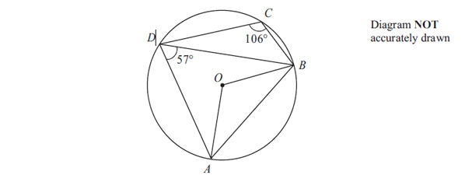
A, B, C and D are points on a circle, centre O.
Angle ADB = 57°.
Angle BCD = 106°.

(a) (i) Calculate the size of angle AOB.
...........................................................°
(ii) Give a reason for your answer.

...............................................................................................................................................

................................................................................................................................................
(2)

(b) Calculate the size of angle BAD.
...........................................................°
(1)
(Total 3 marks)
___________________________________________________________________________

5.
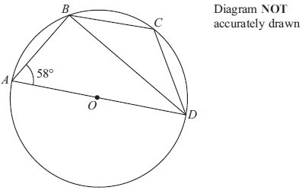

A, B, C and D are four points on a circle, centre O.
AD is a diameter of the circle.
Angle BAD = 58°

(a) Calculate the size of angle ADB.
...........................................................°
(2)

(b) (i) Calculate the size of angle BCD.
...........................................................°
(ii) Give a reason for your answer.

…............................................................................................................................................

................................................................................................................................................
(2)
(Total 4 marks)
___________________________________________________________________________
*6.
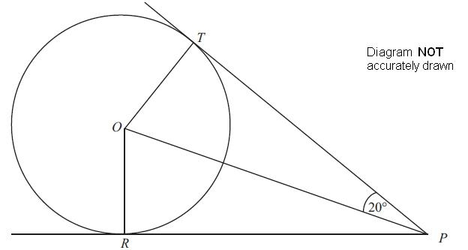

T and R are two points on a circle centre O.
PT and PR are the tangents to the circle from P.
Angle TPO = 20°.
Work out the size of angle TOR.
You must give reasons for each stage of your working.

(Total 4 marks)
___________________________________________________________________________

*7.
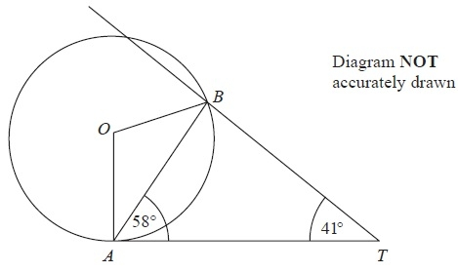
A and B are points on the circumference of a circle, centre O.
AT is a tangent to the circle.
Angle TAB = 58°.
Angle BTA = 41°.
Calculate the size of angle OBT.
You must give reasons at each stage of your working.
(Total 5 marks)
___________________________________________________________________________
8.
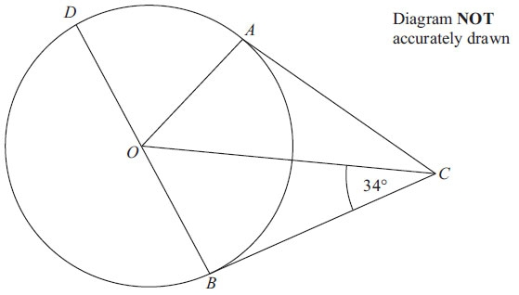

A, B and D are points on the circumference of a circle, centre O.
BOD is a diameter of the circle.
BC and AC are tangents to the circle.
Angle OCB = 34°.
Work out the size of angle DOA.

…. .................................................................................................................................................
(Total 3 marks)
___________________________________________________________________________

9.
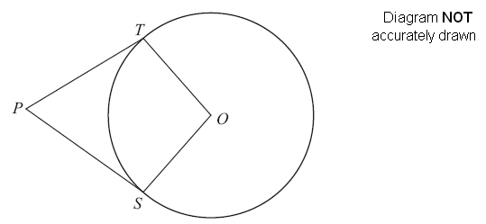
S and T are points on the circumference of a circle, centre O.
PT and PS are tangents.
Angle TPO = 24°.
Work out the size of angle SOT.

. . . . . . . . . . . . . . . . . . . . . .°
(Total 3 marks)
___________________________________________________________________________

10.
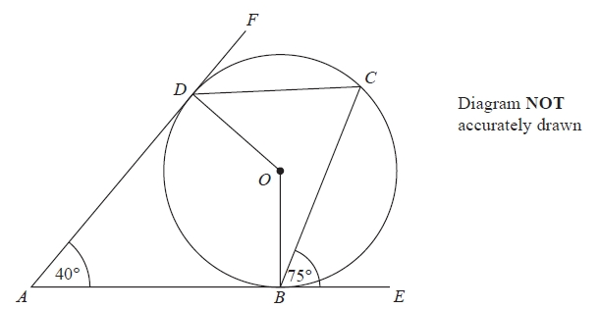
B, C and D are points on the circumference of a circle, centre O.
ABE and ADF are tangents to the circle.
Angle DAB = 40°
Angle CBE = 75°
Work out the size of angle ODC.

...........................................................°
(Total 3 marks)
___________________________________________________________________________

*11.
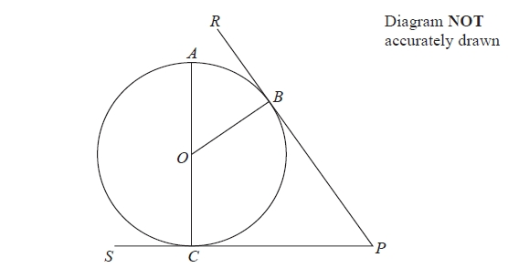

A, B and C are points on a circle, centre O.
RBP is the tangent to the circle at B.
SCP is the tangent to the circle at C.
AOC is a diameter of the circle.
Prove that angle AOB is equal to angle CPB.
You must give reasons at each stage.

(Total 5 marks)
___________________________________________________________________________

12.
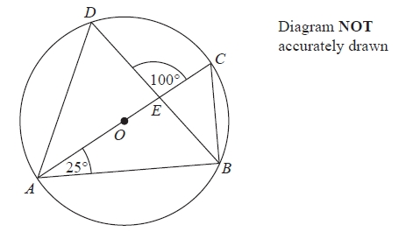
A, B, C and D are points on the circumference of a circle, centre O.
AC is a diameter of the circle.
AC and BD intersect at E.
Angle CAB = 25°
Angle DEC = 100°
Work out the size of angle DAC.
You must show all your working.
........................................................... °
(Total 4 marks)
___________________________________________________________________________

*13.
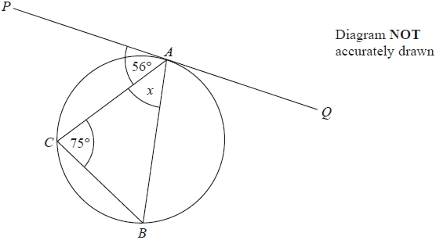

A, B and C are points on the circumference of a circle.
The straight line PAQ is a tangent to the circle.
Angle PAC = 56°
Angle ACB = 75°
Work out the size of the angle marked x.
Give reasons for each stage of your working.

(Total 3 marks)
___________________________________________________________________________

14.
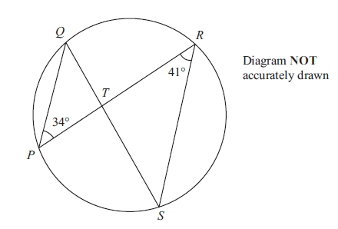

P, Q, R and S are points on the circumference of a circle.
PR and QS intersect at T.
Angle QPR = 34° and angle PRS = 41°
(a) (i) Find the size of angle PQS.
........................................................... °
(ii) Give a reason for your answer.
...............................................................................................................................................
...............................................................................................................................................
(2)
(b) (i) Find the size of angle PTS.
........................................................... °
(ii) Explain why T cannot be the centre of the circle.
...............................................................................................................................................
...............................................................................................................................................
(2)
(Total 4 marks)
_________________________________________________________________________
15.
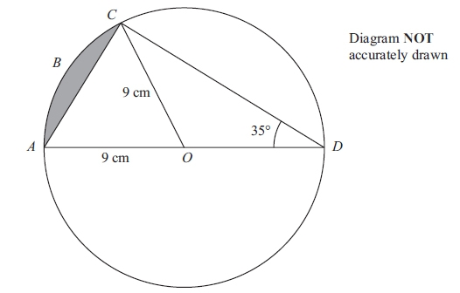

AOD is a diameter of a circle, with centre O and radius 9 cm.
ABC is an arc of the circle.
AC is a chord.
Angle ADC = 35°
Calculate the area of the shaded segment.
Give your answer correct to 3 significant figures.

........................................................... cm²
(Total 6 marks)
___________________________________________________________________________
16. The sides of triangle PQR are tangents to a circle.
The tangents touch the circle at the points S, T and U.
QS = 6 cm. PS = 7 cm.
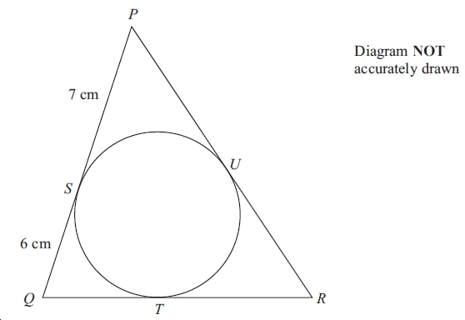

(a) (i) Write down the length of QT.

...............................cm
(ii) Give a reason for your answer.

................................................................................................................................................
(2)

The perimeter of triangle PQR is 42 cm.
(b) Calculate the size of angle PQR.
Give your answer correct to 1 decimal place.
..............................................°
(4)
(Total 6 marks)
___________________________________________________________________________
17.
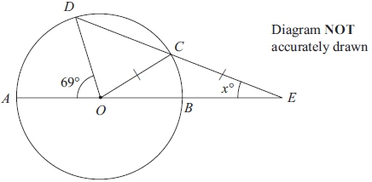

A, B, C and D are points on a circle, centre O.
AOBE and DCE are straight lines.
CO = CE.
Angle AOD = 69º
Angle CEO = xº

Calculate the value of x.
Show your working clearly.

x = ...........................................................
(Total 6 marks)
18.

P, Q, R and S are points on the circumference of a circle, centre O.
APB, BQC, CRD and DSA are tangents to the circle.
ABCD is a kite.

Angle PAS = 2x°
Angle QCR = y°

Find an expression in terms of x and y for the size, in degrees, of the angle POQ.
Give your expression in its simplest form.
Give reasons for your answer.

(Total 5 marks)
___________________________________________________________________________
*19.
ABCD is a quadrilateral.
AB, AD, BC and CD are tangents to a circle.
The tangents touch the circle at Q, P, R and S respectively.
AC goes through the centre of the circle.

AP : PD is in the ratio 3 : 2
AQ : QB is in the ratio 3 : 2

Prove that ABCD is a kite.

(Total is 5 marks)
___________________________________________________________________________
TOTAL FOR PAPER: 80 MARKS

