Maths Emporium Recipe Booklet
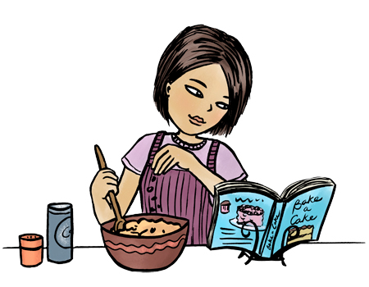
Introduction
Past papers aren’t just for practising your mathematics skills – they also include a number of delicious recipes for you to try in your own homes. You can calculate the correct proportions to be used for any size of gathering, and they’re all suitable for vegetarians. For those with an electronic version of this booklet, chef’s comments can be found here.

Thanks are due to our examiners for coming up with all these mouth-watering confections which both Foundation tier and Higher tier students will enjoy while enhancing their understanding of ratio and proportion.

Information
The marks for individual recipes are shown in round brackets: e.g. (2).
There are 17 recipes in this booklet. The total mark is 64.
Recipes marked with a * sign will require some explanation before serving.

Calculators must not be used for questions marked with a # sign, though Kenwood mixers can be used as and when they are required.

Advice
Show all stages in any calculations.
Work steadily through the paper. Do not spend too long on one recipe.
If you cannot answer a question, leave it and attempt the next one.
Return at the end to those you have left out.
1. Here are the ingredients needed to make 10 pancakes.

Pancakes

Ingredients to make 10 pancakes

300 ml of milk
120 g of flour
2 eggs

Matthew makes 30 pancakes.

(a) Work out how much flour he uses.

.............................................. g
(2)

Tara makes some pancakes.
She uses 750 ml of milk.

(b) Work out how many pancakes she makes.

..............................................
(2)
(Total for recipe 1 is 4 marks)
#2. This is a list of ingredients for making macaroni cheese for 4 people.

Ingredients for 4 people

100ml milk
200g cheese
175g dried macaroni
40g butter
50g plain flour

Work out the amount of each ingredient needed to make macaroni cheese for 10 people.

..............................................ml milk

..............................................g cheese

..............................................g dried macaroni

..............................................g butter

..............................................g plain flour

(Total for recipe 2 is 3 marks)
3. Here is a list of ingredients for making a trifle for 4 people.

Trifle for 4 people
120 g of raspberry jelly
8 sponge fingers
420 ml of custard
180 g of tinned fruit

Rob is going to make a trifle for 6 people.
Work out the amount of each ingredient he needs.

.......................... g of raspberry jelly

.......................... sponge fingers

.......................... ml of custard

.......................... g of tinned fruit
(Total for recipe 3 is 3 marks)
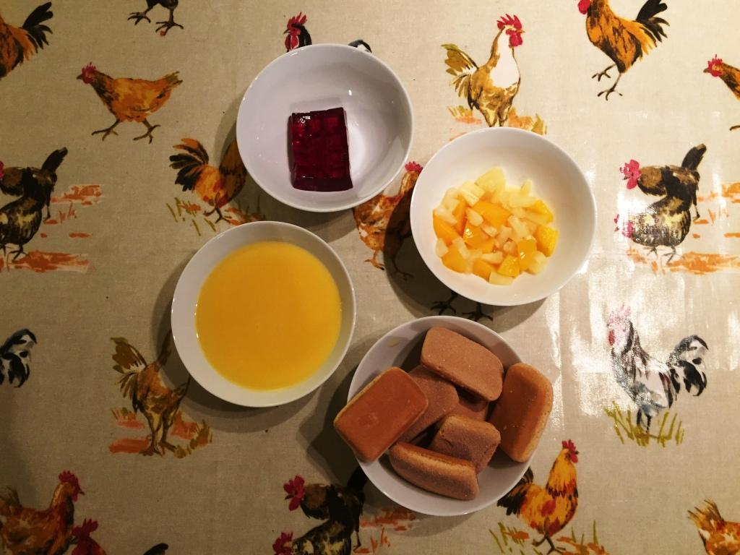

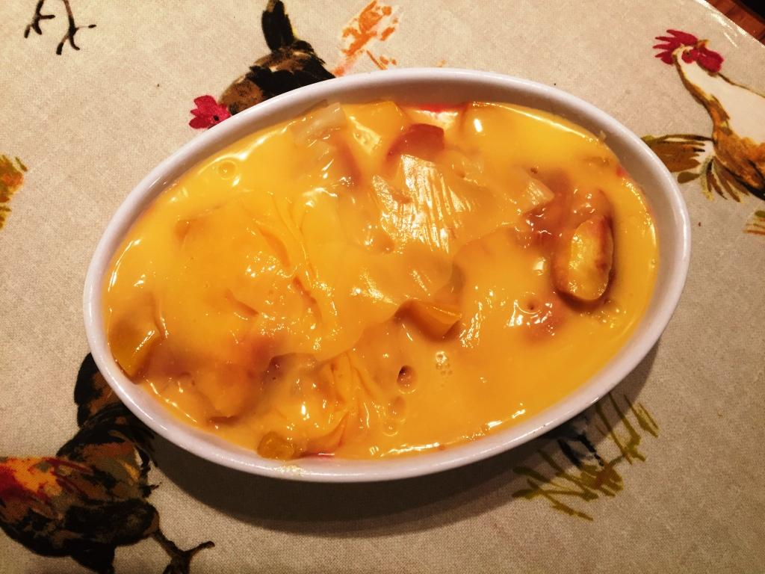
4. Here are the ingredients for making cheese pie for 6 people.

Cheese pie for 6 people

180 g flour
240 g cheese
80 g butter
4 eggs
160 ml milk

Bill makes a cheese pie for 3 people.

(a) Work out how much flour he needs.

...................................... g
(2)

Jenny makes a cheese pie for 15 people.

(b) Work out how much milk she needs.

...................................... ml
(2)
(Total for recipe 4 is 4 marks)
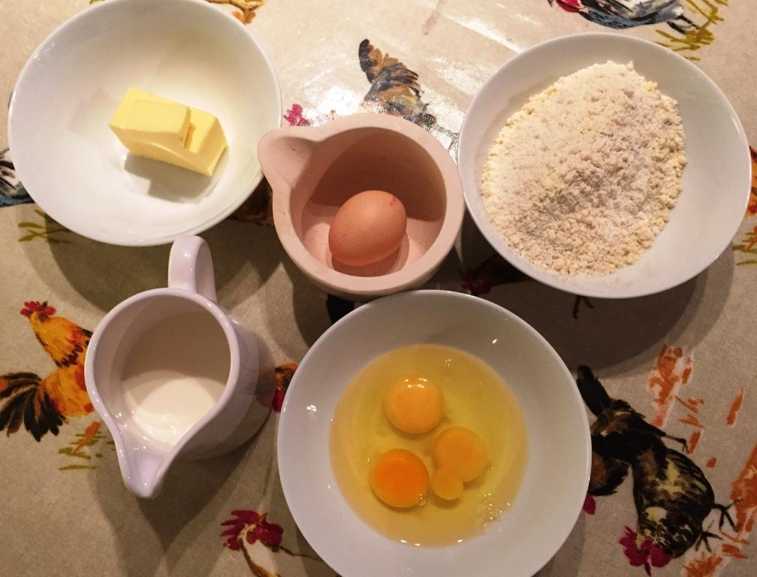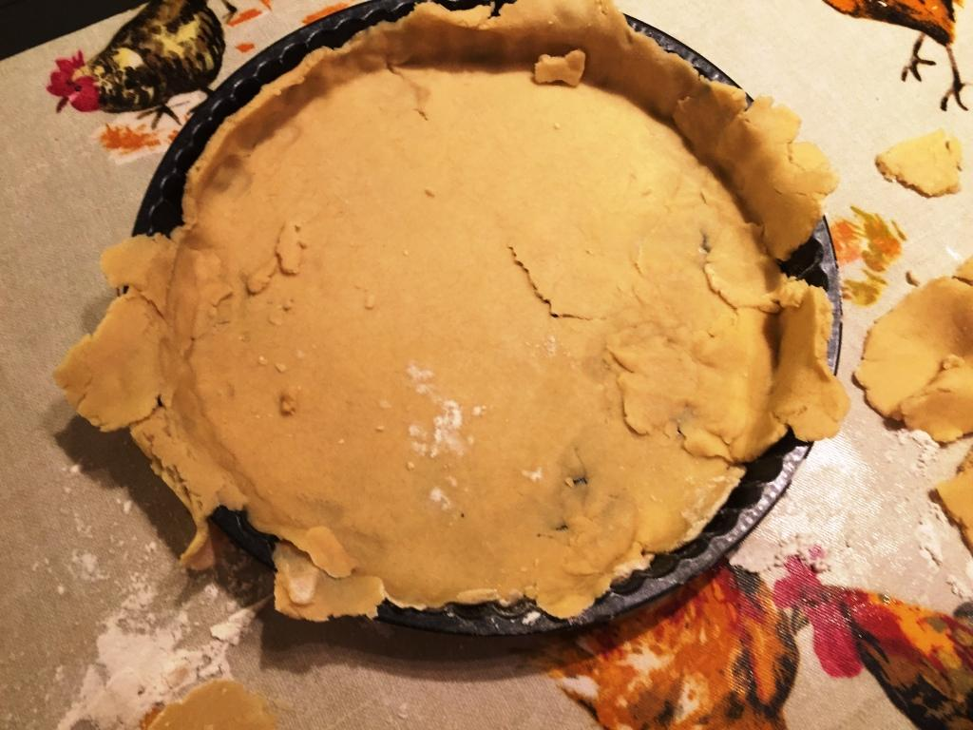

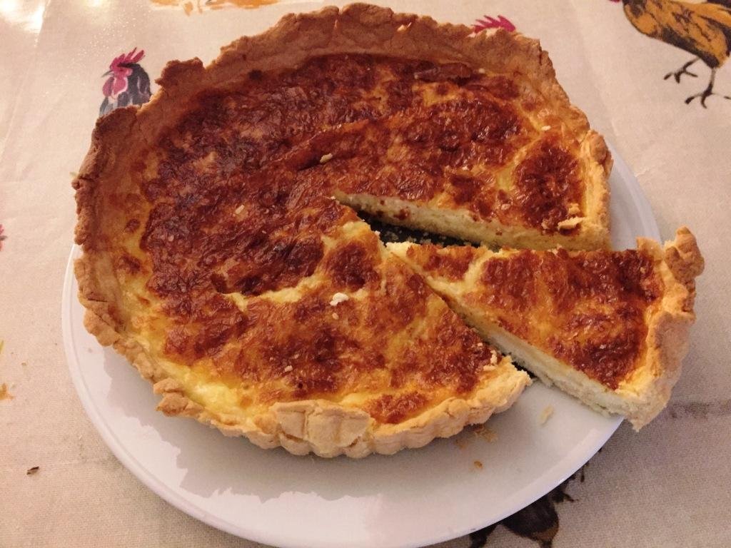

#5. Here is a list of ingredients for making 10 Flapjacks.

Ingredients for 10 Flapjacks

80 g rolled oats

60 g butter

30 ml golden syrup

36 g light brown sugar

Work out the amount of each ingredient needed to make 15 Flapjacks.

..................... g rolled oats

..................... g butter

..................... ml golden syrup

..................... g light brown sugar
(Total for recipe 5 is 3 marks)
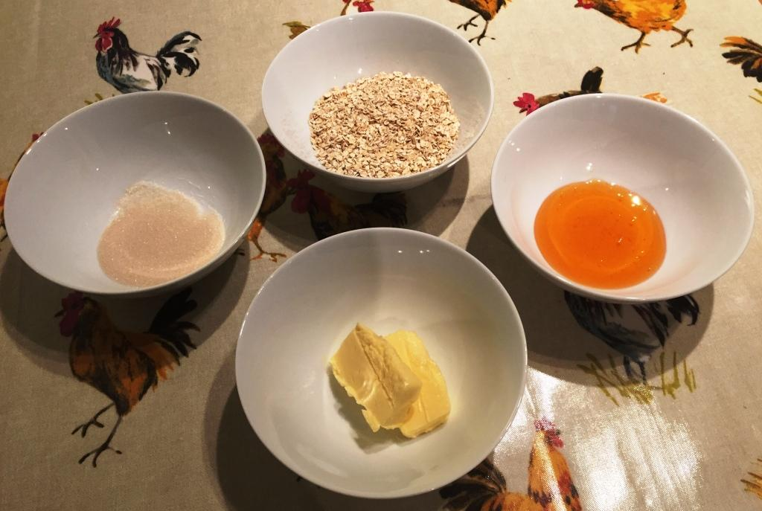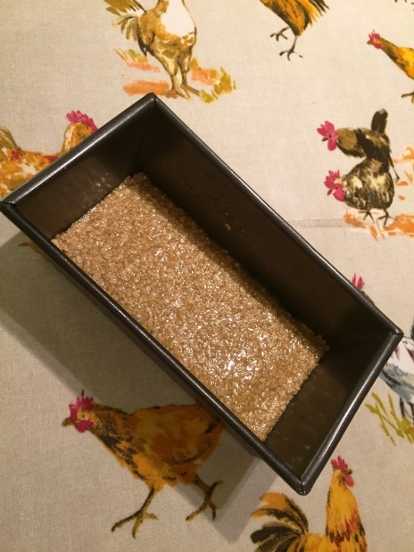

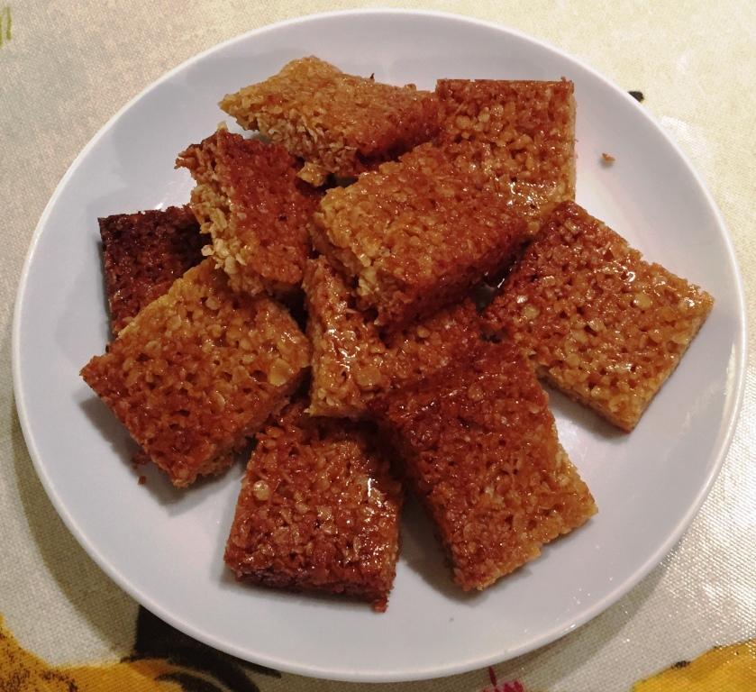

6. Here is a list of ingredients to make melon sorbet for 6 people.

Melon Sorbet
for 6 people
800 g melon
4 egg whites
$\frac{1}{2}$ lime
100 g caster sugar

Terry makes melon sorbet for 18 people.

(a) Work out how much caster sugar he uses.

.................................. g
(2)

Hedley makes melon sorbet.
He uses 2 limes.

(b) Work out how many people he makes melon sorbet for.

.....................................
(2)
(Total for recipe 6 is 4 marks)
#7. This is a list of ingredients for making chicken soup for 4 people.

Ingredients for 4 people
60 g butter
300 g chicken
150 ml cream
1 onion
640 ml chicken stock

Bill is going to make chicken soup for 6 people.

Work out the amount of each ingredient he needs.

.......................................... g butter
.......................................... g chicken
.......................................... ml cream
.......................................... onion
.......................................... ml chicken stock
(Total for recipe 7 is 3 marks)
#8. Here are the ingredients needed to make 8 pancakes.

Pancakes

Ingredients to make 8 pancakes

300 ml milk
1 egg
120 g flour
5 g butter

Jacob makes 24 pancakes.

(a) Work out how much milk he needs.

................................................. ml
(2)

Cathie makes 12 pancakes.

(b) Work out how much flour she needs.

.................................................... g
(2)
(Total for recipe 8 is 4 marks)
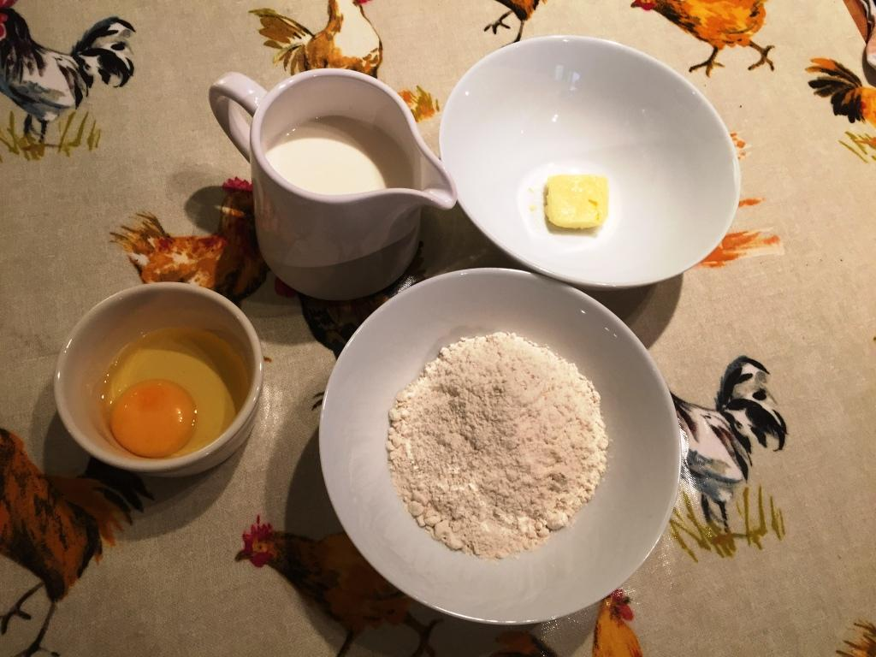

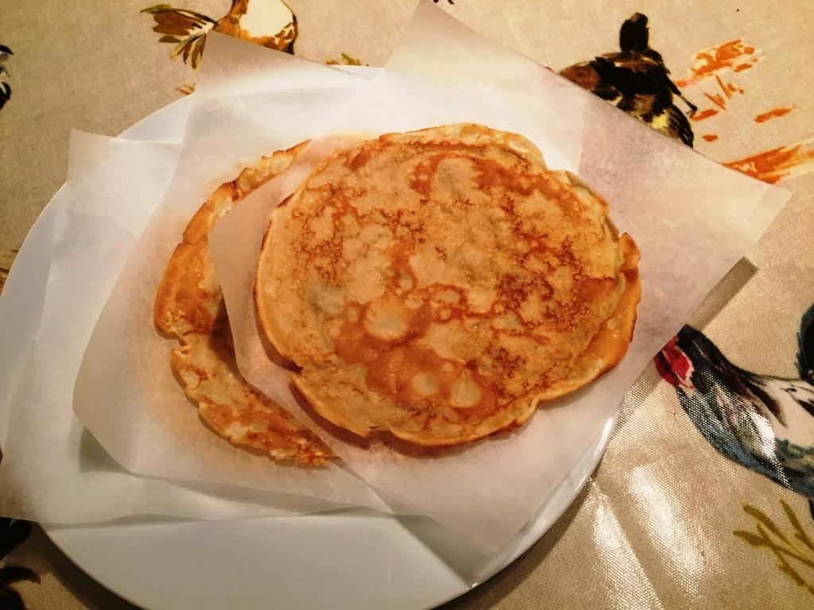
9. Here is a list of ingredients for making small cakes.

Small cakes

400 g flour
200 g butter
200 g sugar
2 eggs

Makes 15 small cakes

Rosie has
2 kg of flour
800 g of butter
1.5 kg of sugar
12 eggs

What is the greatest number of small cakes Rosie can make?
You must show all your working.

..............................................
(Total for recipe 9 is 4 marks)

*10. Here are the ingredients to make 12 cupcakes.

For 12 cupcakes

200 g butter
200 g caster sugar
4 eggs
240 g flour

Martin is making cupcakes to sell at his school play.
Martin wants to make 1 cupcake for each adult and 2 cupcakes for each child.

There will be 90 children and 120 adults at the school play.

Martin can get these ingredients from the school kitchen.

5 kg butter
5 kg caster sugar
90 eggs
5 kg flour

Make a shopping list of any ingredients Martin still needs, showing the amount of each ingredient. You must show all your working.

..............................................
(Total for recipe 10 is 5 marks)
#11. Here is a list of ingredients for making a Cheese Soufflé.

Cheese Soufflé  3 eggs  $\frac{1}{2}$ 1 oz butter  $\frac{1}{2}$ oz flour  $\frac{1}{4}$ pint milk  3 oz grated cheese |  | Imperial Units Metric Units  1 oz = 28 g  1 pint = 568 ml

(a) Complete the list of ingredients using metric units.

Cheese Soufflé

..……………………………….. eggs

…………………………….. g butter

.…………………………….. g flour

.…………………………….. ml milk

…………………….. g grated cheese
(2)

Jemma wants to make 12 Cheese Soufflés.

(b) Work out how much milk she will need.

Give your answer in litres.

………………………………………………….. litres
(2)
(Total for recipe 11 is 4 marks)
#12. Here are the ingredients needed to make 16 gingerbread men.

Ingredients
to make 16 gingerbread men

180 g flour
40 g ginger
110 g butter
30 g sugar

Hamish wants to make 24 gingerbread men.
Work out how much of each of the ingredients he needs.

..........................................................g flour

.......................................................g ginger

........................................................g butter

.........................................................g sugar

(Total for recipe 12 is 3 marks)
13. Here is a list of ingredients for making fruit buns.

Fruit buns

Flour 300 g
Butter 150 g
Sugar 150 g
Mixed fruit 100 g
Eggs 1

Makes 12 fruit buns

Rosie has

3 kg of flour
900 g of butter
1 kg of sugar
800 g of mixed fruit
12 eggs

What is the greatest number of fruit buns Rosie can make?

You must show your working.

..............................................
(Total for recipe 13 is 4 marks)
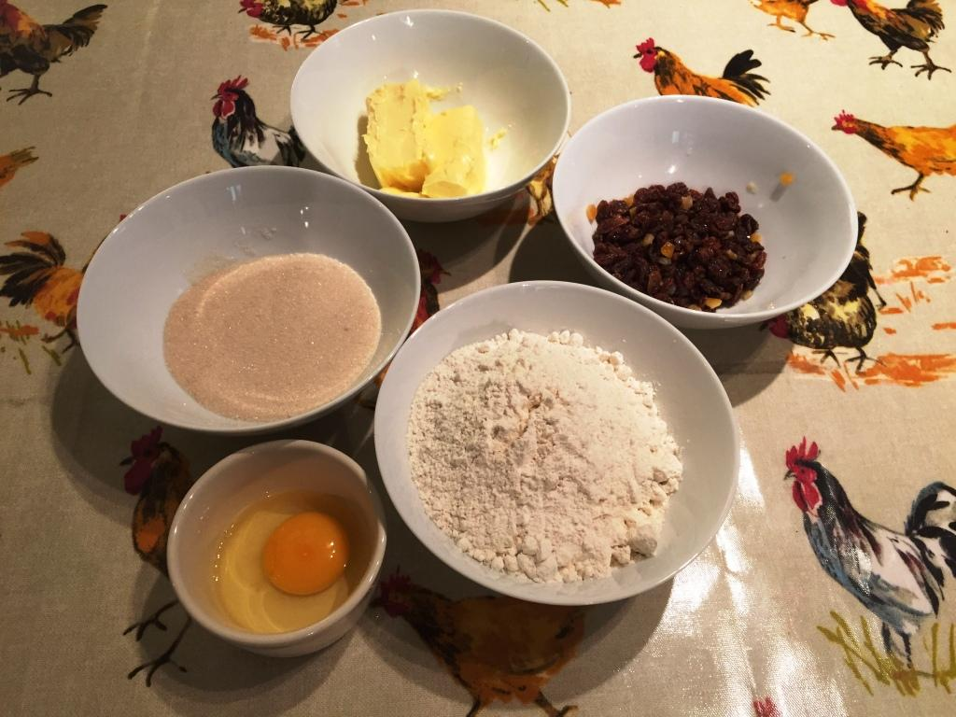

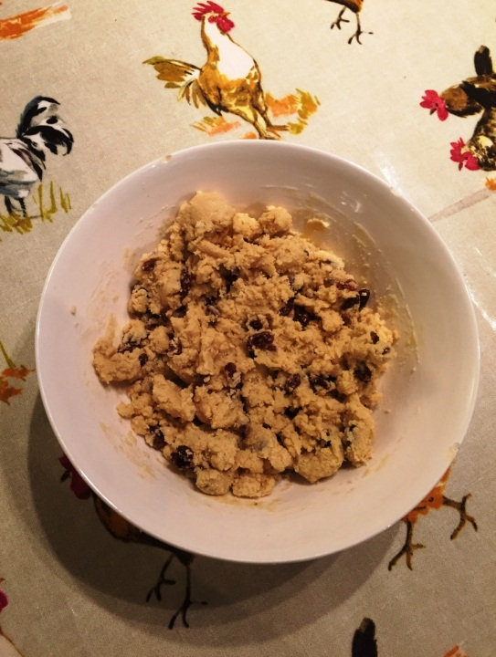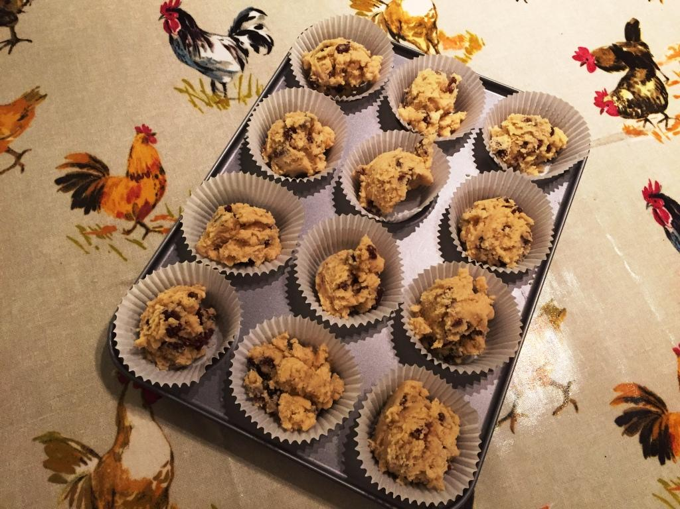

*14. Here are the ingredients needed to make 20 cookies.

Cookies

Ingredients to make 20 cookies

225 g of butter
120 g of caster sugar
275 g of flour

Liz is going to make some cookies for a party.

There will be 4 adults and 14 children at the party.

Liz wants to make 2 cookies for each adult and 3 cookies for each child.

Liz has
500 g of butter
300 g of caster sugar
1 kg of flour

Does Liz have enough butter, enough caster sugar and enough flour to make all the cookies for the party?

You must show all your working.

(Total for recipe 14 is 5 marks)
15. Here are the ingredients needed to make 12 shortcakes.

Shortcakes
Makes 12 shortcakes
50 g of sugar
200 g of butter
200 g of flour
10 ml of milk

Liz makes some shortcakes.
She uses 25 ml of milk.

(a) How many shortcakes does Liz make?

..............................................
(2)

Robert has 500 g of sugar
1000 g of butter
1000 g of flour
500 ml of milk

(b) Work out the greatest number of shortcakes Robert can make.

..............................................
(2)
(Total for recipe 15 is 4 marks)
*16. Here is a list of ingredients for making 18 mince pies.

Ingredients for 18 mince pies
225 g of butter
350 g of flour
100 g of sugar
280 g of mincemeat
1 egg

Elaine wants to make 45 mince pies.

Elaine has
1 kg of butter
1 kg of flour
500 g of sugar
600 g of mincemeat
6 eggs
Does Elaine have enough of each ingredient to make 45 mince pies?
You must show clearly how you got your answer.

(Total for recipe 16 is 4 marks)
#17. Here are the ingredients needed to make 8 shortbread biscuits.

Shortbread biscuits
makes 8 biscuits
120 g butter
60 g caster sugar
180 g flour

Tariq is going to make some shortbread biscuits.
He has the following ingredients

330 g butter 200 g caster sugar 450 g flour

Work out the greatest number of shortbread biscuits that Tariq can make with his ingredients.
You must show all your working.

......................................... biscuits
(Total for recipe 17 is 3 marks)

TOTAL = 64 MARKS

BLANK PAGE

