Maths Emporium
Best Value B
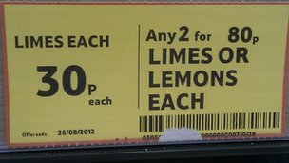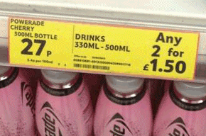

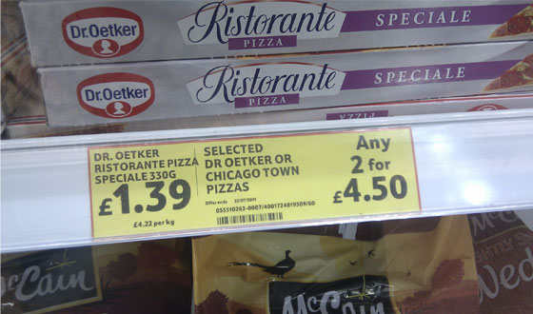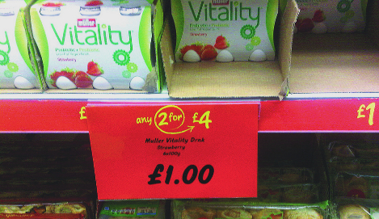

Introduction
Past papers aren’t just for practising your mathematics skills – they also useful for learning the basics you’ll need for all sorts of practical activities such as being able to work out the bargains when you go shopping. Supermarkets get it wrong from time to time – make sure that you don’t.

Information
The marks for individual questions are shown in round brackets: e.g. (2).
There are 8 questions in this booklet. The total mark is 35.
Questions marked with a * sign will require working to be shown.
Calculators may be used in all questions.

Advice
Show all stages in any calculations.
Work steadily through the paper. Do not spend too long on one recipe.
If you cannot answer a question, leave it and attempt the next one.
Return at the end to those you have left out.
*1. Brenda works in an office.
She finds out the prices of folders from two companies, Office Deals and Paper World.
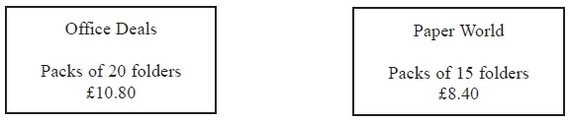
Brenda needs to buy exactly 60 folders.
She wants to buy the folders as cheaply as possible.
Which company should Brenda buy the folders from?
You must explain your answer.

(Total 4 marks)
___________________________________________________________________________

*2. Faiza wants to buy some plants.
She finds out the price of the plants from 2 shops.
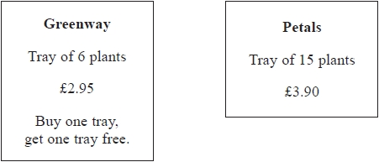
Faiza wants to buy exactly 60 plants.
She wants to buy the plants as cheaply as possible.
Which shop should Faiza buy the plants from?
You must show your working.

(Total 4 marks)
___________________________________________________________________________

*3. Here are the costs of pens in two shops.

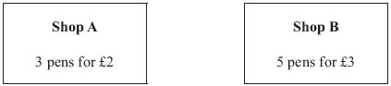
Mrs Evans wants to buy 30 pens for the cheapest possible cost.
Which shop should she buy the pens from?
You must show all your working.

(Total 4 marks)
___________________________________________________________________________

4. George is going to buy exactly 10 ink cartridges.

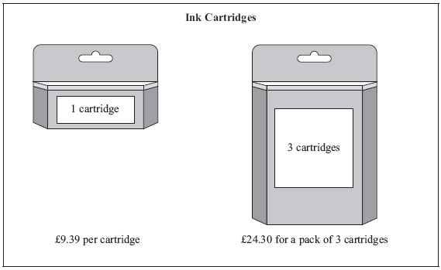
Find the difference in cost between the cheapest way and the most expensive way to buy the 10 ink cartridges.

……...............................................................................................................................................
(Total 5 marks)
___________________________________________________________________________

*5. Becky wants to buy a table and six chairs.
Three shops sell the same types of tables and chairs.

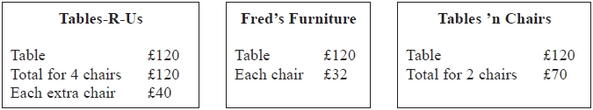
Becky wants to buy the table and six chairs from the same shop.
She wants to pay the lowest total price.
Which shop should Becky buy the table and six chairs from?
You must show all your working.

(Total 4 marks)
___________________________________________________________________________

*6.
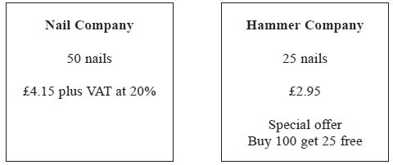
Barak is going to buy 550 nails from one of these companies.
He wants to buy the nails at the cheaper cost.

Where should he buy the nails, from the Nail Company or the Hammer Company?

(Total 5 marks)
___________________________________________________________________________

*7. Sam is going to paint his garden shed.
The paint is sold in two different shops.

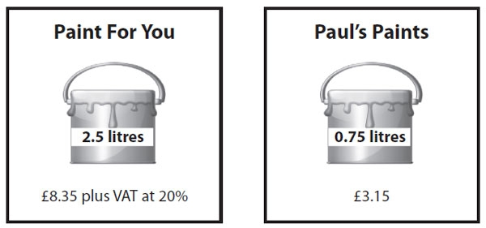

Sam needs 7.5 litres of paint.

Sam wants to buy the cheapest paint.
He is going to buy the paint from one of these shops.

Which shop should he buy the paint from?
You must show your working.

(Total 4 marks)
___________________________________________________________________________

*8. Tom is going to buy 25 plants to make a hedge.
Here is information about the cost of buying the plants.
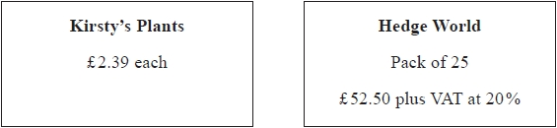
Tom wants to buy the 25 plants as cheaply as possible.
Should Tom buy the plants from Kirsty's Plants or from Hedge World?
You must show all your working.

(Total 5 marks)
___________________________________________________________________________
TOTAL FOR PAPER IS 35 MARKS

BLANK PAGE

