Maths Emporium
DIY

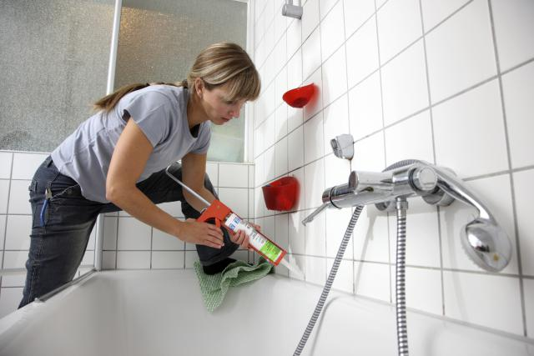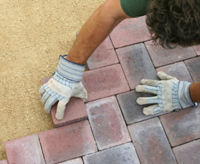

Introduction
Past papers aren’t just for practising your mathematics skills – they also useful for learning the basics you’ll need for all sorts of practical activities. There’s nothing our examiners like better on the weekend than to get involved with a bit of DIY – gardening, tiling, painting and paving – and then writing it up for a maths exam paper.

Information
The marks for individual questions are shown in round brackets: e.g. (2).

There are 24 questions in this booklet. The total mark is 100.

Questions marked with a * sign will require working to be shown.

Calculators must not be used for questions marked with a † sign.

Advice
Show all stages in any calculations.

Work steadily through the paper. Do not spend too long on one question.

If you cannot answer a question, leave it and attempt the next one.

Return at the end to those you have left out.
1. Here is a sketch of the floor of a room.

(a) Work out the perimeter of the floor.

.............................................. m
(1)

(b) Work out the area of the floor.

.............................................. m²
(2)

Jemma wants to cover the floor with carpet tiles.
She needs 80 carpet tiles to cover the floor.

Carpet tiles are sold in boxes.
There are 12 carpet tiles in each box.

(c) How many boxes of carpet tiles does Jemma need to buy?

.............................................. boxes
(2)
(Total 5 marks)
______________________________________________________________________________
2. Here is some information about the cost of carpet tiles at the Handiman Superstore.

Josh needs 120 carpet tiles.
He buys all the carpet tiles in packs.

(a) Work out how much he pays.

£ ..............................................................
(2)

Gemma needs 68 tiles.
She wants to pay the least amount.

(b) How much will she pay?

£ ..............................................................
(3)
(Total 5 marks)
______________________________________________________________________________
3. You can use this rule to work out the total charge for hiring a concrete mixer.

Total charge = £30 plus £8 each day

Esme hired a concrete mixer for 4 days.

(a) Work out the total charge.

£..............................................
(2)

William also hired a concrete mixer.

The total charge was £110

(b) Work out how many days William hired the concrete mixer for.

............................................. days
(3)
(Total 5 marks)
______________________________________________________________________________
*4. Ashley wants to buy some tins of paint.

He finds out the costs of paint at two shops.

Ashley needs 9 tins of paint.
Ashley wants to get all the tins of paint from the same shop.
He wants to pay the cheapest possible total price.

Which of the two shops should Ashley buy the paint from?

(Total 6 marks)
______________________________________________________________________________
5. James is going to cover a rectangular floor with flooring.

The floor has a length of 6 m.
It has a width of 4.5 m.

Flooring is sold in packs.
One pack of flooring covers an area of 1.44 m².

Each pack costs £12.87

James buys the least number of packs so that he has enough flooring to cover the floor.

Work out how much money James pays for the flooring.

£ ..............................................................
(Total 4 marks)
______________________________________________________________________________
6. Richard is going to cover a bathroom wall with tiles.
The wall is in the shape of a rectangle.

The wall is 1.8 m long and 2.4 m high.

The tiles are squares with sides of 30 cm.
There are 14 tiles in a box.

How many boxes of tiles does Richard need?
You must show all your working.

.................................................
(Total 5 marks)
______________________________________________________________________________
7. It takes Tom 1 hour to lay 30 bricks.
He has to lay 180 bricks.

Tom starts to lay the bricks at 9 a.m.
He has half an hour break at 11 a.m.
He has another half an hour break at 1 p.m.

What time should Tom finish laying the 180 bricks?

..............................................
(Total 3 marks)
______________________________________________________________________________

†*8. The diagram shows the floor of a village hall.

The caretaker needs to polish the floor.

One tin of polish normally costs £19.
One tin of polish covers 12 m² of floor.

There is a discount of 30% off the cost of the polish.

The caretaker has £130.

Has the caretaker got enough money to buy the polish for the floor?
You must show all your working.

(Total 5 marks)
______________________________________________________________________________
9. The diagram shows a garden with 4 flower beds.
The garden is a rectangle, 23 m by 17 m.

Each flower bed is a rectangle with the same length and the same width.

Work out the length and the width of a flower bed.

length = .......................................... m
width = .......................................... m
(Total 3 marks)
___________________________________________________________________________
*10. Here is a diagram of a wall.

Halima wants to cover all of the wall with tiles.

The tiles are squares with sides of length 20 cm.

The tiles are sold in packs.
There are 10 tiles in each pack.
Each pack of tiles costs £34.99

Halima only has £1000

Can she buy enough packs of tiles to cover the wall?

(Total 6 marks)
______________________________________________________________________________
*11. The diagram shows the plan of a floor.

All the corners of the floor are right angles.
Jason wants to cover the floor completely with underlay.

Underlay is sold in rolls.
Each roll of underlay has a length of 5 m and a width of 1.5 m.

Each roll of underlay costs £59.99
Jason has £400 to spend.

Does Jason have enough money to buy the underlay he needs?

(Total 4 marks)
______________________________________________________________________________
The Patio

A patio is a paved area outside a house, between the doors and the garden. Those lucky enough to have a garden might also have a patio like the one pictured below.

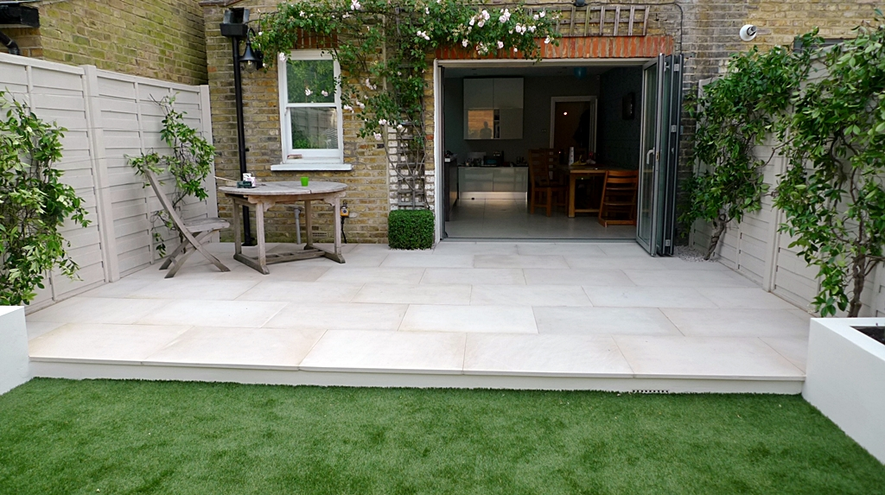

Many patios are square or rectangular, but some of the more spectacular ones might be circular. Anyone laying a patio will have to work out in advance how many paving slabs will be needed; making a mistake with such a calculation can be very expensive.

The picture on tthe left below shows a patio being laid out before the house has been finished or the lawn for the garden seeded. Questions in GCSE Mathematics papers often involve measuring out the the dimensions of a patio, working out how many paving slabs might be needed and what they might cost.

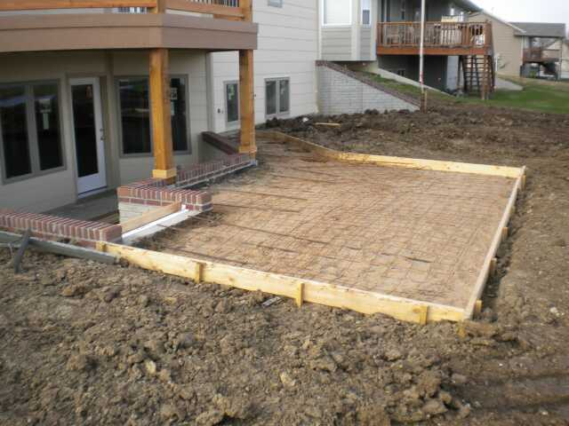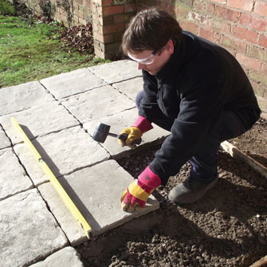

Even if you don’t have one where you live, become familiar with the word patio and don’t confuse it with the word ratio.

12. Judith has a garden in the shape of a triangle.
Here is a sketch of the garden.

(a) Use ruler and compasses to construct an accurate scale drawing of the garden.
You must show all your construction lines.
Use a scale of 1 cm represents 1 m.

The side AB has been drawn for you.

(2)

Judith is going to build a patio in the garden.

The patio will be in the shape of a rectangle.
Judith wants the patio to be 3 m long and 2 m wide.

(b) Is the garden big enough for Judith to build the patio?
You must show how you got your answer.

..............................................................
(2)
(Total 4 marks)
______________________________________________________________________________
†13. The diagram shows a garden in the shape of a rectangle.

The scale of the diagram is 1 cm represents 2 m.

Scale: 1 cm represents 2 m

Irfan is going to plant a tree in the garden.
The tree must be

more than 3 metres from the patio
and more than 6 metres from the centre of the pond.

On the diagram, shade the region where Irfan can plant the tree.

(Total 3 marks)
______________________________________________________________________________

†14. Here is a diagram of Jim’s garden.

Jim wants to cover his garden with grass seed to make a lawn.

Grass seed is sold in bags.
There is enough grass seed in each bag to cover 20 m² of garden.

Each bag of grass seed costs £4.99

Work out the least cost of putting grass seed on Jim’s garden.

£ .........................................................
(Total 4 marks)
______________________________________________________________________________
†*15. Talil is going to make some concrete mix.
He needs to mix cement, sand and gravel in the ratio 1 : 3 : 5 by weight.

Talil wants to make 180 kg of concrete mix.

Talil has

15 kg of cement
85 kg of sand
100 kg of gravel

Does Talil have enough cement, sand and gravel to make the concrete mix?

(Total 4 marks)
______________________________________________________________________________

†16. The diagram shows a patio in the shape of a rectangle.

The patio is 3.6 m long and 3 m wide.

Matthew is going to cover the patio with paving slabs.
Each paving slab is a square of side 60 cm.

Matthew buys 32 of the paving slabs.

(a) Does Matthew buy enough paving slabs to cover the patio?
You must show all your working.

..............................................
(3)

The paving slabs cost £8.63 each.

(b) Work out the total cost of the 32 paving slabs.

£ ..............................................
(3)
(Total 6 marks)
______________________________________________________________________________
17. The diagram shows the plan of a playground.

Bill is going to cover the playground with tarmac.
It costs £2.56 to cover each square metre with tarmac.

Work out the total cost of the tarmac Bill needs.

£..........................................
(Total 4 marks)
______________________________________________________________________________
18. The diagram shows Bob’s bathroom wall.

The wall has a length of 5 m.
The wall has a height of 3 m.

Bob is going to cover the wall with tiles.
He is going to use square tiles of side 25 cm.

How many tiles will Bob have on the bathroom wall?

..............................................
(Total 3 marks)
______________________________________________________________________________
19. Adam is a farmer.
He is building a fence of length 250 m.

Here is a diagram showing a part of the fence.

The distance between posts is 2.35 m.
The width of each post is 0.1 m.

Work out the total number of posts needed to build the fence of length 250 m.

..............................................
(Total 3 marks)
______________________________________________________________________________
†20. Suha has a full 600 ml bottle of wallpaper remover.
She is going to mix some of the wallpaper remover with water.

Here is the information on the label of the bottle.

Suha is going to use 750 ml of water.

How many millilitres of wallpaper remover should Suha use?
You must show your working.

..........................................ml

(Total 4 marks)
______________________________________________________________________________
21.

Jon has a flower garden in the shape of a circle.
The diameter of the garden is 5 metres.

Jon wants to put fencing around the edge of the garden.
The fencing costs £1.80 per metre.

Work out the total cost of the fencing.

£..........................................
(Total 3 marks)
______________________________________________________________________________
22. The diagram shows a circular pond with a path around it.

The pond has a radius of 5m.
The path has a width of 1m.

Work out the area of the path.
Give your answer correct to 3 significant figures.

............................ m²
(Total 3 marks)
______________________________________________________________________________

†*23. Here is a diagram of a garden.

The lawn is a 6 m by 4 m rectangle.

Sabia is going to put a path all the way around the lawn.
The path will be 0.5 m wide.

Sabia is going to use paving stones to make the path.
Each paving stone is a 0.5 m by 0.5 m square.
She has 35 paving stones.

Has Sabia got enough paving stones?
You must show all your working.

(Total 4 marks)
___________________________________________________________________________
†24. Here is a scale drawing of a rectangular garden ABCD.

Scale: 1 cm represents 1 metre.

Jane wants to plant a tree in the garden

at least 5m from point C,
nearer to AB than to AD
and less than 3m from DC.

On the diagram, shade the region where Jane can plant the tree.

(Total 4 marks)
______________________________________________________________________________
TOTAL FOR PAPER IS 100 MARKS

