Maths Emporium
Holidays B



Introduction
Past papers aren’t just for practising your mathematics skills – they are also useful for learning the basics you’ll need for all sorts of practical activities such as working out the cost of your holidays and exchanging money.

Information
The marks for individual questions are shown in round brackets: e.g. (2).

There are 9 questions in this booklet. The total mark is 40.

Questions marked with a * sign will require working to be shown.

Calculators must not be used for questions marked with a † sign.

Advice
Show all stages in any calculations.

Work steadily through the paper. Do not spend too long on one question.

If you cannot answer a question, leave it and attempt the next one.

Return at the end to those you have left out.

1. Mrs Evans is planning a trip to the zoo.
She finds out this information.
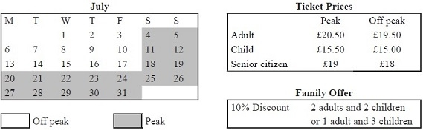

Mrs Evans will go to the zoo on Friday 17th July.
She will need to buy tickets for 1 adult and 3 children.
Mrs Evans wants to buy the tickets as cheaply as possible.
Work out the total cost of the tickets.
£ ...........................................................
(Total 4 marks)
___________________________________________________________________________

2. Eric travels from the UK to India every year.
In 2010, the exchange rate was £1 = 67.1 rupees.
In 2012, the exchange rate was £1 = 82.5 rupees.
In 2010 Eric changed £600 into rupees.
How many pounds (£) did Eric have to change to rupees in 2012 to get the same number
of rupees as he did in 2010?

£..........................................................
(Total 3 marks)
___________________________________________________________________________

3. John changes £450 to euros.
The exchange rate is £1 = 1.16 euros.
(a) Change £450 to euros.
........................................................... euros
(2)

When in Amsterdam, John uses his credit card to pay for a ring costing 850 euros.
He has to pay a bank charge of £3.50 for using his credit card in addition to the cost of the ring.
(b) Work out the total cost, in pounds (£), of the ring and the bank charge.

£ ...........................................................
(3)
(Total 5 marks)
___________________________________________________________________________

*4. Joan is planning a skiing holiday in Hinterglemm for herself and her two children.
They are going skiing for 6 days.
The table shows the costs of ski hire, of boot hire and of buying lift passes in two shops in Hinterglemm.
All prices are in Euros.
Shop A
 |  | Ski hire | Boot hire | Lift pass
Adult | 6 days | 111 | 53 | 236
 | 13 days | 168 | 90 | 314
Child | 6 days | 78 | 52 | 165
 | 13 days | 122 | 87 | 210
Shop B
 |  | Ski hire | Boot hire | Lift pass
Adult | 6 days | 108 | 54 | 242
 | 13 days | 170 | 89 | 324
Child | 6 days | 68 | 48 | 160
 | 13 days | 118 | 85 | 205
Joan will use her own skis and her own boots.
For 6 days she will need
 | to hire skis for each of her two children
 | to hire boots for each of her two children
and | to buy lift passes for herself and each of her two children.
Shop A gives 5% off the total cost.
Shop B gives 3% off the total cost.
Joan wants to hire the skis and boots and buy the lift passes from the same shop.
She wants to get everything from the cheaper shop.
Which shop is cheaper for Joan?
You must show all your working.

(Total 5 marks)
___________________________________________________________________________
5. Here is a conversion graph to change between UK pounds (£) and South African rand.

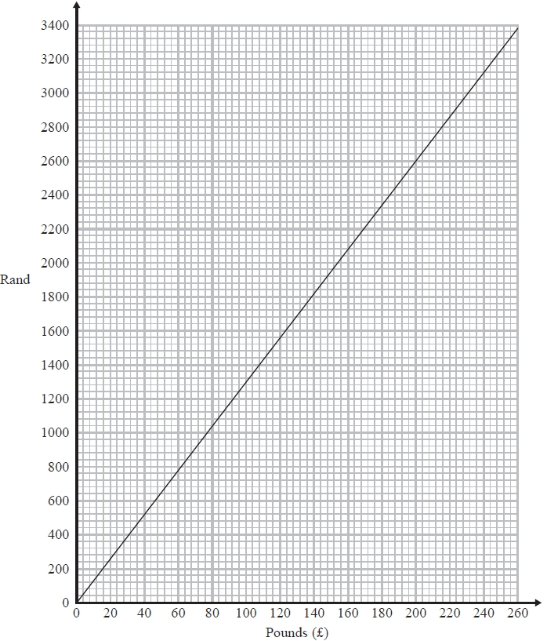

Jo changes £200 into rand.
(a) How many rand does she get?
........................................................... rand
(1)

Simon has £100 and 3700 rand.
He goes to a shop where he can spend both pounds and rand.
He wants to buy
a computer costing £360
or a watch costing £400
or a camera costing £375
∗(b) Which of these items can Simon afford to buy?
You must show clearly how you get your answer.
...........................................................
(3)
(Total 4 marks)
___________________________________________________________________________

*6. You can use this conversion graph to change between pounds (£) and dollars ($).
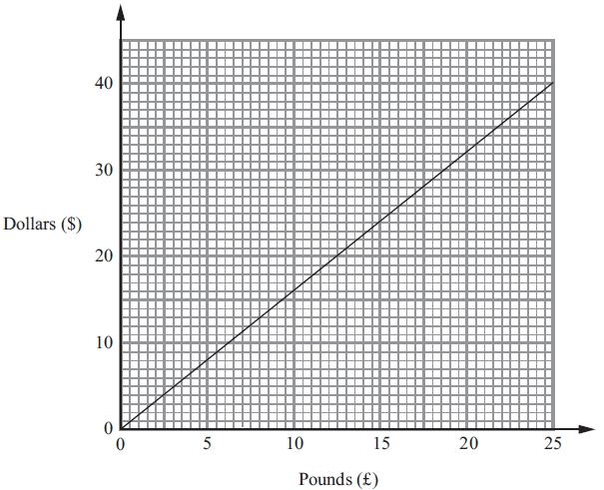
Stacey bought a watch in New York.
The watch cost $220.
In London, the same type of watch costs £140.
Compare the cost of the watch in New York with the cost of the watch in London.

(Total 4 marks)
___________________________________________________________________________
*7. Beth is planning a trip for a group of 36 people.
The group can go to a theme park or to a concert.
If they go to the concert, they will go by train.
If they go to the theme park, they will go by coach.
Beth has information about the costs.
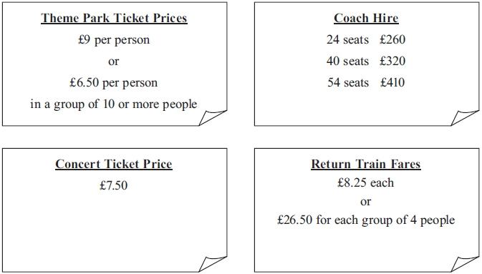
What is the least possible total cost of the trip?
You must show all your working.

(Total 5 marks)
___________________________________________________________________________
8. These graphs can be used to convert between pounds (£), Euros (€) and US dollars ($).

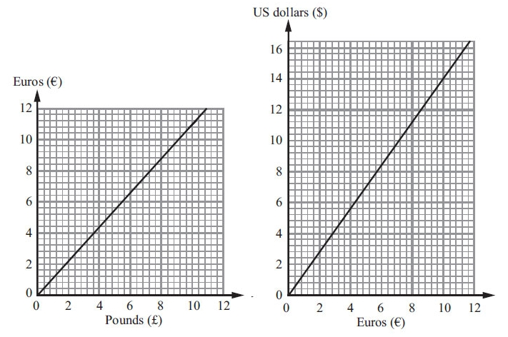

(a) Convert £6 to Euros (€).

€ ...........................................................
(1)

(b) Convert $5 to Euros (€).

€ ...........................................................
(1)

On the internet, Amir sees a pair of trainers.
The trainers cost $65.
(c) Work out the cost of the trainers in pounds (£).

£ ...........................................................
(4)
(Total 6 marks)
___________________________________________________________________________

*†9. Railtickets and Cheaptrains are two websites selling train tickets.
Each of the websites adds a credit card charge and a booking fee to the ticket price.
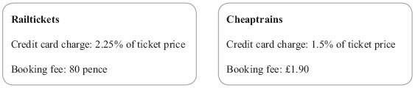
Nadia wants to buy a train ticket.
The ticket price is £60 on each website.
Nadia will pay by credit card.
Will it be cheaper for Nadia to buy the train ticket from Railtickets or from Cheaptrains?

(Total 4 marks)
___________________________________________________________________________

TOTAL FOR PAPER IS 40 MARKS

