Maths Emporium
Percentages (H)

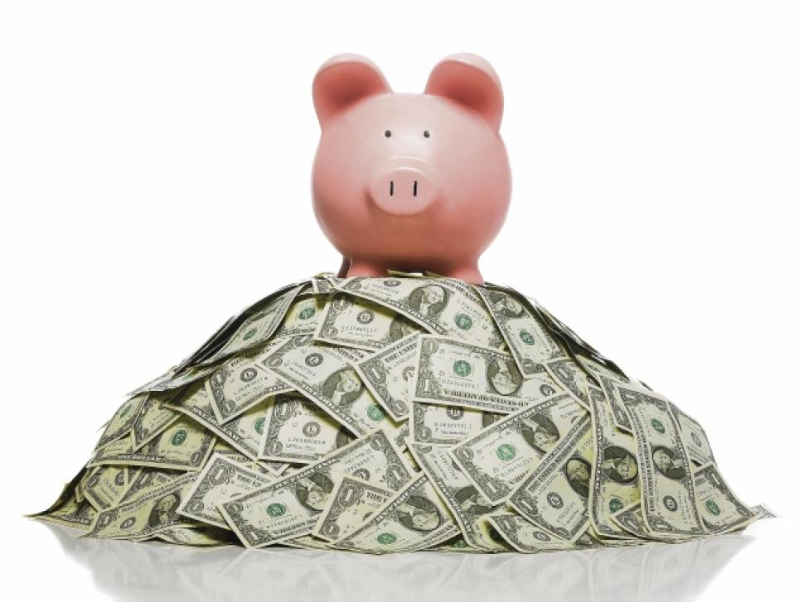

Introduction
Past papers aren’t just for practising your mathematics skills – they are also useful for learning the basics you’ll need for all sorts of practical activities such as working with percentages to calculate sale prices (original or after deductions), percentage increase/decrease, investments, savings and depreciation.

Information
The marks for individual recipes are shown in round brackets: e.g. (2).

There are questions in this booklet. The total mark is 50.

Questions marked with a * sign will require working to be shown.

Calculators must not be used for questions marked with a † sign.

Advice
Show all stages in any calculations.

Work steadily through the paper. Do not spend too long on one recipe.

If you cannot answer a question, leave it and attempt the next one.

Return at the end to those you have left out.
†1. Lydia is buying a ring.
The ring costs £60.
She pays a deposit of 40%.
Work out how much she pays as the deposit.

£ ...........................................................
(Total 2 marks)
___________________________________________________________________________

†2. A set of tyres normally costs £500.
In a sale there is a 30% discount.
Work out the sale price of the set of tyres.

£ ...........................................................
(Total 3 marks)
___________________________________________________________________________

†3. A TV costs £400.
Peter pays a deposit of 15%.
How much does Peter still have to pay for the TV?

£ ...........................................................
(Total 3 marks)
___________________________________________________________________________

4. The value of a car depreciates by 25% each year.
At the end of 2013 the value of the car was £4800.
Work out the value of the car at the end of 2015.
£ ...........................................................
(Total 3 marks)
___________________________________________________________________________
5. A ball fell 2 metres onto horizontal ground.
The ball hit the ground and bounced up and down 3 times.
The first time the ball bounced, it rose to 75% of the height it fell from.
The second time the ball bounced, it rose to 75% of the height it reached after the first bounce.
The third time the ball bounced, it rose to 75% of the height it reached after the second bounce.
Work out the height the ball reached after the third bounce.
Give your answer correct to 2 decimal places.

........................................................... m
(Total 3 marks)
___________________________________________________________________________

6. Martin bought a computer for £1200.
At the end of each year the value of the computer is depreciated by 20%.
After how many years will the value of the computer be £491.52?
You must show your working.

.................................................................................................................................................
(Total 3 marks)
___________________________________________________________________________

†7. Ria is going to buy a caravan.
The total cost of the caravan is £7000 plus VAT at 20%.
Ria pays a deposit of £3000.
She pays the rest of the total cost in 6 equal monthly payments.
Work out the amount of each monthly payment.

£ ...........................................................
(Total 4 marks)
___________________________________________________________________________
8. Neil invested £500 on 1st January 2000 at a fixed compound interest rate of R% each year.
The value V, in pounds, of this investment after n years is given by the formula
V = 500 × (1.025)^{n}
(a) Write down the value of R.

.................................................................................................................................................
(1)
(b) Use your calculator to find the value of Neil's investment at the end of 12 years.

.................................................................................................................................................
(2)
(Total 3 marks)
___________________________________________________________________________

†9. John earns £30 000 each year.
He knows that 20% of his monthly pay is deducted each month.
Work out how much money John has left each month after this deduction.

£ ...........................................................
(Total 3 marks)
___________________________________________________________________________

10. Derek buys a house for £150 000.
He sells the house for £154 500.
(a) Work out Derek's percentage profit.

........................................................... %
(3)

Derek invests £154 500 for 2 years at 4% per year compound interest.
(b) Work out the value of the investment at the end of 2 years.

£ ...........................................................
(3)
(Total 6 marks)
___________________________________________________________________________

11. Liam invests £6200 for 3 years in a savings account.
He gets 2.5% per annum compound interest.
How much money will Liam have in his savings account at the end of 3 years?

£ ...........................................................
(Total 3 marks)
___________________________________________________________________________

12. Aminata invested £2500 for n years in a savings account.
She was paid 3% per annum compound interest.
At the end of n years, Aminata has £2813.77 in the savings account.
Work out the value of n.

.................................................................................................................................................
(Total 2 marks)
___________________________________________________________________________
13. The table gives some information about the average price of a litre of petrol in England.

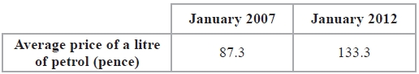
(a) Work out the percentage increase in the average price of a litre of petrol in England between January 2007 and January 2012.
Give your answer correct to 3 significant figures.
........................................................... %
(3)

The average price of a litre of petrol in England increased by 20% from January 2010 to January 2012.
(b) Work out the average price of a litre of petrol in England in January 2010.
Give your answer in pence, correct to 1 decimal place.
........................................................... pence
(3)
(Total 6 marks)
___________________________________________________________________________
†14. The normal price of a television is reduced by 30% in a sale.
The sale price of the television is £350.
Work out the normal price of the television.

£ ...........................................................
(Total 3 marks)
___________________________________________________________________________

15. In a sale normal prices are reduced by 20%.
A washing machine has a sale price of £464.
By how much money is the normal price of the washing machine reduced?

£ ...........................................................
(Total 3 marks)
___________________________________________________________________________
TOTAL FOR PAPER IS 50 MARKS

