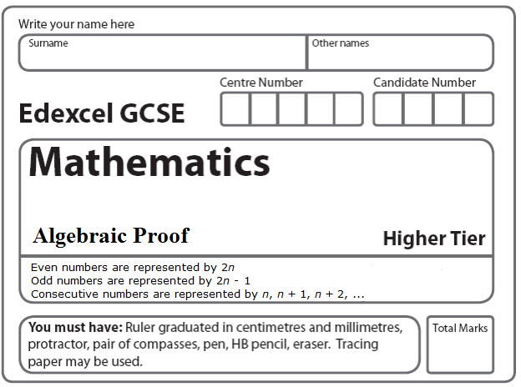
Instructions
- Use black ink or ball-point pen.
- Answer all questions.
- Answer the questions on a separate sheets of paper.
- Calculators must not be used.

Information
- The total mark for this paper is 75.
- The marks for each question are shown in brackets
- use this as a guide as to how much time to spend on each question.
- Questions labelled with an asterisk (*) are ones where the quality of your written communication will be assessed.

Advice
- Read each question carefully before you start to answer it.
- Keep an eye on the time.
- Try to answer every question.
- Check your answers if you have time at the end.

1. Tanaka says ‘When you multiply an odd number and an even number together, you will always get an odd number’. Show that Tanaka is wrong.
(Total 2 marks)

2. Tarish says ‘the sum of two prime numbers is always an even number’. He is wrong. Explain why.
(Total 2 marks)

3. The n th even number is 2n.
The next even number after 2n is 2n + 2.

(a) Explain why.
(1)

(b) Write down an expression, in terms of n, for the next even number after 2n + 2.
(1)

(c) Show algebraically that the sum of any 3 consecutive even numbers is always a multiple of 6.
(3)
(Total 5 marks)

4. Here are the first 4 lines of a number pattern.

n is the first number in the nth line of the number pattern. Show that the above number pattern is true for the four consecutive integers n, (n + 1), (n + 2) and (n + 3).
(Total 4 marks)
______________________________________________________________________________

5. n is a whole number. Prove that n² + (n + 1)² is always an odd number.
(Total 2 marks)
______________________________________________________________________________

6. n and a are integers. Explain why (n² – a²) – (n – a)² is always an integer.
(Total 2 marks)
______________________________________________________________________________
7. n is an integer greater than 1. Use algebra to show that (n² – 1) + (n – 1)² is always equal to an even number.
(Total 4 marks)

8. Prove that the difference between the squares of any two consecutive even numbers is always an odd number multiplied by 4.
(Total 4 marks)

9. Prove algebraically that the sum of the squares of two consecutive integers is always an odd number.
(Total 3 marks)

*10. Prove that the sum of the squares of any two odd numbers is always even.
(Total 4 marks)
______________________________________________________________________________

11. Show that (n + 3)² – (n – 3)² is an even number for all positive integer values of n.
(Total 3 marks)
___________________________________________________________________________

*12. Prove that (7n + 3)² – (7n – 3)² is a multiple of 12, for all positive integer values of n.
(Total 3 marks)

*13. Prove algebraically that the product of two odd numbers is always an odd number.

(Total 3 marks)

14. Prove algebraically that the sum of any two odd numbers is even.
(Total 3 marks)

*15. Prove algebraically that (2n + 1)² – (2n + 1) is an even number for all positive integer values of n.
(Total 3 marks)
______________________________________________________________________________
*16. Given that a and b are two consecutive even numbers, prove algebraically that ${\left(\frac{a+b}{2}\right)}^{2}$is always 1 less than $\frac{a^{2}+b^{2}}{2}$.
(Total 5 marks)

17. Prove that (3n + 1)² – (3n – 1)² is a multiple of 4, for all positive integer values of n.
(Total 3 marks)
______________________________________________________________________________

*18. Prove that the sum of the squares of two consecutive odd numbers is never a multiple of 8.
(Total 4 marks)
______________________________________________________________________________

19. Prove that (2n + 3)² – (2n – 3)² is a multiple of 8 for all positive integer values of n.
(Total 3 marks)
______________________________________________________________________________

20. Prove, using algebra, that the sum of two consecutive whole numbers is always an odd number.
(Total 3 marks)
______________________________________________________________________________

21. Umar thinks (a +1)² = a² + 1 for all values of a.

(a) Show that Umar is wrong.
(2)

Here are two right-angled triangles. All the measurements are in centimetres.

(b) Show that 2a + 2b + 1 = 2c
(3)

(c) a, b and c cannot all be integers. Explain why.
(1)
(Total 6 marks)
______________________________________________________________________________

*22. Prove algebraically that the difference between the squares of any two consecutive integers is equal to the sum of these two integers.
(Total 4 marks)

TOTAL FOR PAPER IS 75 MARKS

