Maths Emporium
Holidays A



Introduction
Past papers aren’t just for practising your mathematics skills – they are also useful for learning the basics you’ll need for all sorts of practical activities such as working out the cost of your holidays and exchanging money.

Information
The marks for individual questions are shown in round brackets: e.g. (2).

There are 8 questions in this booklet. The total mark is 40.

Questions marked with a * sign will require working to be shown.

Calculators must not be used for questions marked with a † sign.

Advice
Show all stages in any calculations.

Work steadily through the paper. Do not spend too long on one question.

If you cannot answer a question, leave it and attempt the next one.

Return at the end to those you have left out.

*1. The Kumar family are going to go to New York.
They will go with Highway Airlines or Jetstream Airlines.
The tables show how much it costs for each adult and each child to go with these airlines.
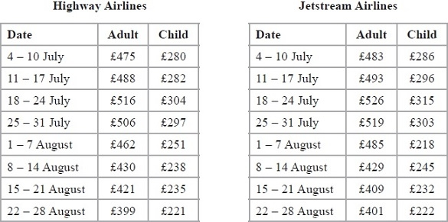
Highway Airlines give a discount of 5% of the total cost for booking online.
Jetstream Airlines give a discount of £25 per person for booking online.
The Kumar family are going to New York on 3 August.
They will buy 2 adult tickets and 1 child ticket.
They will book online.
The Kumar family want to pay the lower total cost.
Which airline should they choose?

(Total 5 marks)
___________________________________________________________________________
2.
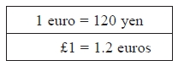

(a) Change 250 euros to yen.
...........................................................yen
(2)

(b) Change 9000 yen to euros.
...........................................................euros
(2)

(c) Change £50 to yen.
...........................................................yen
(2)
(Total 6 marks)
___________________________________________________________________________

*3. Mr and Mrs Jennings are planning a holiday to Italy.
They will go on holiday with their 11 year old daughter.
The table below shows some information about the prices of flights.
Flight to Italy |  |  | Flight back from Italy
Date | Price per adult (£) |  | Date | Price per adult (£)
28th October | 282 |  | 4th November | 305
29th October | 283 |  | 5th November | 303
30th October | 282 |  | 6th November | 285
31st October | 272 |  | 7th November | 283
Child fares
0 to 2 years old |  | No charge
Over 2 to 12 years old |  | 75% of the adult fare
Mr and Mrs Jennings and their daughter want to fly to Italy on 29th October.
They want to fly back from Italy on 6th November.
They have £1600 to spend on flights.
Do they have enough money for the flights?
You must show all your working.

(Total 6 marks)
___________________________________________________________________________
4. Jalin lives in England.
He does a search on the internet and sees the same type of camera on sale in France and in America.
In France, the camera costs 126 euros.
In America, the camera costs $165.24
Jalin finds out these exchange rates.
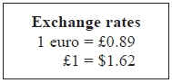
How much cheaper is the camera in America than in France?
Give your answer in pounds (£).
£ ...........................................................
(Total 4 marks)
___________________________________________________________________________

5. You can use this conversion graph to change between pounds (£) and Swiss francs.

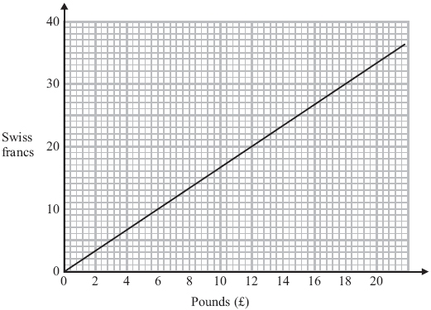
(a) Use the graph to change £6 to Swiss francs.
...........................................................Swiss francs
(1)

(b) Use the graph to change 25 Swiss francs to pounds (£).

£...........................................................
(1)

(c) Change £64 to Swiss francs.

...........................................................Swiss francs
(2)
(Total 4 marks)
___________________________________________________________________________

†6. Mr Brown and his 2 children are going to London by train.
An adult ticket costs £24
A child ticket costs £12
Mr Brown has a Family Railcard.
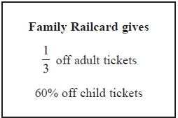
Work out the total cost of the tickets when Mr Brown uses his Family Railcard.

£...........................................................
(Total 4 marks)
___________________________________________________________________________

*†7. Barbara goes on holiday to Prague. The currency in Prague is the Koruna (KC).
This graph can be used to convert between £ (pounds) and KC (Koruna).
The exchange rate is £1 = 30 KC.
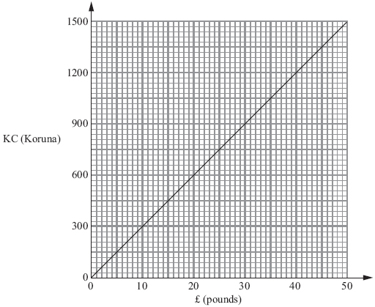

Barbara bought some things in London.
She saw the same things on sale in Prague.
The table shows the cost in £ (pounds) and the cost in KC (Koruna).
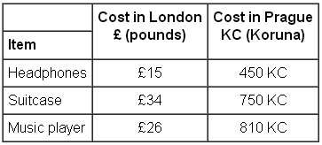
Barbara thinks the total cost of these things was more in London than in Prague.
Is she correct?
Give a reason for your answer.
You must show all your working.

(Total 5 marks)
___________________________________________________________________________

†8. The exchange rate for pounds (£) to euros (€) is £1 = €1.20
(a) Complete the table of values.
£ | 0 | 1 | 5 | 10 | 15 | 20 | 25 | 30
€ |  | 1.20 | 6 |  |  | 24 | 30
(2)
(b) On the grid, draw a conversion graph for pounds (£) to euros (€).

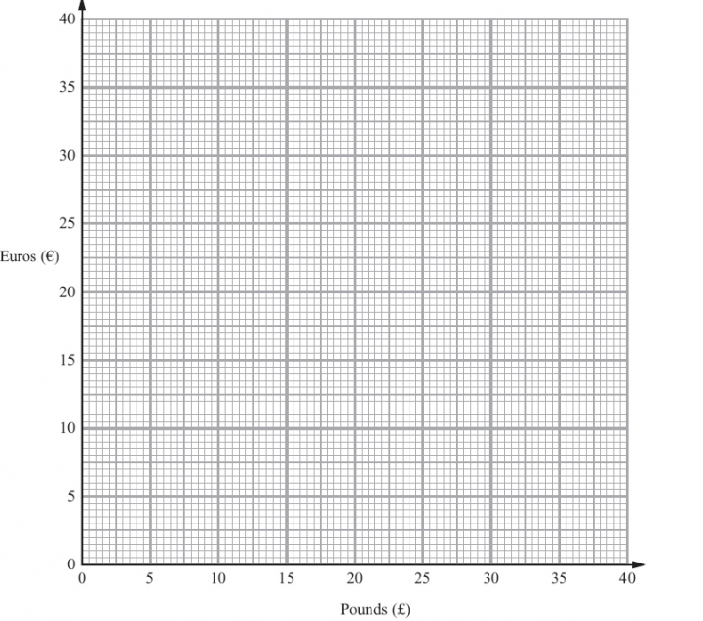
(2)
Louise changes £250 into euros.
(c) Work out how many euros Louise should get.

........................................................... euros
(2)
(Total 6 marks)
___________________________________________________________________________
TOTAL FOR PAPER IS 40 MARKS

