Maths Emporium
Spare change
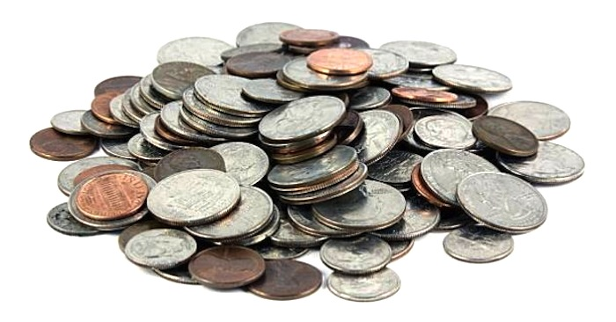

Introduction
Past papers aren’t just for practising your mathematics skills – they also useful for learning the basics you’ll need for all sorts of practical activities such as working out how much money can be spent in different situations and what change should be given.

Information
The marks for individual recipes are shown in round brackets: e.g. (2).
There are 19 questions in this booklet. The total mark is 70.
Questions marked with a * sign will require working to be shown.
Calculators may only be used in Section B of this paper.

Advice
Show all stages in any calculations.
Work steadily through the paper. Do not spend too long on one question.
If you cannot answer a question, leave it and attempt the next one.
Return at the end to those you have left out.

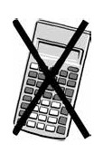
Section A (calculators may NOT be used)

1. Mary buys three tickets for a theatre show.
Each ticket costs £50.
Mary also has to pay a booking fee.
The booking fee is £2.50 per ticket.
Work out the total amount Mary has to pay.
£...........................................................
(Total 3 marks)
___________________________________________________________________________

2. Sarah has saved 254 pound coins.
She puts the pound coins into bags.
There are 20 pound coins in each full bag of coins.
Sarah is going to take all her full bags of coins to the bank.
She can only take up to 5 full bags of coins to the bank each day.
Sarah wants to go to the bank on as few days as possible.
On how many days will Sarah need to go to the bank?
...........................................................
(Total 3 marks)
___________________________________________________________________________
*3. Sarah wants to buy some fruit.
She wants to buy
3 oranges at 30p each
and ½ kg apples at £1.20 per kg.
The only money Sarah has is one 50p coin and six 20p coins.
She pays for the fruit.
Work out how much money Sarah has left.
You must show all your working.

(Total 5 marks)
___________________________________________________________________________

4. Miss Martins is organising a school play.
The total cost of putting on the play is £960
The school pays £300 of this cost.
Miss Martins sells tickets to pay the rest of the cost.
Miss Martins sells 500 tickets.
Each ticket costs £4
Miss Martins has enough money to pay the rest of the costs and to give all the money left over to charity.
Work out how much money Miss Martins gives to charity.
£ ...........................................................
(Total 4 marks)
___________________________________________________________________________

*5. An ice cream van has this price list.

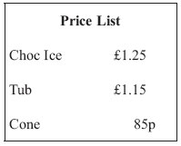

Mitch only has these three coins.
He has no other money.

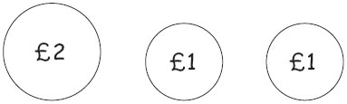

Mitch wants to buy a choc ice, a tub and 2 cones.
Has Mitch got enough money?
You must show your working.

(Total 3 marks)
___________________________________________________________________________

6. Here are the ticket prices for entry to a museum.

Ticket prices
Adult ticket £12
Child ticket £7
Senior ticket £8
Family ticket (2 adult tickets and 2 child tickets) £30

Shamus takes his family to the museum.
He gets tickets for
2 adults,
3 children,
1 senior.
Shamus pays the least possible amount of money for the tickets.
He pays with three £20 notes.
How much change should he get?

£ ...........................................................
(Total 4 marks)
___________________________________________________________________________

*7. Aleena is planning a trip for people at her Youth Club.
Here are the costs for the trip.

Transport | £230
Insurance | £50
Other costs | £30
Entry fee | £14 per person
Aleena charges £18 per ticket for the trip.
She sells 100 tickets.
Is there enough money from the ticket sales for Aleena to pay all the costs for the trip?
You must show your working.
(Total 4 marks)
___________________________________________________________________________

8. Jalin has a £10 note to spend on stickers.
A packet of stickers costs 79p.
He buys as many packets of stickers as possible.
Work out how much change Jalin should get.

…...................................................................................................................................................
(Total 3 marks)
___________________________________________________________________________

9. Daniel buys
one loaf of bread costing £1.18
one tub of spread costing 94p
two jars of strawberry jam.
Daniel pays with a £5 note.
He gets 30p change.
Work out the cost of one jar of strawberry jam.

£ ...........................................................
(Total 3 marks)
___________________________________________________________________________

10. One kilogram of cheese costs £5.60
Jane buys 200 g of cheese.
Work out how much Jane pays.

£...........................................................
(Total 3 marks)
___________________________________________________________________________

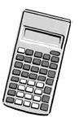
Section B (calculators may be used)

11. Mr and Mrs Pickard and their two children, Lena and Adam, go to a theme park.
Here are the ticket prices for the theme park.

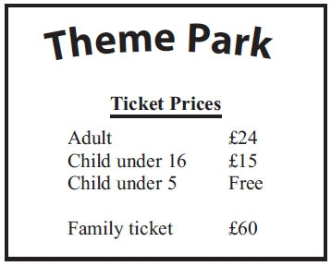

Lena is 8 years old.
Adam is 4 years old.
They can get a family ticket or they can get 4 separate tickets.
It is cheaper to get a family ticket.
How much cheaper?

…...................................................................................................................................................
(Total 4 marks)
___________________________________________________________________________

12. Kylie and Roxy go shopping.
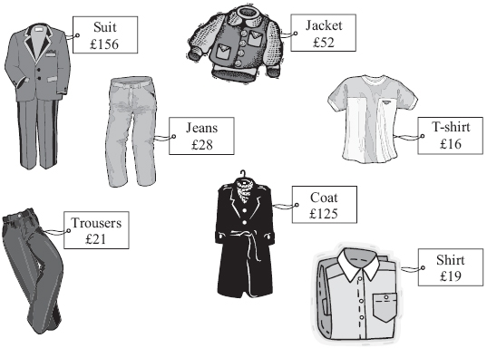
Kylie buys the coat and the T-shirt.
(a) Work out the total cost.

................................................................................................................................................
(2)
Roxy buys two items of clothing.
She pays with £50
She gets £3 change.
(b) Which two items did Roxy buy?

................................................................................................................................................
(3)
(Total 5 marks)
___________________________________________________________________________
13. Here are the prices of drinks and snacks in a cafe.
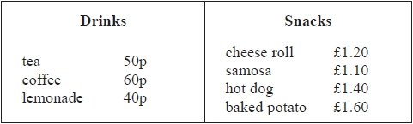
Barry buys a tea, a hot dog and a cheese roll.
(a) Work out the total cost.
£...........................................................
(2)
Naomi buys a drink and a snack.
She pays with 3 pound coins.
She gets 80p change.
(b) Which drink and which snack did Naomi buy?
........................................................... and ...........................................................
(2)
(Total 4 marks)
___________________________________________________________________________

*14. Cheryl is selling books and magazines to raise money for charity.
She wants to raise a total of £50
Cheryl sells 46 hardback books for 50p each.
She sells 68 paperback books for 30p each.
She sells magazines for 20p each.
Cheryl has 26 magazines to sell.
Work out if she has enough magazines to sell to reach her £50 target.
(Total 5 marks)
___________________________________________________________________________

15. The price list shows the normal price of some items in a catalogue.
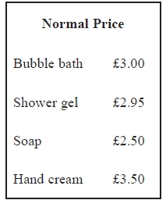
There is a special offer.
Joanna can buy any 3 different items from the list for a total price of £5
Work out the most money she can save.
£...........................................................
(Total 3 marks)
___________________________________________________________________________

16. A supermarket sells milk in three sizes of carton.
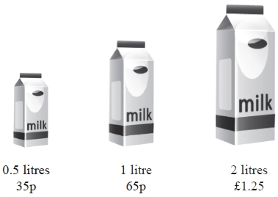
Jerry has £11.50 to spend on milk.

He wants to buy as much milk as possible.
Work out the greatest amount of milk Jerry can buy.
........................................................... litres
(Total 3 marks)
___________________________________________________________________________

*17. Mr Jones uses 730 units of electricity.
He pays:
24p per unit for the first 130 units of electricity he uses
13p per unit for the rest of the units of electricity he uses

Work out the total amount of money Mr Jones pays.
You must show all your working.

(Total 4 marks)
___________________________________________________________________________

18. Glen buys four tickets for a concert.
Each ticket costs £54
Glen also has to pay a booking fee.
The booking fee is 5% of the total price of the tickets.
Work out the total amount Glen has to pay.

£...........................................................
(Total 3 marks)
___________________________________________________________________________
19. Mia buys 3kg of sweets for £11.40
She sells the sweets for 53p per 100 grams.
How much profit does Mia make per kilogram?

£...........................................................
(Total 4 marks)
___________________________________________________________________________
TOTAL FOR PAPER IS 70 MARKS

BLANK PAGE

