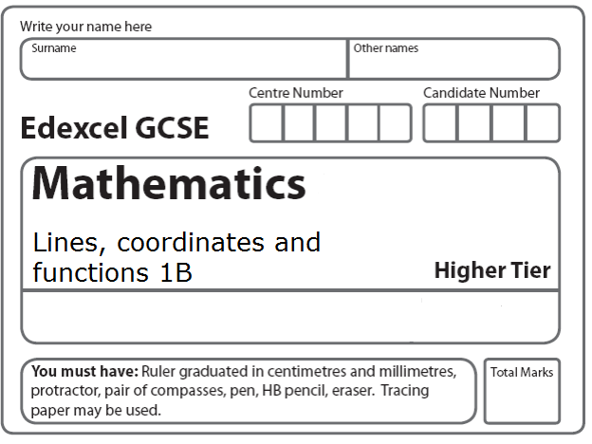
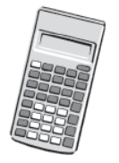
Instructions
- Use black ink or ball-point pen.
- Fill in the boxes at the top of this page with your name.
- Answer all questions.
- Answer the questions in the spaces provided
– there may be more space than you need.
- Calculators may be used.

Information
- The total mark for this paper is 40.
- The marks for each question are shown in brackets.
- use this as a guide as to how much time to spend on each question.
- Questions labelled with an asterisk (*) are ones where the quality of your written communication will be assessed.

Advice
- Read each question carefully before you start to answer it.
- Keep an eye on the time.
- Try to answer every question.
- Check your answers if you have time at the end.
1. (a) Complete the table of values for y = x³ − 3x − 1
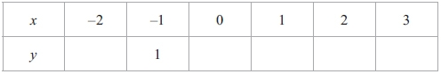
(2)
(b) On the grid, draw the graph of y = x³ − 3x − 1 for −2 ≤ x ≤ 3

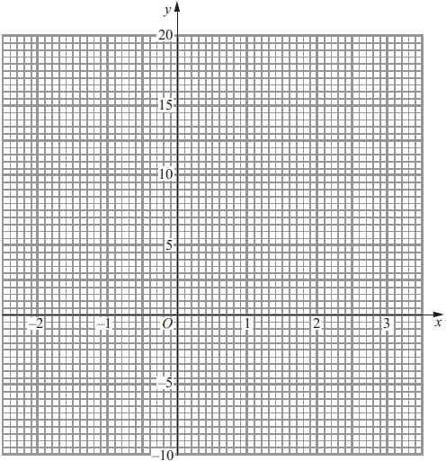

(2)
(Total 4 marks)
___________________________________________________________________________

2. (a) Complete the table of values for y = 2x² – 1

x | –2 | –1 | 0 | 1 | 2
y | 7 |  |  | 1

(b) On the grid below, draw the graph of y = 2x² – 1 for values of x from x = –2 to x = 2

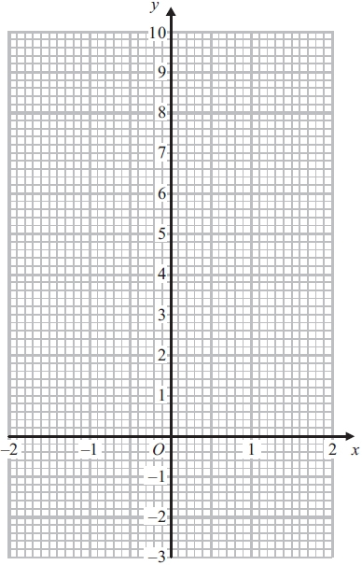
(2)

(c) Use your graph to write down estimates of the solutions of the equation 2x² – 1 = 0

..............................................................................................................................................
(2)
(Total 6 marks)
___________________________________________________________________________

3. f is the function f(x) = 2x + 5

(a) Find f(3)
...........................................................
(1)

(b) Express the inverse function f⁻¹ in the form f⁻¹(x) =
f⁻¹(x) = ...........................................................
(2)
g is the function g(x) = x² − 25

(c) Find g(−3)
...........................................................
(1)

(d) (i) Find gf(x)
Give your answer as simply as possible.
gf(x) = ...........................................................
(ii) Solve gf(x) = 0
...........................................................
(5)
(Total 9 marks)
___________________________________________________________________________
4.
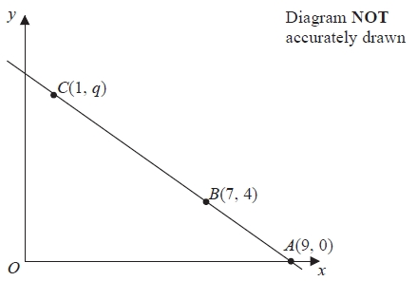

The points A, B and C lie on a straight line.

The coordinates of A are (9, 0).
The coordinates of B are (7, 4).
The coordinates of C are (1, q).

Work out the value of q.
...........................................................
(Total 3 marks)
___________________________________________________________________________
5. The straight line L has equation y = 2x − 5
Find an equation of the straight line perpendicular to L which passes through (−2, 3).

...........................................................
(Total 3 marks)
___________________________________________________________________________
6. The graph of y = f(x) is shown on each of the grids.
(a) On this grid, sketch the graph of y = f(x – 3)

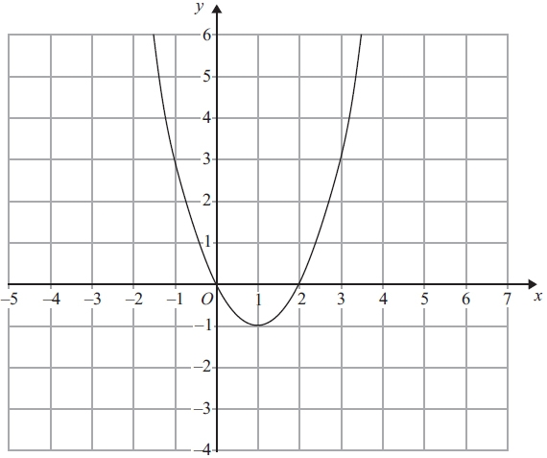
(2)
(b) On this grid, sketch the graph of y = 2f(x)

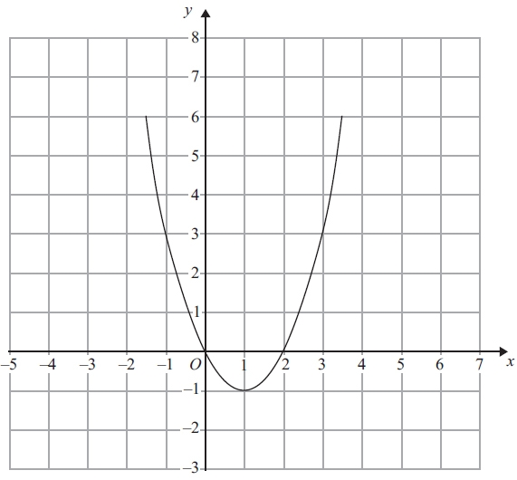
(2)
(Total 4 marks)
___________________________________________________________________________
7. Here is the graph of y = f(x).
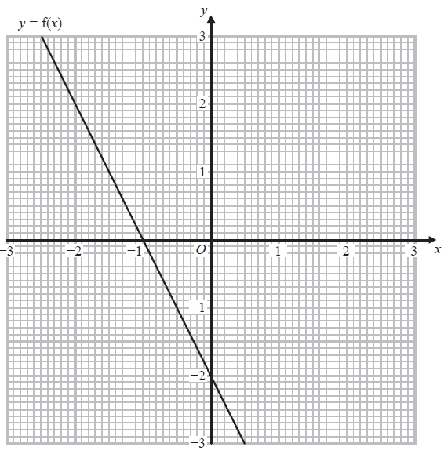
(a) Write down the coordinates of the point where the graph of y = ½ f(x) meets the y-axis.
(....................... , .......................)
(1)
(b) On the grid, draw the graph of y = f(x − 1).
(2)
(Total 3 marks)
___________________________________________________________________________

*8. A and B are straight lines.
Line A has equation 2y = 3x + 8
Line B goes through the points (−1, 2) and (2, 8)
Do lines A and B intersect?
You must show all your working.
(Total 3 marks)
___________________________________________________________________________

9.
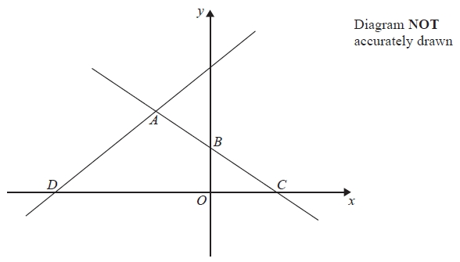
In the diagram, ABC is the line with equation $y=\frac{1}{2}x+5$
AB = BC
D is the point with coordinates (−13, 0)

Find an equation of the line through A and D.

...........................................................
(Total 5 marks)
___________________________________________________________________________
TOTAL FOR PAPER: 40 MARKS

