Maths Emporium
Holidays


Introduction
Past papers aren’t just for practising your mathematics skills – they are also useful for learning the basics you’ll need for all sorts of practical activities such as working out the cost of your holidays and exchanging money.

Information
The marks for individual questions are shown in round brackets: e.g. (2).

There are 17 questions in this booklet. The total mark is 80.

Questions marked with a * sign will require working to be shown.

Calculators must not be used for questions marked with a † sign.

Advice
Show all stages in any calculations.

Work steadily through the paper. Do not spend too long on one question.

If you cannot answer a question, leave it and attempt the next one.

Return at the end to those you have left out.
1. Mrs Evans is planning a trip to the zoo.
She finds out this information.
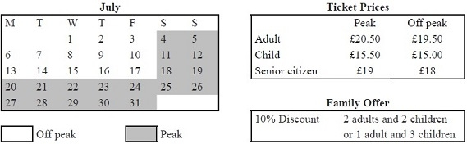

Mrs Evans will go to the zoo on Friday 17th July.
She will need to buy tickets for 1 adult and 3 children.
Mrs Evans wants to buy the tickets as cheaply as possible.
Work out the total cost of the tickets.
£ ...........................................................
(Total 4 marks)
___________________________________________________________________________

*2. The Kumar family are going to go to New York.
They will go with Highway Airlines or Jetstream Airlines.
The tables show how much it costs for each adult and each child to go with these airlines.
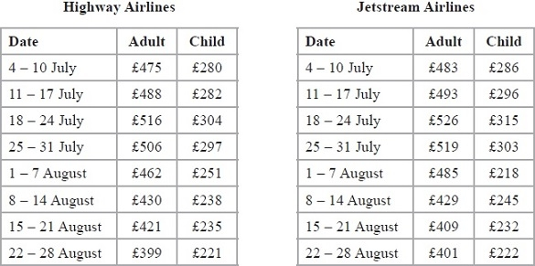
Highway Airlines give a discount of 5% of the total cost for booking online.
Jetstream Airlines give a discount of £25 per person for booking online.
The Kumar family are going to New York on 3 August.
They will buy 2 adult tickets and 1 child ticket.
They will book online.
The Kumar family want to pay the lower total cost.
Which airline should they choose?

(Total 5 marks)
___________________________________________________________________________
3.
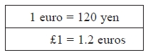

(a) Change 250 euros to yen.
...........................................................yen
(2)

(b) Change 9000 yen to euros.
...........................................................euros
(2)

(c) Change £50 to yen.
...........................................................yen
(2)
(Total 6 marks)
___________________________________________________________________________

*4. Mr and Mrs Jennings are planning a holiday to Italy.
They will go on holiday with their 11 year old daughter.
The table below shows some information about the prices of flights.
Flight to Italy |  |  | Flight back from Italy
Date | Price per adult (£) |  | Date | Price per adult (£)
28th October | 282 |  | 4th November | 305
29th October | 283 |  | 5th November | 303
30th October | 282 |  | 6th November | 285
31st October | 272 |  | 7th November | 283
Child fares
0 to 2 years old |  | No charge
Over 2 to 12 years old |  | 75% of the adult fare
Mr and Mrs Jennings and their daughter want to fly to Italy on 29th October.
They want to fly back from Italy on 6th November.
They have £1600 to spend on flights.
Do they have enough money for the flights?
You must show all your working.

(Total 6 marks)
___________________________________________________________________________

5. Eric travels from the UK to India every year.
In 2010, the exchange rate was £1 = 67.1 rupees.
In 2012, the exchange rate was £1 = 82.5 rupees.
In 2010 Eric changed £600 into rupees.
How many pounds (£) did Eric have to change to rupees in 2012 to get the same number
of rupees as he did in 2010?

£..........................................................
(Total 3 marks)
___________________________________________________________________________

6. John changes £450 to euros.
The exchange rate is £1 = 1.16 euros.
(a) Change £450 to euros.
........................................................... euros
(2)

When in Amsterdam, John uses his credit card to pay for a ring costing 850 euros.
He has to pay a bank charge of £3.50 for using his credit card in addition to the cost of the ring.
(b) Work out the total cost, in pounds (£), of the ring and the bank charge.

£ ...........................................................
(3)
(Total 5 marks)
___________________________________________________________________________

*7. Joan is planning a skiing holiday in Hinterglemm for herself and her two children.
They are going skiing for 6 days.
The table shows the costs of ski hire, of boot hire and of buying lift passes in two shops in Hinterglemm.
All prices are in Euros.
Shop A
 |  | Ski hire | Boot hire | Lift pass
Adult | 6 days | 111 | 53 | 236
 | 13 days | 168 | 90 | 314
Child | 6 days | 78 | 52 | 165
 | 13 days | 122 | 87 | 210
Shop B
 |  | Ski hire | Boot hire | Lift pass
Adult | 6 days | 108 | 54 | 242
 | 13 days | 170 | 89 | 324
Child | 6 days | 68 | 48 | 160
 | 13 days | 118 | 85 | 205
Joan will use her own skis and her own boots.
For 6 days she will need
 | to hire skis for each of her two children
 | to hire boots for each of her two children
and | to buy lift passes for herself and each of her two children.
Shop A gives 5% off the total cost.
Shop B gives 3% off the total cost.
Joan wants to hire the skis and boots and buy the lift passes from the same shop.
She wants to get everything from the cheaper shop.
Which shop is cheaper for Joan?
You must show all your working.

(Total 5 marks)
___________________________________________________________________________
8. Jalin lives in England.
He does a search on the internet and sees the same type of camera on sale in France and in America.
In France, the camera costs 126 euros.
In America, the camera costs $165.24
Jalin finds out these exchange rates.
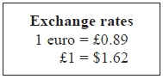
How much cheaper is the camera in America than in France?
Give your answer in pounds (£).
£ ...........................................................
(Total 4 marks)
___________________________________________________________________________

9. You can use this conversion graph to change between pounds (£) and Swiss francs.

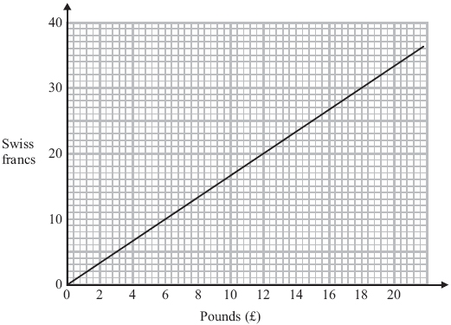
(a) Use the graph to change £6 to Swiss francs.
...........................................................Swiss francs
(1)

(b) Use the graph to change 25 Swiss francs to pounds (£).

£...........................................................
(1)

(c) Change £64 to Swiss francs.

...........................................................Swiss francs
(2)
(Total 4 marks)
___________________________________________________________________________

*10. You can use this conversion graph to change between pounds (£) and dollars ($).
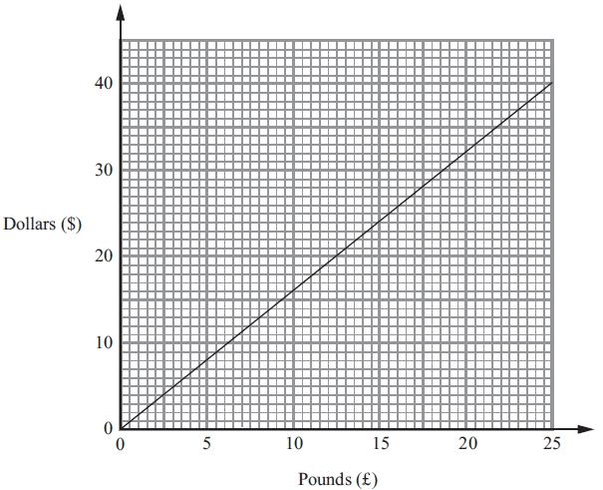
Stacey bought a watch in New York.
The watch cost $220.
In London, the same type of watch costs £140.
Compare the cost of the watch in New York with the cost of the watch in London.

(Total 4 marks)
___________________________________________________________________________
11. Here is a conversion graph to change between UK pounds (£) and South African rand.

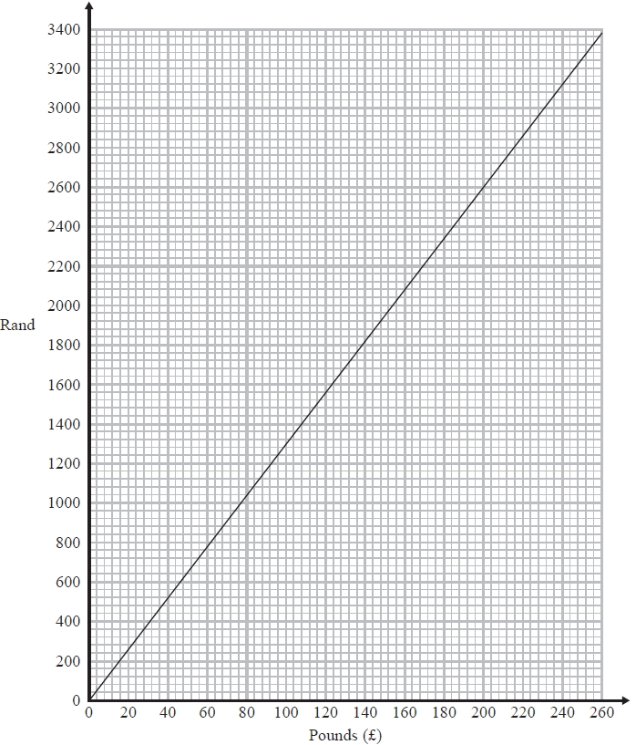

Jo changes £200 into rand.
(a) How many rand does she get?
........................................................... rand
(1)

Simon has £100 and 3700 rand.
He goes to a shop where he can spend both pounds and rand.
He wants to buy
a computer costing £360
or a watch costing £400
or a camera costing £375
∗(b) Which of these items can Simon afford to buy?
You must show clearly how you get your answer.
...........................................................
(3)
(Total 4 marks)
___________________________________________________________________________

†12. Mr Brown and his 2 children are going to London by train.
An adult ticket costs £24
A child ticket costs £12
Mr Brown has a Family Railcard.
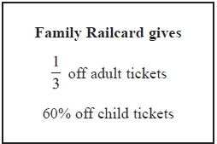
Work out the total cost of the tickets when Mr Brown uses his Family Railcard.

£...........................................................
(Total 4 marks)
___________________________________________________________________________

†13. The exchange rate for pounds (£) to euros (€) is £1 = €1.20
(a) Complete the table of values.
£ | 0 | 1 | 5 | 10 | 15 | 20 | 25 | 30
€ |  | 1.20 | 6 |  |  | 24 | 30
(2)
(b) On the grid, draw a conversion graph for pounds (£) to euros (€).

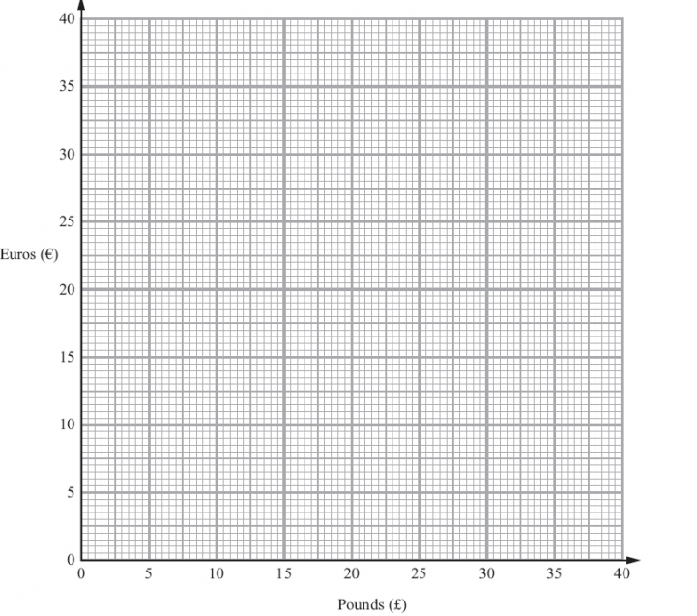
(2)

Louise changes £250 into euros.
(c) Work out how many euros Louise should get.

........................................................... euros
(2)
(Total 6 marks)
___________________________________________________________________________
*14. Beth is planning a trip for a group of 36 people.
The group can go to a theme park or to a concert.
If they go to the concert, they will go by train.
If they go to the theme park, they will go by coach.
Beth has information about the costs.
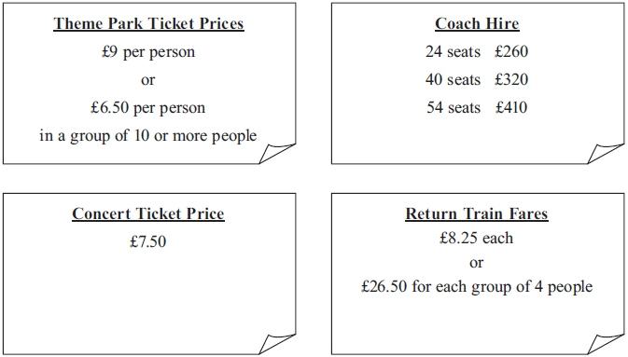
What is the least possible total cost of the trip?
You must show all your working.

(Total 5 marks)
___________________________________________________________________________
*†15. Railtickets and Cheaptrains are two websites selling train tickets.
Each of the websites adds a credit card charge and a booking fee to the ticket price.
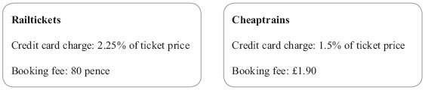
Nadia wants to buy a train ticket.
The ticket price is £60 on each website.
Nadia will pay by credit card.
Will it be cheaper for Nadia to buy the train ticket from Railtickets or from Cheaptrains?

(Total 4 marks)
___________________________________________________________________________

*†16. Barbara goes on holiday to Prague. The currency in Prague is the Koruna (KC).
This graph can be used to convert between £ (pounds) and KC (Koruna).
The exchange rate is £1 = 30 KC.
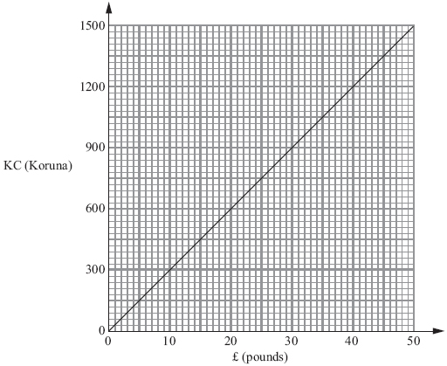
Barbara bought some things in London.
She saw the same things on sale in Prague.
The table shows the cost in £ (pounds) and the cost in KC (Koruna).
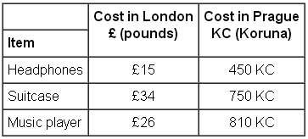
Barbara thinks the total cost of these things was more in London than in Prague.
Is she correct?
Give a reason for your answer.
You must show all your working.

(Total 5 marks)
___________________________________________________________________________

17. These graphs can be used to convert between pounds (£), Euros (€) and US dollars ($).

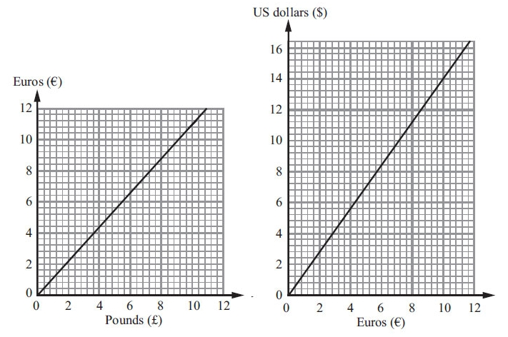

(a) Convert £6 to Euros (€).

€ ...........................................................
(1)

(b) Convert $5 to Euros (€).

€ ...........................................................
(1)

On the internet, Amir sees a pair of trainers.
The trainers cost $65.
(c) Work out the cost of the trainers in pounds (£).

£ ...........................................................
(4)
(Total 6 marks)
___________________________________________________________________________
TOTAL FOR PAPER IS 80 MARKS

BLANK PAGE

