Maths Emporium
Trigonometry with a Twist
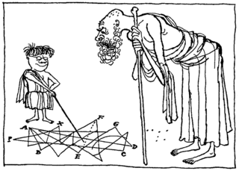
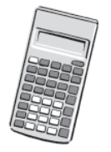
Instructions
- Use black ink or ball-point pen.
- Fill in the boxes at the top of this page with your name.
- Answer all questions.
- Answer the questions in the spaces provided
– there may be more space than you need.
- Calculators may be used.

Information
- The total mark for this paper is 80.
- The marks for each question are shown in brackets.
- use this as a guide as to how much time to spend on each question.
- Questions labelled with an asterisk (*) are ones where the quality of your written communication will be assessed.

Advice
- Read each question carefully before you start to answer it.
- Keep an eye on the time.
- Try to answer every question.
- Check your answers if you have time at the end.

1. The diagram shows a metal plate.
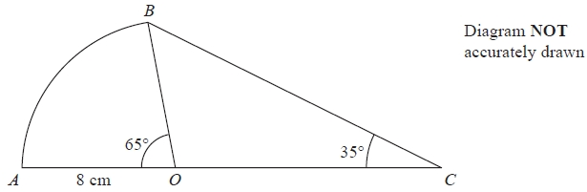
The metal plate is made from a sector OAB of a circle, centre O, and a triangle OCB.
Angle AOB = 65° Angle OCB = 35°
OA = OB = 8 cm.
AOC is a straight line.
(a) Calculate the length of BC.
Give your answer correct to 3 significant figures.
........................................................... cm
(3)
(b) Calculate the total area of the metal plate.
Give your answer correct to 3 significant figures.
........................................................... cm²
(4)
(Total 7 marks)
___________________________________________________________________________
2. ABCD is a kite.
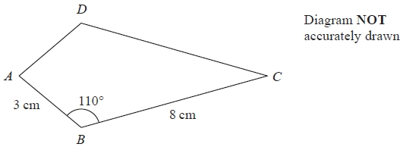
AB = 3 cm
BC = 8 cm
Angle ABC = 110°
Calculate the area of the kite ABCD.
Give your answer correct to 3 significant figures.
........................................................... cm²
(Total 3 marks)
___________________________________________________________________________

3. The diagram shows a quadrilateral ABCD.
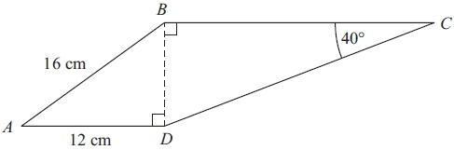 Diagram NOT accurately drawn
AB = 16 cm.
AD = 12 cm.
Angle BCD = 40°.
Angle ADB = angle CBD = 90°.
Calculate the length of CD.
Give your answer correct to 3 significant figures.

...........................................................cm
(Total 5 marks)
___________________________________________________________________________

4.
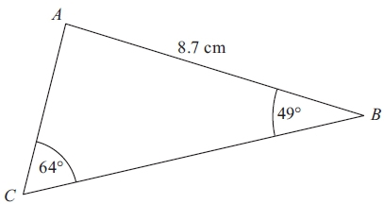
Diagram NOT accurately drawn
ABC is a triangle.
AB = 8.7 cm.
Angle ABC = 49°.
Angle ACB = 64°.
Calculate the area of triangle ABC.
Give your answer correct to 3 significant figures.

...........................................................cm²
(Total 5 marks)
___________________________________________________________________________

5. ABCD is a quadrilateral.
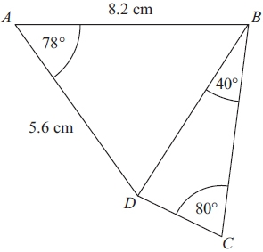 Diagram NOT accurately drawn
Work out the length of DC.
Give your answer correct to 3 significant figures.

...........................................................cm
(Total 6 marks)
___________________________________________________________________________

6.
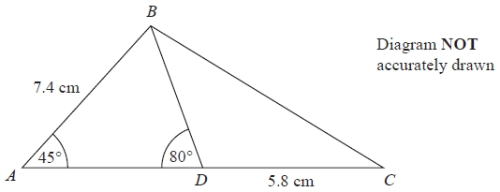
ABC is a triangle.
D is a point on AC.
Angle BAD = 45°
Angle ADB = 80°
AB = 7.4 cm
DC = 5.8 cm
Work out the length of BC.
Give your answer correct to 3 significant figures.
........................................................... cm
(Total 5 marks)
___________________________________________________________________________

7.
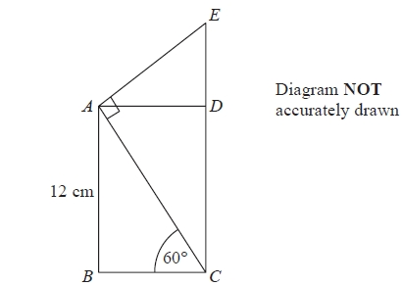
ABCD is a rectangle.
CDE is a straight line.
AB = 12 cm
Angle ACB = 60°
Angle EAC = 90°
Calculate the length of CE.
You must show all your working.
........................................................... cm
(Total 4 marks)
_________________________________________________________________________

8.
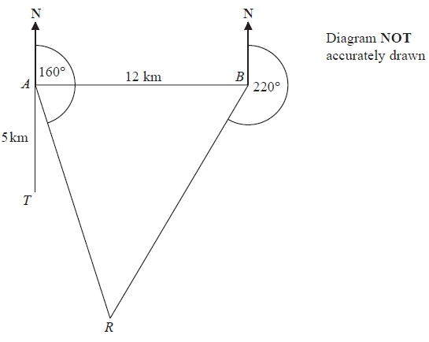
There is a coastguard station at point A and at point B.
B is due East of A.
The distance from A to B is 12 km.
There is a rowing boat at point R.
R is on a bearing of 160° from A.
R is on a bearing of 220° from B.
There is a speedboat at point T.
T is 5 km due South of A.
Work out the shortest distance from T to R.
Give your answer correct to 1 decimal place.
You must show all your working.

...........................................................km
(Total 5 marks)
___________________________________________________________________________
9.
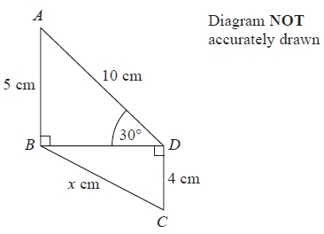
In the diagram,
triangles ABD and BCD are right-angled triangles
AB = 5 cm
AD = 10 cm
CD = 4 cm
Angle ADB = 30°
Work out the value of x.
Give your answer correct to 2 decimal places.
...........................................................cm
(Total 4 marks) _________________________________________________________________________

10. ABC is a triangle.
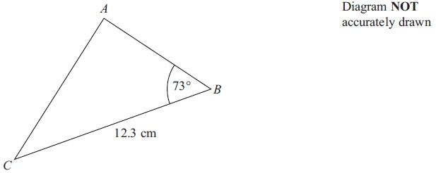
BC = 12.3 cm
Angle ABC = 73°
The area of triangle ABC is 50 cm².
Work out the length of AC.
Give your answer correct to 3 significant figures.

.................................................................................................................................................
(Total 6 marks)
_________________________________________________________________________

11. ABCD is a trapezium.
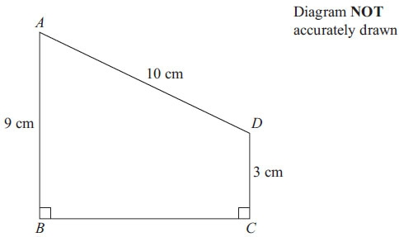
AD = 10 cm
AB = 9 cm
DC = 3 cm
Angle ABC = angle BCD = 90°
Calculate the length of AC.
Give your answer correct to 3 significant figures.

.................................................................................................................................................
(Total 5 marks)
___________________________________________________________________________

12.
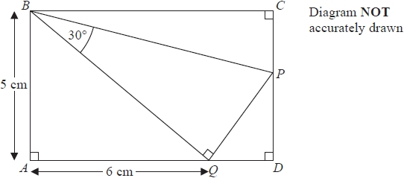
In the diagram,
ABCD is a rectangle
P lies on the line CD
Q lies on the line AD
PQB is a right-angled triangle
Work out the length of BC.
Give your answer correct to 3 significant figures.
You must show your working.
...........................................................cm
(Total 5 marks)
___________________________________________________________________________
13. The diagram shows triangle LMN.
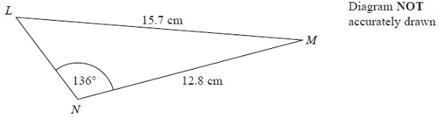
Calculate the length of LN.
Give your answer correct to 3 significant figures.
........................................................... cm
(Total 5 marks)
___________________________________________________________________________

14. ABCD is a parallelogram.
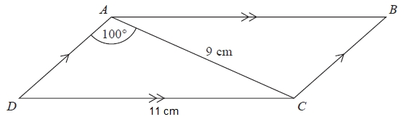
Diagram NOT accurately drawn
AC = 9 cm
DC = 11 cm
Angle DAC = 100°
Calculate the area of the parallelogram.
Give your answer correct to 3 significant figures.
...........................................................cm²
(Total 5 marks)
___________________________________________________________________________
15.
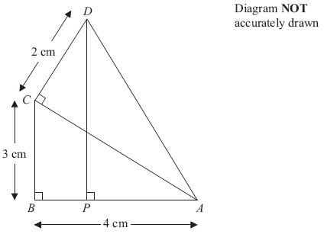
In the diagram,
ABC, ACD and APD are right-angled triangles.
AB = 4 cm.
BC = 3 cm.
CD = 2 cm.
Work out the length of DP.

.................................................................................................................................................
(Total 5 marks)
___________________________________________________________________________

16. The diagram shows two triangles, A and B.
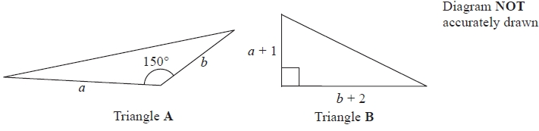
The area of triangle B is 3 times the area of triangle A.
Given that b > 4, find an expression for a in terms of b.
a = ...........................................................
(Total 5 marks)
___________________________________________________________________________
TOTAL FOR PAPER: 80 MARKS

BLANK PAGE

