Maths Emporium
All about Number
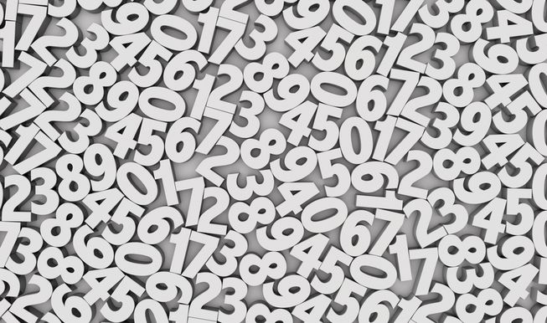

Introduction
Past papers aren’t just for practising your mathematics skills – they also useful for learning the basics you’ll need for all sorts of practical activities such as packing, weighing and measuring.
Information
The marks for individual questions are shown in round brackets: e.g. (2).
There are 11 questions in this booklet. The total mark is 40.
Questions marked with a * sign will require working to be shown.
Calculators may be used in all questions.

Advice
Show all stages in any calculations.
Work steadily through the paper. Do not spend too long on one recipe.
If you cannot answer a question, leave it and attempt the next one.
Return at the end to those you have left out.

1. 138 people are going on a school trip.
Each person will travel by coach or by minibus.
Steve gets 3 coaches for the trip.
Each coach has seats for 35 passengers.
Steve also needs some minibuses for the trip.
Each minibus has seats for 10 passengers.
Work out the smallest number of minibuses Steve needs.
...........................................................
(Total 3 marks)
___________________________________________________________________________

2. Michael sells cans of drink in his shop.
The cans of drink are delivered in boxes to the shop.
There are 24 cans of drink in a box.
On Tuesday morning, Michael had no cans of drink in the shop.
On Tuesday afternoon, 18 boxes of cans of drink were delivered to the shop.
When the shop closed on Tuesday, Michael had 15 cans of drink left.
How many cans of drink did Michael sell on Tuesday?

…..................................................................................................................................................
(Total 3 marks)
___________________________________________________________________________

3. Billy sells apples in bags.
There are 8 apples in each bag he sells.
On Monday morning Billy has 116 apples.
On Monday afternoon he sells 12 bags of apples.
On Tuesday morning Billy gets 86 more apples.
On Tuesday afternoon he sells 9 bags of apples.
Work out how many apples Billy now has.
...........................................................
(Total 4 marks)
___________________________________________________________________________

4. 15 cars were driven onto a ferry.
4 cars had a driver but no passengers.
6 cars had a driver and 1 passenger.
5 cars had a driver and 2 passengers.
Work out the total number of people in the 15 cars.
..........................................................
(Total 3 marks)
___________________________________________________________________________

5. There is enough space for 80 boxes of cornflakes in a stockroom.
On Monday there are 65 boxes of cornflakes in the stockroom.
On Tuesday 17 boxes of cornflakes are taken out of the stockroom.
On Wednesday 29 boxes of cornflakes are put into the stockroom.
Work out how many more boxes of cornflakes can now be put into the stockroom.

...........................................................
(Total 3 marks)
___________________________________________________________________________

6. One day a supermarket has 8420 customers.
65% of the customers pay with a debit card.
$\frac{1}{5}$ of the customers pay with a credit card.
The rest of the customers pay with cash.
Work out how many customers pay with cash.
...........................................................
(Total 4 marks)
___________________________________________________________________________
7. Wendy is putting sweets into packets.
She has 9000 sweets.
She puts 45 sweets in each packet.
Wendy puts the packets of sweets into boxes.
She puts 25 packets of sweets into each box.
(a) Work out the total number of boxes Wendy needs.

….............................................................................................................................................
(3)
Each packet of sweets weighs 690 g.
Each box weighs 260 g.
There are 25 packets of sweets in each box.
(b) Work out the total weight of a full box of sweets.
Give your answer in kilograms.

.................................................................................................................................................
(4)
(Total 7 marks)
___________________________________________________________________________

8. Stephen is making soup.
He mixes one packet of soup with water to make 6 litres of soup.
Stephen has to make 90 bowls of soup.
He wants to put 0.2 litres of soup into each bowl.
How many packets of soup does Stephen need?

….............................................................................................................................................
(Total 3 marks)
___________________________________________________________________________

9. Tony has a hosepipe.
The length of the hosepipe is 20 m.
Tony stores the hosepipe on a reel.
The weight of the reel is 1.4 kg.
¹⁄₂ metre of the hosepipe has a weight of 150 grams.
Work out the total weight of the hosepipe and the reel.
...........................................................kg
(Total 3 marks)
___________________________________________________________________________

10. Rachel bought a packet of 60 balloons.

$\frac{1}{\text{10}}$ of the balloons were yellow.
$\frac{3}{5}$ of the balloons were red.

The rest of the balloons were blue.
How many of the balloons were blue?
........................................................... balloons
(Total 3 marks)
___________________________________________________________________________

11. Suha has a full 600 ml bottle of wallpaper remover.
She is going to mix some of the wallpaper remover with water.
Here is the information on the label of the bottle.
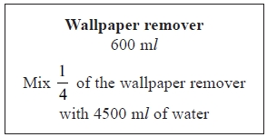
Suha is going to use 750 ml of water.
How many millilitres of wallpaper remover should Suha use?
You must show your working.
........................................................... ml
(Total 4 marks)
___________________________________________________________________________
TOTAL FOR PAPER IS 40 MARKS

