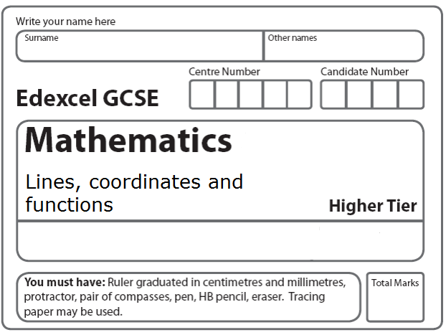
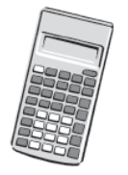
Instructions
- Use black ink or ball-point pen.
- Fill in the boxes at the top of this page with your name.
- Answer all questions.
- Answer the questions in the spaces provided
– there may be more space than you need.
- Calculators may be used.

Information
- The total mark for this paper is 80.
- The marks for each question are shown in brackets.
- use this as a guide as to how much time to spend on each question.
- Questions labelled with an asterisk (*) are ones where the quality of your written communication will be assessed.

Advice
- Read each question carefully before you start to answer it.
- Keep an eye on the time.
- Try to answer every question.
- Check your answers if you have time at the end.

1. Two points, A and B, are plotted on a centimetre grid.
A has coordinates (1, 4) and B has coordinates (8, 2).
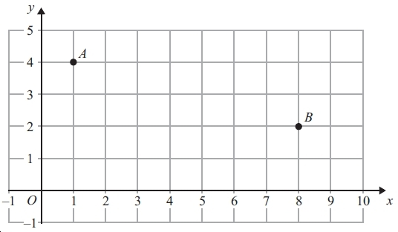

(a) Work out the coordinates of the midpoint of AB.
(....................... , .......................)
(2)
(b) Use Pythagoras’ Theorem to work out the length of AB.
Give your answer correct to 3 significant figures.
............................... cm
(4)
(Total 6 marks)
___________________________________________________________________________

2. (a) Complete the table of values for y = x³ − 3x − 1
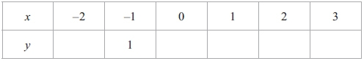
(2)
(b) On the grid, draw the graph of y = x³ − 3x − 1 for −2 ≤ x ≤ 3

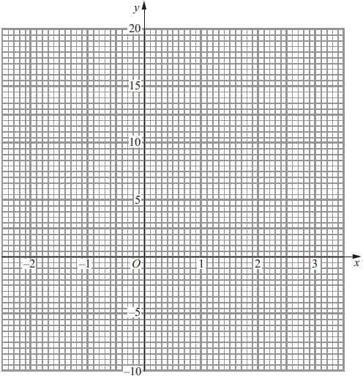

(2)
(Total 4 marks)
___________________________________________________________________________

3. (a) Complete the table of values for $y=\frac{1}{2}\left(x+\frac{9}{x}\right)$
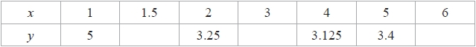
(2)
(b) Draw the graph of $y=\frac{1}{2}\left(x+\frac{9}{x}\right)$ for values of x from 1 to 6
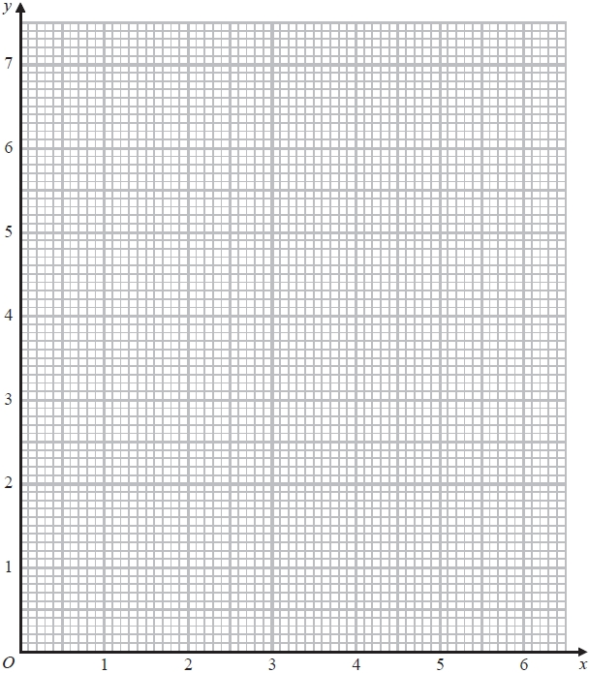
(2)
(c) Use the graph to find estimates for the solutions of the equation $x+\frac{9}{x}=7$.
...........................................................
(2)
(Total 6 marks)
___________________________________________________________________________
4. (a) Complete the table of values for y = 2x² – 1

x | –2 | –1 | 0 | 1 | 2
y | 7 |  |  | 1

(b) On the grid below, draw the graph of y = 2x² – 1 for values of x from x = –2 to x = 2

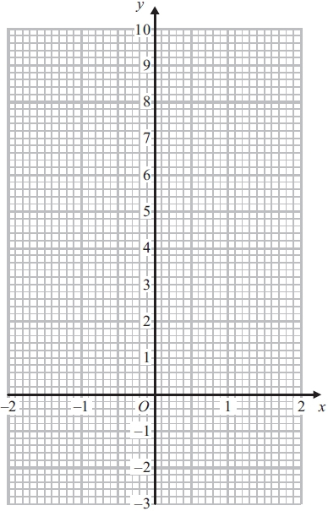
(2)

(c) Use your graph to write down estimates of the solutions of the equation 2x² – 1 = 0

..............................................................................................................................................
(2)
(Total 6 marks)
___________________________________________________________________________

5. $f(x)=3x−2$
$g(x)=\frac{\text{10}}{x+2}$

(a) Express the inverse function f⁻¹ in the form f⁻¹(x) = ...
f⁻¹(x) =...........................................................
(2)
(b) Find gf(x)
Simplify your answer.
gf(x) =...........................................................
(2)
(Total 4 marks)
___________________________________________________________________________

6. f is the function f(x) = 2x + 5

(a) Find f(3)
...........................................................
(1)

(b) Express the inverse function f⁻¹ in the form f⁻¹(x) =
f⁻¹(x) = ...........................................................
(2)
g is the function g(x) = x² − 25

(c) Find g(−3)
...........................................................
(1)

(d) (i) Find gf(x)
Give your answer as simply as possible.
gf(x) = ...........................................................
(ii) Solve gf(x) = 0
...........................................................
(5)
(Total 9 marks)
___________________________________________________________________________
7. (a) Complete the table of values for y = x² − 2x − 1
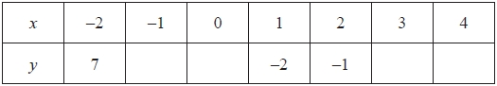
(2)
(b) On the grid, draw the graph of y = x² − 2x − 1 for values of x from −2 to 4
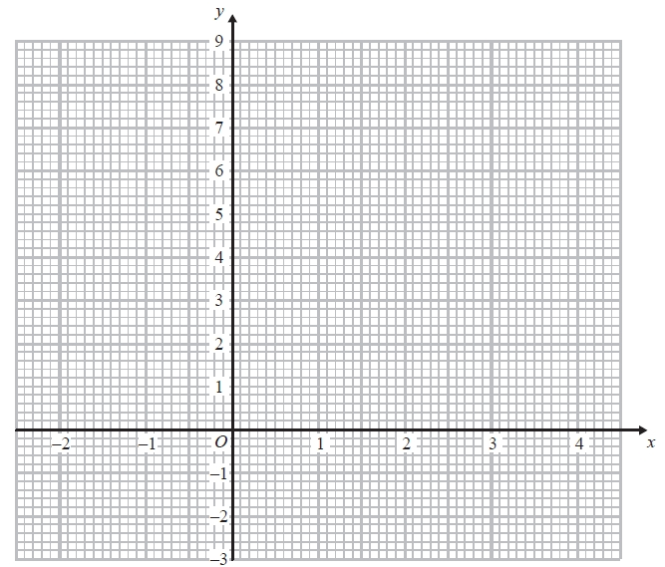
(2)
(c) Solve x² − 2x − 1 = x + 3
...........................................................
(2)
(Total 6 marks)
___________________________________________________________________________

8.
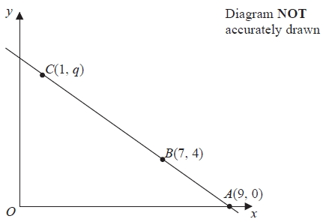

The points A, B and C lie on a straight line.

The coordinates of A are (9, 0).
The coordinates of B are (7, 4).
The coordinates of C are (1, q).

Work out the value of q.
...........................................................
(Total 3 marks)
___________________________________________________________________________
9.
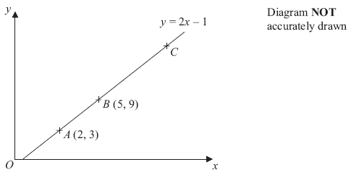

In the diagram, the points A, B and C lie on the straight line y = 2x – 1
The coordinates of A are (2, 3).
The coordinates of B are (5, 9).

Given that AC = 3AB, find the coordinates of C.

.................................................................................................................................................
(Total 3 marks)
___________________________________________________________________________

10. The straight line L has equation y = 2x − 5
Find an equation of the straight line perpendicular to L which passes through (−2, 3).

...........................................................
(Total 3 marks)
___________________________________________________________________________
11. y = f(x)
The graph of y = f(x) is shown on the grid.
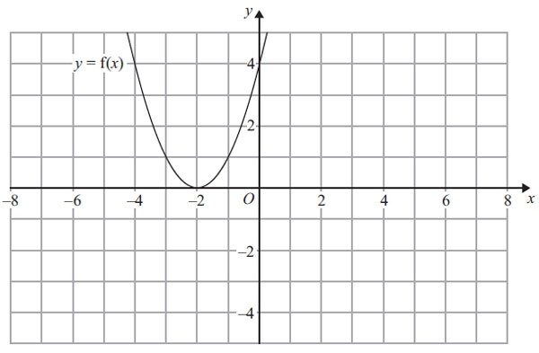
(a) On the grid above, sketch the graph of y = – f(x).
(2)
The graph of y = f(x) is shown on the grid.
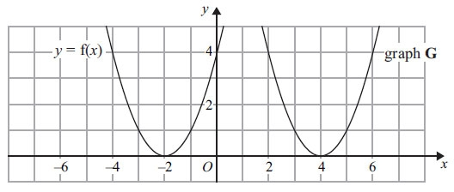
The graph G is a translation of the graph of y = f(x).
(b) Write down the equation of graph G.
..............................................................................................................................................
(2)
(Total 3 marks)
___________________________________________________________________________
12. The graph of y = f(x) is shown on each of the grids.
(a) On this grid, sketch the graph of y = f(x – 3)

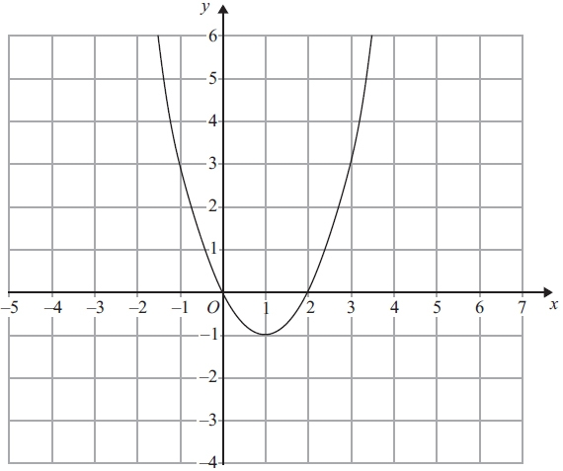
(2)
(b) On this grid, sketch the graph of y = 2f(x)

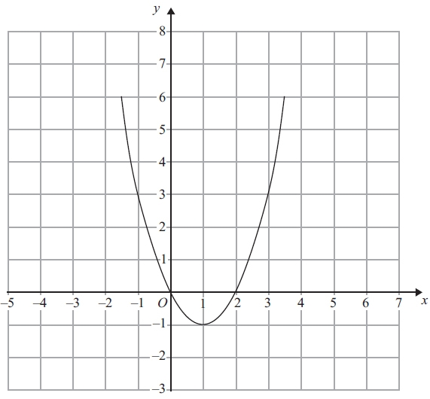
(2)
(Total 4 marks)
___________________________________________________________________________
13.
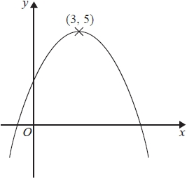
The diagram shows part of the curve with equation y = f(x).
The coordinates of the maximum point of the curve are (3, 5).
(a) Write down the coordinates of the maximum point of the curve with equation
(i) y = f(x + 3)

(....................... , .......................)
(ii) y = 2f(x)
(....................... , .......................)
(iii) y = f(3x)
(....................... , .......................)
(3)
The curve with equation y = f(x) is transformed to give the curve with equation y = f(x) − 4
(b) Describe the transformation.
.............................................................................................................................................
(1)
(Total 4 marks)
___________________________________________________________________________

14. Here is the graph of y = f(x).
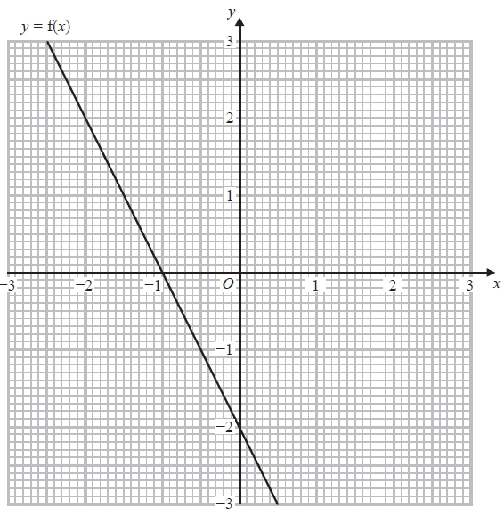
(a) Write down the coordinates of the point where the graph of y = ½ f(x) meets the y-axis.
(....................... , .......................)
(1)
(b) On the grid, draw the graph of y = f(x − 1).
(2)
(Total 3 marks)
___________________________________________________________________________

15. The expression x² – 8x + 21 can be written in the form (x – a)² + b for all values of x.

(a) Find the value of a and the value of b.

a = ………………………….

b = ………………………….
(3)
The equation of a curve is y = f(x) where f(x) = x² – 8x + 21
The diagram shows part of a sketch of the graph of y = f(x).

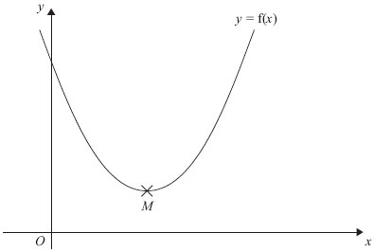

The minimum point of the curve is M.
(b) Write down the coordinates of M.

..............................................................................................................................................
(1)
(Total 4 marks)
___________________________________________________________________________

*16. A and B are straight lines.
Line A has equation 2y = 3x + 8
Line B goes through the points (−1, 2) and (2, 8)
Do lines A and B intersect?
You must show all your working.
(Total 3 marks)
___________________________________________________________________________

*17. A is the point with coordinates (1, 3)
B is the point with coordinates (4, −1)
The straight line L goes through both A and B.

Is the line with equation 2y = 3x − 4 perpendicular to line L?
You must show how you got your answer.

(Total 4 marks)
___________________________________________________________________________
18.
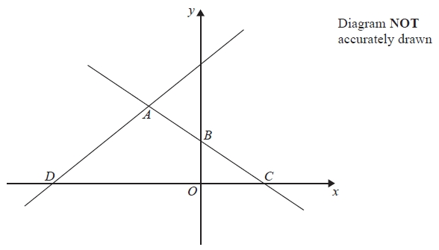
In the diagram, ABC is the line with equation $y=\frac{1}{2}x+5$
AB = BC
D is the point with coordinates (−13, 0)

Find an equation of the line through A and D.

...........................................................
(Total 5 marks)
___________________________________________________________________________
TOTAL FOR PAPER: 80 MARKS

