99 Problems
1MA1 / F
Foundation Tier

Instructions
- Use black ink or ball-point pen.
  - Fill in the boxes at the top of this page with your name,
centre number and candidate number.
- Answer all Questions.
- Answer the Questions in the spaces provided
– there may be more space than you need.
- You must show all your working.
- Diagrams are NOT accurately drawn, unless otherwise indicated.
- Calculators may be used.
- If your calculator does not have a π button, take the value of π to be 3.142
unless the Question instructs otherwise.
Information
- This paper contains 99 Questions.
- The marks for each Question are shown in brackets
– use this as a guide as to how much time to spend on each Question.
Advice
- Read each Question carefully before you start to answer it.
- Try to answer every Question.

1. The diagram shows the average midday temperature in Tenerife and in London during 6 months.
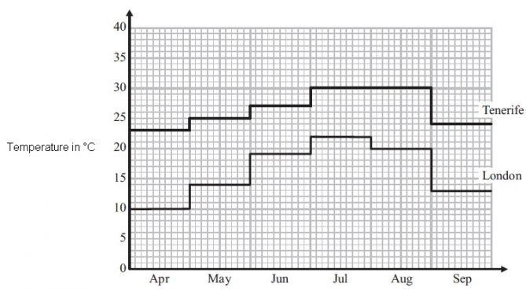

(a) During which two months is the average midday temperature in Tenerife the same?

..............................................................................................................................................
(1)

(b) During which month is there the greatest difference between the average midday temperatures in London and in Tenerife?

..............................................................................................................................................
(1)
(c) Write down the average midday temperature in May for London.

. . . . . . . . . . . . . . . . . . . . . . °C
(1)

(d) In September, what is the difference between the average midday temperatures in London and in Tenerife?

. . . . . . . . . . . . . . . . . . . . . . °C
(2)
(Total for Question is 5 marks)
___________________________________________________________________________

2. Ali has x cards.
Belinda has twice as many cards as Ali.
Charlie has 5 more cards than Ali.

They have a total of 33 cards.

(a) Show that 4x + 5 = 33

(3)

(b) Work out the number of cards Ali has.

..............................................................................................................................................
(2)
(Total for Question is 5 marks)
___________________________________________________________________________

3. The diagram shows the floor plan of Mary's conservatory.

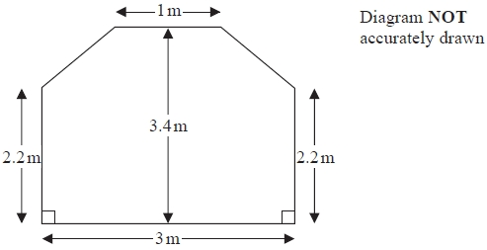

Mary is going to cover the floor with tiles.

The tiles are sold in packs.
One pack of tiles will cover 2m²
A pack of tiles normally costs £24.80
Mary gets a discount of 25% off the cost of the tiles.

Mary has £100

Does Mary have enough money to buy all the tiles she needs?
You must show all your working.

(Total for Question is 5 marks)
___________________________________________________________________________

4. A film starts at 17 50
The film ends at 19 30
(a) How long does the film last?
...........................................................
(2)
Jackie buys some tickets to see the film.
Each ticket costs £4.50
Jackie pays with two £20 notes.
Jackie gets £8.50 change.
(b) How many tickets did Jackie buy?
...........................................................
(3)
(Total for Question is 5 marks)
___________________________________________________________________________

5. (a) How many minutes are there between 8.50 pm and 10.05 pm?

. . . . . . . . . . . . minutes
(1)

(b) (i) Write 15 25 using the 12-hour clock.
. . . . . . . . . . . . . . . . . . . . . .
(ii) Write 9.15 pm using the 24-hour clock.

. . . . . . . . . . . . . . . . . . . . . .
(2)
Lucy and Saad went to a cafe on the same day.
Lucy was in the cafe from 10.15 am to 10.45 am.
Saad was in the cafe from 10.25 am to 11.05 am.
(c) Work out the number of minutes that Lucy and Saad were in the cafe at the same time.

. . . . . . . . . . . . minutes
(2)
(Total for Question is 5 marks)
___________________________________________________________________________

6. 14 students did a history test.

Here are the results.

Girls | 3 | 8 | 2 | 4 | 3 | 4 | 4 | 6
Boys | 3 | 6 | 3 | 3 | 1 | 4

Adele says,

"The range of the girls' marks is 1 more than the range of the boys' marks."

Is Adele right?
You must show your working.

(Total for Question is 3 marks)
___________________________________________________________________________

7. Jake plays a game of throwing a ball at a target.
The table shows information about the probability of each possible score.

Score | 0 | 1 | 2 | 3 | 4 | 5
Probability | 0.09 | x | 0.18 | 0.16 | 0.21 | 0.30

Work out the value of x.

..............................................................................................................................................
(Total for Question is 2 marks)
___________________________________________________________________________

8. Kerry has two fair 6-sided dice, A and B.
Kerry is going to roll both dice.

(a) Complete the sample space diagram to show all the possible outcomes.
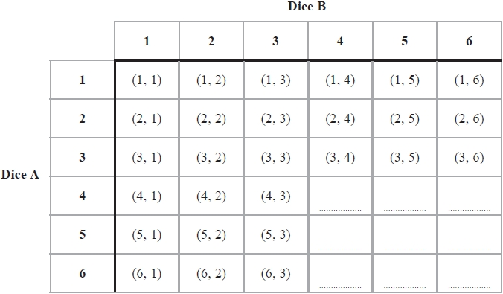
(1)
(b) Write down the probability that Kerry will get a 1 on dice A and a 1 on dice B.
...........................................................
(1)
Kerry rolls dice A and dice B.

(c) Compare the probability that Kerry will get a total of 6 with the probability that she will get a total of 7
.............................................................................................................................................

.............................................................................................................................................
(1)
(Total for Question is 3 marks)
__________________________________________________________________________

9. Some students went on an activity course.

Each student had to choose one activity from art or drama or music.
There were 41 students.
15 of the students chose music.
30 of the students were girls.
8 of the girls chose art.
No boys chose art.
Equal numbers of boys and girls chose drama.

Complete the two-way table.
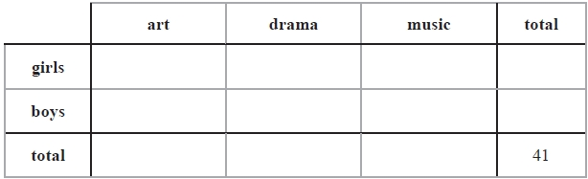

(Total for Question is 3 marks)
__________________________________________________________________________

10. Jamie and Lily are at college.

They want to buy some lockers for their common room.
They decide to do a sponsored walk to raise the money to buy the lockers.

Some people will give them money for each mile they walk.
Some people will give them a fixed amount of money.

Here are Jamie's and Lily's sponsor forms.

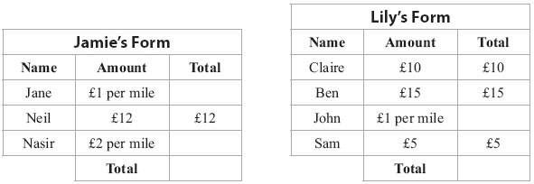

Jamie and Lily each walk 18 miles.
The lockers cost £108

Do Jamie and Lily get enough money to buy the lockers?
You must show your working.

(Total for Question is 5 marks)
__________________________________________________________________________
11. Anna drives 45 miles from her home to a meeting.
Here is the travel graph for Anna's journey to the meeting.

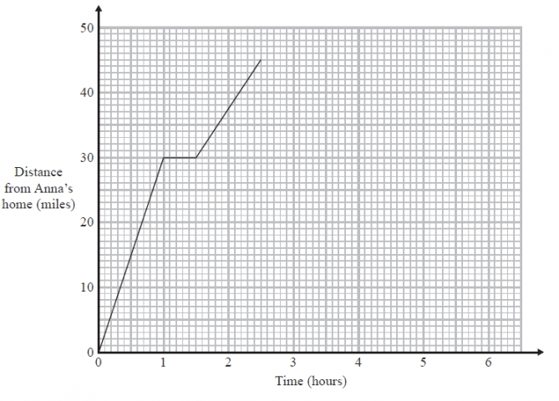

Anna's meeting lasts for 1 hour.
She then drives home at a steady speed of 30 miles per hour with no stops.

Complete the travel graph to show this information.

(Total for Question is 2 marks)
__________________________________________________________________________

12. Here is a map.
The map shows two towns, Burford and Hightown.

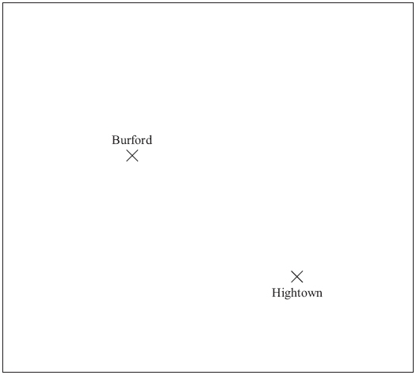
Scale: 1 cm represents 10 km

A company is going to build a warehouse.
The warehouse will be less than 30 km from Burford and less than 50 km from Hightown.

Shade the region on the map where the company can build the warehouse.

(Total for Question is 3 marks)
__________________________________________________________________________

13. Here are some patterns made from dots.

 |  | 
Pattern number 1 | Pattern number 2 | Pattern number 3

(a) Draw Pattern number 4 in the space below.

(1)

(b) How many dots are needed for Pattern number 15?

..................................
(2)
(Total for Question is 3 marks)
__________________________________________________________________________

14. John is walking along a path.
He sees this sign.
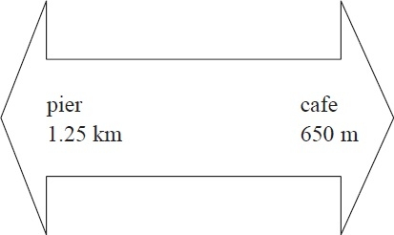
How far is it from the pier to the cafe along the path?
...........................................................
(Total for Question is 3 marks)
__________________________________________________________________________

15. Sameena has 10 m of ribbon on a reel.
She cuts 3 pieces of ribbon from the ribbon on the reel.

The lengths of the pieces are 41 cm, 3.7 cm and 112 cm.

Work out how much ribbon Sameena will have left on the reel.
...........................................................
(Total for Question is 4 marks)
__________________________________________________________________________
16. Tom goes to a theme park.
There are 4 activities at the theme park.

The table gives information about these activities.
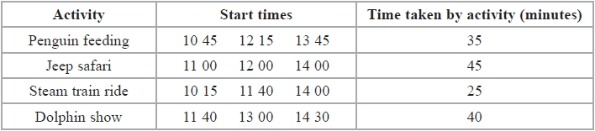
Tom wants to do all 4 activities.

He arrives at the theme park at 10 20
He needs to leave the theme park by 14 30

Plan a schedule for Tom's visit to the theme park so he can do all 4 activities.
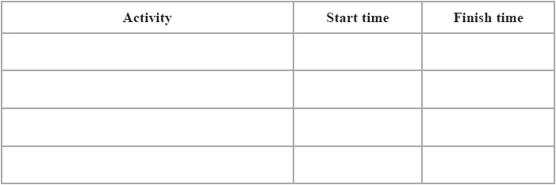

(Total for Question is 3 marks)
__________________________________________________________________________

17. Here is Katya's fitness plan for one week.

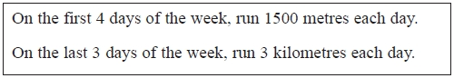

Katya uses her fitness plan for one week.
Work out the total distance she runs.
...........................................................

(Total for question is 3 marks)
___________________________________________________________________________

18. The diagram shows the floor of a village hall.
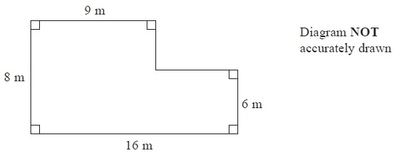
The caretaker needs to polish the floor.
One tin of polish normally costs £19
One tin of polish covers 12 m² of floor.
There is a discount of 30% off the cost of the polish.
The caretaker has £130
Has the caretaker got enough money to buy the polish for the floor?
You must show all your working.
(Total for Question is 5 marks)
___________________________________________________________________________

19. The diagram shows the floor plan of a room.

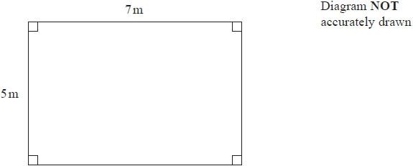

Seamus is going to put a border all around the room.
Borders are sold in rolls.

The table gives some information about three types of border.

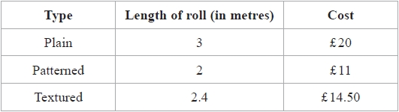

Seamus is going to use only one type of border.
He has a budget of £150

Which of these types of border can Shamus afford to buy?

(Total for question is 5 marks)
___________________________________________________________________________
20. The diagram shows a plan of Brian's lawn.

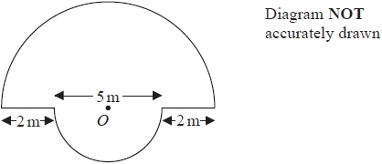

The edge of the lawn consists of two semicircles and two straight lines.
Each semicircle has centre O.
The diameters of the semicircles are 9 m and 5 m.

Brian is going to put lawn edging around the edge of the lawn.
Lawn edging is sold in 2.4 metre rolls.

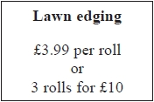
Brian has £35

Has Brian got enough money to buy all the rolls of lawn edging he needs?
You must show all your working.

(Total for question is 5 marks)
___________________________________________________________________________

21. Susan and Joe are going on holiday.
They can take two cases onto the plane free of charge if the total weight of the two cases is no more than 40 kg.

Susan’s case has a weight of 22.8 kg.
Joe’s case has a weight of 19.5 kg.

(a) Can they take their two cases onto the plane free of charge?
(2)
Susan and Joe want to be at the airport terminal at 14 30

It will take 1 hour and 20 minutes to drive from home to the airport.
It will then take a total of 30 minutes to park the car and go into the airport terminal.

(b) What is the latest time they can leave home?
...........................................................
(3)
(Total for Question is 5 marks)

__________________________________________________________________________

22.
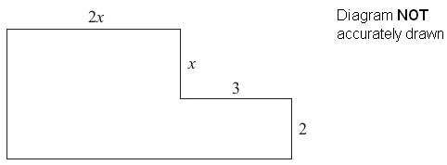

In the diagram, all measurements are given in centimetres.
All angles are right angles.

Show that the perimeter of the shape can be written as 2(3x + 5).

(Total for Question is 4 marks)
__________________________________________________________________________

23. The diagram shows shape A.
All the measurements are in centimetres.
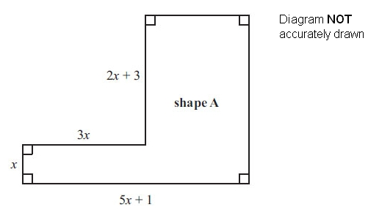
(a) Find an expression, in terms of x, for the perimeter of shape A.

. . . . . . . . . . . . . . . . . . . . .
(3)
A square has the same perimeter as shape A.

(b) Find an expression, in terms of x, for the length of one side of this square.

. . . . . . . . . . . . . . . . . . . . .
(1)
(Total for Question is 4 marks)
__________________________________________________________________________

24.
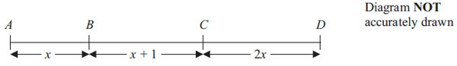

In the diagram,

AB = x cm
BC = (x + 1) cm
CD = 2x cm
AD = 19 cm

(a) Show that 4x + 1 = 19

(2)
(b) Solve 4x + 1 = 19

x = . . . . . . . . . . . . . . . . . . . .
(2)
(c) Work out the length of BD.

BD = . . . . . . . . . . . . . . . . . . . .cm
(2)
(Total for Question is 6 marks)
__________________________________________________________________________

25. ABC is a triangle.
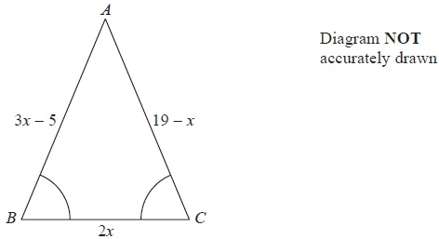
Angle ABC = angle BCA.
The length of side AB is (3x − 5) cm.
The length of side AC is (19 − x) cm.
The length of side BC is 2x cm.
Work out the perimeter of the triangle.
Give your answer as a number of centimetres.
........................................................... cm
(Total for Question is 5 marks)
__________________________________________________________________________

26. Stephanie is x years old.
Tobi is twice as old as Stephanie.
Ulrika is 3 years younger than Tobi.

The sum of all their ages is 52 years.

(a) Show that 5x − 3 = 52
(3)

(b) Work out the value of x.
x =.........................
(2)
(Total for Question is 5 marks)
__________________________________________________________________________

27. Redlands School sent x students to a revision day.
St Samuel's School sent twice as many students as Redlands School.
Francis Long School sent 7 fewer students than Redlands School.

Each student paid £15 for the revision day.
The students paid a total of £1155

Work out how many students were sent by each school to the revision day.
You must show all your working.

(Total for Question is 5 marks)
__________________________________________________________________________

28. Asha and Lucy are selling pencils in a school shop.
They sell boxes of pencils and single pencils.

Asha sells 7 boxes of pencils and 22 single pencils.
Lucy sells 5 boxes of pencils and 2 single pencils.
Asha sells twice as many pencils as Lucy.

Work out how many pencils there are in a box.
You must show all your working.
...........................................................

(Total for Question is 4 marks)
__________________________________________________________________________

x29. Diana is going to have a party.
She wants to find out what people would like to drink at the party.
They can choose lemonade or cola or orange.

(a) Design a suitable table for a data collection sheet she could use.
(3)
Diana buys some bottles of orange and some bottles of lemonade.
A bottle of orange costs £1.75
A bottle of lemonade costs £1.20
Diana buys 2 bottles of orange and 3 bottles of lemonade.
She gets off the total cost.
Diana pays with a £10 note.
(b) How much change should Diana get?
£...........................................................
(4)

(Total for Question is 7 marks)

__________________________________________________________________________

30. Here is a box in the shape of a cuboid.
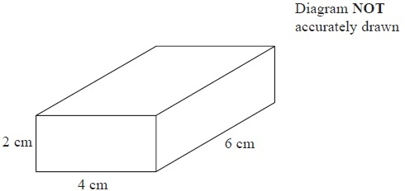

The box is made to hold cubes.
Each cube has edges of length 2 cm.
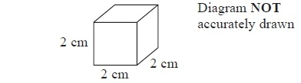
Work out the largest number of cubes that can fit into the box.
...........................................................
(Total for Question is 2 marks)
__________________________________________________________________________

31. The pictogram gives information about the number of buns Sujata sold in her shop on each of four days last week.

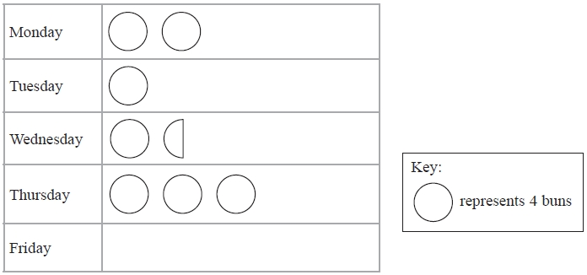

(a) Write down the number of buns Sujata sold on Monday.
...........................................................
(1)

(b) Work out the total number of buns sold on Monday, Tuesday, Wednesday and Thursday.
...........................................................
(2)

On Friday last week Sujata sold 16 buns.

(c) Show this information on the pictogram.
(1)

(Total for Question is 4 marks)
__________________________________________________________________________

32. here are 40 children in a ski club.
Each child has one pair of skis.

The skis are
twin tipped skis
or downhill skis
or slalom skis.

There are 23 boys in the ski club.
7 of the boys have twin tipped skis.
8 of the girls have downhill skis.
5 of the 9 children with slalom skis are girls.

Work out the number of children with twin tipped skis.

............................................
(Total for Question is 4 marks)
__________________________________________________________________________

33. The table shows the temperatures, in °C, in Paris and in Nice on four days.

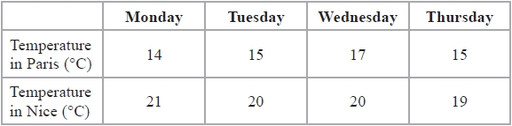

(a) Show this information in a suitable diagram.


(4)
(b) Compare the temperatures in Paris and in Nice for the four days.

.............................................................................................................................................

.............................................................................................................................................

.............................................................................................................................................
(1)

(Total for Question is 5 marks)
__________________________________________________________________________

34. (a) On the grid, draw a kite.

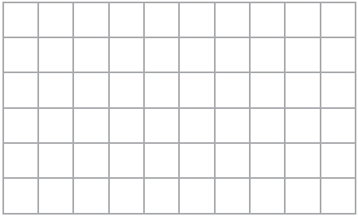
(1)
(b) On this grid, draw a rectangle with a perimeter of 14 cm.

(2)
Here is a hexagon.
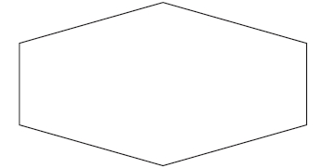

(c) Draw all the lines of symmetry on this hexagon.
(2)
(Total for Question is 5 marks)
__________________________________________________________________________

35. On the grid, draw the graph of y = 2x − 3 for values of x from −2 to 3

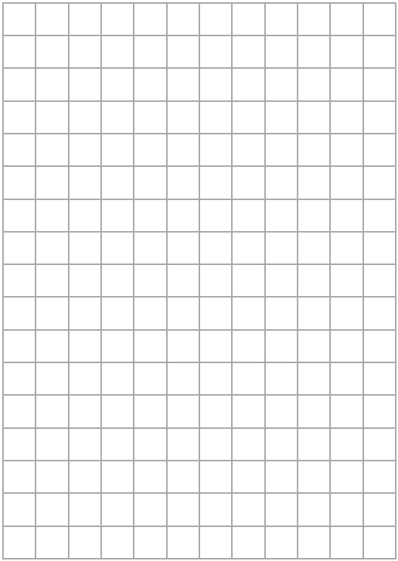
(Total for Question is 4 marks)
__________________________________________________________________________

36. The front elevation and the side elevation of a cuboid are drawn on the grid.
On the grid, draw the plan of the cuboid.

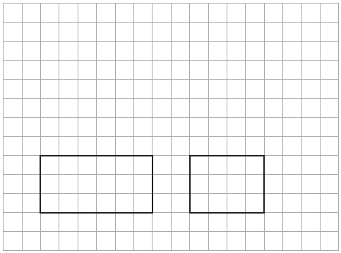

(Total for Question is 2 marks)
__________________________________________________________________________

37. The side elevation and the front elevation of a cuboid are drawn on the centimetre grid.

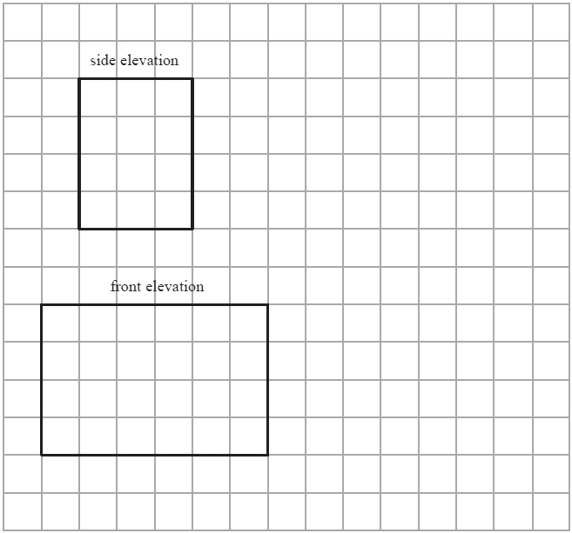

On the grid, draw an accurate plan of the cuboid.
(Total for Question is 2 marks)
__________________________________________________________________________

38. Here is a shape drawn on a grid.

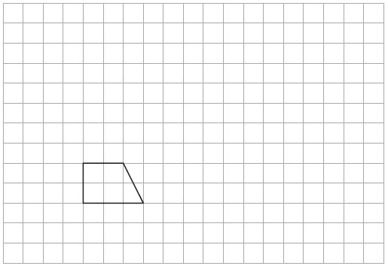

(a) On this grid, draw an enlargement of the shape with scale factor 3
(2)

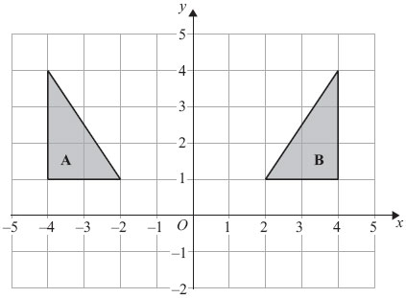

(b) Describe fully the single transformation that maps shape A onto shape B.

..............................................................................................................................................

..............................................................................................................................................
(2)
(Total for Question is 4 marks)
__________________________________________________________________________

39. (a) Expand 5(2c + 3d)

...........................................................
(1)
(b) Here are two straight lines, ABCDE and P.
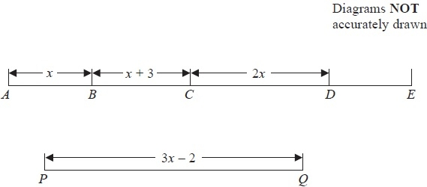
In the diagrams all the lengths are in cm.
AE = 2P.

Find an expression, in terms of x, for the length of DE.
Give your answer in its simplest form.
........................................................... cm
(4)
(Total for Question is 5 marks)
__________________________________________________________________________

40. The table shows information about the cost of hiring a cement mixer from two companies.

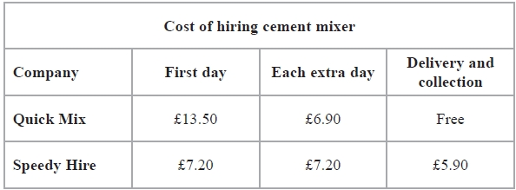

Chris wants to hire a cement mixer for 5 days.
He will hire the cement mixer from either Quick Mix or Speedy Hire.
Chris wants to pay the least amount of money.

Which company should he choose?
You must show all your working.
(Total for Question is 4 marks)
__________________________________________________________________________

41. The table gives information about the prices and the features of five mobile phones.
The ticks () in the table show the features of each phone.

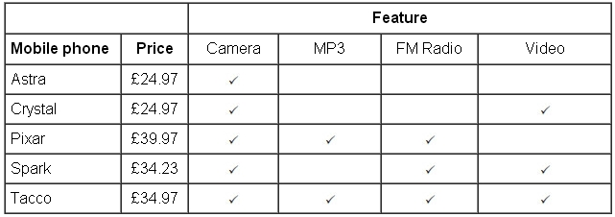
(a) Which of the five mobile phones is the most expensive?

..............................................................................................................................................
(1)
(b) Which of the mobile phones have MP3?

..............................................................................................................................................
(1)
(c) Which mobile phone has Video but not FM Radio?

..............................................................................................................................................
(1)

Mirza has a monthly plan for his mobile phone.
Each month, he pays a total of £9.79 plus the cost of any extra minutes.

Monthly Plan
For £9.79 per month you get:
100 minutes and unlimited texts.
Extra minutes: 24.5p each
Last month, Mirza used 112 minutes.

(d) Work out how much he paid in total last month.

£ . . . . . . . . . . . . . . . . . . . . . .
(4)
(Total for Question is 7 marks)
__________________________________________________________________________
42. Lynn lives in Baston.
She is going to go to the cinema in Peterborough.
She will travel by bus between Baston and Peterborough.

Here is part of the bus timetable from Bourne to Peterborough and from Peterborough to Bourne.

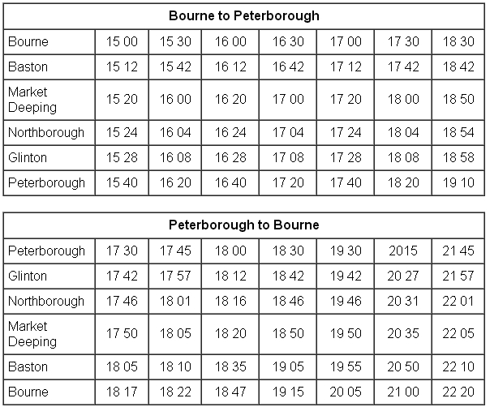

It takes Lynn 30 minutes to walk between the bus station in Peterborough and the cinema.
The latest bus she can catch home leaves Peterborough at 21 45.
Lynn wants to watch a film called Sherlock Holmes.

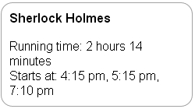

The film lasts for 2 hours 14 minutes.

Plan a schedule for Lynn's visit to the cinema.

Schedule | Time
Bus leaves Baston
Bus arrives Peterborough
Film starts
Bus leaves Peterborough
Bus arrives Baston

(Total for Question is 5 marks)
__________________________________________________________________________

43. You can use this conversion graph to change between temperatures in degrees Celsius (°C) and temperatures in degrees Fahrenheit (°F).

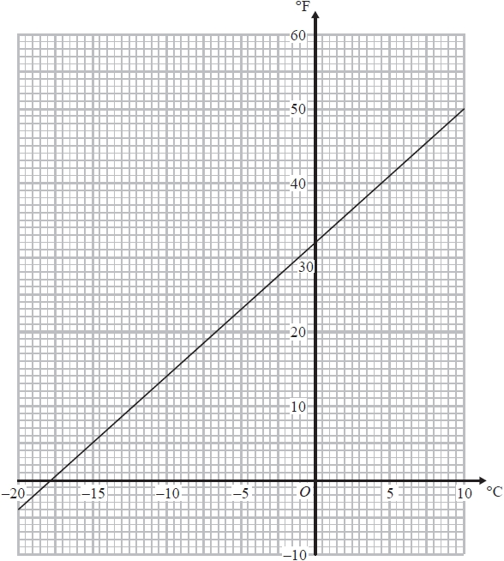

The temperature inside a refrigerator needs to be 40°F.

(a) Use the conversion graph to change a temperature of 40°F into a temperature in °C.

........................................................... °C
(1)
The temperature in a freezer needs to be 0°F.
The temperature in Dave's freezer is –10°C.

(b) Compare the temperature in Dave's freezer with 0°F.
You must show your working.
(3)
(Total for Question is 4 marks)
__________________________________________________________________________

44. Peter goes for a walk.
He walks 15 miles in 6 hours.

(a) Work out Peter's average speed.
Give your answer in miles per hour.

..............................................................................................................................................
(2)

5 miles = 8 km.
Sunita says that Peter walked more than 20 km.

(b) Is Sunita right?
You must show all your working.

(2)
(Total for Question is 4 marks)
___________________________________________________________________________
45. he map shows the positions of three places A, B and C on the edge of a lake.
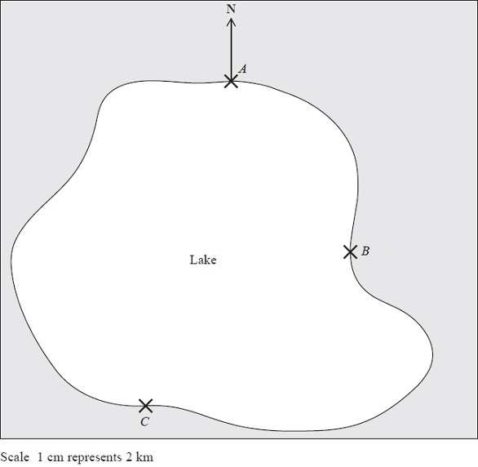
(a) Find the bearing of B from A.
........................................................... °
(1)
A ferry travels in a straight line from A to B.
It then travels in a straight line from B to C.
A speedboat travels in a straight line from A to C.
(b) How many more kilometres does the ferry travel than the speedboat?
You must show your working.
........................................................... km
(4)
(Total for Question is 5 marks)
__________________________________________________________________________
46. The diagram shows the cost of a bag of soil and the cost of a box of seeds.
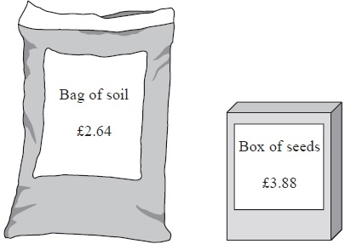
Kate buys two bags of soil and three boxes of seeds.
She gets off the total cost.
Kate pays with a £20 note.
How much change should Kate get?
£ ...........................................................

(Total for Question is 4 marks)
__________________________________________________________________________
47.
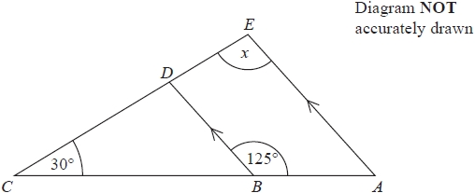

ABC and EDC are straight lines.
AE and BD are parallel.
Angle ABD = 125°
Angle BCD = 30°

Work out the size of the angle marked x.
Give reasons for your answer.

(Total for Question is 4 marks)
__________________________________________________________________________

48.
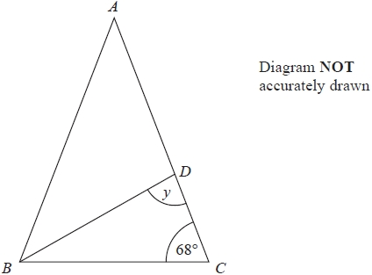
ABC and ABD are both isosceles triangles.
AB = AC
DA = DB

Work out the size of angle y.
You must give reasons for your answer.

(Total for Question is 4 marks)
__________________________________________________________________________

49. Here is a sequence of patterns made with grey squares and with white squares.

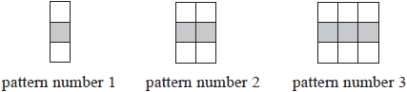

(a) In the space below, draw pattern number 4
(1)
A pattern in the sequence has 10 grey squares.
(b) How many white squares does the pattern have?
...........................................................
(1)
A pattern in the sequence has a total of 45 squares.

(c) (i) How many grey squares does the pattern have?
...........................................................

(ii) Explain how you found your answer.

.............................................................................................................................................

.............................................................................................................................................
(2)
(Total for Question is 4 marks)
__________________________________________________________________________

50. The diagram shows a semicircle drawn inside a rectangle.
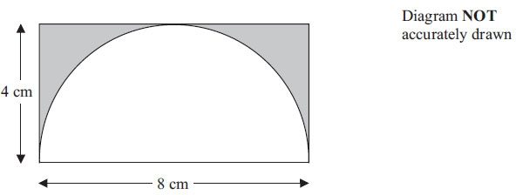

The semicircle has a diameter of 8 cm.
The rectangle is 8 cm by 4 cm.

Work out the area of the shaded region.
Give your answer correct to 3 significant figures.

. . . . . . . . . . . . . . . . . . . . . . . . cm²
(Total for Question is 4 marks)
__________________________________________________________________________

51.
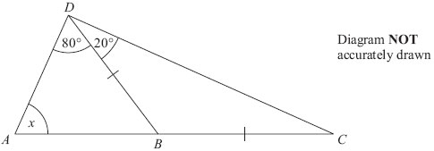

ABC is a straight line.
BD = BC
Angle ADB = 80°
Angle BDC = 20°

Work out the size of the angle marked x.
Give reasons for your answer.

(Total for Question is 4 marks)
__________________________________________________________________________

52.
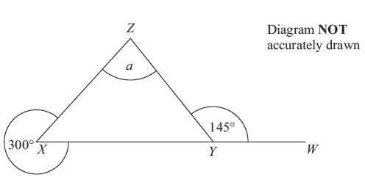

XYW is a straight line.

Work out the size of the angle marked a.
You must give reasons for your answer.

(Total for Question is 4 marks)
__________________________________________________________________________

53.
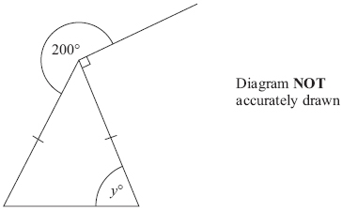

Work out the value of y.
Give reasons for your answer.

(Total for Question is 4 marks)
__________________________________________________________________________

54. Mrs Smith asked each student in her class to record the numbers of times they used their mobile phone last Saturday.

Here are the results for the boys.

Boys 8 10 8 9 7 9 8 13 14

(a) Work out the median.
...........................................................
(2)
Here are the results for the girls.

Girls 6 8 9 9 10 14 14

(b) Compare the numbers of times the boys used their mobile phones with the numbers of times the girls used their mobile phones.
(4)
(Total for Question is 6 marks)
__________________________________________________________________________

55. –2 < n ≤ 3

n is an integer.

(a) Write down all the possible values of n.

..............................................................................................................................................
(2)

3x + 5 > 16

x is an integer.

(b) Find the smallest value of x.

..............................................................................................................................................
(3)
(Total for Question is 5 marks)
__________________________________________________________________________

56.
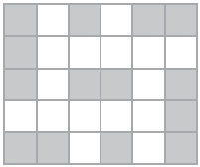

(a) What fraction of this shape is shaded?
Give your answer in its simplest form.
...........................................................
(2)

(b) Write down the order of rotational symmetry of the shape.
...........................................................
(1)

(c) On the shape below, shade as few squares as possible so that the dotted line is a line of symmetry.
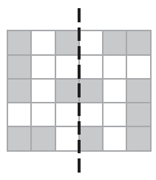
(2)
(Total for Question is 5 marks)
__________________________________________________________________________

57. There are only silver cars, blue cars and red cars in the car parks at Allerton School and at Bragdon School.

The pie charts show information about the numbers of these cars.

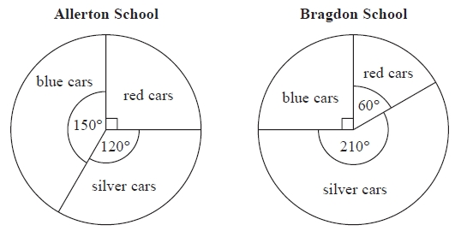
(a) What fraction of the cars in the car park at Allerton School are blue?
Give your fraction in its simplest form.

...........................................................
(2)
There are 12 red cars in the car park at Bragdon School.

(b) How many silver cars are there in this car park?

...........................................................
(2)

(c) In which car park are there more silver cars?
Tick () one box to show your answer.

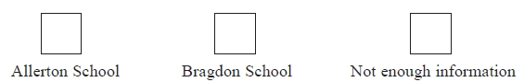
Explain your answer.

.............................................................................................................................................

.............................................................................................................................................

.............................................................................................................................................
(1)
(Total for Question is 5 marks)
__________________________________________________________________________

58.
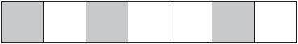

(a) Write down the fraction of this shape that is shaded.

...........................................................
(1)

(b) Shade 40% of this shape.

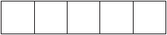

(1)

(c) Work out 0.75 of 200
...........................................................
(2)
Michael says

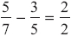

Michael is wrong.

(d) Explain why.
(2)
(Total for Question is 6 marks)
__________________________________________________________________________
59.
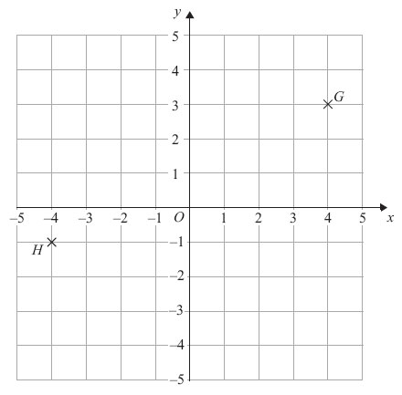

(a) (i) Write down the coordinates of the point G.

..............................................................................................................................................

(ii) Write down the coordinates of the point H.

..............................................................................................................................................
(2)

(b) Find the coordinates of the midpoint of GH.

..............................................................................................................................................
(2)
(Total for Question is 4 marks)
__________________________________________________________________________

60. The diagram shows a semicircle drawn inside a rectangle.

The semicircle has a diameter of 8 cm.
The rectangle is 8 cm by 4 cm.

Work out the area of the shaded region.
Give your answer correct to 3 significant figures.

. . . . . . . . . . . . . . . . . . . . . . . . cm²
(Total for Question is 4 marks)
__________________________________________________________________________

61.
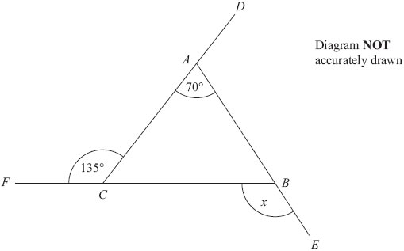

DAC, FCB and ABE are straight lines.

Work out the size of the angle marked x.
You must give reasons for your answer.

(Total for Question is 5 marks)
__________________________________________________________________________

62.
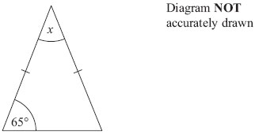

Work out the size of the angle marked x.
Give reasons for your answer.

(Total for Question is 3 marks)
__________________________________________________________________________

63.
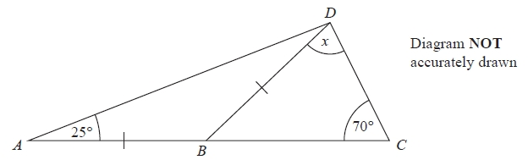

ABC is a straight line.
AB = BD
Angle BAD = 25°
Angle BCD = 70°

Work out the size of the angle marked x.
Give reasons for your answer.

(Total for Question is 4 marks)
__________________________________________________________________________

64.
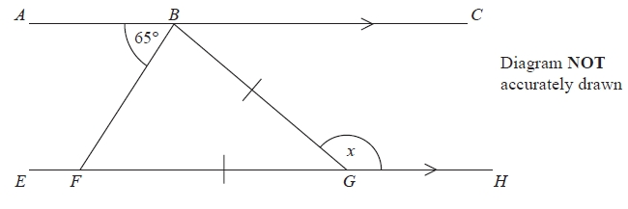
ABC is parallel to EFGH.
GB = GF
Angle ABF = 65°

Work out the size of the angle marked x.
Give reasons for your answer.

(Total for Question is 4 marks)
__________________________________________________________________________

65.
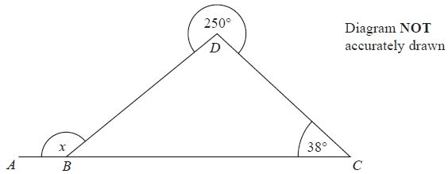
ABC is a straight line.
Angle BCD = 38°
The reflex angle BDC = 250°

Work out the size of the angle marked x.
Give reasons for your answer.
(Total for Question is 4 marks)
__________________________________________________________________________

66. This shape is made from an euilateral triangle and 3 identical isosceles triangles.

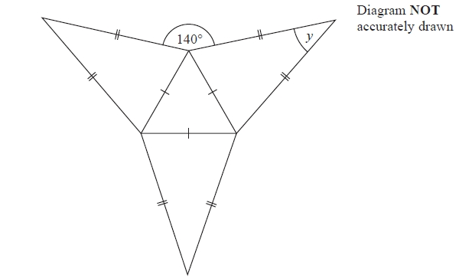

Work out the size of the angle marked y.
Give reasons for your answer.

(Total for Question is 4 marks)
__________________________________________________________________________

67. ABC is an isosceles triangle.

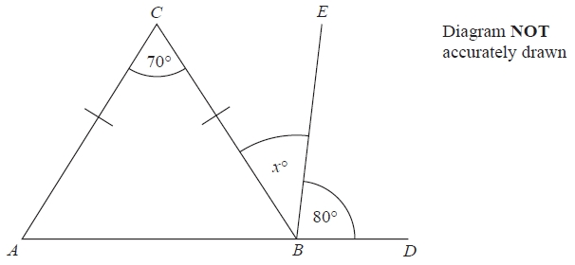

AC = BC
ABD is a straight line.

Angle ACB = 70°
Angle EBD = 80°
Angle CBE = x°

Work out the value of x.
Give reasons for your answer.

(Total for Question is 4 marks)
__________________________________________________________________________

68. Here is the number of goals scored by a football team in each of its first 10 games.

3 1 4 2 0 1 1 1 3 2

(a) Write down the mode.
...........................................................
(1)
(b) Work out the mean number of goals for the first 10 games.
...........................................................
(2)
In the 11th game the team scored 4 goals.
In the 12th game the team scored 2 goals.

(c) Will the mean number of goals for the 12 games be greater than or less than the mean number of goals for the first 10 games?
You must explain your answer.
(2)
(Total for Question is 5 marks)
__________________________________________________________________________

69. Here are some patterns made from grey tiles.

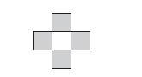 | 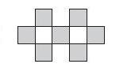 | 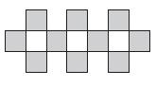
Pattern number 1 | Pattern number 2 | Pattern number 3

(a) Draw Pattern number 4 on the grid below.
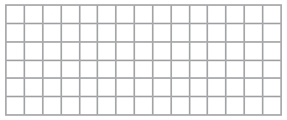
(1)

(b) How many grey tiles are needed for Pattern number 10?

...............................................
(2)

Jenny says,

‘I will need exactly 46 grey tiles for Pattern number 18’.

(c) Is Jenny right?
You must give a reason for your answer.

..............................................................................................................................................

..............................................................................................................................................

..............................................................................................................................................
(2)
(Total for Question is 5 marks)
__________________________________________________________________________

70. There are 3 counters in a bag.

One counter is red.
One counter is green.
One counter is blue.

Mike takes at random a counter from the bag.
He puts the counter back in the bag. Then Ellie takes at random a counter from the bag.

(a) Is Ellie more likely to take a blue counter from the bag than Mike?
You must explain your answer.

..............................................................................................................................................

..............................................................................................................................................
(1)

(b) Write a list of all the possible combinations of the two counters that Mike and Ellie can take.

..............................................................................................................................................

..............................................................................................................................................
(2)

(c) Find the probability that Mike takes a blue counter and then Ellie takes a green counter.

..............................................................................................................................................
(1)
(Total for Question is 4 marks)
__________________________________________________________________________

71. There are 9 white beads and 11 red beads in a bag.
There are no other beads in the bag.

Jim takes at random a bead from the bag.

(a) Write down the probability that the bead will be white.
...........................................................
(2)

There are 9 green beads and 11 blue beads in a box.
Jim adds 10 more beads to this box.

Jim is going to take at random a bead from the 30 beads in the box.
The probability that he will take a green bead is $\frac{2}{5}$

(b) Work out how many green beads Jim adds to the box.

...........................................................
(3)

(Total for Question is 5 marks)
__________________________________________________________________________

72. Here is a four sided spinner.
The spinner is biased.
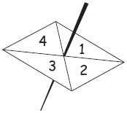

The table shows the probabilities that the spinner will land on 1 or on 3

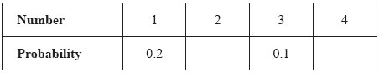

The probability that the spinner will land on 2 is the same as the probability that the spinner will land on 4

(a) Work out the probability that the spinner will land on 4

..............................................................................................................................................
(3)

Shunya is going to spin the spinner 200 times.

(b) Work out an estimate for the number of times the spinner will land on 3

..............................................................................................................................................
(2)
(Total for Question is 5 marks)
__________________________________________________________________________

73. Here are some patterns made from triangles.

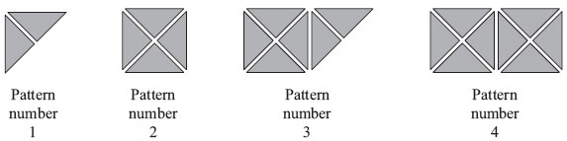

(a) Complete the table.

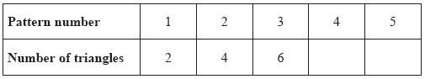
(1)

(b) How many triangles are needed for Pattern number 12?

..............................................................................................................................................
(1)

Luke says that Pattern number 40 has 82 triangles.

(c) Luke is wrong.
Explain why.

..............................................................................................................................................

..............................................................................................................................................
(1)
(Total for Question is 3 marks)
__________________________________________________________________________

74. Here are the first four terms of a number sequence.

3 7 11 15

(a) Write down the next term of this sequence.
...........................................................
(1)

The 50th term of this number sequence is 199

(b) Write down the 51st term of this sequence.
...........................................................
(1)

The number 372 is not a term of this sequence.

(c) Explain why.
.............................................................................................................................................

.............................................................................................................................................
(1)
(Total for Question is 3 marks)
__________________________________________________________________________

75. Here is a sequence of patterns made from triangles and stars.

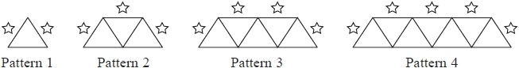

(a) How many stars are needed for Pattern 5?
...........................................................
(1)

(b) How many triangles are needed for Pattern 6?
...........................................................
(1)

A pattern in the sequence is made from exactly 10 stars.

(c) How many triangles are needed for this pattern?
...........................................................
(2)

(Total for Question is 4 marks)
__________________________________________________________________________

76. Here are the first four terms of a number sequence.

3 7 11 15

(a) (i) Write down the next term in the sequence.
...........................................................
(ii) Explain how you got your answer.

.............................................................................................................................................
(2)
(b) Work out the 11th term in the sequence.
...........................................................
(1)

(c) Is 79 a term in this sequence?
Explain how you got your answer.
.............................................................................................................................................

.............................................................................................................................................
(1)

(Total for Question is 4 marks)
__________________________________________________________________________

77. Here are the first five terms of a number sequence.
40 37 34 31 28
(a) (i) Write down the next two terms of this number sequence.
..........................................................., ...........................................................
(ii) Explain how you got your answer.

.............................................................................................................................................

.............................................................................................................................................
(2)
Here are the first five terms of a different number sequence.
−12 −7 −2 3 8
(b) Find the 8th term of this sequence.
...........................................................
(2)
(Total for Question is 4 marks)
__________________________________________________________________________

78. Matthew has five cards.
Each card has a number on it.

2 | 3 | 6 | 7 | 7

(a) Write down the median.

..............................................................................................................................................
(1)

James has three cards.
Each card has a number on it.
The numbers are hidden.

? | ? | ?
The mode of the three numbers is 4
The mean of the three numbers is 5

(b) Work out the three numbers on the cards.

. . . . . . . . . . . , . . . . . . . . . . . , . . . . . . . . . . .
(2)
(Total for Question is 3 marks)
__________________________________________________________________________

79. Here are the ages of 10 children at a party.

6 5 8 6 7 7 8 8 8 6

(a) Write down the mode.
...........................................................
(1)
(b) Work out the mean age of the children.
...........................................................
(2)
(c) Work out the range of the ages of the children at the party.
...........................................................
(2)
Another child comes to the party.
This child is 7 years old.

(d) Does this change the range of the ages of the children at the party?
Explain your answer.

.............................................................................................................................................

.............................................................................................................................................
(1)
(Total for Question is 6 marks)
__________________________________________________________________________

80. The diagram shows the distances between 4 villages C, H, S and Y on a postman's round.

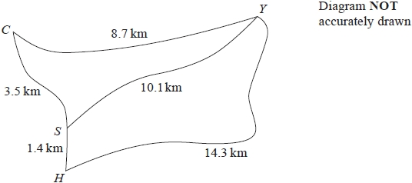

Gordon delivers letters to these 4 villages.
He starts and finishes at C.

Gordon wants to drive the shortest distance to deliver all his letters.

(i) Work out this shortest distance.
You must show all your working.
........................................................... km

(ii) Write down Gordon's route.
......................................................................................................................
(Total for Question is 4 marks)
__________________________________________________________________________
81. A small photograph has a length of 4 cm and a width of 3 cm.
Shez enlarges the small photograph to make a large photograph.

The large photograph has a width of 15 cm.

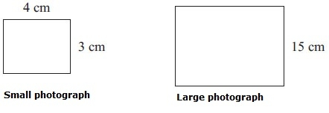
Diagram NOT accurately drawn
The two photographs are similar rectangles.
Work out the length of the large photograph.

..............................................................................................................................................
(Total for Question is 3 marks)
__________________________________________________________________________

82.
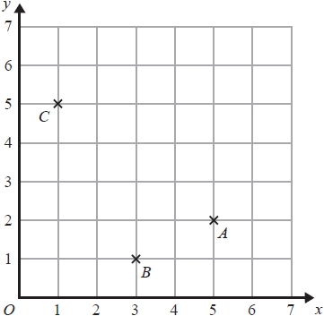

(a) Write down the coordinates of point C.

(........................... , ...........................)
(1)

(b) On the grid, mark with a cross () the point D so that ABCD is a rectangle.
Label this point D.

(1)

(Total for Question is 2 marks)
__________________________________________________________________________

83. Here is a list of numbers.

4 6 8 11 15 33 44

(a) From the list, write down a factor of 42

...........................................................
(1)

(b) From the list, write down a multiple of 22

...........................................................
(1)

(c) From the list, write a different number in each box to make the statement true.

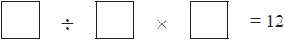

(1)

(Total for Question is 3 marks)
__________________________________________________________________________

84. Here is a list of the names of five types of quadrilateral.

trapezium | parallelogram | square | rhombus | rectangle

(a) From the list, write down the names of two quadrilaterals which must have all four sides the same length.

..............................................................................................................................................
(1)

trapezium | parallelogram | square | rhombus | rectangle

(b) From the list, write down the name of the uadrilateral that has only one pair of parallel sides.

..............................................................................................................................................
(1)

trapezium | parallelogram | square | rhombus | rectangle

For one of these quadrilaterals,

the corners are not right angles,
the quadrilateral has rotational symmetry of order 2
and the diagonals cross at right angles.

(c) Write down the name of this quadrilateral.

..............................................................................................................................................
(1)
(Total for Question is 3 marks)
__________________________________________________________________________

85. Here are a quadrilateral and a triangle drawn on a centimetre grid.
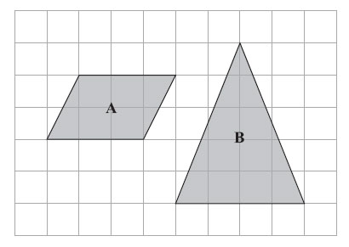

(a) Write down the special name for quadrilateral A.

..............................................................................................................................................
(1)

(b) Write down the special name for triangle B.

..............................................................................................................................................
(1)

(c) Find the area of quadrilateral A.

..........................................cm²
(2)
(Total for Question is 4 marks)
__________________________________________________________________________

86.
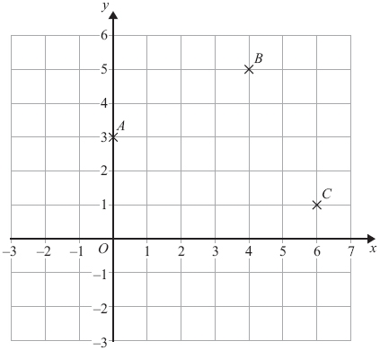
(a) Write down the coordinates of the point B.
..............................................................................................................................................
(1)
A, B and C are three corners of a square.
(b) On the grid, mark with a cross (×) the point D so that ABCD is a square.
(1)
(Total for Question is 2 marks)
__________________________________________________________________________

87. A survey was carried out for a magazine.
90 cat owners were asked to write down the make of cat food their cats liked best.

The bar chart shows information about the results.

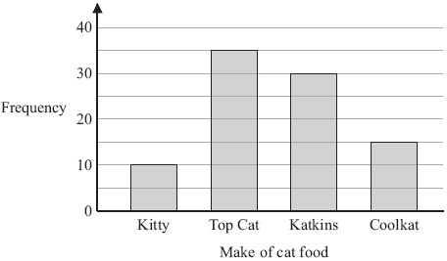

This statement was in the magazine.

“1 out of 6 cats like Coolkat best”.

(a) Is the statement right?
You must explain your answer.

.............................................................................................................................................

.............................................................................................................................................
(1)

The information in the bar chart is going to be shown in a pie chart.

(b) Use the information in the bar chart to complete the pie chart.

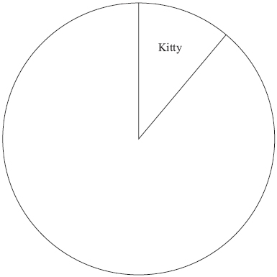

(3)
(Total for Question is 4 marks)
__________________________________________________________________________

88. You can use this conversion graph to change between kilograms and pounds.

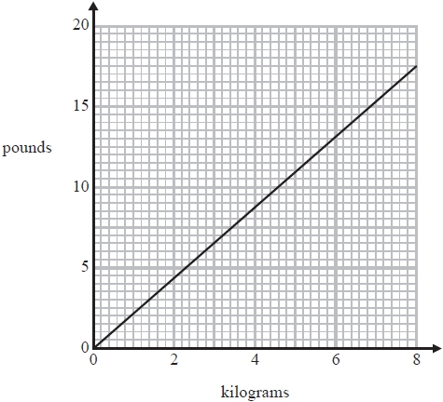

(a) Use the conversion graph to change 5 kilograms to pounds.

........................................................... pounds
(1)

Brett weighs 150 pounds.
Henri weighs 64 kilograms

(b) Work out their total weight.
Give your answer in kilograms.
You must show your working.

........................................................... kilograms
(3)
(Total for Question is 4 marks)
__________________________________________________________________________
89. Beth recorded the temperature, in degrees (°C), inside her greenhouse every hour on one day.
The graph shows information about her results.
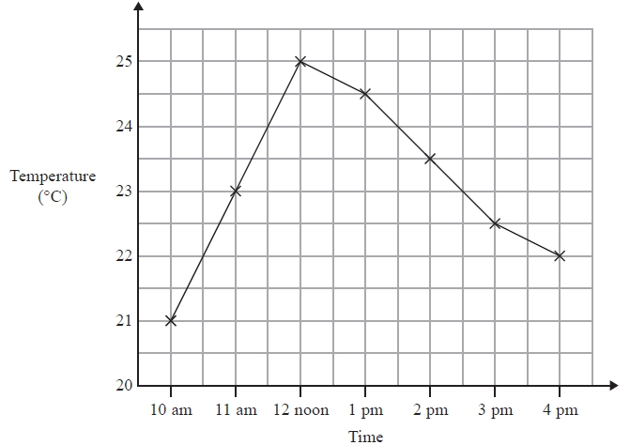

(a) Write down the temperature at 11 a.m.
............................°C
(1)

(b) Write down the highest recorded temperature.
............................°C
(1)

(c) Describe the change in temperature from 12 noon to 4 pm.

.............................................................................................................................................

.............................................................................................................................................
(1)
(Total for Question is 3 marks)
__________________________________________________________________________

90. The pictogram shows information about the number of text messages Stephanie sent on each of 4 days last week.

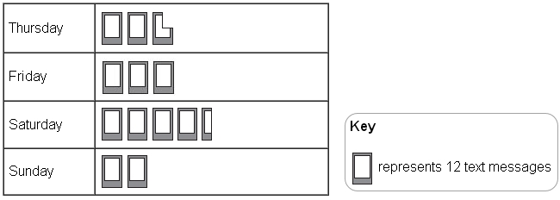
(a) Write down the number of text messages Stephanie sent on Sunday.

..............................................................................................................................................
(1)
Stephanie sent more text messages on Saturday than on Friday.

(b) How many more?

..............................................................................................................................................
(2)
It costs Stephanie 8p to send a text message.

(c) Work out the total cost of the text messages she sent on Thursday.

£ ...........................................
(3)
(Total for Question is 6 marks)
__________________________________________________________________________

91. Here is a pictogram.
It shows the number of boxes of chocolates sold each day last week in a shop.

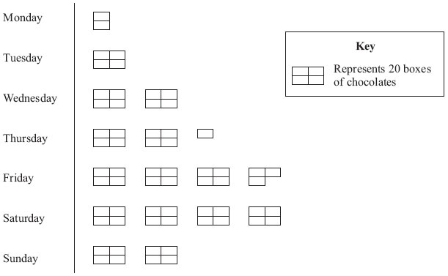

(a) Write down the number of boxes of chocolates sold

(i) on Tuesday,

..............................................................................................................................................

(ii) on Thursday.

..............................................................................................................................................
(2)

(b) Work out the total number of boxes of chocolates sold last week.

..............................................................................................................................................
(2)
(Total for Question is 4 marks)
__________________________________________________________________________

92. The pie chart shows information about how the students in Year 11 get to school.

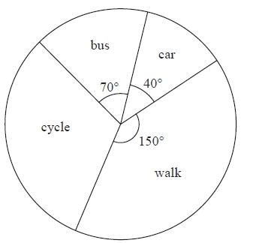
Diagram NOT accurately drawn
Mr Morley says, "Less than 10% of students in Year 11 get to school by car".

(a) Is Mr Morley correct?
You must explain your answer.

.............................................................................................................................................

.............................................................................................................................................

.............................................................................................................................................
(2)

50 students in Year 11 cycle to school.

(b) How many students in Year 11 walk to school?

...........................................................
(3)
(Total for Question is 5 marks)
__________________________________________________________________________
93. The scale diagram shows part of the plan of a classroom.
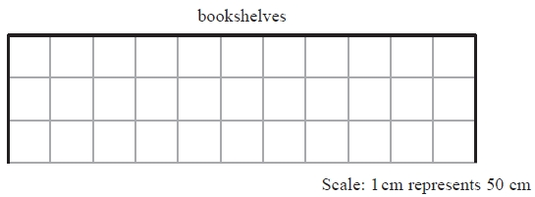
Mr Khan wants to put bookshelves along the complete length of the wall labelled “bookshelves”.

There are two sizes of bookshelves.
Large bookshelves are 150 cm wide.
Small bookshelves are 100 cm wide.

(i) Work out how many large bookshelves and how many small bookshelves Mr Khan can put along the complete length of the wall.
........................................................... large
........................................................... small
Both the large bookshelves and the small bookshelves are 50 cm from front to back.

(ii) Draw these bookshelves on the scale drawing to show how they will fit.

(Total for Question is 4 marks)
__________________________________________________________________________

94. Here is a sequence of patterns made with white squares and grey rectangles.

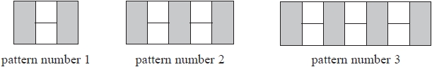

(a) In the space below, draw pattern number 4
(1)

(b) How many grey rectangles are there in pattern number 8?
...........................................................
(1)

Sue says,

"There is a pattern in the sequence with exactly 50 white squares."

(c) Is Sue right?
You must give a reason for your answer.

.............................................................................................................................................

.............................................................................................................................................
(1)

A pattern in the sequence has exactly 20 grey rectangles.

(d) How many white squares does the pattern have?
...........................................................
(1)

(Total for Question is 4 marks)
__________________________________________________________________________
95. Lucy works in a school shop.
She recorded the number of apples sold each day last week.
The bar chart shows this information.

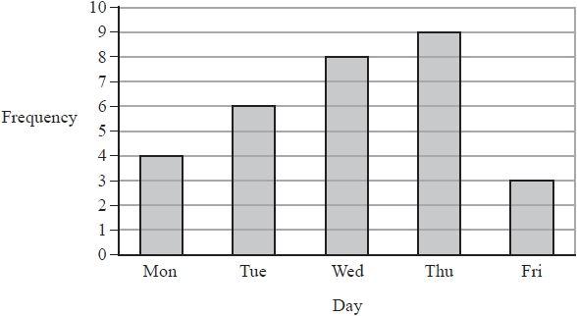

(a) Write down the number of apples sold on Wednesday.

...........................................................
(1)

The total number of apples sold last week is twice the total number of apples sold on two of the days.

(b) Which two days?
.............................................. and ..............................................
(2)

(Total for Question is 3 marks)
__________________________________________________________________________

96. The pie chart shows information about the ages of students at an athletics competition.

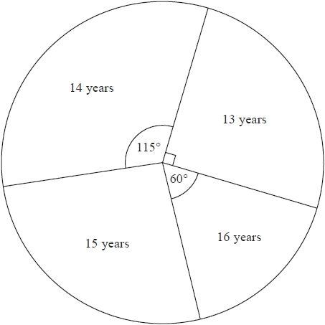

(a) What fraction of the students have an age of 13 years?
...........................................................
(1)

23 of the students have an age of 14 years.

(b) Work out how many of the students have an age of 15 years.
...........................................................
(3)

(Total for Question is 4 marks)
__________________________________________________________________________
97. The dual bar chart shows information about the amount of time Sophie and Zach spent on the Internet on each of 6 days last week.

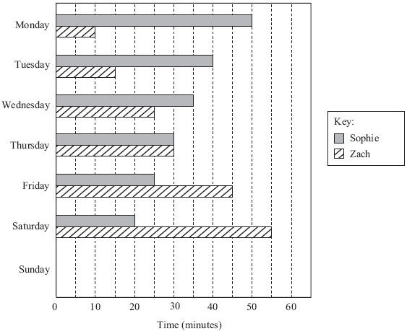

On one of these days, Sophie and Zach spent the same amount of time on the Internet.

(a) Which day?

..............................................................................................................................................
(1)

(b) Write down the amount of time that Zach spent on the Internet on Friday.

..............................................................................................................................................
(1)

On Sunday,
Sophie spent 15 minutes on the Internet,
Zach spent 60 minutes on the Internet.

(c) Complete the dual bar chart.
(2)

(d) Using the information in the dual bar chart, compare the amounts of time Sophie spent on the Internet last week to the amounts of time Zach spent on the Internet last week.

..............................................................................................................................................

..............................................................................................................................................

..............................................................................................................................................
(1)
(Total for Question is 5 marks)
__________________________________________________________________________

98. Here is a scale drawing of the plan of a room.
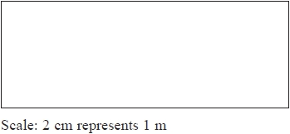
Work out the total length around the edge of the room.
Give your answer in metres.
........................................................... metres
(Total for Question is 3 marks)
__________________________________________________________________________

99. The pie chart shows information about the number of votes each of four candidates got in an election.

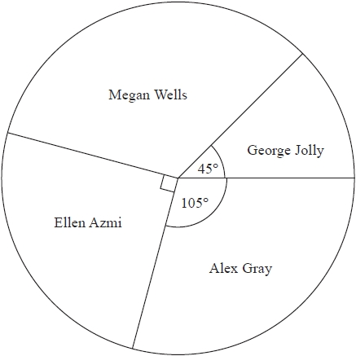

(a) What fraction of the votes did Megan Wells get?
...........................................................
(2)

Ellen Azmi got 4500 votes.

(b) Work out the total number of votes the four candidates got.
...........................................................
(2)

(Total for Question is 4 marks)
__________________________________________________________________________

