99 Problems

1MA1 / H

Instructions
- Use black ink or ball-point pen.
  - Fill in the boxes at the top of this page with your name,
centre number and candidate number.
- Answer all questions.
- Answer the questions in the spaces provided
– there may be more space than you need.
- You must show all your working.
- Diagrams are NOT accurately drawn, unless otherwise indicated.
- Calculators may be used.
- If your calculator does not have a π button, take the value of π to be 3.142
unless the question instructs otherwise.
Information
- This paper contains 99 questions.
- The marks for each question are shown in brackets
– use this as a guide as to how much time to spend on each question.
Advice
- Read each question carefully before you start to answer it.
- Try to answer every question.
1. The diagram shows a solid prism.
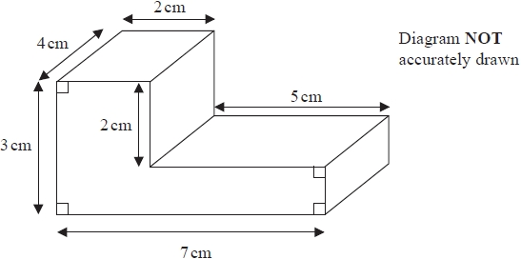
On the grid, draw an accurate plan of the solid prism.
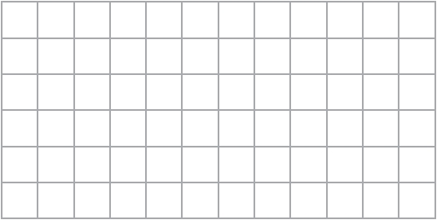

(Total for Question is 2 marks)

2. ABD is a right angled triangle.
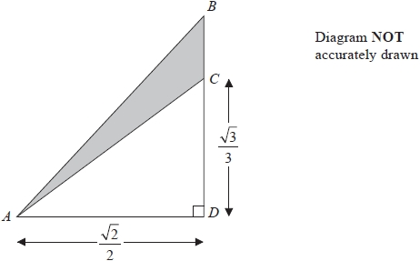

All measurements are given in centimetres.

C is the point on BD such that CD = $\frac{\sqrt{3}}{3}$
AD = BD = $\frac{\sqrt{2}}{2}$

Work out the exact area, in cm², of the shaded region.

........................................................... cm²

(Total for Question is 3 marks)
3. Here is a trapezium.
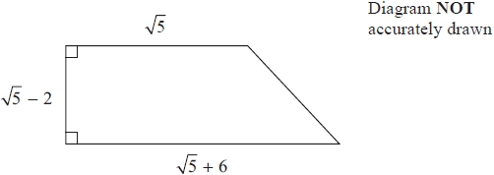

All measurements shown are in centimetres.

Work out the area of the trapezium.
Give your answer in cm² in the form a√5 + b where a and b are integers.

...........................................................cm²

(Total for Question is 3 marks)

4. Write (5 − √5)² in the form a + b√5, where a and b are integers.
...........................................................
(Total for Question is 2 marks)

5. Expand (1 + √2 )(3 − √2 )

Give your answer in the form a + b √2 where a and b are integers.
...........................................................
(Total for Question is 2 marks)

6. (a) Express 5√27 in the form n√3, where n is a positive integer.

..............................................................................................................................................
(2)
(b) Rationalise the denominator of $\frac{\sqrt{\text{21}}}{3}$

..............................................................................................................................................
(2)
(Total for Question is 4 marks)

7. (a) Factorise y² − 5y − 14
...........................................................
(2)
(b) Expand and simplify (2√5 + 1)(3√5 − 1)
...........................................................
(2)
(c) Write $\frac{6}{\sqrt{\text{12}}}$ in the form √n, where n is an integer.
...........................................................
(2)
(Total for Question is 6 marks)

8. The perimeter of a square is √120 cm.

Work out the area of the square.
Give your answer in its simplest form.
...........................................................cm²
(Total for Question is 3 marks)

9. The diagram shows a triangle DEF inside a rectangle ABCD.

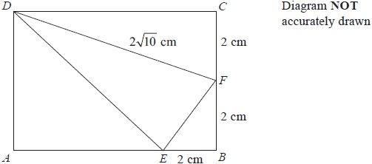

Show that the area of triangle DEF is 8 cm².
You must show all your working.

(Total for Question is 4 marks)

10. a = √8 + 2

b = √8 − 2

T = a² − b²

Work out the value of T.

Give your answer in the form c√2, where c is an integer.
...........................................................

(Total for Question is 4 marks)

11. Rationalise the denominator of $\frac{\text{10}}{\sqrt{5}}$
Give your answer in its simplest form.

...........................................................

(Total for Question is 2 marks)
12. (a) Rationalise the denominator of $\frac{\text{15}}{\sqrt{5}}$

..............................................................................................................................................
(2)

(1 + √3)² can be written in the form a + b√3, where a and b are integers.

(b) Work out the value of a and the value of b.

a = ................................................

b = ................................................
(2)
(Total for Question is 4 marks)

13. Rationalise the denominator of $\frac{(6−\sqrt{5})(6+\sqrt{5})}{\sqrt{\text{31}}}$

Give your answer in its simplest form.

..............................................................................................................................................
(Total for Question is 3 marks)

14. Rationalise the denominator $\frac{3}{\sqrt{7}}$

...............................................
(Total for Question is 2 marks)

15. (a) Rationalise the denominator of $\frac{5}{\sqrt{2}}$

..............................................................................................................................................
(2)
(b) Expand and simplify (2 + √3)² – (2 – √3)²

..............................................................................................................................................
(2)
(Total for Question is 4 marks)

16. (a) Rationalise the denominator of $\frac{\text{12}}{\sqrt{3}}$
...........................................................
(2)
(b) Work out the value of (√2 + √8)²
...........................................................
(2)
(Total for Question is 4 marks)

17. Rationalise the denominator of $\frac{(4+\sqrt{2})(4−\sqrt{2})}{\sqrt{7}}$

Give your answer in its simplest form.
...........................................................

(Total for Question is 3 marks)

18. $\frac{\sqrt{3}}{5}$ + $\frac{2}{\sqrt{3}}$ = a√3, where a is a fraction.

Find the value of a.
...........................................................

(Total for Question is 3 marks)

19. Emily buys a pack of 12 bottles of water.
The pack costs £5.64
Emily sells all 12 bottles for 50p each.
Work out Emily's percentage profit.
Give your answer correct to 1 decimal place.
........................................................... %
(Total for question is 3 marks)

20. (a) Find the value of 2⁻³
...........................................................
(1)
5√5 can be written in the form 5^{k}

(b) Find the value of k.
...........................................................
(1)
(c) Work out the value of (√12 − √3)²
...........................................................
(2)

(Total for Question is 4 marks)

21. (a) Write down the value of 10^{–1}

..............................................................................................................................................
(1)
(b) Find the value of

..............................................................................................................................................
(2)
(c) Write √75 in the form k√3, where k is an integer.

..............................................................................................................................................
(2)
(Total for Question is 5 marks)

22. (a) Write down the value of 7⁰
...........................................................
(1)
(b) Write down the value of 2⁻⁴
...........................................................
(1)
(c) Rationalise the denominator of $\frac{\text{14}}{\sqrt{7}}$

Give your answer in its simplest form.
...........................................................
(2)

(Total for Question is 4 marks)

23. (a) Write the recurring decimal $0\text{.}2\overset{˙}{5}$ as a fraction in its simplest form.

..............................................................................................................................................
(3)
(b) Rationalise the denominator of $\frac{\text{12}}{\sqrt{6}}$
Give your answer in its simplest form.

..............................................................................................................................................
(2)
(Total for Question is 5 marks)

24. Dan, Harry and Regan sell cars.

Dan sells x cars.
Harry sells 5 more cars than Dan.
Regan sells twice as many cars as Dan.

Write an expression, in terms of x, for the mean number of cars Dan, Harry and Regan sell.
...........................................................

(Total for Question is 2 marks)

25. Julie is x years old.
Kevin is x + 3 years old.
Omar is 2x years old.

Write an expression, in terms of x, for the mean of their ages.
...........................................................
(Total for Question is 2 marks)

26. Asha and Lucy are selling pencils in a school shop.
They sell boxes of pencils and single pencils.

Asha sells 7 boxes of pencils and 22 single pencils.
Lucy sells 5 boxes of pencils and 2 single pencils.
Asha sells twice as many pencils as Lucy.
Work out how many pencils there are in a box.

...........................................................

(Total for Question is 4 marks)

27. Hilary, Imogen and Jeeha are playing a game with cards.

Imogen has 3 cards more than Hilary.
Jeeha has twice as many cards as Imogen.
They have a total of 53 cards.

Work out how many cards Hilary has.
...........................................................

(Total for Question is 4 marks)

28. Here is part of an advert for a driving school.

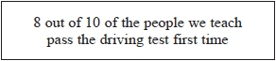

Ali talked to 56 people who had been taught to drive by the driving school.
43 of these people passed the driving test first time.

Does this support what is said in the advert?
You must show how you get your answer.

(Total for Question is 3 marks)

29. A teacher asks George to think of a number.

She then says,

“Add 10 to your number and multiply the answer by 3”

George thinks of the number 5

He writes down

What should George have written down?

(Total for Question is 2 marks)

30. Put a pair of brackets in each statement to make the statement true.

(i) 2 × 7² − 2 = 94
(1)

(ii) 16 ÷ 2 + 6 + 2 = 4
(1)

(Total for Question is 2 marks)

31. Daisy thinks of a whole number.
She multiplies the number by 3
Daisy's answer is 34

(a) Explain how you know Daisy's answer is wrong.

.............................................................................................................................................

.............................................................................................................................................
(1)
Here is a number machine.
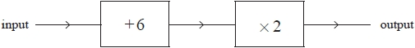

Abbie says that when the output is 36 the input is 60

Here is her working.
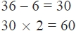

Abbie is wrong.

(b) Explain what she has done wrong.

….............................................................................................................................................

….............................................................................................................................................
(2)

(Total for Question is 3 marks)

32. Jayne writes down the following

3.4 × 5.3 = 180.2

Without doing the exact calculation, explain why Jayne's answer cannot be correct.

.............................................................................................................................................

.............................................................................................................................................

(Total for Question is 1 mark)

33. Here are two numbers.
29 37

Nadia says both of these numbers can be written as the sum of two square numbers.

Is Nadia correct?
You must show how you get your answer.

(Total for Question is 3 marks)

34. laire buys a new car for £5700

She pays a deposit of 12%
She then pays the rest of the cost in 15 equal monthly payments.

How much is each monthly payment?
£ ...........................................................
(Total for Question is 3 marks)

35. Andy flies from the UK to Japan.
His plane ticket costs £554
Andy then flies from Japan to Australia.
His plane ticket costs 70 140 Japanese Yen.
The exchange rate is £1 = 140 Japanese Yen.

Leila flies from the UK to Australia.
Her plane ticket costs 1860 Australian dollars.
The exchange rate is 1 Australian dollar = £0.62

Who pays more to fly from the UK to Australia, Andy or Leila?
You must show clearly how you get your answer.

(Total for Question is 4 marks)

36. 400 g of raspberries and 300 g of strawberries cost a total of £7.46
500 g of strawberries cost £4.10

Work out the total cost of 200 g of raspberries and 200 g of strawberries.
£ ...........................................................

(Total for Question is 4 marks)

37. Only blue vans and white vans are made in a factory.
The ratio of the number of blue vans to the number of white vans is 4 : 3

(a) Write down the fraction of vans that are blue.
...........................................................
(1)
For blue vans,

the number of small vans : the number of large vans = 3 : 5

(b) Work out the fraction of the number of vans made in the factory that are blue and large.
...........................................................
(3)

(Total for Question is 4 marks)

38. There are only red counters, blue counters and green counters in a bag.

number of red counters : number of blue counters : number of green counters = 1 : 3 : 7

A counter is going to be taken at random from the bag.

(a) Complete the table below to show each of the probabilities that the counter will be red or blue or green.

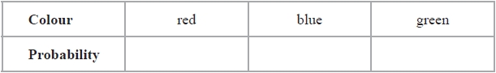
(2)

Jamie takes at random a counter from the bag and records the colour of the counter.
He then puts the counter back in the bag.
Jamie does this a number of times.
He records a total of 68 blue counters.

(b) Work out an estimate for the total number of times Jamie takes a counter from the bag.
...........................................................
(2)

(Total for Question is 4 marks)

39. Frank, Mary and Seth shared some sweets in the ratio 4 : 5 : 7
Seth got 18 more sweets than Frank.

Work out the total number of sweets they shared.
...........................................................

(Total for Question is 3 marks)

40. Michelle and Wayne have saved a total of £458 for their holiday.
Wayne saved £72 more than Michelle.

How much did Wayne save?
£ ...........................................................

(Total for Question is 2 marks)

41. Boxes of chocolates cost £3.69 each.
A shop has an offer.

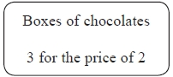

Ali has £50
He is going to get as many boxes of chocolates as possible.

How many boxes of chocolates can Ali get?
...........................................................
(Total for Question is 3 marks)

42. The densities of two different liquids A and B are in the ratio 19 : 22

The mass of 1 cm³ of liquid B is 1.1 g.

5 cm³ of liquid A is mixed with 15 cm³ of liquid B to make 20 cm³ of liquid C.

Work out the density of liquid C.

...........................................................g/cm³

(Total for Question is 4 marks)
43. On a farm

the number of cows and the number of sheep are in the ratio 6 : 5
the number of sheep and the number of pigs are in the ratio 2 : 1

The total number of cows, sheep and pigs on the farm is 189

How many sheep are there on the farm?
...........................................................

(Total for Question is 3 marks)

44. A tin of varnish costs £15

A rectangular floor has dimensions 6 m by 11 m.
The floor is going to be covered in varnish.
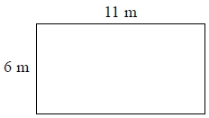
Helen assumes that each tin of this varnish covers an area of 12 m².

(a) Using Helen's assumption, work out the cost of buying the varnish for this floor.
£ ...........................................................
(4)

Helen finds that each tin of varnish covers less than 12 m².

(b) Explain how this might affect the number of tins she needs to buy.

.............................................................................................................................................

.............................................................................................................................................
(1)

(Total for Question is 5 marks)

45. A shop sells pens at different prices.
The cheapest pens in the shop cost 27p each.

Lottie buys 18 pens from the shop.
She pays with a £10 note.

(a) If Lottie buys 18 of the cheapest pens, how much change should Lottie get?
£ ...........................................................
(2)
Instead of buying the cheapest pens, Lottie buys 18 of the more expensive pens.
She still pays with a £10 note.

(b) How does this affect the amount of change she should get?

.............................................................................................................................................

.............................................................................................................................................
(1)

(Total for Question is 3 marks)

46. The diagram shows an oil tank in the shape of a prism.
The cross section of the prism is a trapezium.
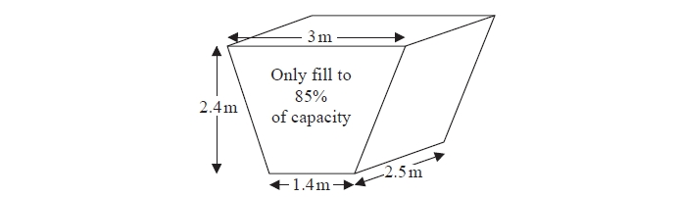

The tank is empty.

Oil flows into the tank.
After one minute there are 300 litres of oil in the tank.

Assume that oil continues to flow into the tank at this rate.

(a) Work out how many more minutes it takes for the tank to be 85% full of oil.
(1 m³ = 1000 litres)
........................................................... minutes
(5)

The assumption about the rate of flow of the oil could be wrong.

(b) Explain how this could affect your answer to part (a).

.............................................................................................................................................

.............................................................................................................................................
(1)

(Total for Question is 6 marks)

47. Here is a list of ingredients for making 20 gingerbread men.

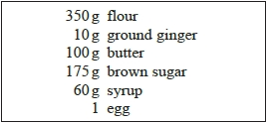
Sue has

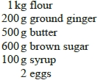

Sue wants to make 60 gingerbread men.
She has not got enough of all the ingredients.

(a) Work out how much more of each ingredient she needs.
(4)
On a different day Sue wants to make 50 gingerbread men.
She has no eggs.
She works out she needs to buy at least 3 eggs.

(b) Explain why she needs to buy at least 3 eggs.

.............................................................................................................................................

.............................................................................................................................................
(1)
(Total for Question is 5 marks)

48. The diagram shows part of a wall in the shape of a trapezium.
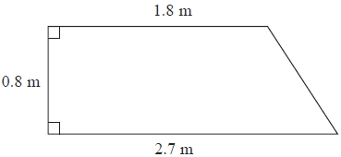
Karen is going to cover this part of the wall with tiles. Each rectangular tile is 15 cm by 7.5 cm

Tiles are sold in packs. There are 9 tiles in each pack.

Karen divides the area of the wall by the area of a tile to work out an estimate for the number of tiles she needs to buy.

(a) Use Karen's method to work out an estimate for the number of packs of tiles she needs to buy.
...........................................................
(5)
Karen is advised to buy 10% more tiles than she estimated.
Buying 10% more tiles will affect the number of the tiles Karen needs to buy.
She assumes she will need to buy 10% more packs of tiles.

(b) Is Karen's assumption correct?
You must show your working.
(2)

(Total for Question is 7 marks)
49. Jake is going to make a path from small paving stones and large paving stones.
The diagram shows Jake's design for the path.
The rest of the path is made using the same pattern of paving stones.

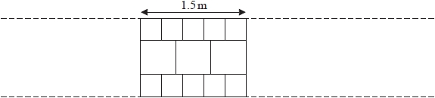

A small paving stone costs £2.30
A large paving stone costs £3.65

Jake needs to buy enough paving stones to make a path that is 6 metres long.

(a) How much will Jake have to pay for the paving stones he needs?
£ ...........................................................
(4)

Harry designs a different path that is also 6 metres long using the large paving stones.

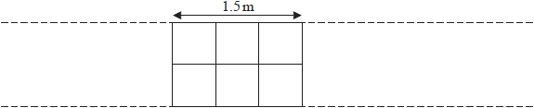

Harry says that the cost of his path will be less than half of the cost of the path that Jake designed.

(b) Is Harry correct?
You must show how you get your answer.
(2)
(Total for Question is 6 marks)

50. Here is a diagram showing a rectangle, ABCD, and a circle.
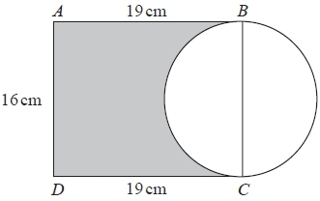
BC is a diameter of the circle.

Calculate the percentage of the area of the rectangle that is shaded.
Give your answer correct to 1 decimal place.
...........................................................%

(Total for Question is 4 marks)

51. A garden is in the shape of a rectangle, ABCD, and a semicircle.
AD is the diameter of the semicircle.

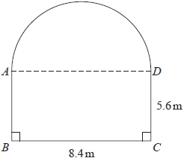

Carol is going to cover the garden with fertiliser.
A box of fertiliser costs £4.99
Carol has been told that one box of fertiliser will cover 12 m² of garden.

(a) Work out the cost of buying enough fertiliser to cover the garden completely.

£ ...........................................................
(5)

Carol finds out that one box of fertiliser will cover more than 12 m² of garden.

(b) Explain how this might affect the number of boxes she needs to buy.

.............................................................................................................................................

.............................................................................................................................................
(1)
(Total for Question is 6 marks)
52. The diagram shows a shape made by overlapping two identical squares.

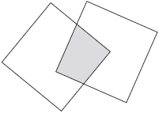

The area of the shaded region is 25% of the area of each square.
Work out what fraction of the area of the whole shape is shaded.
...........................................................

(Total for Question is 3 marks)

53. Soap powder is sold in three sizes of box.
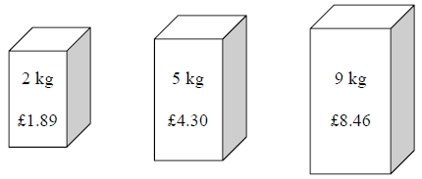
A 2 kg box of soap powder costs £1.89
A 5 kg box of soap powder costs £4.30
A 9 kg box of soap powder costs £8.46

Which size of box of soap powder is the best value for money?
You must show how you get your answer.

(Total for Question is 3 marks)

54. Ibrar buys 3kg of apples.
He also buys 0.4kg of mushrooms.
The total cost is £6.93

1kg of apples cost £1.95

Work out the cost of 1kg of mushrooms.

£ ...........................................................

(Total for Question is 3 marks)

55. Martin has 8 pints of soup in a pan.
He also has 24 soup bowls.
He puts 0.3 pints of soup into each bowl.

How much soup has Martin left over?

........................................................... pints

(Total for Question is 3 marks)
56. Jan writes down

one multiple of 9
and two different factors of 40

Jan adds together her three numbers.
Her answer is greater than 20 but less than 30

Find three numbers that Jan could have written down.

...........................................................

(Total for Question is 3 marks)

57. Amelia, Hayden and Sophie did a test.
The total for the test was 75 marks.

Amelia got 56% of the 75 marks.

Hayden got $\frac{8}{\text{15}}$ of the 75 marks..

Sophie got 43 out of 75

Who got the highest mark?
You must show all your working.

(Total for Question is 3 marks)

58.
There are 6760 people at at a rugby match.
3879 of the people are men.
1241 of the people are women.

$\frac{1}{4}$of the children are girls.

Work out how many boys are at the rugby match.

...........................................................

(Total for Question is 3 marks)

59. Ravi buys some hats to sell at a school fete.
He buys 40 hats for a total of £120

Ravi sells $\frac{3}{4}$ of these hats at £4.50 each.

He reduces the selling price of the remaining hats to £4 each.
He sells half of the remaining hats at this selling price.

Work out the profit that Ravi makes.
£ ...........................................................

(Total for Question is 5 marks)

60.


720 000 babies were born last year.

How many of these babies are expected to live to 100 years old?
...........................................................

(Total for Question is 2 marks)

61. There are 375 pupils at a school.
195 of the pupils are boys.

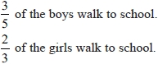

Work out how many pupils walk to school.

...........................................................

(Total for Question is 3 marks)
62. Henry is thinking of having a water meter.
These are the two ways he can pay for the water he uses.
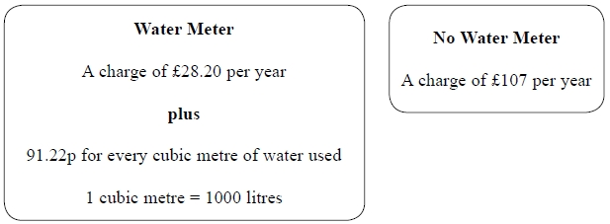
Henry uses an average of 180 litres of water each day.
Use this information to determine whether or not Henry should have a water meter.

(Total for Question is 5 marks)

63. Faiza buys

one magazine costing £2.30
one paper costing 92p
two identical bars of chocolate

Faiza pays with a £5 note.
She gets 40p change.

Work out the cost of one bar of chocolate.
...........................................................

(Total for Question is 3 marks)

64. Tracy buys

2 coffees at £1.10 each
3 teas at 95p each
5 sandwiches at £2.15 each

Tracy shares the total cost equally between 5 people.
How much does each person pay?
£ ...........................................................

(Total for Question is 4 marks)
65. Packs of batteries cost £2.85 each.
Ben has £45 to spend on batteries.
Ben buys as many packs of batteries as he can.
Work out how much change he should get from £45
£ ...........................................................

(Total for Question is 3 marks)

66. Oliver wants to buy some stickers.
He only has a £10 note.

Each packet of stickers costs £1.29
Oliver buys as many packets of stickers as possible.

(a) Work out how much change Oliver should get from the £10 note.
£ ...........................................................
(3)
Jessica also wants to buy some stickers.
There are 6 stickers in each packet.
Jessica works out that she can buy exactly 28 stickers.

(b) Is Jessica correct?
Justify your answer.

.............................................................................................................................................

.............................................................................................................................................
(1)

(Total for Question is 4 marks)

67. Buses to Ashby leave a bus station every 24 minutes.
Buses to Barford leave the same bus station every 20 minutes.
A bus to Ashby and a bus to Barford both leave the bus station at 7 30 am.

When will a bus to Ashby and a bus to Barford next leave the bus station at the same time?

...........................................................

(Total for Question is 3 marks)
68. There are 5 grams of fibre in every 100 grams of bread.
A loaf of bread has a weight of 400 g.
There are 10 slices of bread in a loaf.
Each slice of bread has the same weight.

Work out the weight of fibre in one slice of bread.
........................................................... g

(Total for Question is 3 marks)

69. Sophia pays £222 for a plane ticket.
She also pays 100 euros airport tax.

The exchange rate is £1 = 1.38 euros.

What percentage of the total cost of the ticket and the airport tax does Sophia pay for the airport tax?
Give your answer correct to 1 decimal place.

........................................................... %

(Total for Question is 3 marks)
70. In September Sharon paid £565 for some books.
She sold all the books for a total of £780

In October Sharon bought and sold some more books. The total profit she made in October was 13% greater than the total profit she made in September.

In November Sharon wants to pay a bill of £30

Sharon thinks that the 13% extra profit she made in October will be enough to pay this bill.

Is Sharon correct?
You must show all your working.

(Total for Question is 3 marks)

71. In a shop, the normal price of a coat is £65
The shop has a sale.

In week 1 of the sale, the price of the coat is reduced by 20%
In week 2 of the sale, the price of the coat is reduced by a further £10

Maria has £40

Does Maria have enough money to buy the coat in week 2 of the sale?
You must show how you get your answer.

(Total for Question is 3 marks)

72. Norma makes bags.
She makes 17 bags an hour.
Norma works for 6 hours each day, 5 days a week.

Each bag is checked.
If the bag is perfect, it is put in a box.
When there are 12 bags in a box it is full.
One week 90% of the bags Norma made were perfect.

Work out the number of boxes completely filled with bags made by Norma.
...........................................................

(Total for Question is 5 marks)

73. Here are five digits

0 1 3 5 6

Use each digit once to complete this calculation.
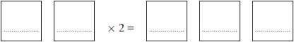

(Total for Question is 2 marks)

74. There are 25 boys and 32 girls in a club.

$\frac{2}{5}$of the boys and $\frac{1}{2}$ of the girls walk to the club.

The club leader picks at random a child from the children who walk to the club.

Work out the probability that this child is a boy.

...........................................................

(Total for Question is 3 marks)

75. On a school trip the ratio of the number of teachers to the number of students is 1 : 15
The ratio of the number of male students to the number of female students is 7 : 5

Work out what percentage of all the people on the trip are female students.
Give your answer correct to the nearest whole number.
........................................................... %

(Total for Question is 3 marks)

76. Kim, Laura and Molly share £385

The ratio of the amount of money Kim gets to the amount of money Molly gets is 2 : 5
Kim gets £105 less than Molly gets.

What percentage of the £385 does Laura get?

........................................................... %

(Total for Question is 4 marks)
77. There are 64 cards in a pack.
Each card is either red or black.
The ratio of the number of red cards to the number of black cards is 1 : 1

8 red cards are removed from the pack.

Find the ratio of the number of red cards now in the pack to the number of black cards now in the pack. Give your answer in its simplest form.
...........................................................

(Total for Question is 3 marks)

78. The ratio of the number of boys to the number of girls in a school is 4:5
There are 95 girls in the school.

Work out the total number of students in the school.
...........................................................

(Total for Question is 3 marks)
79. Jane made some almond biscuits which she sold at a fete.

She had:
5 kg of flour
3 kg of butter
2.5 kg of icing sugar
320 g of almonds

Here is the list of ingredients for making 24 almond biscuits.
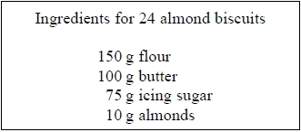
Jane made as many almond biscuits as she could, using the ingredients she had.
Work out how many almond biscuits she made.

...........................................................

(Total for Question is 3 marks)

80. Here is a list of ingredients for making chocolate mousse for 2 people.
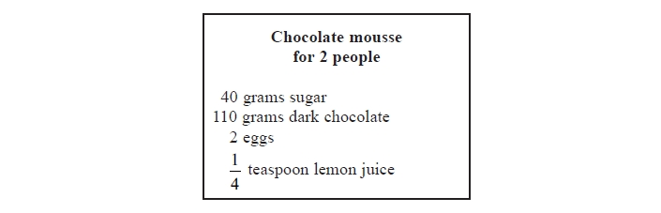
Ellie has 250 grams of sugar and 550 grams of dark chocolate.
She assumes that she has plenty of lemon juice and plenty of eggs.

(a) What is the greatest number of people Ellie can make chocolate mousse for?
You must justify your answer.

(3)

Ellie only has 6 eggs.

(b) What effect would this have on the greatest number of people Ellie can make chocolate mousse for?

............................................................................................................................................

.............................................................................................................................................
(1)
(Total for Question is 4 marks)
81. The two numbers, A and B, are shown on a scale.
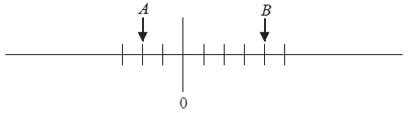
The difference between A and B is 48

Work out the value of A and the value of B.
A = ...........................................................
B = ...........................................................

(Total for Question is 3 marks)

82. A sofa has 6 identical cushions.
Each cushion is a cuboid 18 cm by 80 cm by 95 cm.

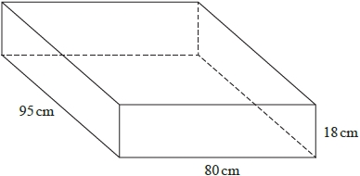

The cushions are covered with a protective spray.
The protective spray is in cans.
The label on each can has this information.

(a) Work out how many cans are needed to cover the 6 cushions with protective spray.
...........................................................
(5)

The information on each label is inaccurate.
The spray in each can covers 10% more than 4 m².

(b) How will this affect the number of cans needed for the 6 cushions?
You must show how you get your answer.

.............................................................................................................................................

.............................................................................................................................................
(2)
(Total for Question is 7 marks)
83. The diagram shows a tank in the shape of a cuboid.
It also shows a container in the shape of a cuboid.
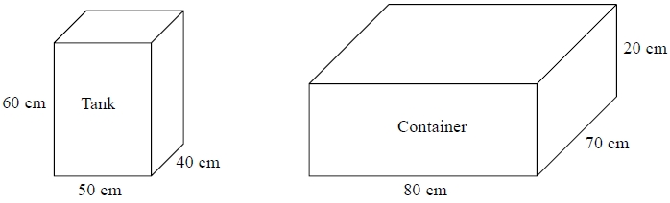

The tank is full of oil.
The container is empty.

35% of the oil from the tank is spilled.
The rest of the oil from the tank is put into the container.

Work out the height of the oil in the container. Give your answer to an appropriate degree of accuracy.

........................................................... cm
(2)
(Total for Question is 5 marks)
84. The total weight of 3 tins of beans and 4 jars of jam is 2080 g.
The total weight of 5 tins of beans is 2000 g.

Work out the weight of 1 tin of beans and the weight of 1 jar of jam.
tin of beans ........................................................... g
jar of jam ........................................................... g

(Total for Question is 4 marks)

85. Asif is going on holiday to Turkey.
The exchange rate is £1 = 3.5601 lira.

Asif changes £550 to lira.

(a) Work out how many lira he should get.
Give your answer to the nearest lira.
........................................................... lira
(2)
Asif sees a pair of shoes in Turkey.
The shoes cost 210 lira.

Asif does not have a calculator.
He uses £2 = 7 lira to work out the approximate cost of the shoes in pounds.

(b) Use £2 = 7 lira to show that the approximate cost of the shoes is £60
(2)

(c) Is using £2 = 7 lira instead of using £1 = 3.5601 lira a sensible start to Asif's method to work out the cost of the shoes in pounds? You must give a reason for your answer.

.............................................................................................................................................

.............................................................................................................................................
(1)

(Total for Question is 5 marks)

86.
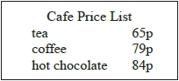

Dylan and some friends went to the cafe.
Dylan bought himself a cup of tea.
He bought each of his friends a cup of coffee.
He paid with a £10 note.
He got £4.61 change.

How many friends were with Dylan at the cafe?
...........................................................

(Total for Question is 4 marks)

87. Here are two rectangles.
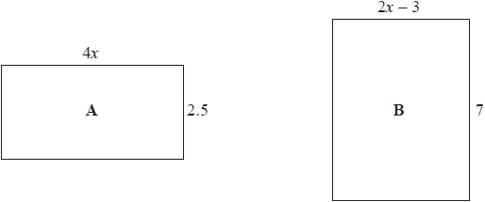

All measurements are in centimetres.
The area of rectangle A is equal to the area of rectangle B.

Work out the perimeter of rectangle B.
........................................................... cm

(Total for question is 5 marks)

88. In triangle RPQ,

RP = 8.7 cm
PQ = 5.2 cm
Angle PRQ = 32°

(a) Assuming that angle PQR is an acute angle, calculate the area of triangle RPQ.
Give your answer correct to 3 significant figures.
...........................................................cm²
(4)

(b) If you did not know that angle PQR is an acute angle, what effect would this have on your calculation of the area of triangle RPQ?

.............................................................................................................................................

.............................................................................................................................................

.............................................................................................................................................
(1)

(Total for question is 5 marks)

89.

a is 8.3 cm correct to the nearest mm
b is 6.1 cm correct to the nearest mm

Calculate the upper bound for c.
You must show your working.
........................................................... cm

(Total for question = 4 marks)

90. There are only blue counters, green counters, red counters and yellow counters in a bag.
Olga is going to take at random a counter from the bag.

The table shows the probability that Olga will take a blue counter and the probability that she will take a yellow counter.

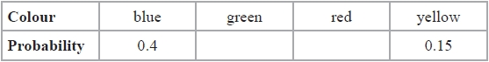

The number of red counters in the bag is 4 times the number of green counters in the bag.
Complete the table.

(Total for question is 3 marks)

91. Eric and Geraldine both drove from town A to town B.

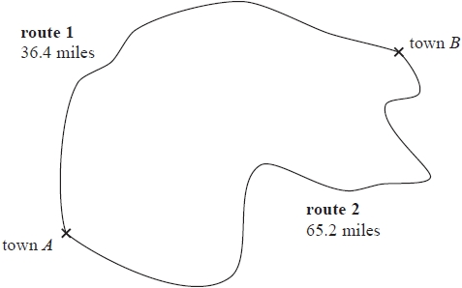

Both Eric and Geraldine left town A at 2 pm.
Eric drove on route 1
He got to town B at 2 48 pm.

Geraldine drove on route 2
She got to town B at 3 25 pm.
Who drove at the greater average speed?
You must show all your working.

(Total for question is 3 marks)

92. Redlands School sent x students to a revision day.
St Samuel's School sent twice as many students as Redlands School.
Francis Long School sent 7 fewer students than Redlands School.
Each student paid £15 for the revision day.
The students paid a total of £1155

Work out how many students were sent by each school to the revision day.
You must show all your working.

(Total for question is 5 marks)

93. There are y black socks and 5 white socks in a drawer.
Joshua takes at random two socks from the drawer.
The probability that Joshua takes one white sock and one black sock is $\frac{6}{\text{11}}$

(a) Show that 3y² – 28y + 60 = 0
(4)

(b) Find the probability that Joshua takes two black socks.

...........................................................
(3)

(Total for question is 7 marks)

94. The population of a city increased by 5.2% for the year 2014

At the beginning of 2015 the population of the city was 1560 000
Lin assumes that the population will continue to increase at a constant rate of 5.2% each year.

(a) Use Lin's assumption to estimate the population of the city at the beginning of 2017
Give your answer correct to 3 significant figures.
...........................................................
(3)

(b) (i) Use Lin's assumption to work out the year in which the population of the city will
reach 2 000 000
...........................................................

(ii) If Lin's assumption about the rate of increase of the population is too low, how might this affect your answer to (b)(i)?

.............................................................................................................................................

.............................................................................................................................................

.............................................................................................................................................
(3)

(Total for question is marks)

95.
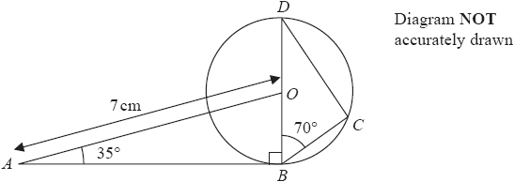

B, C and D are points on the circumference of a circle, centre O.
BOD is a diameter of the circle.

(a) Explain why angle BCD is 90°

.............................................................................................................................................

.............................................................................................................................................
(1)

(b) Calculate the length of BC.
Give your answer correct to 3 significant figures.
.......................................................... cm
(4)

(Total for question is 5 marks)

96. The diagram shows a trapezium ABCD and two identical semicircles.
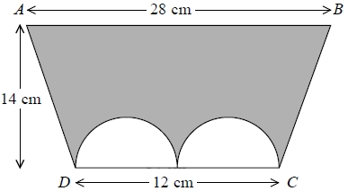
The centre of each semicircle is on DC.

Work out the area of the shaded region.
Give your answer correct to 3 significant figures.

........................................................... cm²

(Total for question is 4 marks)

97. The diagram shows a regular pentagon ABCDE.
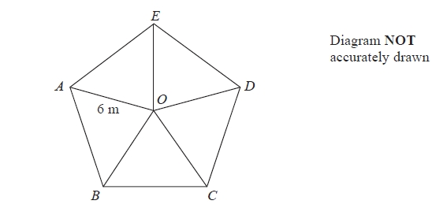
The pentagon is divided into 5 isosceles triangles.
OA = OB = OC = OD = OE = 6 m

Work out the area of the pentagon.
Give your answer correct to 1 decimal place.

........................................................... m²

(Total for question is 4 marks)

98. The diagram shows a solid triangular prism.
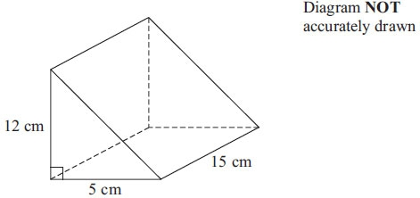

The prism is made from metal.
The density of the metal is 6.6 grams per cm³.

Calculate the mass of the prism.

.............................................................
(Total for Question is 3 marks)

99. Here is a sketch of part of the graph of y = pq^{x} where q > 0.

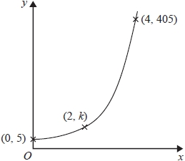

The points (0, 5), (2, k) and (4, 405) are all on the graph of y = pq^{x}

Find the value of k.

...........................................................

(Total for question is 4 marks)

