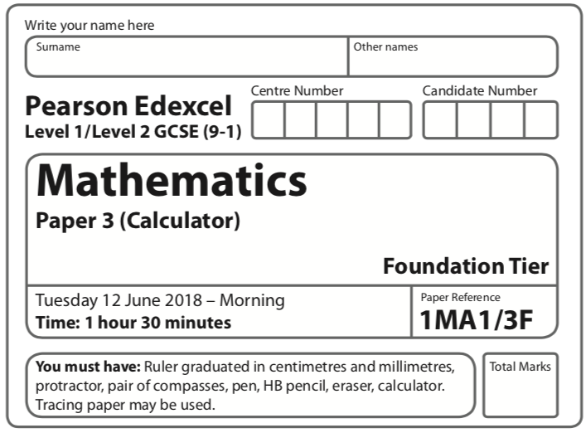
Aiming for 4
Summer 2019 Practice Paper

Instructions
- Use black ink or ball-point pen.
  - Fill in the boxes at the top of this page with your name,
centre number and candidate number.
- Answer all questions.
- Answer the questions in the spaces provided
– there may be more space than you need.
- You must show all your working.
- Diagrams are NOT accurately drawn, unless otherwise indicated.
- Calculators may be used.
- If your calculator does not have a π button, take the value of π to be 3.142
unless the question instructs otherwise.
Information
- The total mark for this paper is 80. There are 39 questions.
- Questions have been arranged in an ascending order of mean difficulty, as found by Grade 4 students in the June 2017 and November 2018 examinations
- The marks for each question are shown in brackets
– use this as a guide as to how much time to spend on each question.
Advice
- Read each question carefully before you start to answer it.
- Keep an eye on the time.
- Try to answer every question.
- Check your answers if you have time at the end.
Answer ALL questions.

Write your answers in the spaces provided.

You must write down all the stages in your working.

1 Find

.......................................................
(Total for Question 1 is 1 mark)
____________________________________________________________________________

2 Write a number in the box to make the calculation correct.

56.3 + = 100
(Total for Question 2 is 1 mark)
____________________________________________________________________________

3 Priti is going to have a meal.
She can choose one starter and one main course from the menu.

Menu
Starter | Main Course
Salad | Pasta
Fish | Rice
Melon | Burger

Write down all the possible combinations Priti can choose.

......................................................................................................................................................

......................................................................................................................................................

......................................................................................................................................................

(Total for Question 3 is 2 marks)
____________________________________________________________________________

4 The table shows the lengths of five rivers.

River | Length (km)
Trent | 297
Don | 112
Severn | 354
Thames | 346
Mersey | 113

Write down the rivers in order of length.
Start with the shortest river.

........................................................................................................................................................

.......................................................................................................................................................
(Total for Question 4 is 1 mark)
____________________________________________________________________________

5 On the grid, reflect the shaded shape in the mirror line.

(Total for Question 5 is 1 mark)
____________________________________________________________________________

6 2 pens cost £2.38
5 folders cost £5.60
Ben wants to buy 20 pens and 20 folders.
He only has £50
Does Ben have enough money to buy 20 pens and 20 folders?
You must show how you get your answer.

(Total for Question 6 is 4 marks)
____________________________________________________________________________

7 T = 4v + 3

Work out the value of T when v = 2

T = .......................................................
(Total for Question 7 is 2 marks)
____________________________________________________________________________

8 Annie sold
45 books at £1.20 each
34 candles at £1.50 each
some calendars at 90p each
She got a total of £150
Work out how many calendars Annie sold.

.......................................................
(Total for Question 8 is 4 marks)
____________________________________________________________________________

9 An ordinary fair dice is thrown once.
On the probability scale below, mark with a cross (×) the probability that the dice lands on an odd number.

(Total for Question 9 is 1 mark)
____________________________________________________________________________

10 Work out of 720

.......................................................
(Total for Question 10 is 1 mark)
____________________________________________________________________________

11 Here is a list of numbers.

12 | 15 | 14 | 17 | 22 | 19 | 13

Bridgit says,
“To work out the median you find the middle number, so the median of these numbers is 17”

Bridgit’s answer is not correct.
What is wrong with Bridgit’s method?

......................................................................................................................................................

......................................................................................................................................................
(Total for Question 11 is 1 mark)
____________________________________________________________________________

12 Joanne wants to buy a dishwasher.
The dishwasher costs £372.
Joanne will pay a deposit of £36.
She will then pay the rest of the cost in 4 equal monthly payments.
How much is each monthly payment?

£.......................................................
(Total for Question 12 is 2 marks)
____________________________________________________________________________

13 Here is a 4-sided spinner.

The table shows the probabilities that when the spinner is spun it will land on 1, on 3 and on 4

Number | 1 | 2 | 3 | 4
Probability | 0.2 |  | 0.4 | 0.1

The spinner is spun once.
Work out the probability that the spinner will land on 2

.......................................................
(Total for Question 13 is 1 mark)
____________________________________________________________________________

14 The table shows the lengths of five rivers.

River | Length (km)
Trent | 297
Don | 112
Severn | 354
Thames | 346
Mersey | 113

Ami says,
“The River Thames is more than three times as long as the River Don.”
(b) Show that Ami is correct.

......................................................................................................................................................

......................................................................................................................................................
(Total for Question 14 is 1 mark)
____________________________________________________________________________

15 Here is a list of numbers.

12 | 15 | 14 | 17 | 22 | 19 | 13

(a) Work out the range of the numbers in the list.

.......................................................
(2)
(b) Work out the mean of the numbers in the list.

.......................................................
(2)
(Total for Question 15 is 4 marks)
____________________________________________________________________________
16 The diagram shows five shapes on a centimetre grid.

Two of the shapes are congruent.
Write down the letters of these two shapes.

............................ and ............................
(Total for Question 16 is 1 mark)
____________________________________________________________________________

17 Complete the table of values for

x | 0.5 | 1 | 1.5 | 2 | 3 | 4 | 5 | 6
y |  | 6 |  | 3 |  | 1.5

(Total for Question 17 is 2 marks)
____________________________________________________________________________
18 A path is made of white tiles and grey tiles.
There is a total of 56 tiles.
Work out the number of grey tiles.

.......................................................
(Total for Question 18 is 2 marks)
____________________________________________________________________________

19 Trevor buys a boat.
The cost of the boat is £14 200 plus VAT at 20%
Trevor pays a deposit of £5000
He pays the rest of the cost in 10 equal payments.
Work out the amount of each of the 10 payments.

£ .......................................................
(Total for Question 19 is 4 marks)
____________________________________________________________________________
20 Here are four digits.

5 | 6 | 1 | 9

(i) Write down the smallest possible two digit number that can be made with two of the digits.

.......................................................
(1)
(ii) Write down the three digit number closest to 200 that can be made with three of the digits.

.......................................................
(1)
(Total for Question 20 is 2 marks)
____________________________________________________________________________

21 Here is a 4-sided spinner.

The table shows the probabilities that when the spinner is spun it will land on 1, on 3 and on 4

Number | 1 | 2 | 3 | 4
Probability | 0.2 |  | 0.4 | 0.1

The spinner is spun once.
Which number is the spinner least likely to land on?

.......................................................
(Total for Question 21 is 1 mark)
____________________________________________________________________________

22 Write a number in the box to make the calculation correct.
+ = 1

(Total for Question 22 is 1 mark)
____________________________________________________________________________

23 Joan asked each of 60 people to name their favourite vegetable.
Here are her results.

Vegetable | Frequency
Peas | 24
Carrots | 16
Mushrooms | 20

Draw an accurate pie chart for her results.

(Total for Question 23 is 3 marks)
____________________________________________________________________________

24 Write down the ratio of 450 grams to 15 grams.
Give your answer in its simplest form.

.......................................................
(Total for Question 24 is 2 marks)
____________________________________________________________________________

25 10x + 6 = 18

Find the value of x.

x = .......................................................
(Total for Question 25 is 2 marks)
____________________________________________________________________________

26 An ordinary fair dice is thrown once.
Write down the probability that the dice lands on a number greater than 4

.......................................................
(Total for Question 26 is 1 mark)
____________________________________________________________________________

27 Here is a 3-D shape.
(a) Write down the name of this 3-D shape.

.......................................................
(1)
(b) Write down the number of edges of this 3-D shape.

.......................................................
(1)
(Total for Question 27 is 2 marks)
____________________________________________________________________________

28 Write 3% as a fraction.

.......................................................
(Total for Question 28 is 1 mark)
____________________________________________________________________________

29 Work out $\frac{\sqrt{\text{17}+4^{2}}}{7\text{.}3^{2}}$
Write down all the figures on your calculator display.

.......................................................
(Total for Question 29 is 2 marks)
____________________________________________________________________________

30 David is a cleaner.
The table shows information about the time it will take him to clean each of four rooms
in a house.

Room | Time
Kitchen | 2 hours
Sitting room | 1 hour 40 minutes
Bedroom | hours
Bathroom | 45 minutes

David wants to clean all four rooms in one day.
He will have breaks for a total time of 75 minutes.
David is going to start cleaning at 9 a.m.
Will he finish cleaning by 4 p.m.?
You must show all your working.

(Total for Question 30 is 3 marks)
____________________________________________________________________________

31 Shaun is 1.88 m tall.
David is 6 cm taller than Shaun.
How tall is David?

.......................................................
(Total for Question 31 is 2 marks)
____________________________________________________________________________

32 Here is a 4-sided spinner.

The table shows the probabilities that when the spinner is spun it will land on 1, on 3 and on 4

Number | 1 | 2 | 3 | 4
Probability | 0.2 |  | 0.4 | 0.1

Jake is going to spin the spinner 60 times.
Work out an estimate for the number of times the spinner will land on 1

.......................................................
(Total for Question 32 is 2 marks)
____________________________________________________________________________

33 3 < y ≤ 7 where y is an integer.

Write down all the possible values of y.

.....................................................................................
(Total for Question 33 is 2 marks)
____________________________________________________________________________

34 Andy went on holiday to Canada.
His flights cost a total of £1500.
Andy stayed for 14 nights.
His hotel room cost $196 per night.
Andy used wifi for 12 days.
Wifi cost $5 per day.
The exchange rate was $1.90 to £1.

Work out the total cost of the flights, the hotel room and wifi.
Give your answer in pounds.

£ .......................................................
(Total for Question 34 is 5 marks)
____________________________________________________________________________
35 Daniel bakes 420 cakes.
He bakes only vanilla cakes, banana cakes, lemon cakes and chocolate cakes.
of the cakes are vanilla cakes.
35% of the cakes are banana cakes.
The ratio of the number of lemon cakes to the number of chocolate cakes is 4:5
Work out the number of lemon cakes Daniel bakes.

.......................................................
(Total for Question 35 is 5 marks)
____________________________________________________________________________

36 A path is made of white tiles and grey tiles.
of the tiles are white.
Write down the ratio of white tiles to grey tiles.

.......................................................
(Total for Question 36 is 1 mark)
____________________________________________________________________________

37 of a number is 32.
Find the number.

.......................................................
(Total for Question 37 is 2 marks)
____________________________________________________________________________

38 Bert has 100 cards.
There is a whole number from 1 to 100 on each card.
No cards have the same number.
Bert puts a star on every card that has a multiple of 3 on it.
He puts a circle on every card that has a multiple of 5 on it.
Work out how many cards have both a star and a circle on them.

.......................................................
(Total for Question 38 is 3 marks)
____________________________________________________________________________

39 On the grid below, draw the graph of for values of x from 0.5 to 6.

(Total for Question 39 is 2 marks)

TOTAL FOR PAPER IS 80 MARKS

