GCSE Mathematics (1MA1) – Aiming for 4: Paper 2F

Summer 2019: Student-friendly mark scheme

Please note that this mark scheme is not the one used by examiners for making scripts. It is intended more as a guide to good practice, indicating where marks are given for correct answers. As such, it doesn’t show follow-through marks (marks that are awarded despite errors being made) or special cases.

It should also be noted that for many questions, there may be alternative methods of finding correct solutions that are not shown here – they will be covered in the formal mark scheme.

NOTES ON MARKING PRINCIPLES

Guidance on the use of codes within this mark scheme

M1 – method mark. This mark is generally given for an appropriate method in the context of the question. This mark is given for showing your working and may be awarded even if working is incorrect.

P1 – process mark. This mark is generally given for setting up an appropriate process to find a solution in the context of the question.

A1 – accuracy mark. This mark is generally given for a correct answer following correct working.

B1 – working mark. This mark is usually given when working and the answer cannot easily be separated.

C1 – communication mark. This mark is given for explaining your answer or giving a conclusion in context supported by your working.

Some questions require all working to be shown; in such questions, no marks will be given for an answer with no working (even if it is a correct answer).

Question 1 (Total 5 marks)
Part | Working or answer an examiner might expect to see | Mark | Notes
(a) | Walk | B1 | This mark is given for the correct answer only
(b) | 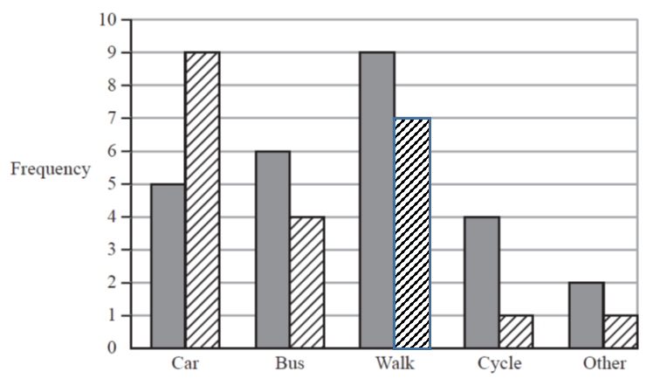 | B1 | This mark is given for a bar of height 7 drawn for girls walking
(c) | (5 + 9) – (6 + 4) = 14 – 10 = 4 | B1 | This mark is given for the correct answer only
(d) | (5 + 9) + (6 + 4) + (9 + 7) + (4 + 1) + (2 + 1) = 48  or  14 + 10 + 16 + 5 + 3 = 48 | M1 | This mark is given for a method to find the number of Year 6 students in the survey
(d) | 48 × 2 = 96 | A1 | This mark is given for the correct answer only

Question 2 (Total 3 marks)
Part | Working or answer an examiner might expect to see | Mark | Notes
 | 24 | B1 | This mark is given for the correct answer only

Question 3 (Total 1 mark)
Part | Working or answer an examiner might expect to see | Mark | Notes
 | $$\frac{\text{31}}{\text{100}}$$ | B1 | This mark is given for the correct answer (or an equivalent fraction)

Question 4 (Total 1 mark)
Part | Working or answer an examiner might expect to see | Mark | Notes
 | There is a difference in tally marks (11) and frequency (12) for Monday | C1 | This mark is given for a correct comment

Question 5 (Total 3 marks)
Part | Working or answer an examiner might expect to see | Mark | Notes
 | $\frac{\text{30}}{\text{100}}$ × 80 = 24 | M1 | This mark is given for a method to calculate Adam’s bonus
 | 28 – 24 | M1 | This mark is given for a method to find the difference between Adam’s and Katy’s bonus
 | 4 | A1 | This mark is given for the correct answer only

Question 6 (Total 2 marks)
Part | Working an or answer examiner might expect to see | Mark | Notes
 | 49 – 20 = 29 | P1 | This mark is given for  $\frac{\text{29}}{a}$ where a > 29 or $\frac{b}{\text{49}}$ where b < 49
 | $$\frac{\text{29}}{\text{49}}$$ | A1 | This mark is given for the correct answer (or equivalent fraction)

Question 7 (Total 3 marks)
Part | Working or answer an examiner might expect to see | Mark | Notes
 | 25 | B1 | This mark is given for the correct answer only

Question 8 (Total 2 marks)
Part | Working or answer an examiner might expect to see | Mark | Notes
 | $\frac{2}{5}$ = $\frac{\text{12}}{\text{30}}$, $\frac{\text{11}}{\text{30}}$, $\frac{1}{2}$ = $\frac{\text{15}}{\text{30}}$, $\frac{7}{\text{15}}$ = $\frac{\text{14}}{\text{30}}$  or  $\frac{2}{5}$ = 0.4, $\frac{\text{11}}{\text{30}}$ = 0.3666…,  $\frac{1}{2}$ = 0.5, $\frac{7}{\text{15}}$ = 0.4666… | M1 | This mark is given for converting fractions to a common form; for example, fractions with a denominator of 30 or decimals
 | $\frac{\text{11}}{\text{30}}$, $\frac{2}{5}$, $\frac{7}{\text{15}}$, $\frac{1}{2}$ | A1 | This mark is given for writing the fractions in the correct order, starting from the smallest
Question 9 (Total 3 marks)
Part | Working or answer an examiner might expect to see | Mark | Notes
 | Cement: 10 bags × 25 kg = 250 kg  Sand: 20 bags × 22.5 kg = 4500 kg  Stone: 20 bags × 50 kg = 1000 kg | P1 | This mark is given for working out what Adrian already has
 | 80 kg of stone needed | P1 | This mark is given for working out what Adrian still needs
 | Two bags of stone | C1 | This mark is given for a correct conclusion supported by working

Question 10 (Total 3 marks)
Part | Working or answer an examiner might expect to see | Mark | Notes
(a) | 8 × 5 – 2 = 38 | B1 | This mark is given for the correct answer only
(b) | input × 5 – 2 = 28  (28 + 2) ÷ 5 | M1 | This mark is given for a method to find the input
(b) | 6 | A1 | This mark is given for the correct answer only

Question 11 (Total 4 marks)
Part | Working or answer an examiner might expect to see | Mark | Notes
 | 1H, 2H, 3H, 4H, 5H, 6H  1T, 2T, 3T, 4T, 5T, 6T | B2 | This mark is given for a full and correct set of outcomes  (B1 is given for at least six correct)

Question 12 (Total 1 mark)
Part | Working or answer an examiner might expect to see | Mark | Notes
 | 2m³ | B1 | This mark is given for the correct answer only

Question 13 (Total 1 mark)
Part | Working or answer an examiner might expect to see | Mark | Notes
 | 34 200 | B1 | This mark is given for the correct answer only

Question 14 (Total 2 marks)
Part | Working or answer an examiner might expect to see | Mark | Notes
 | 14 × 18.8 | M1 | This mark is given for a method to find the real distance
 | 263.2 | A1 | This mark is given for the correct answer only

Question 15 (Total 1 mark)
Part | Working or answer an examiner might expect to see | Mark | Notes
 | 4m | B1 | This mark is given for the correct answer only

Question 16 (Total 1 mark)
Part | Working or answer an examiner might expect to see | Mark | Notes
 | 0.47 | B1 | This mark is given for the correct answer only

Question 17 (Total 4 marks)
Part | Working or answer an examiner might expect to see | Mark | Notes
 | 3x – 12 = 12  3x = 24 | M1 | This mark is given for a method to solve the equation
 | 8 | A1 | This mark is given for the correct answer only

Question 18 (Total 1 mark)
Part | Working or answer an examiner might expect to see | Mark | Notes
 | An extra picture is needed for Tuesday (it shows 15 televisions, not 18 televisions)  or  7.5 televisions shown for Wednesday is not possible | C1 | This mark is given for a correct comment

Question 19 (Total 1 mark)
Part | Working or answer an examiner might expect to see | Mark | Notes
 | 8np | B1 | This mark is given for the correct answer only

Question 20 (Total 1 mark)
Part | Working an or answer examiner might expect to see | Mark | Notes
 | 29 (inches) | B1 | This mark is given for an answer in the range 29 to 30

Question 21 (Total 1 mark)
Part | Working or answer an examiner might expect to see | Mark | Notes
 | For example 9, 25, 49, 81… | B1 | This mark is given for a correct odd square number

Question 22 (Total 2 marks)
Part | Working or answer an examiner might expect to see | Mark | Notes
 | For example,  0.75, 0.7142…, 0.76, 0.73333…. | M1 | This mark is given for at least three fractions in order or fractions converted into decimals
 | $\frac{5}{7}$, $\frac{\text{11}}{\text{15}}$, $\frac{3}{4}$, $\frac{\text{19}}{\text{25}}$ | A1 | This mark is given for a correct answer only

Question 23 (Total 2 marks)
Part | Working or answer an examiner might expect to see | Mark | Notes
(a) | 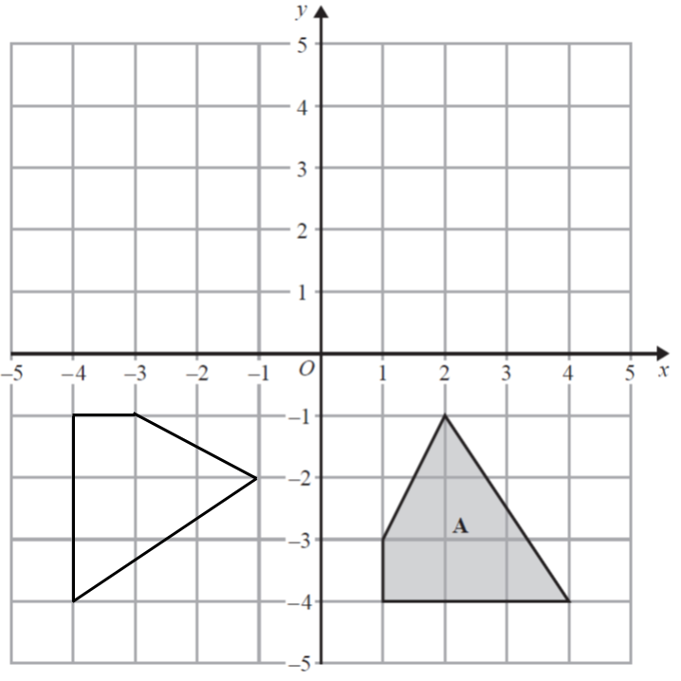 | B2 | These two marks are given for a fully correct rotation with vertices at (–4,–1), (–3,–1), (–4,–4), (–1,–2)  (One mark is given for the quadrilateral in correct orientation and size or rotated 90º anticlockwise about the origin)

Question 24 (Total 2 marks)
Part | Working or answer an examiner might expect to see | Mark | Notes
 | $$\frac{3\text{.}\text{4496376}}{\text{47}\text{.}\text{0596}}$$ | M1 | This mark is given for a correct numerator or a correct denominator
 | 0.0733035 | A1 | This mark is given for a correct answer only

Question 25 (Total 1 mark)
Part | Working or answer an examiner might expect to see | Mark | Notes
 | 1 – 0.015 = 0.985 | B1 | This mark is given for the correct answer only

Question 26 (Total 4 marks)
Part | Working or answer an examiner might expect to see | Mark | Notes
 | Letters2send: 150 ÷ 25 = 6  Stationery World: 150 ÷ 10 = 15, so only 10 packs to be paid for | P1 | This mark is given for the start of a process to find comparable costs at each shop
 | Letters2send:  6 × 3.49 = 20.94 | P1 | This mark is given for a process to find the cost of envelopes from Letters2send
 | Stationery World:  10 × 2.10 = 21.00 | P1 | This mark is given for a process to find the cost of envelopes from Stationery World
 | Suha should buy envelopes from Letters2send | C1 | This mark is given for a correct conclusion with correct supporting values

Question 27 (Total 1 mark)
Part | Working or answer an examiner might expect to see | Mark | Notes
 | No; the probability is the same for each number. | C1 | This mark is given for a correct statement

Question 28 (Total 4 marks)
Part | Working or answer an examiner might expect to see | Mark | Notes
 | 495 ÷ 3 = 165 | P1 | This mark is given for a process find the value of the £1 coins
 | 124 × 0.50 = 62 | P1 | This mark is given for a process to find the value of the 50p coins
 | 495 – 165 – 124 = 206  206 × 0.20 = 41.20 | P1 | This mark is given for a process to find the value of the 20p coins
 | 165 + 62 + 41.20 = 268.20 | A1 | This mark is given for the correct answer only

Question 29 (Total 1 mark)
Part | Working or answer an examiner might expect to see | Mark | Notes
 | 40 | B1 | This mark is given for the correct answer only

Question 30 (Total 2 marks)
Part | Working or answer an examiner might expect to see | Mark | Notes
 | –4c or 6d | M1 | This mark is given for a method to collect c or d terms
 | 10 – 4c + 6d | A1 | This mark is given for the correct answer only

Question 31 (Total 3 marks)
Part | Working or answer an examiner might expect to see | Mark | Notes
 | $\frac{1}{2}$ × 16 × 9 = 72 | M1 | This mark is given for finding the area of the triangle
 | 72 × 5 = 360 | M1 | This mark is given for finding the area of the parallelogram
 | h = 360 ÷ 30  = 12 | A1 | This mark is given for the correct answer only

Question 32 (Total 4 marks)
Part | Working an or answer examiner might expect to see | Mark | Notes
(a) |  | C4 | Four marks are given for a fully correct Venn diagram  (3 marks for at least 6 numbers in the correct position)  (2 marks for at least 4 numbers in the correct position)  (1 mark for at least 2 numbers in the correct position)

Question 33 (Total 3 marks)
Part | Working an or answer examiner might expect to see | Mark | Notes
 | 90 + 2x + 3x = 360 | M1 | This mark is given for a method to form an equation
 | 2x + 3x = 360 – 90  5x = 270 | M1 | This mark is given for a method to solve the equation formed
 | 54 | A1 | This mark is given for the correct answer only

Question 34 (Total 2 marks)
Part | Working or answer an examiner might expect to see | Mark | Notes
 | $\frac{2\text{.}3×6\text{.}7}{5}$ × $\frac{{\text{10}}^{4}×{\text{10}}^{3}}{{\text{10}}^{−8}}$ | M1 | This mark is given for a method to work out the calculation
 | 3.082 × 10¹⁵ | A1 | This mark is given for any number equal to 3.082 × 10¹⁵

Question 35 (Total 2 marks)
Part | Working or answer an examiner might expect to see | Mark | Notes
 | 4560 ÷ 1000 = 4.56 | B1 | This mark is given for the correct answer only

Question 36 (Total 2 marks)
Part | Working or answer an examiner might expect to see | Mark | Notes
 | Bill has increased 150 by 30% rather than 3%. He should have used 1.03, not 1.3 | B1 | This mark is given for a correct explanation

Question 37 (Total 3 mark)
Part | Working an or answer examiner might expect to see | Mark | Notes
 | 6 feet 3 inches = (6 × 12) + 3 = 75 inches | M1 | This mark is given for finding 6 ft 3 inches in inches
 | 25 inches = 63 cm | M1 | This mark is given for finding a method to convert to cm
 | 75 inches = 189 cm | A1 | This mark is given for an answer in the range 186 to 195

Question 38 (Total 2 marks)
Part | Working or answer an examiner might expect to see | Mark | Notes
 | 7, 11  or  8, 16 | B1 | This mark is given for two correct numbers
 | Add one more each time  or  Double the number each time | C1 | This mark is given for a correct explanation

Question 39 (Total 2 marks)
Part | Working or answer an examiner might expect to see | Mark | Notes
 | √81 = 9 | P1 | This mark is given to find the length of the side of the square
 | 9 × 4 = 36 | A1 | This mark is given for the correct answer only

Question 40 (Total 4 marks)
Part | Working or answer an examiner might expect to see | Mark | Notes
 | Side elevation  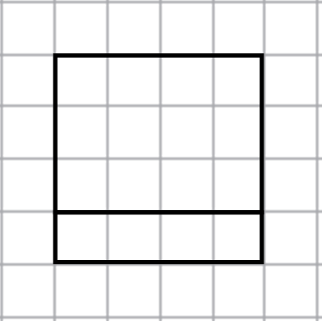 | C2 | These two marks are given for a side elevation (4 cm by 2 cm rectangle with a solid line drawn 1 cm from the 2 cm edge, and correct orientation)  (One mark is given for the side elevation drawn as a rectangle)
 | Front elevation  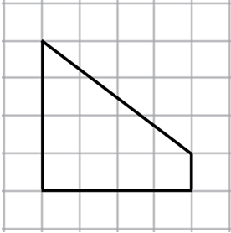 | C2 | These two marks are given for a front elevation as a trapezium in correct orientation with base 4 cm, parallel sides 1 cm and 4 cm  (One mark is given for the front elevation as a trapezium with two right angles)

Suggested Grade Boundaries for Aiming for 4: Paper 2F
Grade | 5 | 4 | 3 | 2 | 1
Mark | 68 | 60 | 49 | 36 | 21

For example:
A student aiming for Grade 4 would be expected to score at least 60 marks on this practice paper.

