GCSE Mathematics
Practice Tests: Set 7
Paper 2F (Calculator)
Time: 1 hour 30 minutes
You should have: Ruler graduated in centimetres and millimetres, protractor, pair of compasses, pen, HB pencil, eraser, calculator. Tracing paper may be used.

Instructions
- Use black ink or ball-point pen.
- Fill in the boxes at the top of this page with your name,
centre number and candidate number.
- Answer all questions.
- Answer the questions in the spaces provided
– there may be more space than you need.
- Calculators may be used.
- Diagrams are NOT accurately drawn, unless otherwise indicated.
- You must show all your working out.

Information
- The total mark for this paper is 80
- The marks for each question are shown in brackets
– use this as a guide as to how much time to spend on each question.

Advice
- Read each question carefully before you start to answer it.
- Keep an eye on the time.
- Try to answer every question.
- Check your answers if you have time at the end.

Answer ALL questions.

Write your answers in the spaces provided.

You must write down all the stages in your working.

- $\frac{5}{8}$ of the people at a swimming club are girls.
The rest of the members are boys.
What fraction of the members are boys?

.......................................................
(Total for Question 1 is 1 mark)
___________________________________________________________________________

2. Change 5.5 metres into centimetres.

....................................................... metres
(Total for Question 2 is 1 mark)
___________________________________________________________________________

3. Here is a list of fractions.
One of these fractions is not equivalent to
Which fraction?

.......................................................
(Total for Question 3 is 1 mark)
___________________________________________________________________________

4. Write down an even cube number.

.......................................................°C
(Total for Question 4 is 1 mark)
___________________________________________________________________________

5. 1 kg = 2.2 pounds
Change 44 pounds to kg.

....................................................... kg
(Total for Question 5 is 2 marks)
___________________________________________________________________________

6. There are blue counters and green counters in a bag.
The ratio of blue to green counters is 1:6.
Write down the fraction of blue counters in the bag.

.......................................................
(Total for Question 6 is 1 mark)
___________________________________________________________________________

7. The diagram shows the positions of White Tor and Gilly Tor on a map.

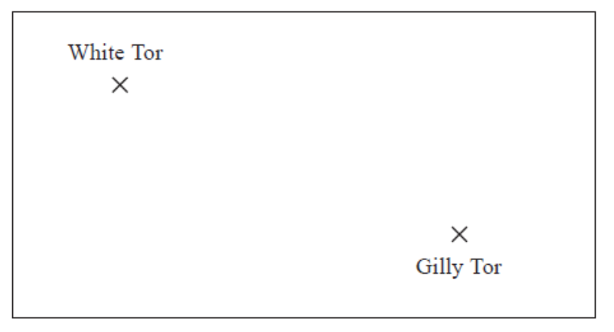
The scale of the map is 1 centimetre represents 2.5 kilometres.
Work out the real distance between White Tor and Gilly Tor.

...........................................................kilometres

(Total for Question 7 is 2 marks)
___________________________________________________________________________

8. Here are the first four terms in a number sequence.

5 8 11 14
Kasey thinks that the number 34 is in this sequence.
Is Kasey correct?
You must show how you get your answer.

(Total for Question 8 is 3 marks)
___________________________________________________________________________

9. Ursula is planning a party for 120 children.
She is going to give every child a toy.

A pack of 8 toys costs £4.35

Work out how much Uzma will have to pay for the toys.

£.......................................................
(Total for Question 9 is 3 marks)
___________________________________________________________________________

10. A bowl contains

1 apple
1 banana
1 orange
and 1 peach

Jess takes 2 pieces of fruit from the bowl.

Write down all the possible combinations of fruit that Jess can take.

......................................................................................................................................................

......................................................................................................................................................

......................................................................................................................................................
(Total for Question 10 is 2 marks)
___________________________________________________________________________

11. There are 500 passengers on a train.
of the passengers are men.
40% of the passengers are women.
The rest of the passengers are children.

Work out the number of children on the train.

.......................................................
(Total for Question 11 is 3 marks)
___________________________________________________________________________

12.

Tom says,
“ABC cannot be a straight line.”

Explain why Tom is correct.

......................................................................................................................................................

......................................................................................................................................................
(Total for Question 12 is 2 marks)
___________________________________________________________________________

13. Bhavin buys a car in a sale.

Before the sale, the cost of the car was £6720
In the sale, the cost of every car is reduced by 20%.

Bhavin pays a deposit of £1500
He will pay the rest of the cost in 24 equal monthly payments.

Work out the amount of each monthly payment.
You must show all your working.

£ ...........................................................
(Total for Question 13 is 3 marks)
___________________________________________________________________________

14. Here is a rectangle.
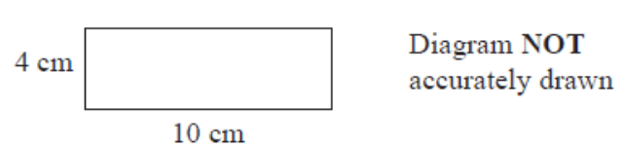
The 12-sided shape below is made from 4 of these rectangles.
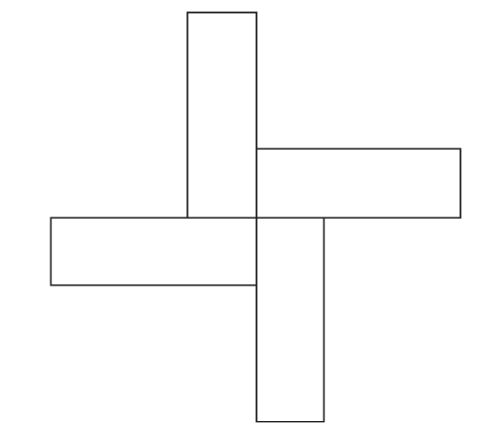
Work out the perimeter of the shape.

........................................................... cm

(Total for Question 14 is 3 marks)
___________________________________________________________________________

15. Here are the ingredients needed to make 8 shortbread biscuits.
Shortbread biscuits
Makes 8 biscuits
120 g butter
60 g caster sugar
180 g flour

Tariq is going to make some shortbread biscuits.
He has the following ingredients

330 g butter 200 g caster sugar 450 g flour

Work out the greatest number of shortbread biscuits that Tariq can make with his ingredients.
You must show all your working.

........................................................... biscuits

(Total for Question 15 is 3 marks)
___________________________________________________________________________

16. Jean records the maximum daily temperature each day for 10 days.
She also records the number of children going to a paddling pool for each of these days.
She draws this scatter graph for her information.

Jean’s information for one of these days is an outlier on the scatter graph.

(a) Give a possible reason for this.

......................................................................................................................................................

......................................................................................................................................................
(1)
(b) What type of correlation does the scatter graph show?

.......................................................
(1)
On the 11th day, the maximum daily temperature was 19 °C.

(c) Write down an estimate for the number of children going to the paddling pool on
the 11th day.

.......................................................
(1)
It would not be sensible to use the scatter graph to predict the number of children going
to the paddling pool on a day when the maximum daily temperature was 13 °C.

(d) Give a reason why.

......................................................................................................................................................

......................................................................................................................................................
(1)
(Total for Question 16 is 4 marks)
___________________________________________________________________________

17. (a) Complete the table of values for y =

x | 0.5 | 1 | 2 | 3 | 4 | 5 | 6
y |  | 3 | 1.5 |  | 0.75
(2)
(b) On the grid, draw the graph of y = for values of x from 0.5 to 6
(2)
(Total for Question 17 is 4 marks)
___________________________________________________________________________

18. Sameena has a round pencil case and a square pencil case.

There are 4 blue pens and 3 red pens in the round pencil case.
There are 3 blue pens and 5 red pens in the square pencil case.

Sameena takes at random one pen out of each pencil case.

(a) Complete the probability tree diagram.
(2)
(b) Work out the probability that the pens Sameena takes are both red.

.......................................................
(2)
(Total for Question 18 is 4 marks)
___________________________________________________________________________

19.

Describe fully the single transformation that maps triangle P onto triangle Q.

......................................................................................................................................................

......................................................................................................................................................
(Total for Question 19 is 2 marks)
___________________________________________________________________________

20. Katie has x pets.
Agatha has twice as many pets as Katie.
Isabel has 3 more pets than Katie.

Write an expression, in terms of x, for the total number of pets that Katie, Agatha and Isabel have.

...........................................
(Total for Question 20 is 2 marks)
___________________________________________________________________________

21. Solve the simultaneous equations
4x + y = 10
x – 5y = 13

x = .......................................................
y = .......................................................
(Total for Question 21 is 3 marks)
___________________________________________________________________________

22. Here is a number line.

(a) On this number line, show the inequality –2 ≤ x < 3
(2)
(b) Solve 5n + 3 > 27

.......................................................
(2)
(Total for Question 22 is 4 marks)
___________________________________________________________________________

23. The diagram shows a shape ABCDEF.

All the corners of the shape are right angles.
The perimeter of the shape is 28 m.

Work out the area of ABCE shown shaded on the diagram.

.......................................................
(Total for Question 23 is 5 marks)
___________________________________________________________________________

24. There are 240 students in Year 7 at a school.

The pie chart shows the proportion of boys and the proportion of girls in Year 7.

There are 8 more girls in Year 8 than in Year 7.
There are 32 fewer boys in Year 8 than in Year 7.

Andy draws a pie chart to show the proportion of boys and the proportion of girls in Year 8

Work out the angle of the sector in Andy’s pie chart that represents girls.

.......................................................°
(Total for Question 24 is 4 marks)
___________________________________________________________________________

25. A number, y, is rounded to 2 significant figures.

The result is 0.76

Write down the error interval for y.

..................................................................................
(Total for Question 25 is 2 marks)
___________________________________________________________________________

26. M = 3x² – nx

Work out the value of M when x = –2 and n = 5

M = ................................
(Total for Question 26 is 2 marks)
___________________________________________________________________________

27. Mortar mix is made by mixing cement, sand and quicklime in the ratio 1 : 2 : 3

(a) Work out the volume of sand needed to make 2.1 m³ of mortar mix.

............................ m³
(2)

Julie has 0.75 m³ of quicklime.
She has plenty of sand and cement.

(b) Work out the greatest volume of mortar mix she could make.

............................ m³
(2)
(Total for Question 27 is 4 marks)
___________________________________________________________________________

28.

In the isosceles triangle ABC,
AB = AC
angle B = (3x + 32)°
angle C = (87 – 2x)°

Work out the value of x.
You must show your working.

x = ................................
(Total for Question 28 is 4 marks)
___________________________________________________________________________

29. Samir invests £350 in a savings account.
He gets 2% per annum compound interest.

How much money will Samir have in the account at the end of 3 years?

£.......................................................
(Total for Question 29 is 2 marks)
___________________________________________________________________________

30. Solve 3(2z – 5) = 4z + 11

z = .........................................
(Total for Question 30 is 3 marks)

TOTAL FOR PAPER: 80 MARKS

