GCSE Mathematics
Practice Tests: Set 10
Paper 2H/3H (Calculator)
Time: 1 hour 30 minutes
You should have: Ruler graduated in centimetres and millimetres, protractor, pair of compasses, pen, HB pencil, eraser, calculator. Tracing paper may be used.
Instructions
- Use black ink or ball-point pen.
- Fill in the boxes at the top of this page with your name,
centre number and candidate number.
- Answer all questions.
- Answer the questions in the spaces provided
– there may be more space than you need.
- Calculators may be used.
- Diagrams are NOT accurately drawn, unless otherwise indicated.
- You must show all your working out.

Information
- The total mark for this paper is 80
- The marks for each question are shown in brackets
– use this as a guide as to how much time to spend on each question.

Advice
- Read each question carefully before you start to answer it.
- Keep an eye on the time.
- Try to answer every question.
- Check your answers if you have time at the end.

Answer ALL TWENTY FOUR questions.

Write your answers in the spaces provided.

You must write down all the stages in your working.

1 ABC and DEF are similar triangles.

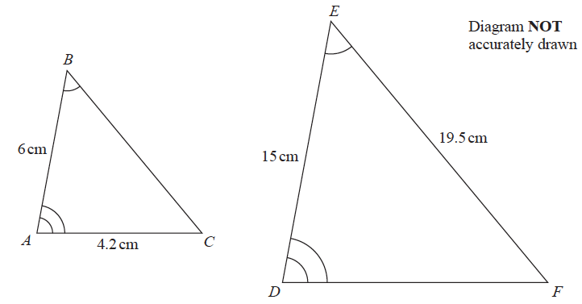

(a) Work out the length of DF.

.......................................................cm
(2)
(b) Work out the length of BC.

.......................................................cm
(2)
(Total for Question 1 is 4 marks)
___________________________________________________________________________
2 The diagram shows a solid cuboid made from wood.

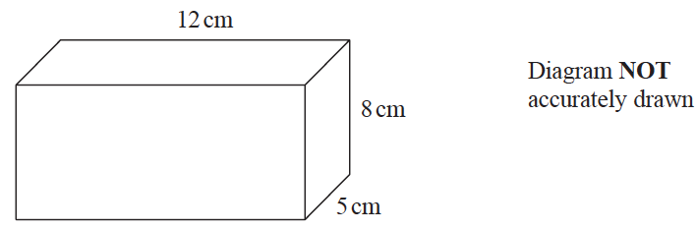

The wood has density 0.7 g/cm³
Work out the mass of the cuboid.

....................................................... grams
(Total for Question 2 is 3 marks)
___________________________________________________________________________

3 The table shows information about the heights, in cm, of 48 sunflowers in a garden centre.

Height of sunflower (h cm) | Frequency
90 < h ≤ 100 | 8
100 < h ≤ 110 | 12
110 < h ≤ 120 | 15
120 < h ≤ 130 | 10
130 < h ≤ 140 | 3

Work out an estimate for the mean height of the sunflowers.

.......................................................cm
(Total for Question 3 is 4 marks)
___________________________________________________________________________

4 Solve the simultaneous equations
x + 2y = –0.5
3x – y = 16
Show clear algebraic working.

x =.......................................................
y =.......................................................
(Total for Question 4 is 3 marks)
___________________________________________________________________________

5 On 1st January 2016 Lionel bought a boat for £170 000
The value of the boat depreciates by 8% per year.
Work out the value of the boat on 1st January 2019
Give your answer correct to the nearest pound.

£ .......................................................
(Total for Question 5 is 3 marks)
___________________________________________________________________________
6 The table gives information about the times taken, in minutes, for 80 taxi journeys.

Time taken (t minutes) | Frequency
0 < t ≤ 5 | 7
5 < t ≤ 10 | 10
10 < t ≤ 15 | 12
15 < t ≤ 20 | 19
20 < t ≤ 25 | 18
25 < t ≤ 30 | 14

(a) Complete the cumulative frequency table.

Time taken (t minutes) | Cumulative frequency
0 < t ≤ 5
0 < t ≤ 10
0 < t ≤ 15
0 < t ≤ 20
0 < t ≤ 25
0 < t ≤ 30

(1)
(b) On the grid provided, draw a cumulative frequency graph for your table.
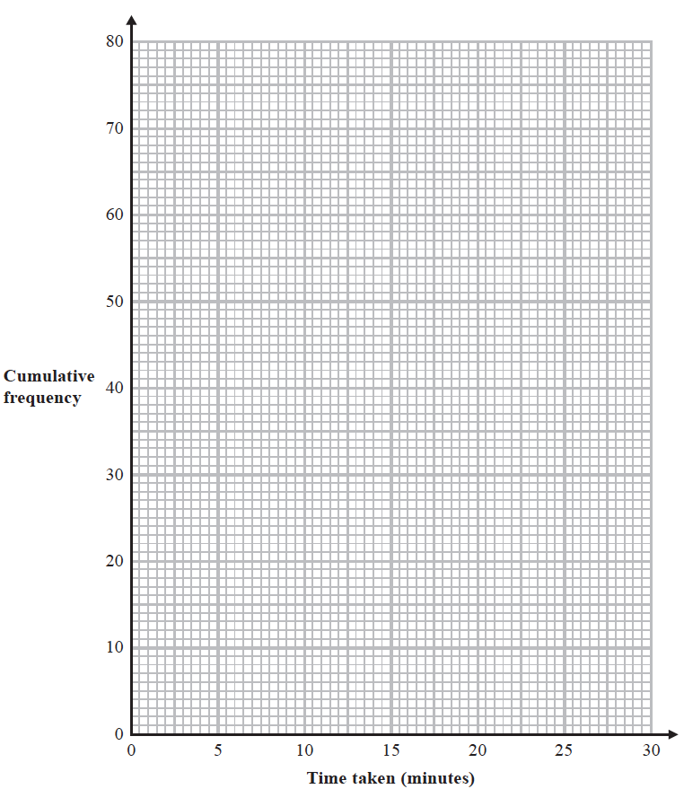
(2)

(c) Use your graph to find an estimate for the median.

.......................................................minutes
(1)
(d) Use your graph to find an estimate for the interquartile range.

.......................................................minutes
(2)
(Total for Question 6 is 6 marks)
___________________________________________________________________________

7 The diagram shows triangle PQR.

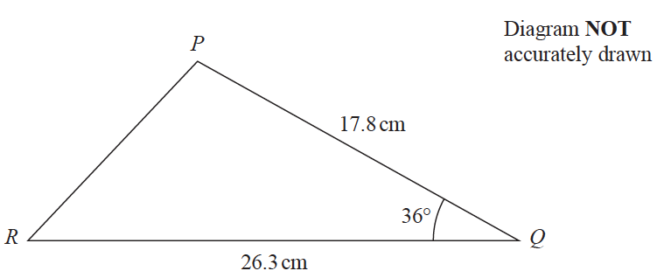

Calculate the length of PR.
Give your answer correct to 3 significant figures.

....................................................... cm
(Total for Question 7 is 3 marks)
___________________________________________________________________________

8 ABCD is a trapezium.

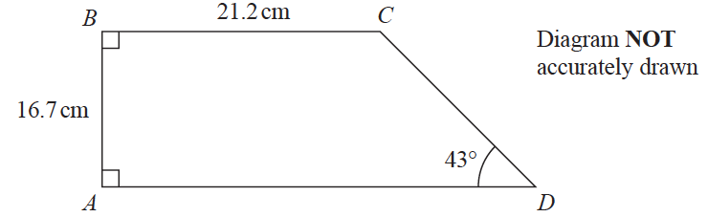

Calculate the perimeter of the trapezium.
Give your answer correct to 3 significant figures.

.......................................................cm
(Total for Question 8 is 4 marks)
___________________________________________________________________________

9 30 students in a class sat a Mathematics test.
The mean mark in the test for the 30 students was 26.8
13 of the 30 students in the class are boys.
The mean mark in the test for the boys was 25
Find the mean mark in the test for the girls.
Give your answer correct to 3 significant figures.

.......................................................
(Total for Question 9 is 3 marks)
___________________________________________________________________________

10 A and B are two similar vases.

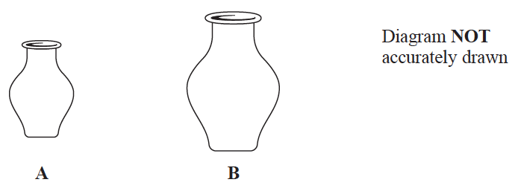

Vase A has height 24 cm.
Vase B has height 36 cm.
Vase A has a surface area of 960 cm²
(a) Work out the surface area of vase B.

....................................................... cm²
(2)

Vase B has a volume of V cm³
(b) Find in terms of V, an expression for the volume, in cm³, of vase A.

....................................................... cm³
(2)
(Total for Question 10 is 4 marks)
___________________________________________________________________________

11 Jalina left her home at 10 00 to cycle to a park. On her way to the park, she stopped at a friend’s house and then continued her journey to the park.

Here is the distance-time graph for her journey to the park.

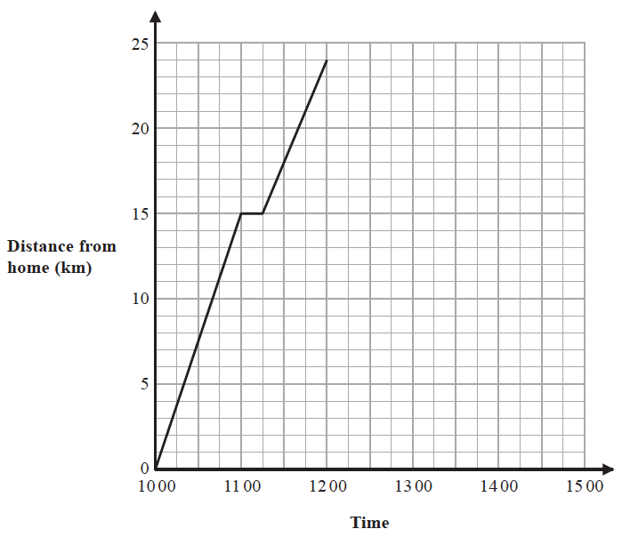

(a) On her journey to the park, did Jalina cycle at a faster speed before or after she stopped at her friend’s house?

Give a reason for your answer.

.............................................................................................................................................

.............................................................................................................................................

.............................................................................................................................................
(1)

Jalina stayed at the park for 45 minutes. She then cycled, without stopping, at a constant speed of 16 km/h from the park back to her home.

(b) Show all this information on the distance-time graph.

(2)
(c) Work out Jalina’s average cycling speed, in kilometres per hour, for the complete journey to the park and back.

Do not include the times when she was not cycling in your calculation.
Give your answer correct to 1 decimal place.

....................................................... km/h
(3)
(Total for Question 11 is 6 marks)
___________________________________________________________________________

12 Change a speed of x kilometres per hour into a speed in metres per second.
Simplify your answer.

.......................................................m/s
(Total for Question 12 is 3 marks)
___________________________________________________________________________

13 The diagram shows cuboid ABCDEFGH.

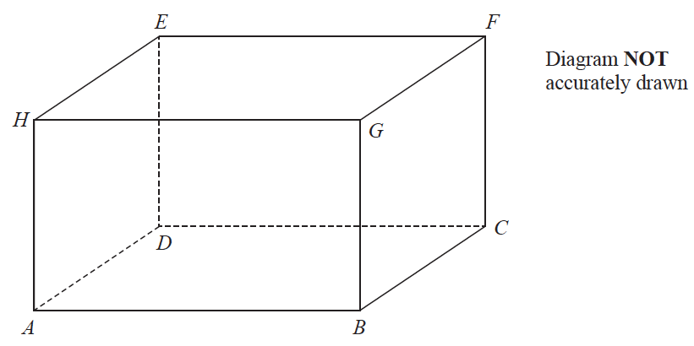

For this cuboid
the length of AB : the length of BC : the length of CF = 4 : 2 : 3
Calculate the size of the angle between AF and the plane ABCD.
Give your answer correct to one decimal place.

.......................................................°
(Total for Question 13 is 3 marks)
___________________________________________________________________________

14 ABCD is a quadrilateral.

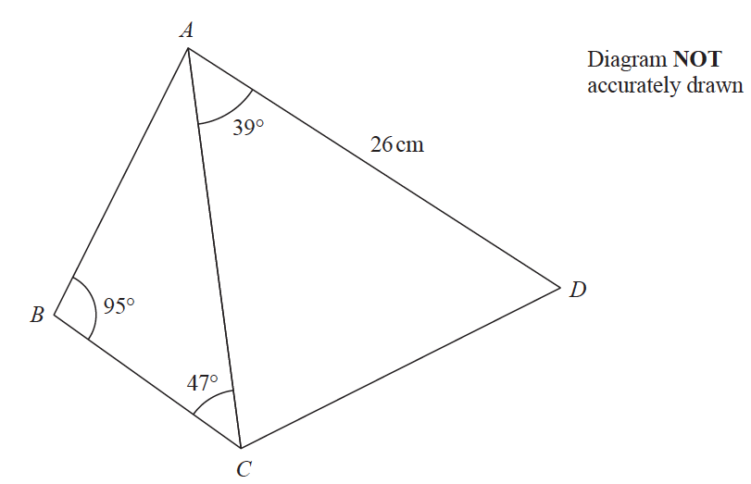

The area of triangle ACD is 250 cm²
Calculate the area of the quadrilateral ABCD.
Show your working clearly.
Give your answer correct to 3 significant figures.

.......................................................cm²
(Total for Question 14 is 6 marks)
___________________________________________________________________________

15 y is directly proportional to the cube of x
y = 20 h when x = h (h ≠ 0)
(a) Find a formula for y in terms of x and h

y =.......................................................
(3)
(b) Find x in terms of h when y = 67.5 h
Give your answer in its simplest form.

x =.......................................................
(2)
(Total for Question 15 is 5 marks)
___________________________________________________________________________

16 A solid is made from a hemisphere and a cylinder.
The plane face of the hemisphere coincides with the upper plane face of the cylinder.

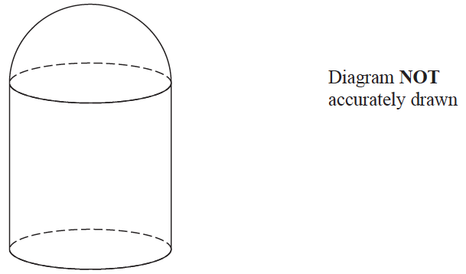

The hemisphere and the cylinder have the same radius.
The ratio of the radius of the cylinder to the height of the cylinder is 1 : 3
Given that the solid has volume 792π cm³, work out the height of the solid.

....................................................... cm
(Total for Question 16 is 5 marks)
___________________________________________________________________________
17
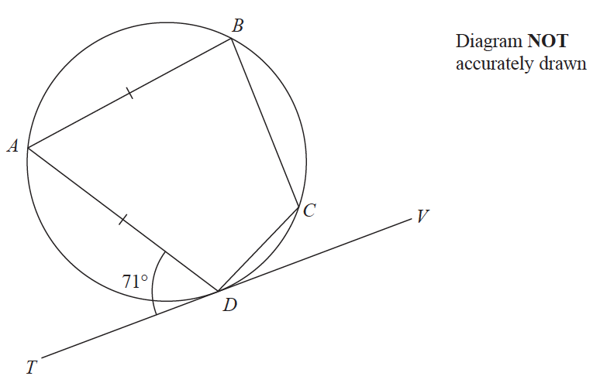

A, B, C and D are points on a circle.
TDV is the tangent to the circle at D.
AB = AD
Angle ADT = 71°
Work out the size of angle BCD.
Give a reason for each stage of your working.

....................................................... °
(Total for Question 17 is 5 marks)
___________________________________________________________________________

18 The equation of the line L is y = 9 − x
The equation of the curve C is x² − 3xy + 2y² = 0
L and C intersect at two points.
Find the coordinates of these two points.
Show clear algebraic working.

(............................. , .............................) and (............................. , .............................)
(Total for Question 18 is 5 marks)
___________________________________________________________________________

19 Hannah has a bag that only contains yellow sweets and orange sweets.
Hannah takes at random 2 sweets from the bag.
The probability that Hannah takes exactly 1 yellow sweet from the bag is
Originally there were 3 yellow sweets in the bag.
Work out how many orange sweets there were originally in the bag.
Show your working clearly.

.......................................................
(Total for Question 19 is 5 marks)

TOTAL FOR PAPER IS 80 MARKS

BLANK PAGE

