GCSE Mathematics
Practice Tests: Set 10
Paper 1F (Non-calculator)
Time: 1 hour 30 minutes
You should have: Ruler graduated in centimetres and millimetres, protractor, pair of compasses, pen, HB pencil, eraser, calculator. Tracing paper may be used.

Instructions
- Use black ink or ball-point pen.
- Fill in the boxes at the top of this page with your name,
centre number and candidate number.
- Answer all questions.
- Answer the questions in the spaces provided
– there may be more space than you need.
- Calculators may be used.
- Diagrams are NOT accurately drawn, unless otherwise indicated.
- You must show all your working out.

Information
- The total mark for this paper is 80
- The marks for each question are shown in brackets
– use this as a guide as to how much time to spend on each question.

Advice
- Read each question carefully before you start to answer it.
- Keep an eye on the time.
- Try to answer every question.
- Check your answers if you have time at the end.

BLANK PAGE
Answer ALL questions.
Write your answers in the spaces provided.
You must write down all the stages in your working.

1 The diagram shows a fair 6-sided spinner.

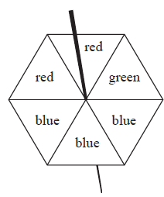

Rami is going to spin the spinner once.
(a) Circle the word in the box below that best describes the likelihood that the spinner
will land on green.

impossible | unlikely | evens | likely | certain

(1)
(b) On the probability scale below, mark with a cross (×) the probability that the spinner
will land on blue.

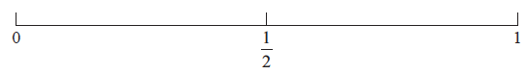

(1)

(c) On the probability scale below, mark with a cross (×) the probability that the spinner
will land on yellow.

(1)
(Total for Question 1 is 3 marks)
___________________________________________________________________________
2 The bar chart gives information about the population, in millions, of each of five cities.

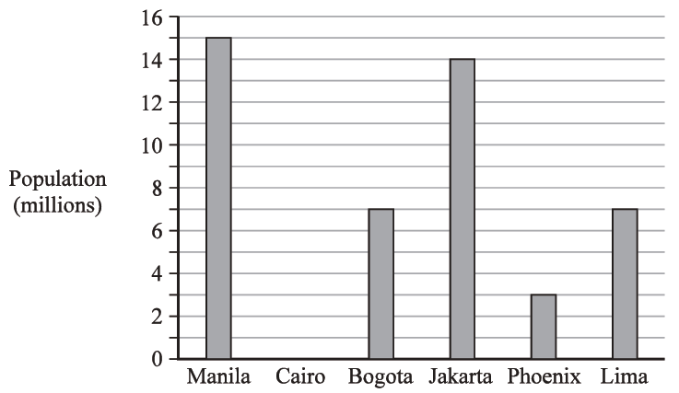

Cairo has a population of 12 million.

(a) Draw a bar on the bar chart to show this information.
(1)

The populations of two cities are equal.

(b) Write down the names of these two cities.

............................................ and ............................................
(1)

(c) Write down the name of the city with a population of 15 million.

.......................................................
(1)

(d) Work out the difference in population between Jakarta and Phoenix.

....................................................... million
(1)

In Manila, there are 90 badminton clubs and 60 football clubs.

(e) Find the ratio of the number of badminton clubs to the number of football clubs.
Give your ratio in its simplest form.

.......................................................
(2)
(Total for Question 2 is 6 marks)
___________________________________________________________________________

3
 | 3 | 8 | 16 | 19 | 24 | 51 | 60 | 81

From the numbers in the box, write down

(a) an odd number

.......................................................
(1)

(b) a multiple of 12

.......................................................
(1)

(c) a square number

.......................................................
(1)

(d) a prime number

.......................................................
(1)
(Total for Question 3 is 4 marks)
___________________________________________________________________________

4 (a) Simplify 6e × 2f

.......................................................
(1)

(b) Simplify 5m + 7k − 2m + k

.......................................................
(2)

(c) Solve 5y + 3 = 14

y = .......................................................
(2)
(Total for Question 4 is 5 marks)
___________________________________________________________________________

5 (a) Which one of these fractions is equivalent to ?

.......................................................
(1)

Here is a shape made of squares.
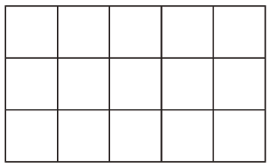
(b) Shade of the shape.
(1)

(c) Write as a percentage.

....................................................... %
(1)

of a number is 48
(d) What is the number?

.......................................................
(2)
(Total for Question 5 is 5 marks)
___________________________________________________________________________
6 Complete the following statements by writing a number on each dotted line.

(a) A pentagon has ....................................................... sides.
(1)

(b) The size of each angle in an equilateral triangle is ....................................................... °
(1)

(c) 1 kilometre = ....................................................... metres.
(1)
(Total for Question 6 is 3 marks)
___________________________________________________________________________

7 Here are the shoe sizes of 11 people.

7 | 8 | 4 | 4 | 4 | 10 | 5 | 7 | 7 | 4 | 4

(a) Write down the mode.

.......................................................
(1)

(b) Work out the range.

.......................................................
(2)

(c) Find the median.

.......................................................
(2)

Clark works in a shoe shop.

On Tuesday morning he sold some pairs of shoes.
The mean price of the pairs of shoes was £34

On Tuesday afternoon he sold only two pairs of shoes.
The prices of these pairs of shoes were £31 and £49

(d) Is the mean price of all the pairs of shoes Clark sold on Tuesday more or less than £34?
You must give a reason for your answer.

......................................................................................................................................................

......................................................................................................................................................

......................................................................................................................................................
(1)
(Total for Question 7 is 6 marks)
___________________________________________________________________________

8 (a) Write 5.7 × 10⁶ as an ordinary number.

....................................................................
(1)
(b) Write 0.004 in standard form.

....................................................................
(1)
(Total for Question 8 is 2 marks)
___________________________________________________________________________

9 In a game, a fair 3-sided spinner is spun once and a fair dice is rolled once.

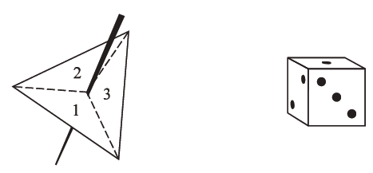

The spinner can land on 1, 2 or 3
The dice can land on 1, 2, 3, 4, 5 or 6

In the game, the score is found by multiplying the number the spinner lands on by the
number the dice lands on.

(a) Complete the table to show all possible scores.
Eleven of the scores have been done for you.

 |  | Dice
 |  | 1 | 2 | 3 | 4 | 5 | 6
 | 1 | 1 | 2 | 3 | 4
Spinner | 2 |  | 4 |  | 8 | 10
 | 3 | 3 | 6 |  | 12 |  | 18
(2)

Steven plays the game once.

(b) Work out the probability that his score is greater than 10

.......................................................
(2)
Adam plays the game and Carmen plays the game.

Adam gets a prize if his score is 5 or less.
Carmen gets a prize if her score is a multiple of 6

Carmen says the game is unfair because Adam is more likely to get a prize.

(c) Is the game unfair?
You must give a reason for your answer.

......................................................................................................................................................

......................................................................................................................................................
(2)
(Total for Question 9 is 6 marks)
___________________________________________________________________________

10 Find the highest common factor (HCF) of 40 and 64

.......................................................
(2)
(Total for Question 10 is 2 marks)
___________________________________________________________________________

11 Here is a sequence of patterns made from sticks.

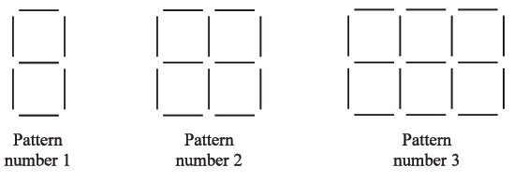

(a) In the space below, draw Pattern number 4

(1)
(b) How many sticks are needed to make Pattern number 7?

.......................................................
(2)
(c) Work out the Pattern number of the pattern made from exactly 62 sticks.

.......................................................
(2)

Pedro says,

“There will be a pattern in the sequence with exactly 123 sticks.”

(d) Is Pedro correct?
You must give a reason for your answer.

......................................................................................................................................................

......................................................................................................................................................

......................................................................................................................................................
(1)
(Total for Question 11 is 6 marks)
___________________________________________________________________________

12 P = 2g + 3h

(a) Work out the value of P when g = 7 and h = −4

.......................................................
(2)

(b) Simplify e⁹ ÷ e⁵

.......................................................
(1)

(b) Simplify (y²)⁸

.......................................................
(1)

(d) Expand and simplify (x + 9)(x – 2)

....................................................................
(2)

(e) Factorise fully 16c⁴p² + 20cp³

....................................................................
(2)
(Total for Question 12 is 8 marks)
___________________________________________________________________________

13 A, B and C are points on a circle, centre O.
AOC is a straight line.
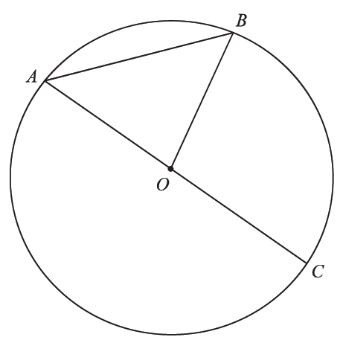

(a) Write down the mathematical name for the line AC.

.......................................................
(1)

(b) Write down the mathematical name for the line AB.

.......................................................
(1)

(c) On the diagram, shade a sector of the circle.

.......................................................
(1)
(Total for Question 13 is 3 marks)
___________________________________________________________________________
14
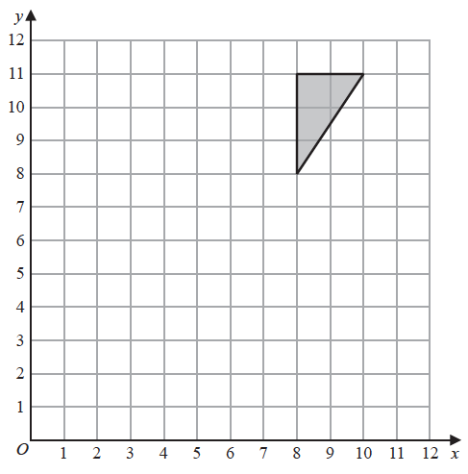
(a) On the grid above, rotate the triangle 180° about (7, 6)
(2)

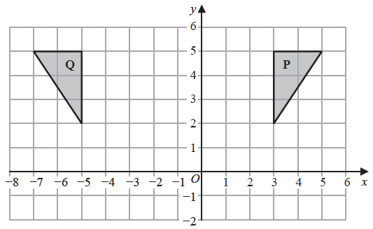

(b) Describe fully the single transformation that maps triangle P onto triangle Q.

......................................................................................................................................................

......................................................................................................................................................
(2)
(Total for Question 14 is 4 marks)
___________________________________________________________________________

15 (a) Complete the table of values for y = x² – 3x − 1

x | −2 | −1 | 0 | 1 | 2 | 3 | 4
y |  |  | −1 |  | −3 |  | 3
(2)

(b) On the grid, draw the graph of y = x² – 3x – 1 for all values of x from –2 to 4
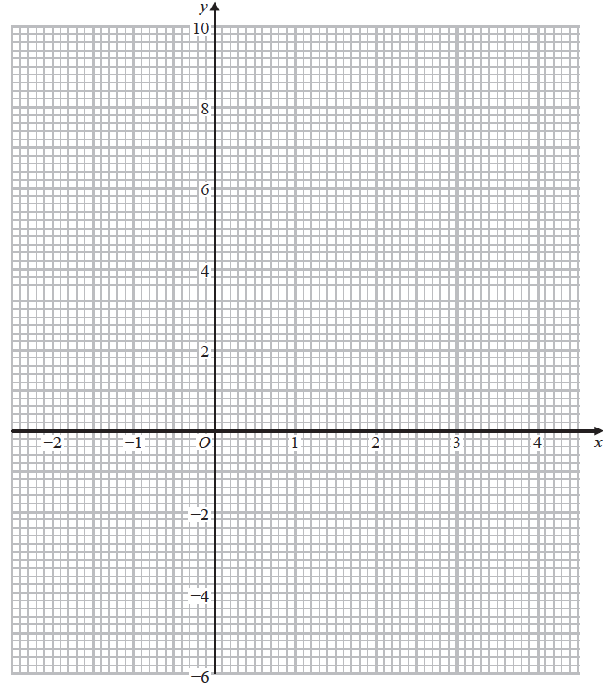(2)
(Total for Question 15 is 4 marks)
___________________________________________________________________________

16 In a box,

number of red buttons : number of blue buttons = 5 : 3
number of blue buttons : number of green buttons = 1 : 2

There are 48 green buttons in the box.
Work out the number of red buttons in the box.

....................................................................
(Total for Question 16 is 4 marks)
___________________________________________________________________________

17 Show that

(3)
(Total for Question 17 is 3 marks)
___________________________________________________________________________
18 Becky has a biased 6-sided dice.

The table gives information about the probability that, when the dice is thrown, it will
land on each number.

Number | 1 | 2 | 3 | 4 | 5 | 6
Probability | 2x | 0.18 | 2x | 3x | 0.26 | x

Becky is going to throw the dice 200 times.

Work out an estimate for the number of times that the dice will land on an even number.

.......................................................
(Total for Question 18 is 4 marks)
___________________________________________________________________________
19 A = 2^{n} × 3 × 5^{m}

Write 8A as a product of powers of its prime factors.

...............................................................................................
(2)
(Total for Question 19 is 2 marks)

TOTAL FOR PAPER IS 80 MARKS

