GCSE Mathematics
Practice Tests: Set 10
Paper 2F/3F (Calculator)
Time: 1 hour 30 minutes
You should have: Ruler graduated in centimetres and millimetres, protractor, pair of compasses, pen, HB pencil, eraser, calculator. Tracing paper may be used.
Instructions
- Use black ink or ball-point pen.
- Fill in the boxes at the top of this page with your name,
centre number and candidate number.
- Answer all questions.
- Answer the questions in the spaces provided
– there may be more space than you need.
- Calculators may be used.
- Diagrams are NOT accurately drawn, unless otherwise indicated.
- You must show all your working out.

Information
- The total mark for this paper is 80
- The marks for each question are shown in brackets
– use this as a guide as to how much time to spend on each question.

Advice
- Read each question carefully before you start to answer it.
- Keep an eye on the time.
- Try to answer every question.
- Check your answers if you have time at the end.
Answer ALL questions.

Write your answers in the spaces provided.

You must write down all the stages in your working.

1 Nina buys 8 pencils and 13 identical rulers.

Each pencil costs 58 pence
The total cost is £23.62

(a) Work out the cost of each ruler.

£ .......................................................
(3)

Bjorn has £15 to spend on pens.

Each pen costs 62 pence
He buys as many pens as he can.

(b) Work out how much change Bjorn should get.

$ .......................................................
(3)
(Total for Question 1 is 6 marks)
___________________________________________________________________________

2 (a) Write these numbers in order.
Start with the smallest number.

3 | −8 | 1 | −5 | 0

.......................................................
(1)
(b) Write these numbers in order of size.
Start with the smallest number.

2.5 | 2.85 | 2.082 | 2.28 | 2.805

.......................................................
(1)
(c) Find
(i) the value of

.......................................................
(ii) the cube root of 6859

.......................................................
(2)
(Total for Question 2 is 4 marks)
___________________________________________________________________________
3 There are 12 481 people at a concert.

8906 of these people are adults.
The rest of the people are children.
of the children are boys.

Work out the number of girls at the concert.

.......................................................
(Total for Question 3 is 4 marks)
___________________________________________________________________________

4 The pictogram gives information about the number of emails Sami sent on each of five
days last week.

Monday
Tuesday
Wednesday
Thursday
Friday

represents 8 emails

Work out the mean number of emails Sami sent on these 5 days.

.......................................................
(Total for Question 4 is 4 marks)
___________________________________________________________________________

5 The table gives the surface areas, in square kilometres, of six lakes in Africa.

Lake | Surface area (square kilometres)
Albert | 5299
Malawi | 29 500
Mweru | 5120
Tanganyika | 32 600
Turkana | 6405
Victoria | 68 879

(a) Which of these lakes has the least surface area?

.......................................................
(1)

(b) Write the number 6405 in words.

......................................................................................................................................................
(1)

(c) Write the number 68 879 correct to the nearest thousand.
.......................................................
(1)

Sammy says that the surface area of Lake Malawi is about times the surface area of Lake Albert.

(d) Is Sammy correct?
Give a reason for your answer.

......................................................................................................................................................

......................................................................................................................................................
(2)
(Total for Question 5 is 5 marks)
___________________________________________________________________________

6 (a) Use your calculator to work out the value of

Write down all the figures on your calculator display.

....................................................................
(2)
(b) Write your answer to part (a) correct to 1 significant figure.

.......................................................
(1)
(Total for Question 6 is 3 marks)
___________________________________________________________________________

7 Calvin and Jenny are planning a holiday together.
The total cost of the flights is £1190

Calvin and Jenny share the cost of the flights so that
the money that Calvin pays : the money that Jenny pays = 2 : 5

(a) How much more money does Jenny pay than Calvin?

£ .......................................................
(3)

The cost of the villa for their holiday is £3500
They have to pay a deposit of 12% of this cost.

The rest of the cost of the villa is to be paid in monthly instalments of £220

(b) How many monthly instalments must be paid?

.......................................................
(3)
(Total for Question 7 is 6 marks)
___________________________________________________________________________

8 Each exterior angle of a regular polygon is 24°

Work out the number of sides of the polygon.

.......................................................
(Total for Question 8 is 2 marks)
___________________________________________________________________________

9 A cylinder has diameter 14 cm and height 20 cm.

Work out the volume of the cylinder.
Give your answer correct to 3 significant figures.

.......................................................cm³
(Total for Question 9 is 2 marks)
___________________________________________________________________________

10 The table shows information about the heights, in cm, of 48 sunflowers in a garden centre.

Height of sunflower (h cm) | Frequency
90 < h ≤ 100 | 8
100 < h ≤ 110 | 12
110 < h ≤ 120 | 15
120 < h ≤130 | 10
130 < h ≤ 140 | 3

Work out an estimate for the mean height of the sunflowers.

.......................................................cm
(Total for Question 10 is 4 marks)
___________________________________________________________________________
11 The diagram shows a solid cuboid made from wood.

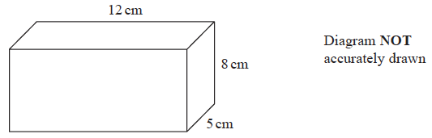

The wood has density 0.7 g/cm³

Work out the mass of the cuboid.

....................................................... grams
(Total for Question 11 is 3 marks)
___________________________________________________________________________

12 On 1st January 2016 Liz bought a boat for £170 000

The value of the boat depreciates by 8% per year.

Work out the value of the boat on 1st January 2019
Give your answer correct to the nearest dollar.

£ .......................................................
(Total for Question 12 is 3 marks)
___________________________________________________________________________

13 Josh buys and sells books for a living.

He buys 120 books for £4 each.
He sells of the books for £5 each.
He sells 40% of the books for £7 each.
He sells the rest of the books for £8 each.

(a) Calculate Josh’s percentage profit.

....................................................... %
(5)

One book that Josh owns had a value of £15 on the 1st May 2019
The value of this book had increased by 20% in the last year.

(b) Find the value of the book on the 1st May 2018

£ .......................................................
(3)
(Total for Question 13 is 8 marks)
___________________________________________________________________________
14 The diagram shows two triangles, CDB and BDA.

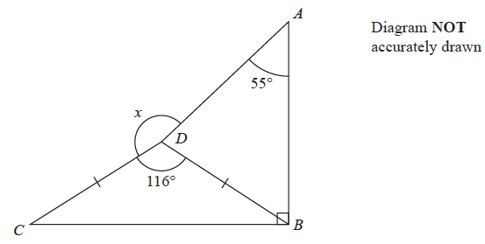

DC = DB

Angle ABC = 90°
Angle CDB = 116°
Angle DAB = 55°

Work out the size of the angle marked x.
Give a reason for each stage of your working.

....................................................... °
(Total for Question 14 is 5 marks)
___________________________________________________________________________
15 ABC and DEF are similar triangles.

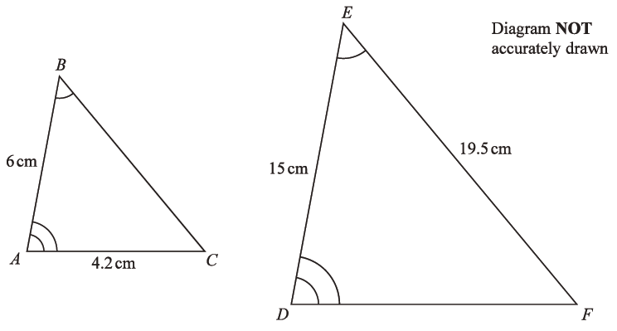

(a) Work out the length of DF.

....................................................... cm
(2)
(b) Work out the length of BC.

....................................................... cm
(2)
(Total for Question 15 is 4 marks)
___________________________________________________________________________

16 Jalina left her home at 10 00 to cycle to a park.

On her way to the park, she stopped at a friend’s house and then continued her journey to
the park.

Here is the distance-time graph for her journey to the park.

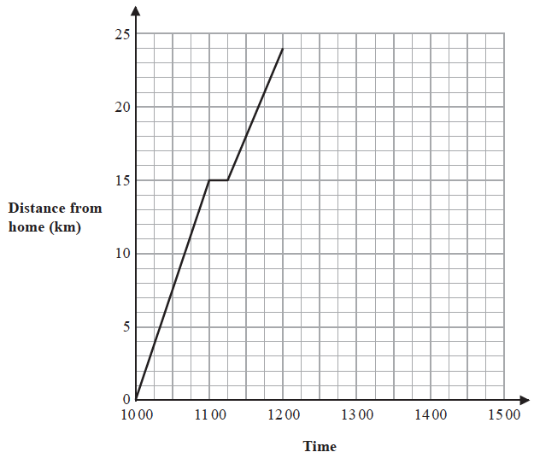

(a) On her journey to the park, did Jalina cycle at a faster speed before or after she stopped at her friend’s house?

Give a reason for your answer.

......................................................................................................................................................

......................................................................................................................................................

......................................................................................................................................................
(1)

Jalina stayed at the park for 45 minutes.

She then cycled, without stopping, at a constant speed of 16 km/h from the park back to
her home.

(b) Show all this information on the distance-time graph.

(2)

(c) Work out Jalina’s average cycling speed, in kilometres per hour, for the complete
journey to the park and back.

Do not include the times when she was not cycling in your calculation.
Give your answer correct to 1 decimal place.

....................................................... km/h
(3)
(Total for Question 16 is 6 marks)
___________________________________________________________________________

17 The diagram shows a shape made from a right-angled triangle and a semicircle.

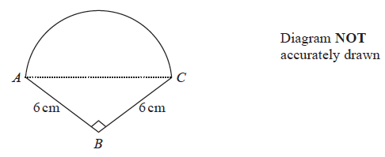

AC is the diameter of the semicircle.

BA = BC = 6 cm
Angle ABC = 90°

Work out the area of the shape.
Give your answer correct to 1 decimal place.

....................................................... cm²
(Total for Question 17 is 5 marks)
___________________________________________________________________________

18 30 students in a class sat a Mathematics test.
The mean mark in the test for the 30 students was 26.8

13 of the 30 students in the class are boys.
The mean mark in the test for the boys was 25

Find the mean mark in the test for the girls.
Give your answer correct to 3 significant figures.

.......................................................
(Total for Question 18 is 3 marks)
___________________________________________________________________________

19 Change a speed of x kilometres per hour into a speed in metres per second.
Simplify your answer.

....................................................... m/s
(Total for Question 19 is 3 marks)

TOTAL FOR PAPER IS 80 MARKS

BLANK PAGE

