GCSE Mathematics
Practice Tests: Set 11
Paper 1H (Non-calculator)
Time: 1 hour 30 minutes
You should have: Ruler graduated in centimetres and millimetres, protractor, pair of compasses, pen, HB pencil, eraser, calculator. Tracing paper may be used.

Instructions
- Use black ink or ball-point pen.
- Fill in the boxes at the top of this page with your name,
centre number and candidate number.
- Answer all questions.
- Answer the questions in the spaces provided
– there may be more space than you need.
- Calculators may be used.
- Diagrams are NOT accurately drawn, unless otherwise indicated.
- You must show all your working out.

Information
- The total mark for this paper is 80
- The marks for each question are shown in brackets
– use this as a guide as to how much time to spend on each question.

Advice
- Read each question carefully before you start to answer it.
- Keep an eye on the time.
- Try to answer every question.
- Check your answers if you have time at the end.
Answer ALL questions.

Write your answers in the spaces provided.

You must write down all the stages in your working.

1 (a) Simplify w⁵ × w⁷

.......................................................
(1)
(b) Simplify t⁹ ÷ t³

.......................................................
(1)
(Total for Question 1 is 2 marks)
___________________________________________________________________________

2 Solve 4x – 13 = 17 + 8x

x = .......................................................
(Total for Question 2 is 2 marks)
___________________________________________________________________________

3 Show that

(Total for Question 3 is 3 marks)
___________________________________________________________________________

4 Simplify fully

.......................................................
(Total for Question 4 is 2 marks)
___________________________________________________________________________

5 E = {11, 12, 13, 14, 15, 16, 17, 18, 19, 20}
A = {even numbers}
B = {multiples of 3}
List the members of the set
(i) A B

.......................................................
(ii) A B

.......................................................
(Total for Question 5 is 2 marks)
___________________________________________________________________________

6 (a) Complete the table of values for y = 1 + 5x − x²

x | −1 | 0 | 1 | 2 | 3 | 4 | 5 | 6
y |  | 1 |  | 7 | 7 |  | 1

(2)
(b) On the grid, draw the graph of y = 1 + 5x − x² for values of x from −1 to 6
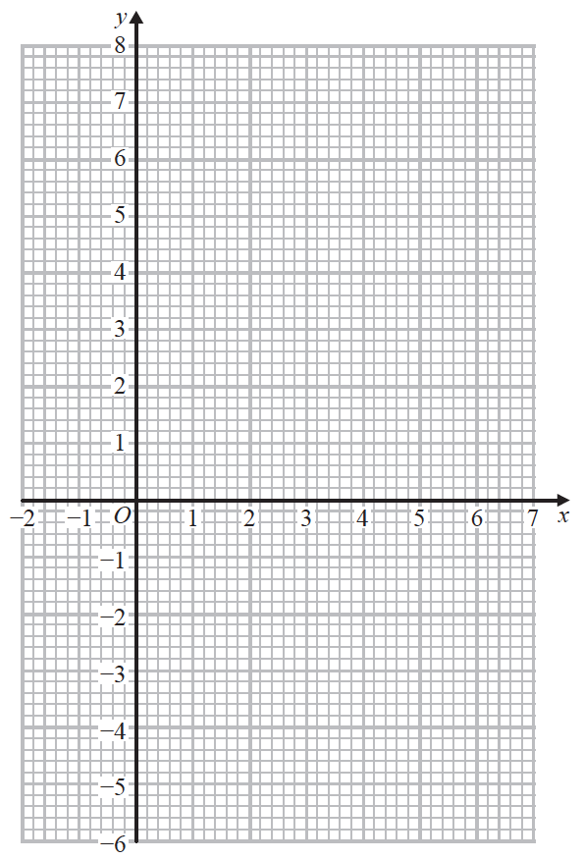
(2)
(Total for Question 6 is 4 marks)
___________________________________________________________________________

7 Simplify (5xy²)³

.......................................................
(Total for Question 7 is 2 marks)
___________________________________________________________________________

8 Expand and simplify (x + 2)(2x + 3)(x – 7)
Show your working clearly.

.......................................................
(Total for Question 8 is 3 marks)
___________________________________________________________________________

9 Line L is drawn on the grid.
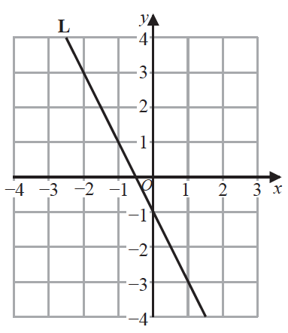
Find an equation for L.

.......................................................
(Total for Question 9 is 3 marks)
___________________________________________________________________________

10 The histogram shows information about the ages of all the passengers travelling on a plane.
No one on the plane is older than 80 years.

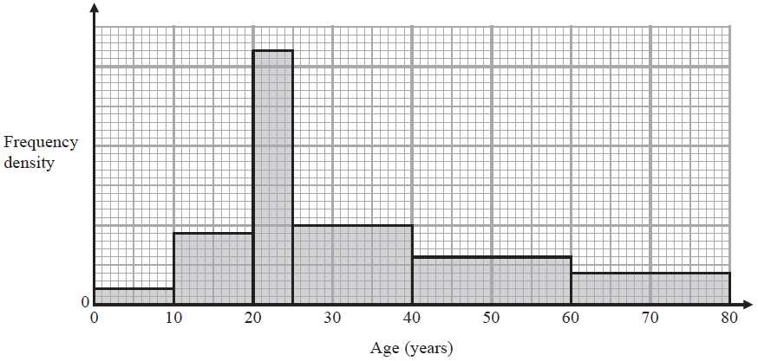

24 passengers on the plane are aged between 40 years and 60 years.
(a) Work out the total number of passengers on the plane.

.......................................................
(3)

A passenger on the plane is picked at random.
(b) Work out an estimate for the probability that this person is older than 55 years.

.......................................................
(2)
(Total for Question 10 is 5 marks)
___________________________________________________________________________

11 Sandeep recorded the length of time, in minutes, that each of 100 adults went for a walk
one Saturday afternoon.
The cumulative frequency table gives information about these times.

Time (t minutes) | Cumulative frequency
30 < t ≤ 40 | 6
30 < t ≤ 50 | 20
30 < t ≤ 60 | 56
30 < t ≤ 70 | 84
30 < t ≤ 80 | 95
30 < t ≤ 90 | 100

(a) On the grid, draw a cumulative frequency graph for the information in the table.
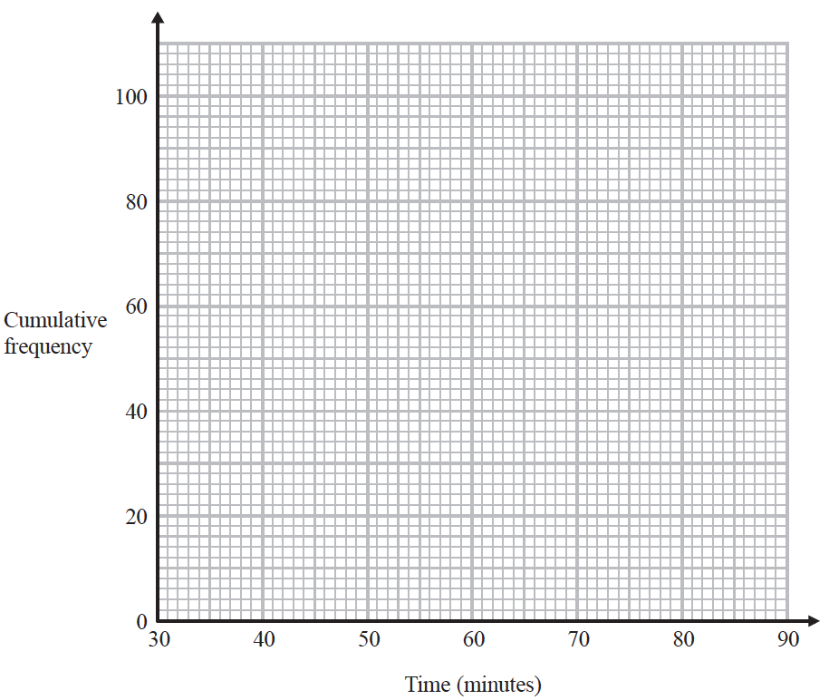
(2)
(b) Use your graph to find an estimate for the median length of time that these adults went for a walk.

....................................................... minutes
(2)

One of the 100 adults is chosen at random.
(c) Use your graph to find an estimate for the probability that this adult went for a walk for more than 72 minutes.

.......................................................
(3)
(Total for Question 11 is 7 marks)
___________________________________________________________________________

12 Solve the simultaneous equations
2x² + 3y² = 5
y = 2x + 1
Show clear algebraic working.

......................................................................................................................................................
(Total for Question 12 is 5 marks)
___________________________________________________________________________

13 Make m the subject of p² = $\frac{x+m}{2m−y}$

.......................................................
(Total for Question 13 is 3 marks)
___________________________________________________________________________
14 The straight line L₁ has equation 2y = 6x − 5
The straight line L₂ is perpendicular to L₁ and passes through the point (9, −1)
Find an equation for L₂
Give your answer in the form ay + bx = c

.......................................................
(Total for Question 14 is 4 marks)
___________________________________________________________________________

15 A curve has equation y = f (x)
There is only one maximum point on the curve.
The coordinates of this maximum point are (4, 3)
Write down the coordinates of the maximum point on the curve with equation
(i) y = f (x – 5)

(............................ , ............................)
(ii) y = 3f (x)

(............................ , ............................)
(Total for Question 15 is 2 marks)
___________________________________________________________________________
16 The functions f and g are defined as
f (x) = and g (x) = x − 5
(a) State which value of x must be excluded from any domain of the function f.

.......................................................
(1)
(b) Find fg (x).
Simplify your answer.

fg (x) = .......................................................
(2)
(c) Express the inverse function f⁻¹ in the form f⁻¹ (x) = …

f⁻¹ (x) = .......................................................
(3)

Part of the curve with equation y = h(x) is shown on the grid.
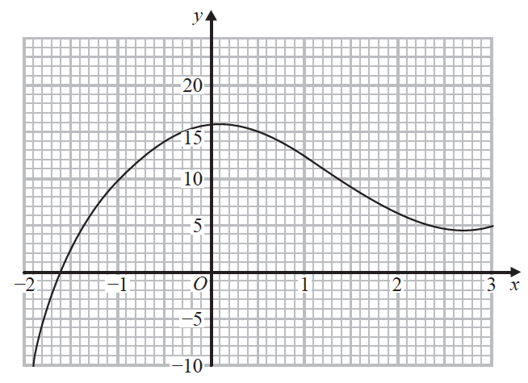
(d) Find an estimate for the gradient of the curve at the point where x = −0.5
Show your working clearly.

.......................................................
(3)
(Total for Question 16 is 9 marks)
___________________________________________________________________________

17 Given that 3^{n} = $\frac{3^{x}}{9^{y}}$, find an expression for n in terms of x and y.

n = .......................................................
(Total for Question 14 is 2 marks)
___________________________________________________________________________

18 A box contains marbles.
4 of the marbles are red.
The rest of the marbles are yellow.
Antonia takes at random a marble from the box and does not replace it.
Sergio then takes at random a marble from the box.
The probability that Antonia and Sergio both take a yellow marble is 0.7
Work out how many marbles were originally in the box.
Show your working clearly.

.......................................................
(Total for Question 18 is 5 marks)
___________________________________________________________________________
19 Write 5 + 12x − 2x² in the form a + b(x + c)² where a, b and c are integers.

.......................................................
(Total for Question 19 is 4 marks)
___________________________________________________________________________
20 Here is the graph of y = a sin (bx)° for 0 ≤ x ≤ 360

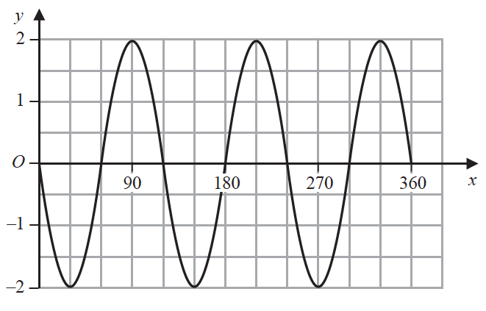

Find the value of a and the value of b.

a = .......................................................
b = .......................................................
(Total for Question 20 is 2 marks)
___________________________________________________________________________

21 The table gives information about the first six terms of a sequence of numbers.

Term number | 1 | 2 | 3 | 4 | 5 | 6
Term of sequence

Prove algebraically that the sum of any two consecutive terms of this sequence is always
a square number.

(Total for Question 21 is 4 marks)
___________________________________________________________________________

22
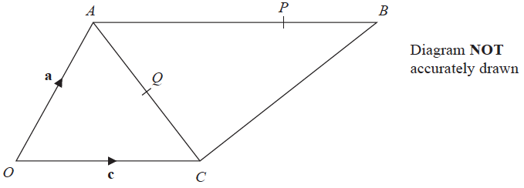

= a = c = 2c
P is the point on AB such that AP : PB = 3 : 1
Q is the point on AC such that OQP is a straight line.
Use a vector method to find AQ : QC
Show your working clearly.

AQ : QC = .......................................................
(Total for Question 22 is 5 marks)

TOTAL FOR PAPER IS 80 MARKS

BLANK PAGE

