GCSE Mathematics
Practice Tests: Set 11
Paper 2H/3H (Calculator)
Time: 1 hour 30 minutes
You should have: Ruler graduated in centimetres and millimetres, protractor, pair of compasses, pen, HB pencil, eraser, calculator. Tracing paper may be used.
Instructions
- Use black ink or ball-point pen.
- Fill in the boxes at the top of this page with your name,
centre number and candidate number.
- Answer all questions.
- Answer the questions in the spaces provided
– there may be more space than you need.
- Calculators may be used.
- Diagrams are NOT accurately drawn, unless otherwise indicated.
- You must show all your working out.

Information
- The total mark for this paper is 80
- The marks for each question are shown in brackets
– use this as a guide as to how much time to spend on each question.

Advice
- Read each question carefully before you start to answer it.
- Keep an eye on the time.
- Try to answer every question.
- Check your answers if you have time at the end.

Answer ALL questions.

Write your answers in the spaces provided.

You must write down all the stages in your working.

1 A football team played 55 games.
Each game was won, drawn or lost.
number of games won : number of games drawn : number of games lost = 6 : 3 : 2
Work out how many more games the team won than the team lost.

.......................................................
(Total for Question 1 is 3 marks)
___________________________________________________________________________

2 Write 720 as a product of its prime factors.
Show your working clearly.

.......................................................
(Total for Question 2 is 3 marks)
___________________________________________________________________________
3 Solve the inequality 4y – 13 ≤ y + 8

.......................................................
(Total for Question 3 is 2 marks)
___________________________________________________________________________

4 There are some ice lollies in a freezer.
The flavour of each ice lolly is banana or strawberry or mint or chocolate.
Julius takes at random an ice lolly from the freezer.
The table shows the probabilities that the flavour of the ice lolly that Julius takes is
banana or strawberry or chocolate.

Flavour | banana | strawberry | mint | chocolate
Probability | 0.35 | 0.32 |  | 0.12

Work out the probability that the flavour of the ice lolly that Julius takes is either
strawberry or mint.

.......................................................
(Total for Question 4 is 3 marks)
___________________________________________________________________________

5 Henri buys a yacht for £150 000.
The yacht depreciates in value by 18% each year.
Work out the value of the yacht at the end of 3 years.
Give your answer correct to the nearest euro.

£.......................................................
(Total for Question 5 is 3 marks)
___________________________________________________________________________

6
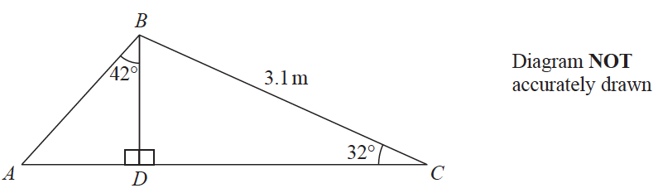

Calculate the length of AB.
Show your working clearly.
Give your answer correct to 3 significant figures.

....................................................... m
(Total for Question 6 is 5 marks)
___________________________________________________________________________

7 Lorenzo increases all the prices on his restaurant menu by 8%
After the increase, the price of lasagne is £9.45
Work out the price of lasagne before the increase.

£ .......................................................
(Total for Question 7 is 3 marks)
___________________________________________________________________________

8 There are 10 people in a lift.
These 10 people have a mean weight of 79.2 kg.
3 of these people get out of the lift.
These 3 people have a mean weight of 68 kg.
Work out the mean weight of the 7 people left in the lift.

....................................................kg
(Total for Question 8 is 3 marks)
___________________________________________________________________________
9 Each interior angle of a regular polygon is 162°
Work out the number of sides the polygon has.

.......................................................
(Total for Question 9 is 3 marks)
___________________________________________________________________________

10 Find the smallest whole number that 720 can be multiplied by to give a square number.

.......................................................
(Total for Question 10 is 1 mark)
___________________________________________________________________________

11 Change 22 metres per second to a speed in kilometres per hour.
Show your working clearly.

....................................................km/h
(Total for Question 11 is 3 marks)
___________________________________________________________________________

12 A, B, C and D are points on a circle, centre O.

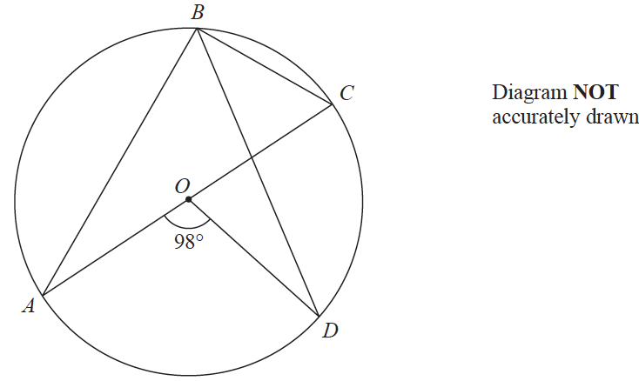

AOC is a diameter of the circle.
Angle AOD = 98°
Work out the size of angle DBC.
Give a reason for each stage in your working.

....................................................... °
(Total for Question 12 is 4 marks)
___________________________________________________________________________

13 The diagram shows a cylinder.

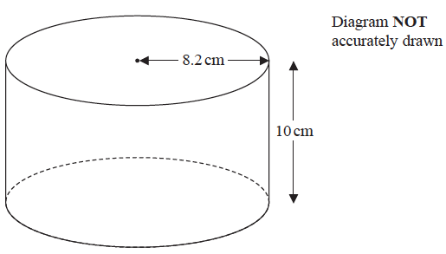

The cylinder has radius 8.2 cm and height 10 cm.
The cylinder is empty.
Pam pours 1.5 litres of water into the cylinder.
Work out the depth of the water in the cylinder.
Give your answer correct to 1 decimal place.

....................................................cm
(Total for Question 13 is 3 marks)
___________________________________________________________________________

14
A = 3² × 5⁴ × 7 B = 3⁴ × 5³ × 7 × 11
(a) Find the highest common factor (HCF) of A and B.

.......................................................
(2)
(b) Find the lowest common multiple (LCM) of A and B.

.......................................................
(2)
(Total for Question 14 is 4 marks)
___________________________________________________________________________

15 The following table gives values of x and y where y is inversely proportional to the
square of x.

x | 1.5 | 2 | 3 | 4
y | 16 | 9 | 4 | 2.25

(a) Find a formula for y in terms of x.

.......................................................
(3)

Given that x > 0
(b) find the value of x when y = 144

.......................................................
(2)
(Total for Question 15 is 5 marks)
___________________________________________________________________________

16 3 years ago, the ratio of Tom’s age to Clemmie’s age was 2 : 7
Tom is now 15 years old and Clemmie is now x years old.
Find the value of x.

x = .......................................................
(Total for Question 16 is 3 marks)
___________________________________________________________________________

17
x =
a = 3.46 correct to 3 significant figures.
b = 6.3 correct to 1 decimal place.
Work out the upper bound for the value of x.

Give your answer as a decimal correct to 3 significant figures.
Show your working clearly.

.......................................................
(Total for Question 17 is 3 marks)
___________________________________________________________________________

18 The diagram shows two similar bottles, A and B.

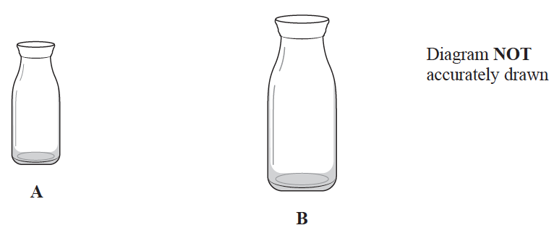

Bottle A has surface area 240 cm²
Bottle B has surface area 540 cm² and volume 2025 cm³
Work out the volume of bottle A.

....................................................... cm³
(Total for Question 18 is 3 marks)
___________________________________________________________________________

19 The diagram shows a sector OAPB of a circle, centre O.

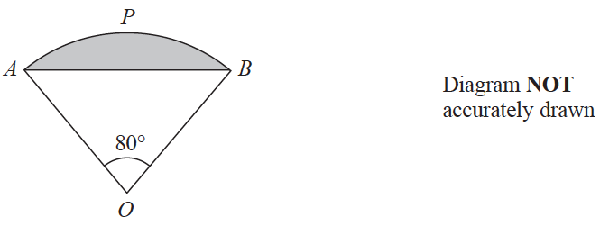

AB is a chord of the circle.
Angle AOB = 80°
The area of sector OAPB is π cm²
Work out the perimeter of the shaded segment.
Give your answer correct to 3 significant figures.

....................................................... cm
(Total for Question 19 is 6 marks)
___________________________________________________________________________

20 The diagram shows a solid pyramid ABCDE with a horizontal base.

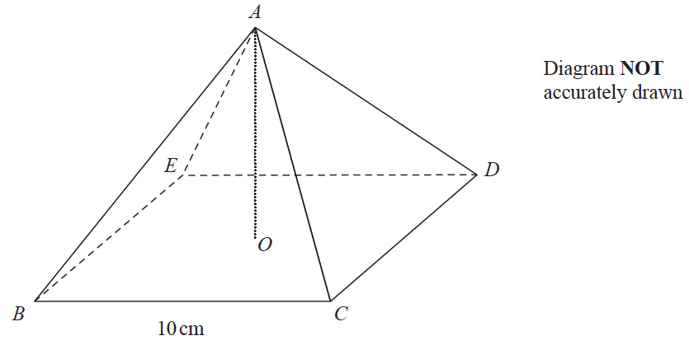

The base, BCDE, of the pyramid is a square of side 10 cm.
The vertex A of the pyramid is vertically above the centre O of the base so that
AB = AC = AD = AE
The total surface area of the pyramid is 360 cm²
Work out the size of the angle between AC and the base BCDE.
Give your answer correct to 3 significant figures.

....................................................... °
(Total for Question 20 is 6 marks)
___________________________________________________________________________
21 ABC and DEF are similar triangles.
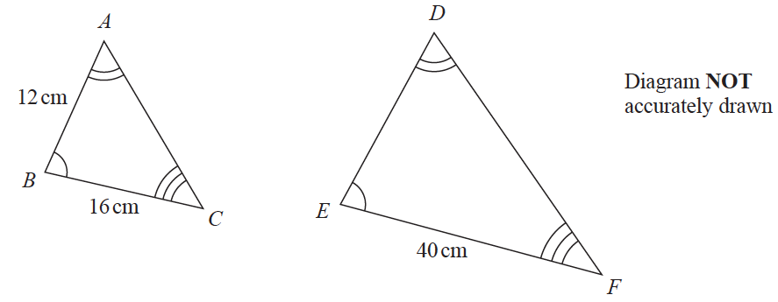

The area of triangle DEF is 525 cm²
Find the area of triangle DEF in m²

....................................................... m²
(Total for Question 4 is 21 marks)
___________________________________________________________________________

22
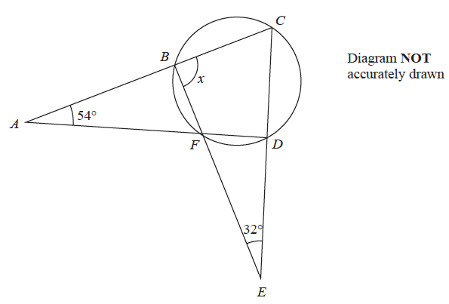

B, C, D and F are points on a circle.
ABC, AFD, BFE and CDE are straight lines.
Work out the size of angle x.
Show your working clearly.

x = .......................................................°
(Total for Question 22 is 4 marks)
___________________________________________________________________________

23 A boat sails from point X to point Y and then to point Z.
Y is on a bearing of 280° from X.
Z is on a bearing of 220° from Y.
The distance from X to Y is 3.5 km.
The distance from Y to Z is 6 km.
Work out the bearing of Z from X.
Give your answer correct to 1 decimal place.

.......................................................°
(Total for Question 23 is 5 marks)

TOTAL FOR PAPER IS 80 MARKS

