GCSE Mathematics
Practice Tests: Set 11
Paper 1F (Non-calculator)
Time: 1 hour 30 minutes
You should have: Ruler graduated in centimetres and millimetres, protractor, pair of compasses, pen, HB pencil, eraser, calculator. Tracing paper may be used.

Instructions
- Use black ink or ball-point pen.
- Fill in the boxes at the top of this page with your name,
centre number and candidate number.
- Answer all questions.
- Answer the questions in the spaces provided
– there may be more space than you need.
- Calculators may be used.
- Diagrams are NOT accurately drawn, unless otherwise indicated.
- You must show all your working out.

Information
- The total mark for this paper is 80
- The marks for each question are shown in brackets
– use this as a guide as to how much time to spend on each question.

Advice
- Read each question carefully before you start to answer it.
- Keep an eye on the time.
- Try to answer every question.
- Check your answers if you have time at the end.
Answer ALL questions.
Write your answers in the spaces provided.
You must write down all the stages in your working.

1 Write a number in each box so that each calculation is correct.

(i) |  | + 357 = 486

(ii) |  | × 23 = 1840

(Total for Question 1 is 2 marks)
___________________________________________________________________________

2 The diagram shows a circle with centre O.
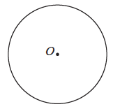

On the diagram, draw a radius of the circle.
(Total for Question 2 is 1 mark)
___________________________________________________________________________

3 Write as a percentage.

.......................................................%
(Total for Question 3 is 1 mark)
___________________________________________________________________________

4 Here is a number machine.

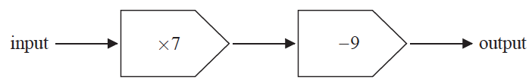

(a) Work out the output when the input is 8

.......................................................
(1)
(b) Work out the input when the output is 82

.......................................................
(2)
(Total for Question 4 is 3 marks)
___________________________________________________________________________

5 The pictogram shows information about the number of naan breads sold in a restaurant
each day from Wednesday to Saturday.
Wednesday |  |  | represents  8 naan  breads
Thursday
Friday
Saturday
Sunday

(a) How many naan breads were sold on Wednesday?

.......................................................
(1)

More naan breads were sold on Saturday than were sold on Friday.
(b) How many more?

.......................................................
(2)

12 naan breads were sold in the restaurant on Sunday.
(c) Show this information on the pictogram.
(1)

The manager of the restaurant says,
“More than 100 naan breads were sold in the restaurant from Wednesday to Sunday.”
(d) Is the manager correct?
You must show your working.

......................................................................................................................................................
(2)
(Total for Question 5 is 6 marks)
___________________________________________________________________________

6 Here are four cards.
Each card has a number on it.
The four cards are arranged to make the number 2745

(i) Show how the cards can be arranged to make the smallest number using all four cards.

(ii) Show how the cards can be arranged to make an even number using all four cards.

(Total for Question 6 is 2 marks)
___________________________________________________________________________

7 Write 0.72 as a fraction.
Give your fraction in its simplest form.

.......................................................
(2)
(Total for Question 7 is 2 marks)
___________________________________________________________________________

8
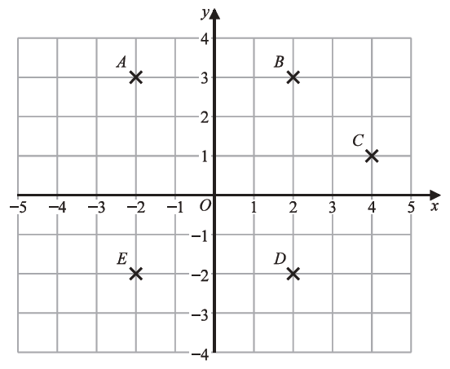

(a) Write down the coordinates of point B.

(.................................. , ..................................)
(1)
(b) Write down the letter of the point with coordinates (2, −2)

.......................................................
(1)
(c) Find the coordinates of the midpoint of AC.

(.................................. , ..................................)
(2)
(Total for Question 8 is 4 marks)
___________________________________________________________________________

9 Here is a list of eight numbers.

10 | 23 | 27 | 30 | 42 | 52 | 74 | 81

From the list, write down
(i) a square number

.......................................................
(ii) a factor of 50

.......................................................
(iii) a prime number.

.......................................................
(Total for Question 9 is 3 marks)
___________________________________________________________________________

10 The table shows the temperature in each of five Canadian cities one day in January.

City | Temperature
Vancouver | 6 °C
Edmonton | −8 °C
Yellowknife | −23 °C
Quebec | −20 °C
Ottawa | −5 °C

(a) Work out the difference between the temperature in Vancouver and the temperature in
Edmonton.

....................................................°C
(1)

The temperature in Yellowknife is lower than the temperature in Ottawa.
(b) How much lower?

....................................................°C
(1)

The temperature in Winnipeg was 8 °C greater than the temperature in Quebec.
(c) Work out the temperature in Winnipeg.

....................................................°C
(1)
(Total for Question 10 is 3 marks)
___________________________________________________________________________

11 Imran throws an ordinary fair dice.
(a) On the probability scale, mark with a cross (×) the probability that the dice will land
on 10

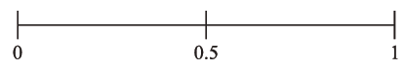
(1)
(b) On the probability scale, mark with a cross (×) the probability that the dice will land
on an odd number.

(1)
(Total for Question 11 is 2 marks)
___________________________________________________________________________

12
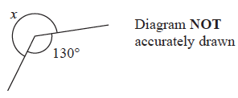

Work out the size of the angle marked x.

....................................................°
(Total for Question 12 is 1 mark)
___________________________________________________________________________

13 Simplify 3e + 7g + 5e – 4g

.......................................................
(Total for Question 13 is 2 marks)
___________________________________________________________________________

14 Here is a centimetre grid.
(a) On the grid, draw a rectangle with a perimeter of 14 cm.

(2)

Here is a centimetre grid.
(b) On the grid, draw a right-angled triangle with an area of 12 cm²

(2)
(Total for Question 14 is 4 marks)
___________________________________________________________________________

15 Bella buys
4 packets of sandwiches at £2.40 each packet
a bottle of water for £1.20
and 3 packets of crisps.
Bella pays with a £20 note.
She gets £5.75 change.
Each packet of crisps has the same price.
Work out the price of each packet of crisps.

£ .......................................................
(Total for Question 15 is 3 marks)
___________________________________________________________________________

16 Here is a pentagon.

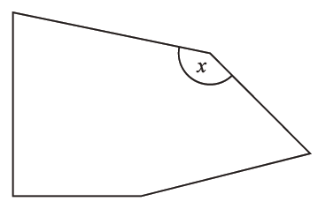

acute | obtuse | reflex | right

(a) Write down the word from the box that describes the angle marked x.

....................................................... angle
(1)
(b) Write down the mathematical name of the following polygon.
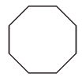

.......................................................
(1)
(Total for Question 16 is 2 marks)
___________________________________________________________________________

17 Expand w(w + 3)

.......................................................
(Total for Question 17 is 1 mark)
___________________________________________________________________________

18 Simplify w⁵ × w⁷

.......................................................
(Total for Question 18 is 1 mark)
___________________________________________________________________________

19 Simplify a + a + a + a

.......................................................
(Total for Question 19 is 1 mark)
___________________________________________________________________________

20 Solve 3f − 5 = 11

f = .......................................................
(Total for Question 20 is 2 marks)
___________________________________________________________________________

21 Simplify t ⁹ ÷ t ³

.......................................................
(Total for Question 21 is 1 mark)
___________________________________________________________________________

22 On the grid, draw the graph of y = 2x – 3 for values of x from –1 to 5

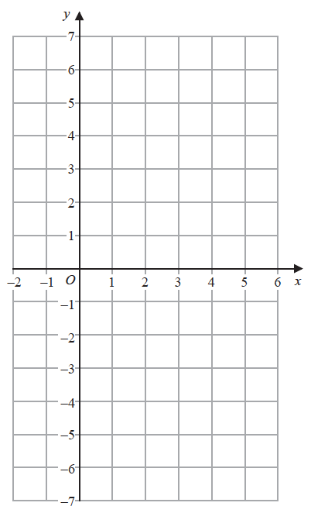

(Total for Question 22 is 3 marks)
___________________________________________________________________________

23 The diagram shows a circle with centre O.

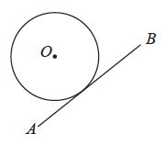

Write down the word from the box that describes the line AB.

sector | segment | tangent | chord | diameter

.......................................................
(Total for Question 23 is 1 mark)
___________________________________________________________________________

24 Factorise 5y + 15

.......................................................
(1)
(Total for Question 24 is 1 mark)
___________________________________________________________________________

25 Potatoes cost 2 dollars per kg.
Carrots cost 3 dollars per kg.
Alfred buys p kg of potatoes and c kg of carrots.
The total cost is T dollars.
Write down a formula for T in terms of p and c.

.......................................................
(Total for Question 25 is 3 marks)
___________________________________________________________________________

26 Here is a number machine.

The input is y.
Find an expression, in terms of y, for the output.

.......................................................
(Total for Question 26 is 2 marks)
___________________________________________________________________________

27 y = 5e² + 20
Work out the value of y when e = −3

y = .......................................................
(Total for Question 27 is 2 marks)
___________________________________________________________________________

28 Show that

(Total for Question 28 is 3 marks)
___________________________________________________________________________

29 Simplify 3c × 5c

.......................................................
(Total for Question 29 is 1 mark)
___________________________________________________________________________

30 Make y the subject of H = 3y – w

.......................................................
(Total for Question 30 is 2 marks)
___________________________________________________________________________

31
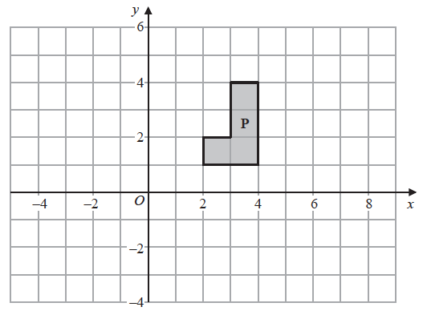
(a) On the grid above, translate shape P by the vector
(1)

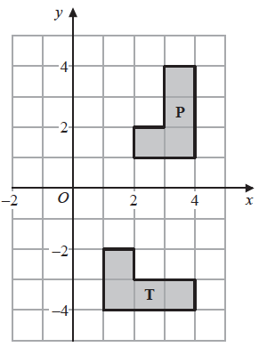
(b) Describe fully the single transformation that maps shape P onto shape T.
......................................................................................................................................................
......................................................................................................................................................
(3)
(Total for Question 31 is 4 marks)
___________________________________________________________________________

32 The scale diagram shows the position of two statues, A and B, on a map.

Scale: 2 cm represents 1 km

(a) Measure the bearing of B from A.

....................................................... °
(1)

Another statue C is on a bearing of 120° from B.
Statue C is 4.5 km from B.
(b) Mark the position of statue C with a cross (×).
Label your cross C.
(3)
(Total for Question 16 is 4marks)
___________________________________________________________________________

33 Simplify (5xy²)³

.......................................................
(Total for Question 33 is 2 marks)
___________________________________________________________________________
34 Factorise x² − 5x − 36

.......................................................
(Total for Question 34 is 2 marks)
___________________________________________________________________________

35 Line L is drawn on the grid.
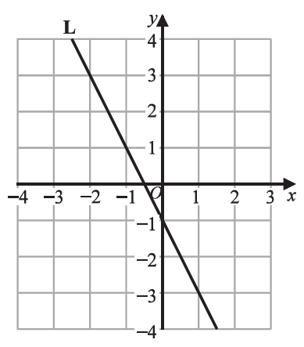

Find an equation for L.

.......................................................
(Total for Question 35 is 3 marks)

TOTAL FOR PAPER IS 80 MARKS

