GCSE Mathematics
Practice Tests: Set 11
Paper 2F/3F (Calculator)
Time: 1 hour 30 minutes
You should have: Ruler graduated in centimetres and millimetres, protractor, pair of compasses, pen, HB pencil, eraser, calculator. Tracing paper may be used.

Instructions
- Use black ink or ball-point pen.
- Fill in the boxes at the top of this page with your name,
centre number and candidate number.
- Answer all questions.
- Answer the questions in the spaces provided
– there may be more space than you need.
- Calculators may be used.
- Diagrams are NOT accurately drawn, unless otherwise indicated.
- You must show all your working out.

Information
- The total mark for this paper is 80
- The marks for each question are shown in brackets
– use this as a guide as to how much time to spend on each question.

Advice
- Read each question carefully before you start to answer it.
- Keep an eye on the time.
- Try to answer every question.
- Check your answers if you have time at the end.
Answer ALL questions.

Write your answers in the spaces provided.

You must write down all the stages in your working.

1 Work out 65% of 720

.......................................................
(Total for Question 1 is 2 marks)
___________________________________________________________________________

2 Sandeep has £12 rupees to spend on pencils.
Each pencil costs 45 pence.
Sandeep buys as many pencils as he can.
Work out how much change Sandeep should get.

(Total for Question 2 is 3 marks)

3 Write these numbers in order of size.
Start with the smallest number.

0.43 |  | 40.5% |  | 0.427

......................................................................................................................................................
(Total for Question 3 is 2 marks)
___________________________________________________________________________

4 Leslie increases all the prices on his restaurant menu by 8%
Before the increase, the price of a dessert was £4.25
Work out the price of the dessert after the increase.

£ .......................................................
(Total for Question 4 is 3 marks)
___________________________________________________________________________

5 The diagram shows kite ABCD.
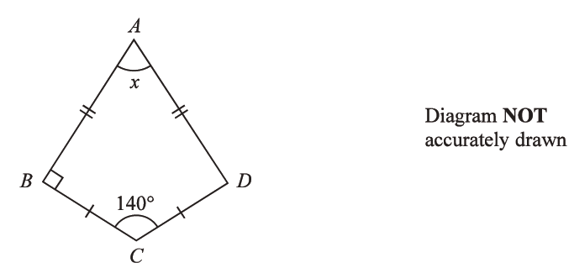

Work out the size of the angle marked x.

....................................................... °
(Total for Question 5 is 2 marks)
___________________________________________________________________________

6 There are some ice lollies in a freezer.
The flavour of each ice lolly is banana or strawberry or mint or chocolate.
Julius takes at random an ice lolly from the freezer.
The table shows the probabilities that the flavour of the ice lolly that Julius takes is banana or strawberry or chocolate.

Flavour | banana | strawberry | mint | chocolate
Probability | 0.35 | 0.32 |  | 0.12

Work out the probability that the flavour of the ice lolly that Julius takes is either strawberry or mint.

......................................................
(Total for Question 6 is 3 marks)
___________________________________________________________________________
7 Find the highest common factor (HCF) of 21 and 35

.......................................................
(Total for Question 7 is 1 mark)
___________________________________________________________________________

8 (a) Work out the value of
Give your answer as a decimal.
Write down all the figures on your calculator display.

.......................................................
(2)
(b) Give your answer to part (a) correct to 2 significant figures.

.......................................................
(1)
(Total for Question 8 is 3 marks)
___________________________________________________________________________

9 This graph can be used to find the distance travelled, in kilometres, by Chuck’s car and the amount of petrol, in litres, used.

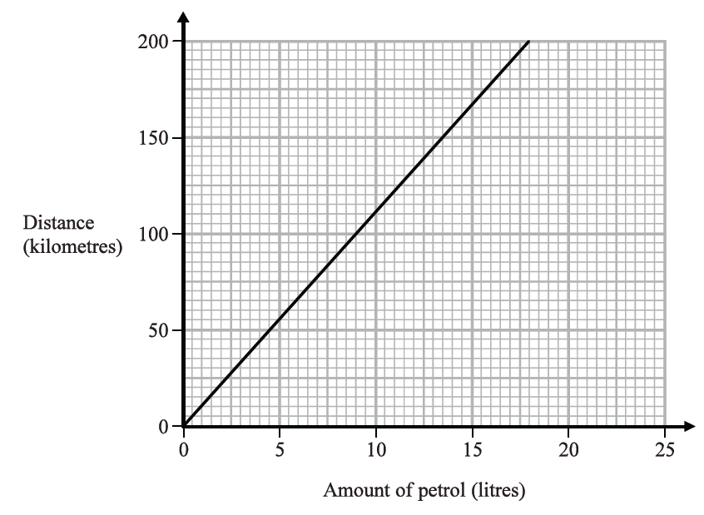

Chuck travels 150 kilometres in his car.
(a) Using the graph, find the amount of petrol used.

....................................................... litres
(1)

Chuck lives in Fiji.
He puts petrol into the petrol tank of his car.
This petrol costs him 16.24 Fiji dollars.
1 litre of petrol in Fiji costs 2.03 Fiji dollars.
(b) Find the distance that Chuck’s car travels on the petrol he put in his car.

....................................................... kilometres
(3)
(Total for Question 9 is 4 marks)
___________________________________________________________________________
10 Anjali travels from Beijing to Shanghai by train.
The train leaves Beijing at 0725
The train arrives in Shanghai at 13 15 the same day.
Work out how long the train takes to travel from Beijing to Shanghai.
Give your answer in hours and minutes.

............................ hours ............................ minutes
(Total for Question 10 is 2 marks)
___________________________________________________________________________

11 Three bags, A, B and C, each contain some marbles.

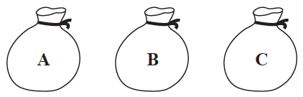

There is a total of 75 marbles in the three bags.
of the marbles are in bag A.
There are 4 more marbles in bag B than in bag C.
Work out the number of marbles in each bag.

Bag A .......................................................

Bag B .......................................................

Bag C .......................................................
(Total for Question 11 is 3 marks)
___________________________________________________________________________

12 Karl has 5700 bricks.
He wants to put all the bricks into crates.

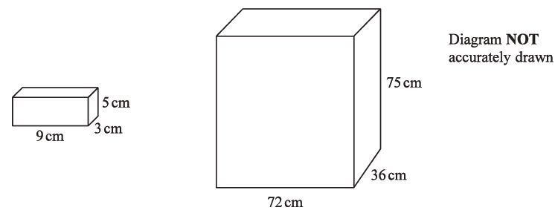

Each brick is a cuboid measuring 9 cm by 3 cm by 5 cm.
Each crate is a cuboid measuring 72 cm by 36 cm by 75 cm.
Karl has 4 crates.
Is there enough room in the 4 crates for 5700 bricks?
Show your working clearly.

(Total for Question 12 is 4 marks)
___________________________________________________________________________

13 A football team played 55 games.
Each game was won, drawn or lost.
number of games won : number of games drawn : number of games lost = 6 : 3 : 2
Work out how many more games the team won than the team lost.

......................................................
(Total for Question 13 is 3 marks)
___________________________________________________________________________

14 Maria is going to make blackcurrant pies.
Here is a list of ingredients to make 6 blackcurrant pies.

Blackcurrant pies
Ingredients for 6 pies
150 g flour
420 g blackcurrants
170 g sugar
95 g butter

Maria has the following ingredients.
755 g of flour 1265 g of blackcurrants
685 g of sugar 950g of butter

Work out the greatest number of blackcurrant pies that Maria can make using her ingredients. Show your working clearly.

.......................................................
(Total for Question 14 is 4 marks)
___________________________________________________________________________
15 Work out (6 × 10⁷) ÷ (8 × 10⁻²)
Give your answer in standard form.

.......................................................
(Total for Question 15 is 2 marks)
___________________________________________________________________________

16 Write 720 as a product of its prime factors.
Show your working clearly.

.......................................................
(Total for Question 16 is 3 marks)
___________________________________________________________________________

17 The diagram shows kite PQRS.

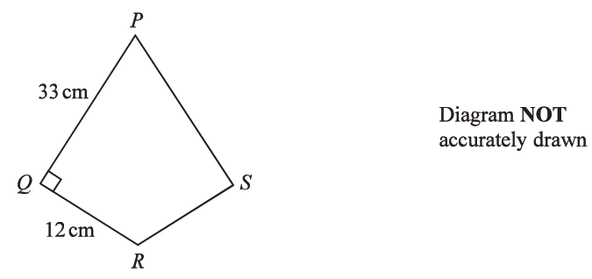

Work out the area of kite PQRS.

....................................................... cm²
(Total for Question 17 is 2 marks)
___________________________________________________________________________

18 Henri buys a yacht for £150 000.
The yacht depreciates in value by 18% each year.
Work out the value of the yacht at the end of 3 years.
Give your answer correct to the nearest £.

£.......................................................
(Total for Question 18 is 3 marks)
___________________________________________________________________________

19 Write 840000 in standard form.

.......................................................
(Total for Question 19 is 1 mark)
___________________________________________________________________________

20 Solve the inequality 4y − 13 ≤ y + 8

.......................................................
(Total for Question 20 is 2 marks)
___________________________________________________________________________

21 Find the smallest whole number that 720 can be multiplied by to give a square number.

.......................................................
(Total for Question 21 is 1 mark)
___________________________________________________________________________

22 Change 22 metres per second to a speed in kilometres per hour.
Show your working clearly.

....................................................km/h
(Total for Question 22 is 3 marks)
___________________________________________________________________________

23 A box of 12 toy cars contains
3 red cars
4 blue cars
5 yellow cars
Some extra red cars are put in the box.
When a car is taken at random from the box, the probability that the car is yellow is
Work out the number of extra red cars that are put in the box.

.......................................................
(Total for Question 23 is 2 marks)
___________________________________________________________________________
24 Ravina counts the number of matches in each of 40 boxes of matches.
The table shows information about her results.

Number of matches | Frequency
21 | 13
22 | 8
23 | 8
24 | 6
25 | 5

(a) Find the median of the numbers of matches in the boxes.

.......................................................
(2)
(b) Work out the mean number of matches.

.......................................................
(2)
(Total for Question 24 is 5 marks)
___________________________________________________________________________
25 The diagram shows a cylinder.

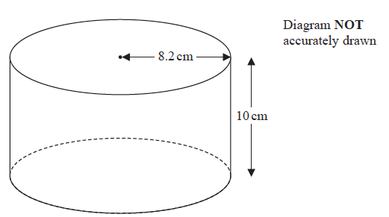

The cylinder has radius 8.2 cm and height 10 cm.
The cylinder is empty.
Pam pours 1.5 litres of water into the cylinder.
Work out the depth of the water in the cylinder.
Give your answer correct to 1 decimal place.

....................................................cm
(Total for Question 25 is 3 marks)
___________________________________________________________________________

26 There are 10 people in a lift.
These 10 people have a mean weight of 79.2 kg.
3 of these people get out of the lift.
These 3 people have a mean weight of 68 kg.
Work out the mean weight of the 7 people left in the lift.

....................................................kg
(Total for Question 26 is 3 marks)
___________________________________________________________________________

27 3 years ago, the ratio of Tom’s age to Clemmie’s age was 2 : 7
Tom is now 15 years old and Clemmie is now x years old.
Find the value of x.

x = .......................................................
(Total for Question 27 is 3 marks)
___________________________________________________________________________

28 Each interior angle of a regular polygon is 162°
Work out the number of sides the polygon has.

.......................................................
(Total for Question 28 is 3 marks)
___________________________________________________________________________

29 Lorenzo increases all the prices on his restaurant menu by 8%
After the increase, the price of lasagne is £9.45
Work out the price of lasagne before the increase.

£ .......................................................
(Total for Question 29 is 3 marks)
___________________________________________________________________________

30 ABC and DEF are similar triangles.

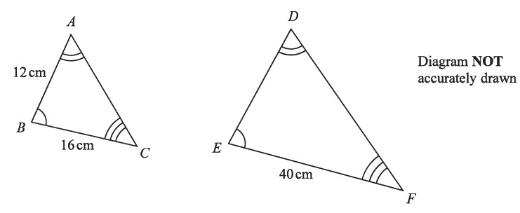

Work out the length of DE.

....................................................... cm
(Total for Question 30 is 2 marks)

TOTAL FOR PAPER IS 80 MARKS

