PHILOSOPHY AND ETHICS STUDENT HANDBOOK

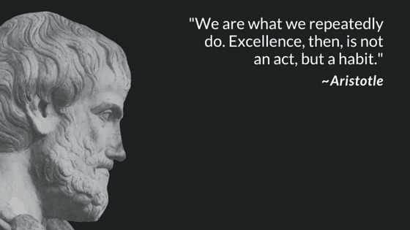

CONTENT

- INTRODUCTION TO THE DEPARTMENT.

- SPECIFICATION OVERVIEW.

- DEPARTMENT RESOURCES, RECOMMENDED TEXTBOOKS AND DIGITAL RESOURCES.

INTRODUCTION TO THE DEPARTMENT.

We are pleased that you have chosen to begin or continue your studies in the subject and look forward to having you on the course. Philosophy and ethics is a popular and important part of the curriculum offered to Year 12 and Year 13 students, it is well resourced and taught. The teachers are all specialists, with their own enthusiasm for the subject and do their upmost to ensure the success of every student. It goes without saying, then, that cultivating a positive work ethic will be central to your success in the subject.

Teaching staff: Mrs Odusola – Head of Department

Mrs Heaton – Teacher of Religious Studies

If you meet our minimum entry requirements, it is almost certain that you have some, or indeed, many of the attributes of a good philosophy and ethics student. They include, but are not limited to:

- Command of clear and coherent oral and/or written expression. Persistent in following or constructing a line of reasoning. This may well involve the asking of pertinent questions of the teacher, of text or of theorists. Little is taken at face value! These pupils are analytical!

- Has empathy with people from different faith positions.

- Has the ability to offer points of view and is able to question others’ views intelligently.

- Enjoys reading and researching around the subject.

- Works hard to diligently complete task to the highest standard, catching up on missed assignments and gaps in knowledge.

- Engages with peer study groups created to provide support and a space to discuss and unpack challenging concepts.

The departments external examination results have been consistently commendable. A pleasing number of students have continued their study of Philosophy at University.

SPECIFICATION OVERVIEW

At LPGS we follow the AQA A-level Religious Studies course which was introduced in September 2016. This qualification is linear. Linear means that students will sit all their exams at the end of the course in May/June 2022.
This course attracts no coursework.

You will have up to twelve 50-minute lessons over 2 weeks. These will consist of Ethics and Philosophy lessons each taught by separate members of the department.

There are two assessed components. Students must take assessments in both Component 1 Philosophy of religion and ethics and Component 2 Study of religion and dialogues in the same exam series.

Component 1: Philosophy of religion and ethics (7062)
What's assessed:

Section A: Philosophy of religion

- Arguments for the existence of God
- Evil and suffering
- Religious experience
- Religious language
- Miracles
- Self and life after death.

Section B: Ethics and religion

- Ethical theories
- Issues of human life and death
- Issues of animal life and death
- Introduction to meta ethics
- Free will and moral responsibility
- Conscience
- Bentham and Kant.

How it's assessed

Written exam: 3 hours
100 marks
50% of A-level

Questions

Section A: Philosophy of religion – two compulsory two-part questions, each worth 10 marks and 15 marks.

Section B: Ethics and religion – two compulsory two-part questions, each worth 10 marks and 15 marks.

In both sections, questions may span more than one topic. In each two-part question, the first part tests AO1 and the second part tests AO2.

Component 2: Study of religion and dialogues
What's assessed

Section A: Study of religion –Christianity. The following topics are covered:

- Sources of wisdom and authority
- God/gods/ultimate reality
- Self, death and the afterlife
- Good conduct and key moral principles
- Expression of religious identity
- Religion, gender and sexuality
- Religion and science
- Religion and secularisation
- Religion and religious pluralism.

Section B: The dialogue between philosophy of religion and religion.

How religion is influenced by, and has an influence on philosophy of religion in
relation to the issues studied.

Section C: The dialogue between ethical studies and religion.

How religion is influenced by, and has an influence on ethical studies in relation to
the issues studied.

How it's assessed

Written exam: 3 hours
100 marks
50% of A-level
Questions

Section A: Study of religion – two compulsory two-part questions, each worth 10 marks and 15 marks relating to the religion chosen. Questions may be set that span more than one topic. In each two-part question, the first part tests AO1 and the second part tests AO2.

Section B: The dialogue between philosophy of religion and religion – one unstructured synoptic question from a choice of two (25 marks).

Section C: The dialogue between ethical studies and religion – one unstructured synoptic question from a choice of two (25 marks).

DEPARTMENT RESOURCES,
RECOMMENDED TEXTBOOKS AND DIGITAL RESOURCES

In addition to basic course materials and access to online resources, you will be provided with the core textbook specifically written for our years 12 and 13 syllabus. Some students like to purchase a personal copy to allow them to annotate and make note in.

Year 12: AQA Religious Studies for A-Level year 1 and AS
John Frye 2017

Year 13: AQA Religious Studies for A-Level
John Frye 2017

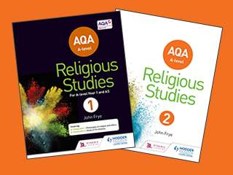

Personal resources

It will be your responsibility to purchase additional resources such as folders (one each for Philosophy and Ethics), dividers, paper and stationary.

Additional reading

Religious Studies: Philosophy and Ethics: through diagrams. Greg Dewar, Oxford University Press

- Foundations for the Study of Religion by Libby Ahluwalia

- Access to Philosophy of Religion by Peter Cole

- The Puzzle of God by Peter Vardy

- The Puzzle of Ethics by Peter Vardy and Paul Grosch

- Ethics and Religion by Joe Jenkins, 2003 Heinemann

- Examining Philosophy and Ethics – Answers for A Level. Patrick J Clarke, 2002 Nelson Thornes

- Frye, J, 2017. Religious Studies for A-Level Year 1 and AS

- Frye, J, et al, 2017. Religious Studies for A-Level Year 2

- Davies, B. 1983, 1993, 2004. An Introduction to Philosophy of Religion

- Cole, P. 2008. Philosophy of Religion (Access to Religion)

- Jordan, A, Lockyer N and Tate, E. 1999. Philosophy of Religion for A-Level

- Vardy, P and Arliss, J. 2003. The Thinkers Guide to God

- Vary, P and Vardy, C. 2013. God Matters

- Thompson, M. 2010. Understand the Philosophy of Religion: Teach Yourself

- Gaarder, J. 1995. Sophie’s World

- Hansell, N. 2016. The Sage Train (Philosophy comes to Life)

- Bowie, R. 2001. Ethical Studies

- Vardy, P and Grosch, P. 1999. The Puzzle of Ethics

- Vary, P and Vardy, C. 2012. Ethics Matters

- Thompson, M. 2010. Understand Ethics: Teach Yourself

- Hodder. RS Review

A Level philosophy and ethics requires you to back up your answers with the most RECENT RELEVANT EXAMPLES that you can find. In addition, it is useful to read more ‘challenging’ texts than you may be used to so that you learn how to write superior quality answers in your examinations. To help you do this it is recommended that:

- You could consider subscribing to the RS Association’s magazine “Religious Studies Today" which is published three times a year. This has many in depth articles on a broader range of religious issues.

- It helps to read a quality newspaper (The Times, Telegraph, Guardian, Independent, Sunday Times, Observer, Sunday Telegraph, Independent on Sunday) at least once a week. Probably your best bet would be read a Sunday paper as they tend to have more of the sort of analysis and comment that you would find helpful.

Newspapers: Very useful for archived articles and if you miss any stories which may be of use:
www.guardianunlimited.co.uk
www.telegraph.co.uk
www.independent.co.uk
www.timesonline.co.uk
www.sunday-times.co.uk
Contemporary Moral, Philosophical and Religious Issues

The internet, other media learning sites:

- www.AQA.org.uk– the website of the exam board, you can download specifications, examiners reports etc.

- www.nelsonthornes.com/secondary/re/ethics/ethicalstudies -A support site for the Bowie books with tests, mindmaps and links to pages for each chapter.

- www.ethics.acusd.edu.index – Ethics updates. Have current literature, many articles and links.

- www.philosophypages.com – This is an online short-entry dictionary of philosophy and philosophers.

- www.utm.edu/research/iep - This valuable encyclopaedia has articles on philosophers and ethicists.

- www.epistemelinks.com – This is a thorough links site for ethics and philosophy, with substantial search facilities.

- www.philosophers.co.uk – This is an online version of the excellent magazine, which is a must for A Level Philosophy and Ethics courses. Subscribers to the magazine get full access to the archive resource. Very worthwhile.

- www.britannica.com – The encyclopaedia is online and it has a very thorough section on philosophy and ethics.

- www.rsweb.org.uk – A website providing links and tips for students of Religious Studies at A Level.

- www.faithnet.org.uk

- www.bbc.co.uk/news



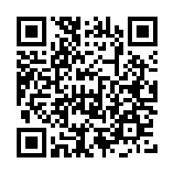
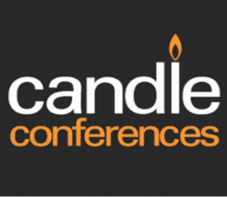













**WHEN USING WEBSITES REMEMBER TO THINK OF ITS AUTHOR AND PURPOSE. IS THE INFORMATION PRESENTED TRUE? IS IT REPRESENTATIVE OF THE COMMUNITY BEING STUDIED ETC**

TV and films

- Religious and ethical issues get lots of coverage on the TV. You should try to watch the news as often as possible. Look out for documentaries and movies on streaming platform like Netflix.

- “Newsnight”-looks at events in more depth and is good at explaining complicated news items.

- “Channel 4 News” is useful for its daily bulletin.

- Look out for the latest TED talks, podcasts and forums on philosophical and ethical issues.

