GCSE Mathematics
Practice Tests: Set 10
Paper 1H (Non-calculator)
Time: 1 hour 30 minutes
You should have: Ruler graduated in centimetres and millimetres, protractor, pair of compasses, pen, HB pencil, eraser, calculator. Tracing paper may be used.

Instructions
- Use black ink or ball-point pen.
- Fill in the boxes at the top of this page with your name,
centre number and candidate number.
- Answer all questions.
- Answer the questions in the spaces provided
– there may be more space than you need.
- Calculators may be used.
- Diagrams are NOT accurately drawn, unless otherwise indicated.
- You must show all your working out.

Information
- The total mark for this paper is 80
- The marks for each question are shown in brackets
– use this as a guide as to how much time to spend on each question.

Advice
- Read each question carefully before you start to answer it.
- Keep an eye on the time.
- Try to answer every question.
- Check your answers if you have time at the end.
Answer ALL questions.

Write your answers in the spaces provided.

You must write down all the stages in your working.

1 (a) Write 5.7 × 10⁶ as an ordinary number.

....................................................................
(1)
(b) Write 0.004 in standard form.

....................................................................
(1)
(Total for Question 1 is 2 marks)
____________________________________________________________________________

2 (a) Simplify e⁹ ÷ e⁵

.......................................................
(1)
(b) Simplify (y²)⁸

.......................................................
(1)
(c) Expand and simplify (x + 9)(x – 2)

....................................................................
(2)
(d) Factorise fully 16c⁴p² + 20cp³

.......................................................
(2)
(Total for Question 2 is 6 marks)
____________________________________________________________________________

3 (a) Complete the table of values for y = x² − 3x − 1

x | −2 | −1 | 0 | 1 | 2 | 3 | 4
y |  |  | −1 |  | −3 |  | 3
(2)
(b) On the grid, draw the graph of y = x² − 3x – 1 for all values of x from −2 to 4
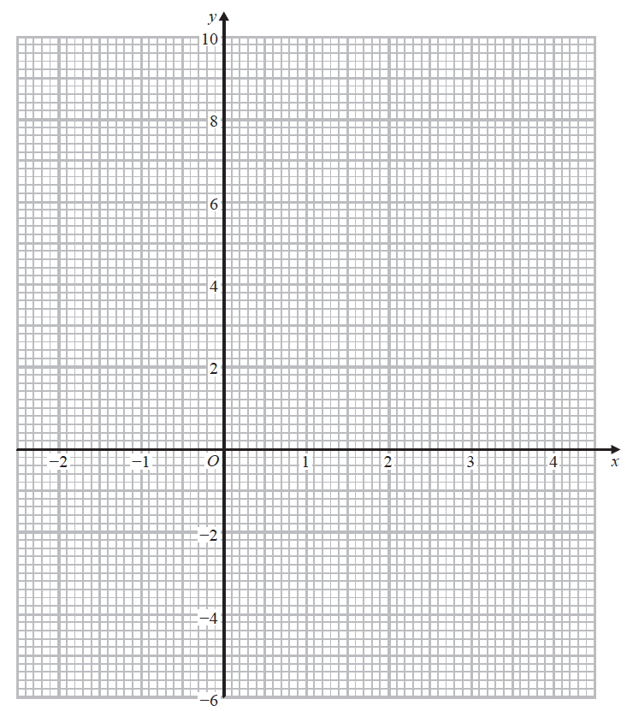
(2)
(Total for Question 3 is 4 marks)
____________________________________________________________________________

4 Show that

(Total for Question 4 is 3 marks)
____________________________________________________________________________

5 In group C, there are 6 girls and 8 boys.
In group D, there are 3 girls and 7 boys.
A team is made by picking at random one child from group C and one child from group D.
(a) Complete the probability tree diagram.

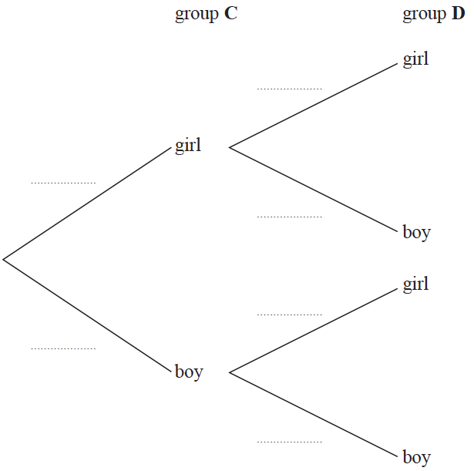
(2)
(b) Work out the probability that there are two boys in the team.

.......................................................
(2)
(Total for Question 5 is 4 marks)
____________________________________________________________________________

6 Use ruler and compasses to construct the perpendicular bisector of the line DE.
You must show all your construction lines.

(Total for Question 6 is 2 marks)
____________________________________________________________________________

7 E = {1, 2, 3, 4, 5, 6, 7, 8, 9, 10}
A = {2, 3, 5, 7}
B = {4, 6, 8, 10}
(a) Explain why A ∩ B has no elemnts.

......................................................................................................................................................
......................................................................................................................................................
......................................................................................................................................................
(1)

x ∈ E and x ∉ A ∪ B
(b) Write down the two possible values of x.

............................. , .............................
(1)

Set C is such that
A B C = E
A C = {2}
B C ′ = {4, 6, 10}
(c) List all the members of set C.

.............................................................................................................
(2)
(Total for Question 7 is 4 marks)
____________________________________________________________________________
8 The diagram shows a shape made from a right-angled triangle and a semicircle.

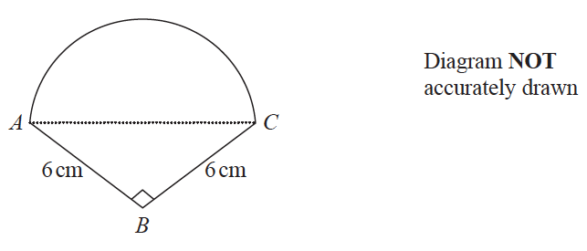

AC is the diameter of the semicircle.
BA = BC = 6 cm
Angle ABC = 90°
Work out the area of the shape.
Give your answer correct to 1 decimal place.

....................................................... cm²
(Total for Question 8 is 5 marks)
____________________________________________________________________________

9 The table gives information about the heights of some trees.

Height (h metres) | Frequency
0 < h ≤ 20 | 15
20 < h ≤ 35 | 48
35 < h ≤ 40 | 21
40 < h ≤ 50 | 16

On the grid, draw a histogram for this information.
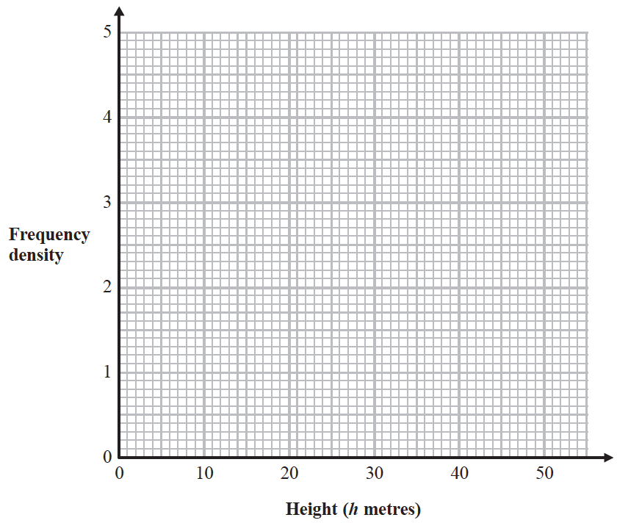

(Total for Question 9 is 3 marks)
____________________________________________________________________________

10 (a) Factorise 2x² − 7x + 6

.......................................................
(2)
(b) Solve = 7 − 2m
Show clear algebraic working.

m = .......................................................
(4)
(c) Write $\frac{\sqrt[4]{y}}{y}$ in the form y^{b} where b is a fraction.

…....................................................
(2)
(Total for Question 10 is 8 marks)

11 E = {positive integers less than 20}

A = {x : x < 12}

B = {x : 7 ≤ x < 16}

List the members of A ∩ B

…...............................................................................
(2)
(Total for Question 11 is 2 marks)

12 Becky has a biased 6-sided dice.
The table gives information about the probability that, when the dice is thrown, it will
land on each number.

Number | 1 | 2 | 3 | 4 | 5 | 6
Probability | 2x | 0.18 | 2x | 3x | 0.26 | x

Becky is going to throw the dice 200 times.
Work out an estimate for the number of times that the dice will land on an even number.

…....................................................
(Total for Question 12 is 4 marks)

13 Make x the subject of the formula y = $\sqrt{\frac{3x−2}{x+1}}$

…....................................................
(Total for Question 13 is 4 marks)
____________________________________________________________________________

14 C = b − a
a = 6 correct to the nearest integer.
b = 15 correct to the nearest 5.
Work out the upper bound for the value of C
Show your working clearly.

.......................................................
(Total for Question 14 is 3 marks)
____________________________________________________________________________
15 Use algebra to show that the recurring decimal

(Total for Question 15 is 2 marks)
____________________________________________________________________________

16 Show that can be written in the form a + b√2, where a and b are integers.
Show each stage of your working clearly and give the value of a and the value of b.

(Total for Question 16 is 3 marks)
____________________________________________________________________________

17 The graph of y = sin x° for 0 ≤ x ≤ 360 is drawn on the grid.
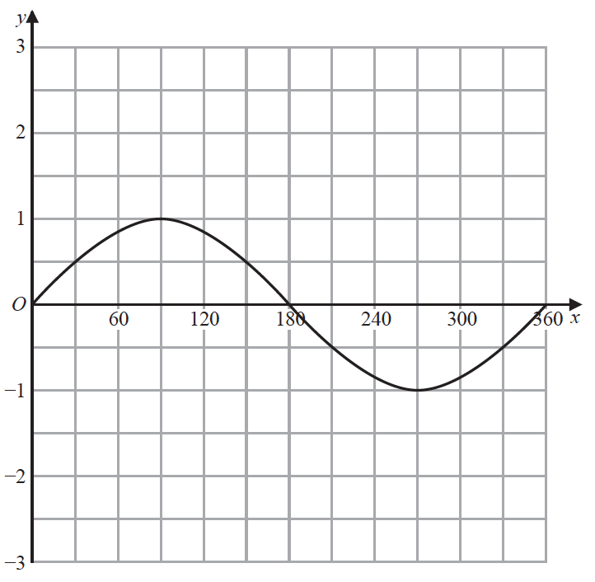

(a) On the grid, draw the graph of y = 2 sin (x + 30)° for 0 ≤ x ≤ 360
(2)
(b) (i) Write x² − 6x + 10 in the form (x – a)² + b where a and b are integers.

.......................................................
(2)
(ii) Hence, describe fully the single transformation that maps the curve with equation
y = x² onto the curve with equation y = x² − 6x + 10
................................................................................................................................................
................................................................................................................................................
(2)
(Total for Question 17 is 6 marks)
____________________________________________________________________________

18 Simplify fully $\frac{6x^{3}+\text{13}x^{2}−5x}{4x^{2}−\text{25}}$

.......................................................
(Total for Question 18 is 3 marks)
____________________________________________________________________________

19 ABCD is a kite with AB = AD and CB = CD.
B is the point with coordinates (10, 19)
D is the point with coordinates (2, 7)
Find an equation of the line AC.
Give your answer in the form py + qx = r where p, q and r are integers.

.......................................................
(Total for Question 19 is 5 marks)
____________________________________________________________________________

20 A = 2^{n} × 3 × 5^{m}
Write 8A as a product of powers of its prime factors.

.......................................................
(Total for Question 20 is 2 marks)
____________________________________________________________________________

21 The function f is such that f (x) = 3x – 2
(a) Find f (5)

.......................................................
(1)

The function g is such that g (x) = 2x² – 20x + 9 where x ⩾ 5
(b) Express the inverse function g^{–1} in the form g^{–1}(x) = ...

g^{–1}(x) = .......................................................
(4)
(Total for Question 21 is 5 marks)

TOTAL FOR PAPER IS 80 MARKS

BLANK PAGE

