
Accessing Firefly from outside of school

Firefly is a web based platform meaning it can be accessed from any device with an internet connection. This includes smart phones, tablets, laptops and desktops.
It is compatible with Windows Apple and Android products.
You may wish to access it from outside of school for several reasons including:
- Checking email
- Sending messages to classes
- Setting homework
- Uploading or viewing lesson resources

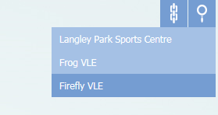
In order to do this you can:
1.Go to the main school site and click on the Firefly VLE quick link towards the top right of the homepage.

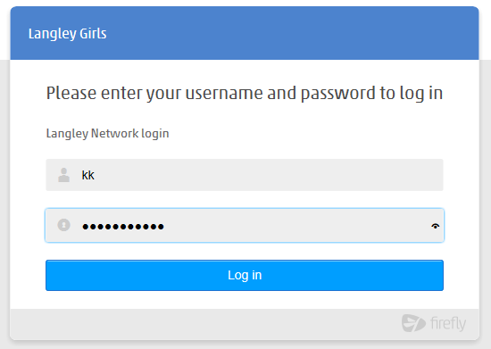
2. Login using your normal school username and password

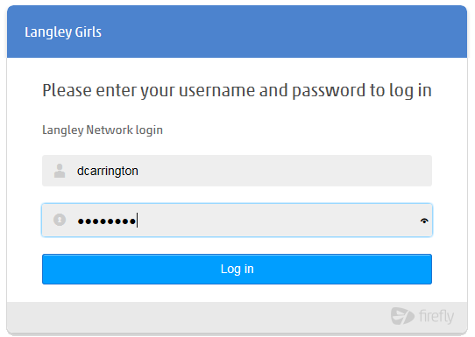

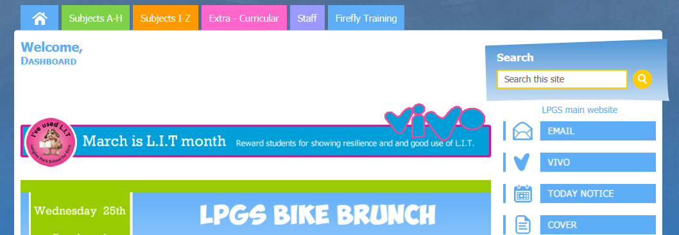
You will be presented with the student dashboard and can access all the Firefly features in the normal way.

