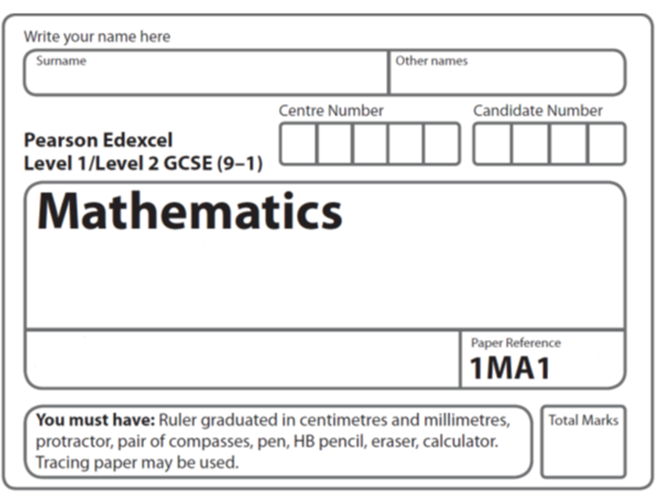
Circle Theorems B
Instructions
- Use black ink or ball-point pen.
  - Fill in the boxes at the top of this page with your name,
centre number and candidate number.
- Answer all questions.
- Answer the questions in the spaces provided
– there may be more space than you need.
- You must show all your working.
- Diagrams are NOT accurately drawn, unless otherwise indicated.
- If your calculator does not have a π button, take the value of π to be 3.142
unless the question instructs otherwise.

Information
- The total mark for this paper is 23. There are 6 questions.
- Questions have been arranged in an ascending order of mean difficulty, as found by all students in the June 2017–November 2019 examinations.
- The marks for each question are shown in brackets
– use this as a guide as to how much time to spend on each question.

Advice
- Read each question carefully before you start to answer it.
- Keep an eye on the time.
- Try to answer every question.
- Check your answers if you have time at the end.

1 A, B, C and D are four points on the circumference of a circle.

AEC and BED are straight lines.
Prove that triangle ABE and triangle DCE are similar.
You must give reasons for each stage of your working.

(Total for Question 1 is 3 marks)
___________________________________________________________________________

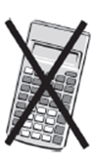
2 A, B, C and D are four points on a circle.

AEC and DEB are straight lines.
Triangle AED is an equilateral triangle.
Prove that triangle ABC is congruent to triangle DCB.

(Total for Question 2 is 4 marks)

3

A, B and C are points on the circumference of a circle, centre O.
AOB is a diameter of the circle.
Prove that angle ACB is 90°
You must not use any circle theorems in your proof.

(Total for Question 3 is 4 marks)
___________________________________________________________________________

4

A, B, R and P are four points on a circle with centre O.
A, O, R and C are four points on a different circle.
The two circles intersect at the points A and R.
CPA, CRB and AOB are straight lines.
Prove that angle CAB = angle ABC.

(Total for Question 4 is 4 marks)
5 A, B, C and D are points on the circumference of a circle, centre O.

Prove that the sum of angle ABC and angle ADC is 180°

(Total for Question 5 is 4 marks)
___________________________________________________________________________

6

A, B and C are points on a circle, centre O.
CT is the tangent to the circle at C.

Prove that angle BAC = angle BCT.

(Total for Question 6 is 4 marks)
___________________________________________________________________________

TOTAL MARKS FOR PAPER: 23

