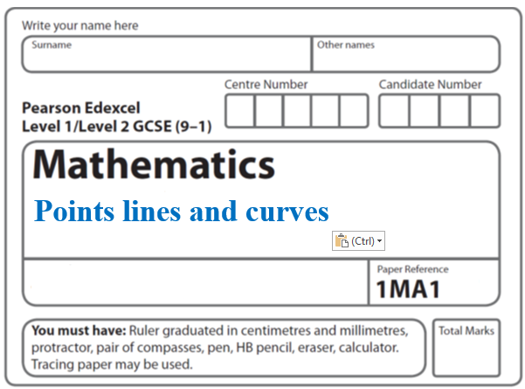Instructions
Transformations: Trig graphs

- Use black ink or ball-point pen.
  - Fill in the boxes at the top of this page with your name,
centre number and candidate number.
- Answer all questions.
- Answer the questions in the spaces provided
– there may be more space than you need.
- You must show all your working.
- Diagrams are NOT accurately drawn, unless otherwise indicated.
- If your calculator does not have a π button, take the value of π to be 3.142
unless the question instructs otherwise.

Information
- The total mark for this paper is 30. There are 11 questions.
- Questions have been arranged in an ascending order of mean difficulty, as found by all students in the June 2017–November 2019 examinations.
- The marks for each question are shown in brackets
– use this as a guide as to how much time to spend on each question.

Advice
- Read each question carefully before you start to answer it.
- Keep an eye on the time.
- Try to answer every question.
- Check your answers if you have time at the end.

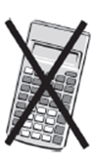
1 Here is the graph of y = sin x° for –180 ⩽ x ⩽ 180

On the grid, sketch the graph of y = sin x° – 2 for –180 ⩽ x ⩽ 180

(Total for Question 1 is 2 marks)
___________________________________________________________________________

2 Sketch the graph of y = tan x° for 0 ⩽ x ⩽ 360

(Total for Question 2 is 2 marks)
___________________________________________________________________________


3 The graph of y = f(x) is shown on the grid.

Graph A is a reflection of the graph of y = f(x).

(a) Write down the equation of graph A.

.........................................
(1)

The graph of y = g(x) is shown on the grid.

Graph B is a translation of y = g(x).

(b) Write down the equation of graph B.

.........................................
(1)
The graph of y = cos x° is shown.

(c) Write down the coordinates of the point marked C.

(............................ , ............................)
(1)
(Total for Question 3 is 3 marks)
___________________________________________________________________________

4 The equation of a curve is y = a^{x}
A is the point where the curve intersects the y-axis.
(a) State the coordinates of A.

( .......................... , ..........................)
(1)

The equation of circle C is x² + y² = 16
The circle C is translated by the vector to give circle B.
(b) Draw a sketch of circle B.
Label with coordinates
the centre of circle B
and any points of intersection with the x-axis.

(3)
(Total for Question 4 is 4 marks)

5 The graph of the curve C with equation y = f(x) is transformed to give the graph of
the curve S with equation y = f(−x) − 3
The point on C with coordinates (7, 2) is mapped to the point Q on S.
Find the coordinates of Q.

(............................ , ............................)
(Total for Question 5 is 2 marks)
___________________________________________________________________________

6 The graph of y = f(x) is shown on the grid below.

(a) On the grid above, sketch the graph of y = f(x – 2)
(1)

On the grid, graph A has been reflected to give graph B.
The equation of graph A is y = g(x)
(b) Write down the equation of graph B.

......................................................
(1)
(Total for Question 6 is 2 marks)
___________________________________________________________________________

7 The graph of y = f(x) is shown on the grid.

(a) On the grid, draw the graph with equation y = f(x + 1) ̶ 3
(2)

Point A(–2, 1) lies on the graph of y = f(x).
When the graph of y = f(x) is transformed to the graph with equation y = f(–x), point A is
mapped to point B.
(b) Write down the coordinates of point B.

(............................ , ............................)
(1)
(Total for Question 7 is 3 marks)
___________________________________________________________________________

8 Here is a sketch of the curve y = sin (x + a)° + b

Given that 0 < a < 360
find the value of a and the value of b.
a = ......................................................
b = ......................................................
(Total for Question 8 is 2 marks)
___________________________________________________________________________

9 The graph of y = x² is reflected in the line with equation y = x to give the curve C.

(a) Sketch the graph of y = x² and the curve C.
Clearly label the graphs.

(Total for Question 9 is 3 marks)

10 Here is a sketch of the graph of a trigonometric function for 0 ≤ x ≤ 360

(a) Write down a possible equation of the graph.

.......................................................
(1)

Here is a sketch of the graph of y = cos (x – p)° + r for 0 ≤ x ≤ 360

(b) Find the value of p and the value of r.

p = .......................................................

r = .......................................................
(2)
(Total for Question 10 is 3 marks)
___________________________________________________________________________

11 (a) Sketch the graph of y = cos x° for 0 ≤ x ≤ 360

(2)

(b) The graph of y = f(x) is shown on both grids below.
(i) On this grid, draw the graph of y = –f(x)

(ii) On the grid below, draw the graph of y = f(x − 3)

(2)
(Total for Question 11 is 4 marks)
___________________________________________________________________________
TOTAL MARKS FOR PAPER: 30

