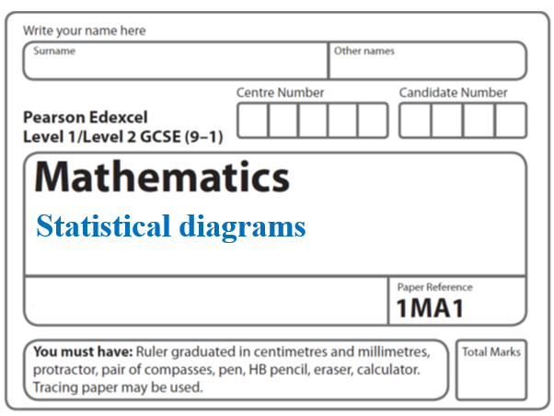Instructions
Scatter graphs and Frequency polygons

- Use black ink or ball-point pen.
  - Fill in the boxes at the top of this page with your name,
centre number and candidate number.
- Answer all questions.
- Answer the questions in the spaces provided
– there may be more space than you need.
- You must show all your working.
- Diagrams are NOT accurately drawn, unless otherwise indicated.
- If your calculator does not have a π button, take the value of π to be 3.142
unless the question instructs otherwise.

Information
- The total mark for this paper is 42. There are 12 questions.
- Questions have been arranged in an ascending order of mean difficulty, as found by all students in the June 2017–November 2019 examinations.
- The marks for each question are shown in brackets
– use this as a guide as to how much time to spend on each question.

Advice
- Read each question carefully before you start to answer it.
- Keep an eye on the time.
- Try to answer every question.
Check your answers if you have time at the end.

1 The scatter graph shows the maximum temperature and the number of hours of sunshine
in fourteen British towns on one day.

One of the points is an outlier.
(a) Write down the coordinates of this point.

( .......................... , ..........................)
(1)
(b) For all the other points write down the type of correlation.

.......................................................
(1)

On the same day, in another British town, the maximum temperature was 16.4°C.
(c) Estimate the number of hours of sunshine in this town on this day.

...................................................... hours
(2)

A weatherman says,
“Temperatures are higher on days when there is more sunshine.”
(d) Does the scatter graph support what the weatherman says?
Give a reason for your answer.

..........................................................................................................................................

..........................................................................................................................................
(1)
(Total for Question 1 is 5 marks)
_____________________________________________________________________

2 Oliver records the distance from London to each of eight cities in the USA.
He also records the time taken to fly from London to each of these cities.
The scatter graph shows this information.

Chicago is a city in the USA.
Chicago is 4000 miles from London.
(a) (i) By drawing a line of best fit, find an estimate for the time taken to fly from
London to Chicago.

.......................................................minutes
(2)
(ii) Why is your answer to part (i) only an estimate?
..........................................................................................................................................
...........................................................................................................................................(1)
(b) (i) Calculate the gradient of your line of best fit.

.......................................................
(2)
(ii) Give an interpretation of the gradient of your line of best fit.
..........................................................................................................................................
..........................................................................................................................................
(1)
(Total for Question 2 is 6 marks)
_____________________________________________________________________

3 The scatter graph shows information about the marks a group of students got in a Science
test and in a Maths test.

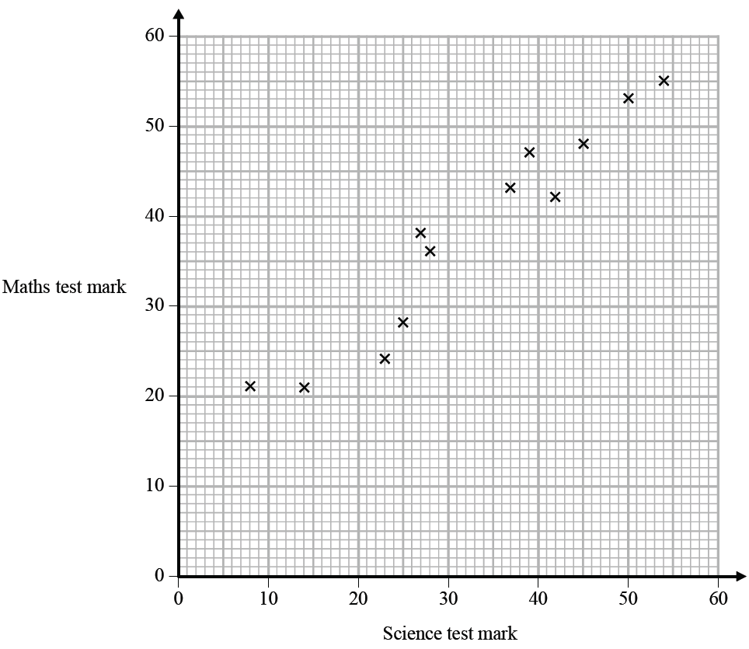

Jamie got a mark of 34 in the Science test.
Using the scatter graph, find an estimate for Jamie’s mark in the Maths test.

.......................................................
(Total for Question 3 is 2 marks)
_____________________________________________________________________
4 The table shows information about the heights of 80 plants.

Height (h cm) | Frequency
10 < h ⩽ 20 | 7
20 < h ⩽ 30 | 13
30 < h ⩽ 40 | 14
40 < h ⩽ 50 | 12
50 < h ⩽ 60 | 16
60 < h ⩽ 70 | 18

(a) Find the class interval that contains the median.

..................................................................................
(1)
(b) On the grid, draw a frequency polygon for the information in the table.

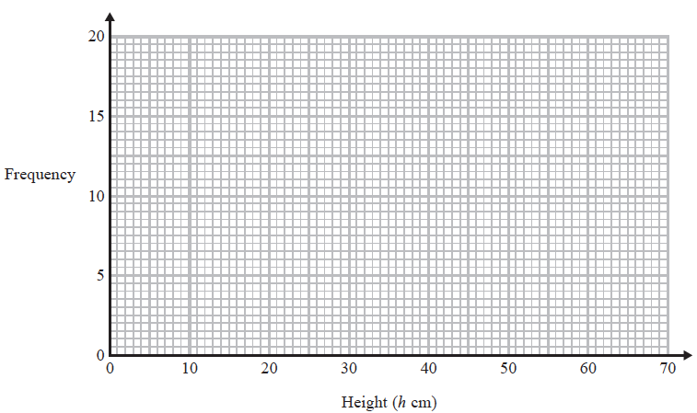
(2)
(Total for Question 4 is 3 marks)
_____________________________________________________________________

5 Jean records the maximum daily temperature each day for 10 days.
She also records the number of children going to a paddling pool for each of these days.
She draws this scatter graph for her information.

Jean’s information for one of these days is an outlier on the scatter graph.

(a) Give a possible reason for this.

..........................................................................................................................................

..........................................................................................................................................
(1)
(b) What type of correlation does the scatter graph show?

.......................................................
(1)
On the 11th day, the maximum daily temperature was 19 °C.

(c) Write down an estimate for the number of children going to the paddling pool on
the 11th day.

.......................................................
(1)
It would not be sensible to use the scatter graph to predict the number of children going
to the paddling pool on a day when the maximum daily temperature was 13°C.

(d) Give a reason why.

..........................................................................................................................................

..........................................................................................................................................
(1)
(Total for Question 5 is 4 marks)
_____________________________________________________________________

6 The table gives information about the times that 100 people took to travel to work.

Time (t minutes) | Frequency
0 < t ≤ 10 | 10
10 < t ≤ 20 | 26
20 < t ≤ 30 | 23
30 < t ≤ 40 | 19
40 < t ≤ 50 | 14
50 < t ≤ 60 | 8

(a) Find the class interval that contains the median.

.......................................................
(1)
(b) Draw a frequency polygon for the information in the table.

(2)
(Total for Question 6 is 3 marks)

7 The table shows information about the heights of 60 trees.

Height (h metres) | Frequency
0 < h ≤ 4 | 13
4 < h ≤ 8 | 24
8 < h ≤ 12 | 15
12 < h ≤ 16 | 6
16 < h ≤ 20 | 2

Jacob drew this frequency polygon for the information in the table.
The frequency polygon is not correct.

Write down two things that are wrong with the frequency polygon.

1........................................................................................................................................

2........................................................................................................................................
(Total for Question 7 is 2 marks)
_____________________________________________________________________

8 The table gives information about the speeds of 70 cars.

Speed (s mph) | Frequency
0 < s ⩽ 10 | 14
10 < s ⩽ 20 | 18
20 < s ⩽ 30 | 26
30 < s ⩽ 40 | 12

Draw a frequency polygon for this information.

(Total for Question 8 is 2 marks)
_____________________________________________________________________

9 Fran asks each of 40 students how many books they bought last year.
The chart below shows information about the number of books bought by each of the 40 students.

(a) Work out the percentage of these students who bought 20 or more books.

.......................................................%
(2)
(b) Show that an estimate for the mean number of books bought is 9.5
You must show all your working.

(4)
(Total for Question 9 is 6 marks)
_____________________________________________________________________

10 The table shows information about the heights of 80 children.

Height (h cm) | Frequency
130 < h ⩽ 140 | 4
140 < h ⩽ 150 | 11
150 < h ⩽ 160 | 24
160 < h ⩽ 170 | 22
170 < h ⩽ 180 | 19

(a) Find the class interval that contains the median.

............................................................................
(1)
(b) Draw a frequency polygon for the information in the table.

(2)
(Total for Question 10 is 3 marks)
_____________________________________________________________________

11 The scatter diagram shows information about 12 girls.
It shows the age of each girl and the best time she takes to run 100 metres.
(a) Write down the type of correlation.

..............................................................................................................
(1)

Kristina is 11 years old.
Her best time to run 100 metres is 12 seconds.
The point representing this information would be an outlier on the scatter diagram.
(b) Explain why.
..........................................................................................................................................

..........................................................................................................................................
(1)

Debbie is 15 years old.
Debbie says,
“The scatter diagram shows I should take less than 12 seconds to run 100 metres.”
(c) Comment on what Debbie says.
..........................................................................................................................................
..........................................................................................................................................
(1)
(Total for Question 11 is 3 marks)
_____________________________________________________________________

12 The scatter graph shows information about 10 adult snakes of the same type.
It shows the length and weight of each snake.
Length (cm)
Weight (g)

An adult snake of this type has a weight of 740 g.
(a) Use the scatter graph to estimate the length of this snake.

....................................................... cm
(2)
Steven wants to estimate the weight of an adult snake of length 110 cm.

He says he will draw a line of best fit and read off the weight at 110 cm.

(b) Explain what is wrong with his method.

..........................................................................................................................................

..........................................................................................................................................
(1)
(Total for Question 12 is 3 marks)

TOTAL MARKS FOR PAPER: 42

