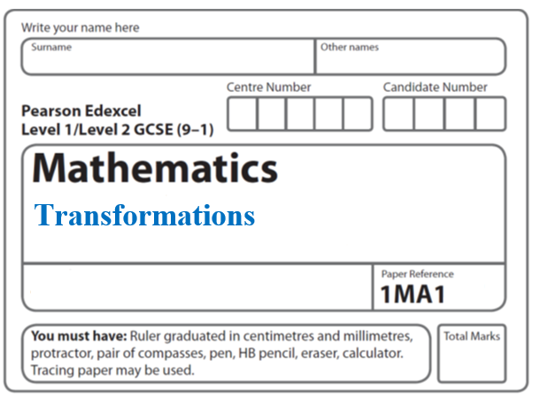Instructions
- Use black ink or ball-point pen.
  - Fill in the boxes at the top of this page with your name,
centre number and candidate number.
- Answer all questions.
- Answer the questions in the spaces provided
– there may be more space than you need.
- You must show all your working.
- Diagrams are NOT accurately drawn, unless otherwise indicated.
- If your calculator does not have a π button, take the value of π to be 3.142
unless the question instructs otherwise.

Information
- The total mark for this paper is 38. There are 17 questions.
- Questions have been arranged in an ascending order of mean difficulty, as found by all students in the June 2017–November 2019 examinations.
- The marks for each question are shown in brackets
– use this as a guide as to how much time to spend on each question.

Advice
- Read each question carefully before you start to answer it.
- Keep an eye on the time.
- Try to answer every question.
- Check your answers if you have time at the end.
1

Describe fully the single transformation that maps triangle P onto triangle Q.

..........................................................................................................................................

..........................................................................................................................................
(Total for Question 1 is 2 marks)
_____________________________________________________________________

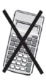
2

Describe fully the single transformation that maps triangle A onto triangle B.

..........................................................................................................................................

..........................................................................................................................................
(Total for Question 2 is 2 marks)
_____________________________________________________________________

3

(a) Rotate shape S 90° clockwise, centre (5, 4)
Label your image T.
(2)
(b) Describe fully the single transformation that will map shape T onto shape S.
..........................................................................................................................................
(1)
(Total for Question 3 is 3 marks)
_____________________________________________________________________

4
Enlarge shape A by scale factor centre (0, 1)

(Total for Question 4 is 2 marks)
_____________________________________________________________________

5

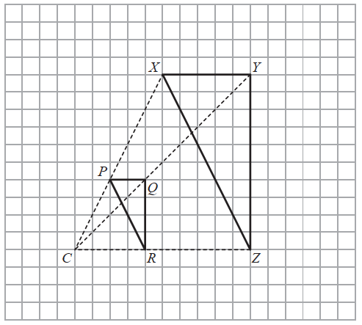

Roy is going to enlarge triangle PQR with centre C and scale factor 1
He draws triangle XYZ.
(b) Explain why Roy’s diagram is not correct.
..........................................................................................................................................
..........................................................................................................................................
..........................................................................................................................................
(1)
(Total for Question 5 is 2 marks)
_____________________________________________________________________

6
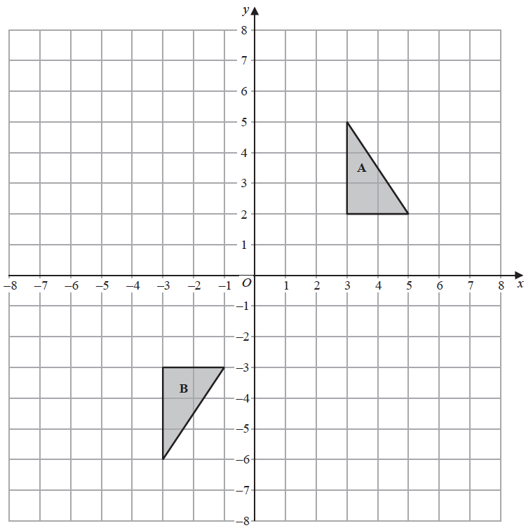
Shape A can be transformed to shape B by a reflection in the x-axis followed by a
translation
Find the value of c and the value of d.

c = .......................................................

d = .......................................................
(Total for Question 6 is 3 marks)
_____________________________________________________________________

7
Shape T is reflected in the line x = −1 to give shape R.
Shape R is reflected in the line y = −2 to give shape S.
Describe the single transformation that will map shape T to shape S.
..........................................................................................................................................
..........................................................................................................................................
..........................................................................................................................................
(Total for Question 7 is 2 marks)
_____________________________________________________________________

8
(a) Rotate trapezium T 180° about the origin.
Label the new trapezium A.
(1)
(b) Translate trapezium T by the vector
Label the new trapezium B.
(1)
(Total for Question 8 is 2 marks)
_____________________________________________________________________

9 The diagram shows triangle A drawn on a grid.

Kyle reflects triangle A in the x-axis to get triangle B.
He then reflects triangle B in the line y = x to get triangle C.
Amy reflects triangle A in the line y = x to get triangle D.
She is then going to reflect triangle D in the x-axis to get triangle E.
Amy says that triangle E should be in the same position as triangle C.
Is Amy correct?
You must show how you get your answer.

(Total for Question 9 is 3 marks)
_____________________________________________________________________
10
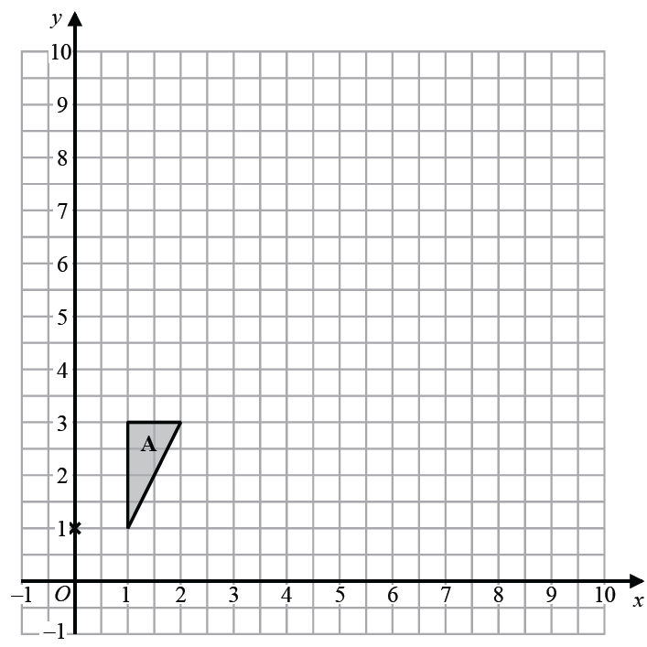

Enlarge triangle A by scale factor 2.5 with centre (0, 1)
(Total for Question 10 is 2 marks)
_____________________________________________________________________

11
Triangle P is reflected in the line y = − x to give triangle Q.
Triangle Q is reflected in the line x = −1 to give triangle R.
Describe fully the single transformation that maps triangle R to triangle P.

..........................................................................................................................................
(Total for Question 11 is 3 marks)
_____________________________________________________________________
12

Triangle A is transformed by the combined transformation of a rotation of 180° about the
point (−2, 0) followed by a translation with vector
One point on triangle A is invariant under the combined transformation.
Find the coordinates of this point.

(............................ , ............................)
(Total for Question 12 is 2 marks)
_____________________________________________________________________

13
Enlarge shape P by scale factor with centre of enlargement (0, 0).
Label your image Q.

(Total for Question 13 is 2 marks)
_____________________________________________________________________

14

Describe fully the single transformation that maps triangle A onto triangle B.

..........................................................................................................................................
(Total for Question 14 is 2 marks)

15

Describe fully the single transformation that maps triangle M onto triangle N.

..........................................................................................................................................

..........................................................................................................................................
(Total for Question 15 is 2 marks)

16
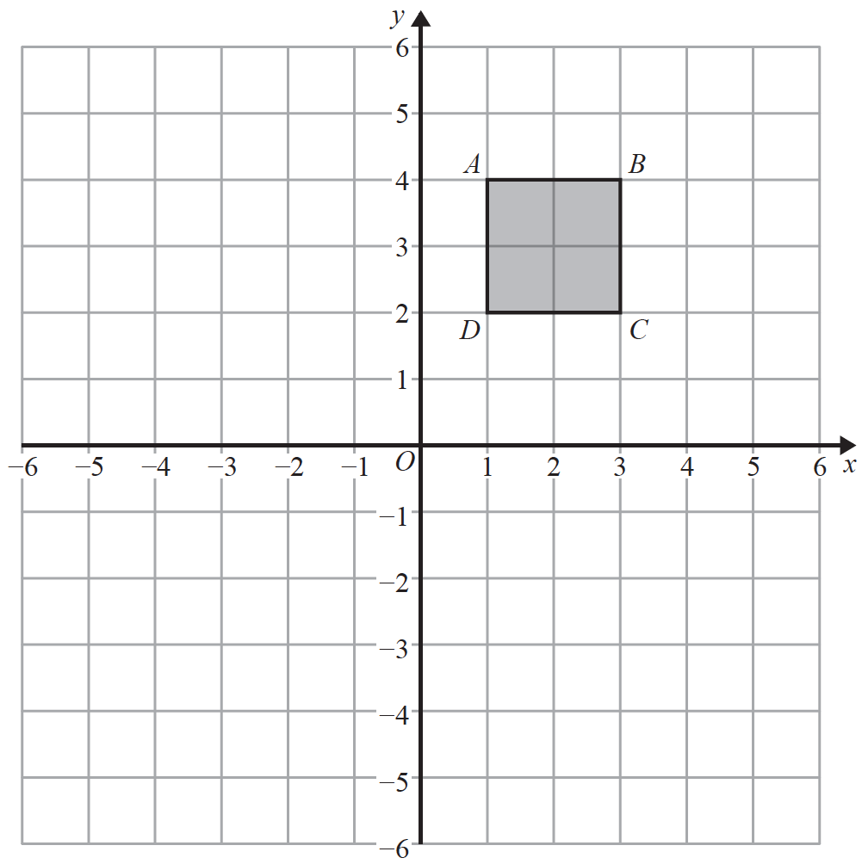

Square ABCD is transformed by a combined transformation of a reflection in the line x = −1
followed by a rotation.
Under the combined transformation, two vertices of the square ABCD are invariant.
Describe fully one possible rotation.

..........................................................................................................................................
(Total for Question 16 is 2 marks)
_____________________________________________________________________

17

The shaded shape is rotated 180° about the point (2, 2)

(a) How many of the vertices of the shaded shape are invariant?

.......................................................
(1)

Rectangle ABCD is transformed by a combination of two transformations so that

all points on AB are invariant
and there are no other invariant points.

The first transformation is

a reflection in the line with equation y = k, where k is an integer and k ≠ 1

(b) Describe fully the second transformation.

....................................................................................................................................

....................................................................................................................................
(2)
(Total for Question 17 is 3 marks)
_____________________________________________________________________

TOTAL MARKS FOR PAPER: 38

