GCSE Mathematics (1MA1)

Themed papers – Match the graph to the Equation

Compiled from student-friendly mark schemes

Please note that this mark scheme is not the one used by examiners for making scripts. It is intended more as a guide to good practice, indicating where marks are given for correct answers. As such, it doesn’t show follow-through marks (marks that are awarded despite errors being made) or special cases.

It should also be noted that for many questions, there may be alternative methods of finding correct solutions that are not shown here – they will be covered in the formal mark scheme.

NOTES ON MARKING PRINCIPLES

Guidance on the use of codes within this mark scheme

M1 – method mark. This mark is generally given for an appropriate method in the context of the question. This mark is given for showing your working and may be awarded even if working is incorrect.

P1 – process mark. This mark is generally given for setting up an appropriate process to find a solution in the context of the question.

A1 – accuracy mark. This mark is generally given for a correct answer following correct working.

B1 – working mark. This mark is usually given when working and the answer cannot easily be separated.

C1 – communication mark. This mark is given for explaining your answer or giving a conclusion in context supported by your working.

Some questions require all working to be shown; in such questions, no marks will be given for an answer with no working (even if it is a correct answer).

Question 1 (Total 2 marks)
Part | Working or answer an examiner might expect to see | Mark | Notes
 |  | B2 | These marks are given for all four graphs identified correctly  (B1 is given for at least 2 identified correctly)
  Type of proportionality | Graph
  y ∝ x
  y ∝ x²
  y ∝ √x
  y ∝

Question 2 (Total 3 marks)
Part | Working or answer an examiner might expect to see | Mark | Notes
 | C, F, A, H  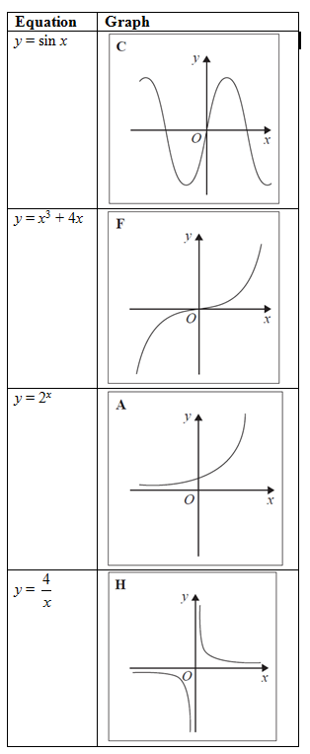 | B3 | This mark is given for a fully correct table  (Two marks are given for two or three correct, one mark is given for one correct)

Question 3 (Total 2 marks)
Part | Working or answer an examiner might expect to see | Mark | Notes
 |  | B2 | These marks are given for all four graphs labelled correctly  (B1 is given for two graphs labelled correctly)
  Description of function | Graph
  f(x) is inversely proportional to x | B
  f(x) is a trigonometrical function | A
  f(x) is an exponential function | D
  f(x) is directly proportional to √x | C

Question 4 (Total 3 marks)
Part | Working or answer an examiner might expect to see | Mark | Notes
(a) |  | P1 | This mark is given for identifying the correct graph for the equation y = x³
(b) |  | P1 | This mark is given for identifying the correct graph for the equation y =

Question 5 (Total 2 marks)
Part | Working or answer an examiner might expect to see | Mark | Notes
(i) | D | B1 | This mark is given for a correct answer only
(ii) | A | B1 | This mark is given for a correct answer only

Question 6 (Total 3 marks)
Part | Working an or answer examiner might expect to see | Mark | Notes
 | E, C, D, A, B | B3 | These marks are given for all five graphs labelled correctly  (B2 for 3 or 4 graphs correct,  B1 for 1 or 2 graphs correct)

Question 7 (Total 3 marks)
Part | Working an or answer examiner might expect to see | Mark | Notes
 | A, D, G, E | B3 | These marks are given for all 4 correct  (B2 for 3 correct,  B1 for 2 correct)

Question 8 (Total 4 marks)
Part | Working an or answer examiner might expect to see | Mark | Notes
(a) | 4500 ÷ 1200 = 3.75 | M1 | This mark is given for a method to find one temperature
(a) | (4500 ÷ 1200) – (4500 ÷ 2500) | M1 | This mark is given for a complete method to find the difference in the temperatures
(a) | 1.95 | A1 | This mark is given for a correct answer only
(b) | D | B1 | This mark is given for a correct answer only

Performance data:

Q | Taken from |  |  | Total Marks available | TOPIC | Spec Ref | AO | % Mean marks | Edexcel mean averages  Marks of candidates who achieved grade:
Q | Q | Series | Paper |  |  |  |  |  | ALL | 9 | 8 | 7 | 6 | 5 | 4 | 3 | 2 | 1 | U
1 | 12 | June 2018 | 2H | 2 | Ratio | R10 | 2 | 71 | 1.41 | 1.92 | 1.80 | 1.64 | 1.45 | 1.23 | 1.02 | 0.82 | - | - | 0.61
2 | 14 | June 2017 | 2H | 3 | Algebra | A12 | 2 | 52 | 1.57 | 2.83 | 2.48 | 2.00 | 1.51 | 1.10 | 0.78 | 0.55 | - | - | 0.37
3 | 17 | June 2019 | 3H | 2 | Algebra | A12, R10, R14 | 2 | 51 | 1.02 | 1.85 | 1.59 | 1.28 | 0.95 | 0.67 | 0.49 | 0.40 | - | - | 0.37
4a | 5a | Nov 2019 | 2H | 1 | Algebra | A12 | 2 | 34 | 0.34 | 0.78 | 0.78 | 0.61 | 0.59 | 0.39 | 0.26 | 0.14 | - | - | 0.13
4b | 5b | Nov 2019 | 2H | 1 | Algebra | A12 | 2 | 36 | 0.36 | 1.00 | 0.89 | 0.76 | 0.63 | 0.47 | 0.24 | 0.12 | - | - | 0.08
5i | 9i | Mock Set 1 | 3H | 1 | - | - | - | - | - | - | - | - | - | - | - | - | - | - | -
5ii | 9ii | Mock Set 1 | 3H | 1 | - | - | - | - | - | - | - | - | - | - | - | - | - | - | -
6 | 13 | Mock Set 3 | 2H | 3 | - | - | - | - | - | - | - | - | - | - | - | - | - | - | -
7 | 16b | Mock Set 4 | 2H | 3 | - | - | - | - | - | - | - | - | - | - | - | - | - | - | -
8a | 6a | Spec Set 2 | 3H | 3 | - | - | - | - | - | - | - | - | - | - | - | - | - | - | -
8b | 6b | Spec Set 2 | 3H | 1 | - | - | - | - | - | - | - | - | - | - | - | - | - | - | -
 |  |  |  | 21 |  |  |  |  | 4.7 | 8.38 | 7.54 | 6.29 | 5.13 | 3.86 | 2.79 | 2.03 | - | - | 1.56

