GCSE Mathematics (1MA1)

Themed papers – Transformations

Compiled from student-friendly mark schemes

Please note that this mark scheme is not the one used by examiners for making scripts. It is intended more as a guide to good practice, indicating where marks are given for correct answers. As such, it doesn’t show follow-through marks (marks that are awarded despite errors being made) or special cases.

It should also be noted that for many questions, there may be alternative methods of finding correct solutions that are not shown here – they will be covered in the formal mark scheme.

NOTES ON MARKING PRINCIPLES

Guidance on the use of codes within this mark scheme

M1 – method mark. This mark is generally given for an appropriate method in the context of the question. This mark is given for showing your working and may be awarded even if working is incorrect.

P1 – process mark. This mark is generally given for setting up an appropriate process to find a solution in the context of the question.

A1 – accuracy mark. This mark is generally given for a correct answer following correct working.

B1 – working mark. This mark is usually given when working and the answer cannot easily be separated.

C1 – communication mark. This mark is given for explaining your answer or giving a conclusion in context supported by your working.

Some questions require all working to be shown; in such questions, no marks will be given for an answer with no working (even if it is a correct answer).

Question 1 (Total 2 marks)
Part | Working or answer an examiner might expect to see | Mark | Notes
 | Rotation, 90° anti-clockwise (or 270° clockwise, centre (0, –1) | M1 | This mark is given for seeing one of these terms used.
 | Rotation 90° anti-clockwise with centre (0, –1) | A1 | This mark is given for the correct answer only

Question 2 (Total 2 marks)
Part | Working or answer an examiner might expect to see | Mark | Notes
 | Rotation of 90° anticlockwise about (–2, 1) | B2 | These marks are given for a full description of the transformation  (B1 is given for two of the elements of the description)

Question 3 (Total 3 marks)
Part | Working an or answer examiner might expect to see | Mark | Notes
(a) | T | M1 | This mark is given for the shape T drawn in the correct orientation
(a) |  | A1 | This mark is given for the shape T drawn in the correct orientation with coordinates (4, 5), (3, 7) and (7, 7)
(b) | Rotation of 90° anticlockwise with centre (5, 4) | B1 | This mark is given for a correct description of the transformation

Question 4 (Total 2 marks)
Part | Working or answer an examiner might expect to see | Mark | Notes
 |  | B2 | These marks are given for a correct enlargement at the points (1, 2) (2, 3) (2, 4) and (1, 4)  (B1 is given for a shape with the correct size and orientation but in the wrong position)

Question 5 (Total 1 marks)
Part | Working or answer an examiner might expect to see | Mark | Notes
 | For example:  The scale factor in the diagram is 2.5  5 ÷ 2 is not 1 | C1 | This mark is given for the correct statement to say why Roy’s diagram is not correct

Question 6 (Total 3 marks)
Part | Working or answer an examiner might expect to see | Mark | Notes
 |  | M1 | This mark is given for a correct reflection of A shown on the diagram
 | c = –6  d = –1 | A1 | This mark is given for a correct value for either c or d
 | c = –6  d = –1 | A1 | This mark is given for a correct value for both c and d

Question 7 (Total 2 marks)
Part | Working or answer an examiner might expect to see | Mark | Notes
 | 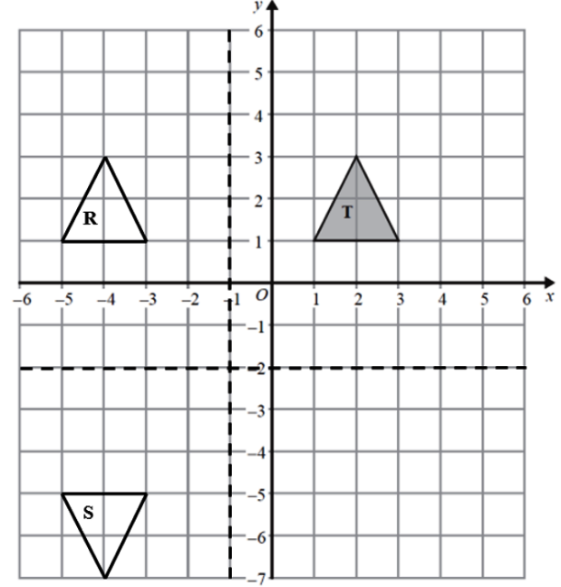 | B1 | Rotation  or  Enlargement with scale factor –1
 | Rotation of 180° about (–1, –2)  or  Enlargement with scale factor –1, with centre (–1, –2) | B1 | About (–1, –2)  or  With centre (–1, –2)

Question 8 (Total 2 marks)
Part | Working an or answer examiner might expect to see | Mark | Notes
 | A  B | 1 | This mark is given for a shape labelled A with coordinates (–2, 1), (–4, 1), (–2, 2) and (–5, 2)
 |  | 1 | This mark is given for a shape labelled B with coordinates (1, –4), (3, –4), (1, –5) and (4, –5)

Question 9 (Total 3 marks)
Part | Working or answer an examiner might expect to see | Mark | Notes
 | 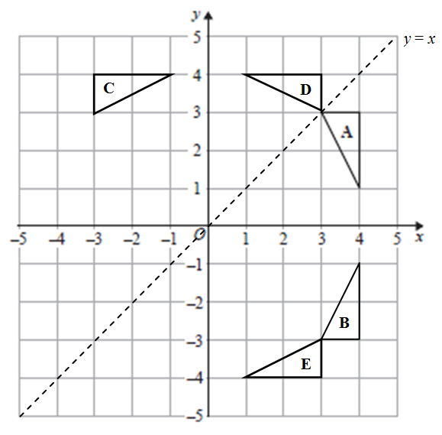 | M2 | These marks are given for the correct position of triangle C or triangle E  (One mark is given for the correct position of triangle B or triangle D)
 | Amy is not correct | C1 | This mark is given for a correct conclusion with supporting evidence

Question 10 (Total 2 marks)
Part | Working or answer an examiner might expect to see | Mark | Notes
 |  | B2 | These marks are given for a triangle with vertices at (2.5, 1), (2.5, 6) and (5, 6)  (B1 is given for a triangle of the right size and orientation but in the wrong place or a correct enlargement of a different scale factor with centre (0, 1))

Question 11 (Total 3 marks)
Part | Working or answer an examiner might expect to see | Mark | Notes
 | Q  R  y = –x  x = –1  Rotation | M1 | This mark is given for stating rotation or showing R twice reflected on the grid with coordinates (1, 1), (1, –3) and (3, –3)
 | 90° clockwise | A1 | This mark is given for the correct angle and direction of the rotation
 | centre (–1, 1) | A1 | This mark is given for the correct centre of rotation

Question 12 (Total 2 marks)
Part | Working an or answer examiner might expect to see | Mark | Notes
 |  | M1 | This mark is given for showing a rotation of 180° about (–2, 0) followed by a translation
 | (–3.5, 1) | A1 | This mark is given for the correct answer only

Question 13 (Total 2 marks)
Part | Working or answer an examiner might expect to see | Mark | Notes
 |  | 2 | These two marks are given for a correct enlargement (position, size and orientation) with coordinate points (–1, –1.5), (–1, –3.5) and (–2, –1.5)  [1 mark is given for an enlargement with correct size an orientation in the incorrect position]

Question 14 (Total 2 marks)
Part | Working an or answer examiner might expect to see | Mark | Notes
 | Enlargement of scale factor –  with centre (2, 2) | C1 | This mark is given for all two parts of the transformation described
 |  | C1 | This mark is given for all three parts of the transformation described

Question 15 (Total 2 marks)
Part | Working or answer an examiner might expect to see | Mark | Notes
 | Enlargement, scale factor –2, centre (4, 6) | B2 | These two marks are given for a full description of the transformation  (B1 is given for two correct aspects)

Question 16 (Total 2 marks)
Part | Working or answer an examiner might expect to see | Mark | Notes
 | Rotation 180°  or  Rotation 90° clockwise  or  Rotation 90° anticlockwise | C1 | This mark is given for finding an angle of the rotation
 | about (–1, 2) or (–1, 4)  or  about (–1, 0)  or  about (–1, 6) | C1 | This mark is given for finding the corresponding centre of rotation

Question 17 (Total 2 marks)
Part | Working or answer an examiner might expect to see | Mark | Notes
(a) | 1 | B1 | This mark is given for a correct answer only
(b) | Translation | C1 | This mark is given for the correct answer only
(b) |  | C1 | This mark is given for the correct answer only, including correct notation

Performance data:

Q | Taken from |  |  | Total Marks available | TOPIC | Spec Ref | AO | % Mean marks | Edexcel mean averages  Marks of candidates who achieved grade:
Q | Q | Series | Paper |  |  |  |  |  | ALL | 9 | 8 | 7 | 6 | 5 | 4 | 3 | 2 | 1 | U
1 | 2 | Mock Set 1 | 2H | 2 | - | - | - | - | - | - | - | - | - | - | - | - | - | - | -
2 | 4 | Mock Set 4 | 1H | 2 | - | - | - | - | - | - | - | - | - | - | - | - | - | - | -
3a | 2a | Mock Set 3 | 2H | 2 | - | - | - | - | - | - | - | - | - | - | - | - | - | - | -
3b | 2b | Mock Set 3 | 2H | 1 | - | - | - | - | - | - | - | - | - | - | - | - | - | - | -
4 | 7 | June 2018 | 2H | 2 | Geometry | G7 | 1 | 69 | 1.37 | 1.96 | 1.86 | 1.72 | 1.50 | 1.18 | 0.73 | 0.31 | - | - | 0.12
5 | 8b | June 2019 | 3H | 1 | Geometry | G7 | 3 | 66 | 0.66 | 0.89 | 0.81 | 0.74 | 0.66 | 0.58 | 0.47 | 0.36 | - | - | 0.27
6 | 5 | June 2019 | 1H | 3 | Geometry | G7 | 2 | 66 | 1.99 | 2.78 | 2.61 | 2.37 | 2.07 | 1.65 | 1.15 | 0.60 | - | - | 0.29
7 | 7 | June 2018 | 1H | 2 | Geometry | G7 | 2 | 60 | 1.19 | 1.88 | 1.72 | 1.52 | 1.27 | 0.96 | 0.59 | 0.28 | - | - | 0.13
8a | 5a | Nov 2017 | 2H | 1 | Geometry | G7 | 1 | 53 | 0.53 | 1 | 0.88 | 0.71 | 0.71 | 0.68 | 0.59 | 0.48 | - | - | 0.26
8b | 5b | Nov 2017 | 2H | 1 | Geometry | G7 G24 | 1 | 37 | 0.37 | 0.88 | 0.79 | 0.61 | 0.61 | 0.5 | 0.41 | 0.29 | - | - | 0.15
9 | 9 | June 2017 | 2H | 3 | Geometry | G7, G8 | 2 | 52 | 1.57 | 2.55 | 2.23 | 1.91 | 1.59 | 1.27 | 0.88 | 0.53 | - | - | 0.33
10 | 9 | Nov 2019 | 3H | 2 | Geometry | G7 | 1 | 45 | 0.90 | 1.89 | 1.62 | 1.45 | 1.36 | 1.19 | 0.75 | 0.45 | - | - | 0.20
11 | 8 | Nov 2018 | 2H | 3 | Geometry | G7, G8 | 2 | 20 | 0.59 | 2.10 | 2.03 | 1.36 | 1.04 | 0.70 | 0.43 | 0.30 | - | - | 0.22
12 | 20 | Nov 2018 | 3H | 2 | Geometry | G8 | 2 | 11 | 0.21 | 1.3 | 0.68 | 0.48 | 0.38 | 0.28 | 0.15 | 0.08 | - | - | 0.01
13 | 18 | Nov 2017 | 1H | 2 | Geometry | G7 | 1 | 9 | 0.18 | 2.00 | 1.47 | 1.09 | 0.63 | 0.44 | 0.09 | 0.02 | - | - | 0.01
14 | 13 | Nov 2018 | 1H | 2 | Geometry | G7 | 2 | 7 | 0.14 | 1 | 0.67 | 0.5 | 0.33 | 0.19 | 0.06 | 0.02 | - | - | 0.02
15 | 16 | Mock Set 2 | 2H | 2 | - | - | - | - | - | - | - | - | - | - | - | - | - | - | -
16 | 24 | Nov 2019 | 2H | 2 | Geometry | G8 | 2 | 4 | 0.08 | 0.78 | 0.32 | 0.21 | 0.14 | 0.09 | 0.04 | 0 | - | - | 0.01
17a | 21a | Mock Set 4 | 3H | 1 | - | - | - | - | - | - | - | - | - | - | - | - | - | - | -
17b | 21b | Mock Set 4 | 3H | 2 | - | - | - | - | - | - | - | - | - | - | - | - | - | - | -
 |  |  |  | 38 |  |  |  |  | 9.78 | 21.01 | 17.69 | 14.67 | 12.29 | 9.71 | 6.34 | 3.72 | - | - | 2.02

