GCSE Mathematics (1MA1)

Themed papers – Transformations of Functions

Compiled from student-friendly mark schemes

Please note that this mark scheme is not the one used by examiners for making scripts. It is intended more as a guide to good practice, indicating where marks are given for correct answers. As such, it doesn’t show follow-through marks (marks that are awarded despite errors being made) or special cases.

It should also be noted that for many questions, there may be alternative methods of finding correct solutions that are not shown here – they will be covered in the formal mark scheme.

NOTES ON MARKING PRINCIPLES

Guidance on the use of codes within this mark scheme

M1 – method mark. This mark is generally given for an appropriate method in the context of the question. This mark is given for showing your working and may be awarded even if working is incorrect.

P1 – process mark. This mark is generally given for setting up an appropriate process to find a solution in the context of the question.

A1 – accuracy mark. This mark is generally given for a correct answer following correct working.

B1 – working mark. This mark is usually given when working and the answer cannot easily be separated.

C1 – communication mark. This mark is given for explaining your answer or giving a conclusion in context supported by your working.

Some questions require all working to be shown; in such questions, no marks will be given for an answer with no working (even if it is a correct answer).

Question 1 (Total 2 marks)
Part | Working or answer an examiner might expect to see | Mark | Notes
 | 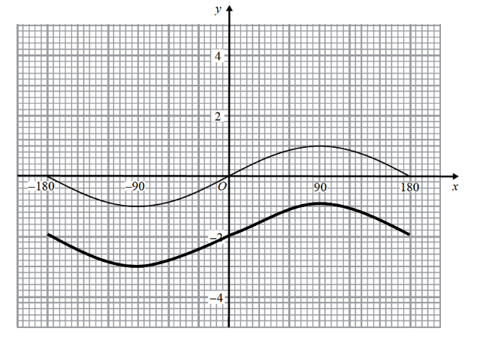 | C2 | These marks are given for a graph translated –2 in the y-direction  (One mark is given for a graph translated by another amount in the y-direction)

Question 2 (Total 2 marks)
Part | Working or answer an examiner might expect to see | Mark | Notes
 |  | C2 | These marks are given for a fully correct sketch between 0° and 360°  (C1 is given for a partially correct shape drawn)

Question 3 (Total 3 marks)
Part | Working or answer an examiner might expect to see | Mark | Notes
(a) | y = f(–x) | B1 | This mark is given for the correct answer only
(b) | y = g(x) + 1 | B1 | This mark is given for the correct answer only
(c) | (180,−1) | B1 | This mark is given for the correct answer only

Question 20 (Total 4 marks)
Part | Working or answer an examiner might expect to see | Mark | Notes
(a) | The curve cuts the y axis at x = 0  y = a^{x} = a⁰ = 1  (0, 1) | B1 | This mark is given for the correct answer only
(b) | (–1, 0)  (3, 0)  (7, 0) | M1 | This mark is given for any one of a circle with radius 4, centre (3, 0) or points (−1, 0) and (7, 0) labelled
(b) | (–1, 0)  (3, 0)  (7, 0) | M1 | This mark is given for any further element of a circle with radius 4, centre (3, 0) or points (−1, 0) and (7, 0) labelled
(b) | (–1, 0)  (3, 0)  (7, 0) | A1 | This mark is given for a fully correct sketch only: a circle with radius 4 and centre (3, 0) and with the points (−1, 0) and (7, 0) labelled

Question 5 (Total 2 marks)
Part | Working or answer an examiner might expect to see | Mark | Notes
 | Translation | M1 | This mark is given for a method showing which type of transformation is required to give the graph of the curve S
 | (7 × –1, 2 – 3)  = (–7, –1) | A1 | This mark is given for the correct answer only

Question 6 (Total 4 marks)
Part | Working or answer an examiner might expect to see | Mark | Notes
(a) |  | B1 | This mark is given for a correct sketch with a curve that crosses the x-axis at (2, 0) and (4, 0), with minimum point (3, –1) and endpoints (1, 3) and (5, 3)
(b) | y = g(–x) | B1 | This mark is given for the correct answer only

Question 7 (Total 3 marks)
Part | Working or answer an examiner might expect to see | Mark | Notes
(a) | y = f(x + 1) – 3 | C1 | These marks are given for a graph drawn translated by the vector  (C1 is given for a translation of the graph by vector or where a ≠ 1 or b ≠ –3)
(b) | (2, 1) | B1 | This mark is given for the correct answer only

Question 8 (Total 2 marks)
Part | Working or answer an examiner might expect to see | Mark | Notes
 | sin (180 + a)° = –1, so b = –1 | B1 | This mark is given for the correct answer only
 | sin (180 + a)° = –1,  so 180 + a = 270  so a = 90 | B1 | This mark is given for the correct answer only

Question 9 (Total 4 marks)
Part | Working or answer an examiner might expect to see | Mark | Notes
 | 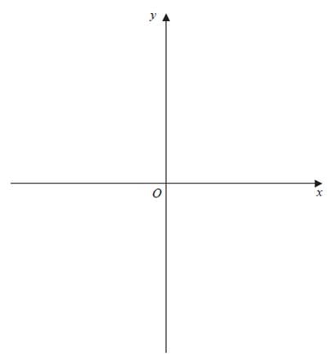  $$y=x²$$ | M1 | This mark is given for an approximate sketch of the graph $y=x²$
 |  | M1 | This mark is given for a partially correct reflection of $y=x²$
 |  | A1 | This mark is given for both curves sketched with the curves both passing through the origin

Question 10 (Total 4 marks)
Part | Working or answer an examiner might expect to see | Mark | Notes
(a) | y = –cos x or y = cos (x + 180) or  y = cos (x – 180) or y = sin(x – 90) | B1 | This mark is given for a correct equation
(b) | 45 or 405 or –315 | B1 | This mark is given for a correct value given
(b) | 1 | B1 | This mark is given for a correct answer only

Question 11 (Total 4 marks)
Part | Working or answer an examiner might expect to see | Mark | Notes
(a) | 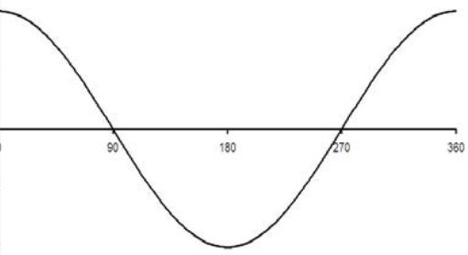  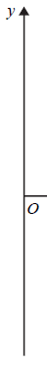 | B1 | This mark is given for the correct shape drawn
(a) |  | B1 | This mark is given for a fully correct sketch with labels
(b) | 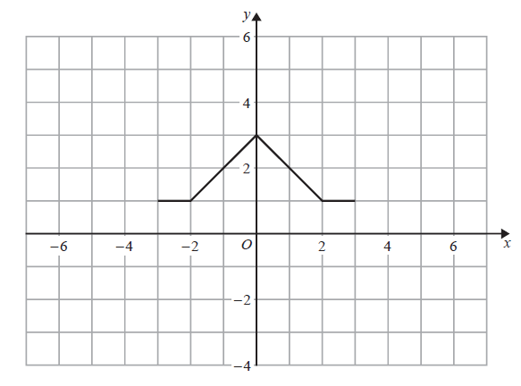 | B1 | This mark is given for a correct answer only
(b) |  | B1 | This mark is given for a correct answer only

Performance data:

Q | Taken from |  |  | Total Marks available | TOPIC | Spec Ref | AO | % Mean marks | Edexcel mean averages  Marks of candidates who achieved grade:
Q | Q | Series | Paper |  |  |  |  |  | ALL | 9 | 8 | 7 | 6 | 5 | 4 | 3 | 2 | 1 | U
1 | 18 | June 2018 | 1H | 2 | Algebra | A13 | 2 | 55 | 1.10 | 1.91 | 1.69 | 1.44 | 1.13 | 0.82 | 0.53 | 0.29 | - | - | 0.16
2 | 11 | Nov 2018 | 3H | 2 | Algebra | A12 | 2 | 5 | 0.10 | 1.90 | 1.47 | 0.61 | 0.22 | 0.04 | 0.01 | 0.00 | - | - | 0.00
3a | 22a | Mock Set 1 | 1H | 1 | - | - | - | - | - | - | - | - | - | - | - | - | - | - | -
3b | 22b | Mock Set 1 | 1H | 1 | - | - | - | - | - | - | - | - | - | - | - | - | - | - | -
3c | 22c | Mock Set 1 | 1H | 1 | - | - | - | - | - | - | - | - | - | - | - | - | - | - | -
4a | 20a | June 2017 | 3H | 1 | Algebra | A14 | 1 | 20 | 0.2 | 0.81 | 0.49 | 0.22 | 0.1 | 0.05 | 0.03 | 0.03 | - | - | 0.03
4b | 20b | June 2017 | 3H | 3 | Algebra | A13 | 2 | 25 | 0.76 | 2.66 | 2.01 | 1.1 | 0.44 | 0.14 | 0.04 | 0.02 | - | - | 0.01
5 | 15 | June 2019 | 3H | 2 | Algebra | A13 | 1 | 28 | 0.56 | 1.62 | 1.17 | 0.73 | 0.4 | 0.22 | 0.13 | 0.08 | - | - | 0.05
6a | 18a | Nov 2018 | 1H | 1 | Algebra | A13 | 2 | 12 | 0.12 | 0.9 | 0.67 | 0.57 | 0.31 | 0.13 | 0.03 | 0.01 | - | - | 0.01
6b | 18b | Nov 2018 | 1H | 1 | Algebra | A13 | 2 | 13 | 0.13 | 0.9 | 0.58 | 0.29 | 0.18 | 0.17 | 0.11 | 0.06 | - | - | 0.03
7a | 20a | Nov 2019 | 1H | 2 | Algebra | A13 | 2 | 13 | 0.25 | 2 | 1.62 | 1.06 | 0.47 | 0.26 | 0.04 | 0 | - | - | 0.02
7b | 20b | Nov 2019 | 1H | 1 | Algebra | A13 | 2 | 10 | 0.1 | 1 | 0.7 | 0.33 | 0.2 | 0.09 | 0.03 | 0.02 | - | - | 0.01
8 | 18 | Mock Set 3 | 3H | 2 | - | - | - | - | - | - | - | - | - | - | - | - | - | - | -
9 | 16a | Mock Set 4 | 2H | 3 | - | - | - | - | - | - | - | - | - | - | - | - | - | - | -
10a | 22a | Mock Set 4 | 3H | 1 | - | - | - | - | - | - | - | - | - | - | - | - | - | - | -
10b | 22b | Mock Set 4 | 3H | 2 | - | - | - | - | - | - | - | - | - | - | - | - | - | - | -
11a | 19a | Spec Set 2 | 2H | 2 | - | - | - | - | - | - | - | - | - | - | - | - | - | - | -
11b | 19b | Spec Set 2 | 2H | 2 | - | - | - | - | - | - | - | - | - | - | - | - | - | - | -
 |  |  |  | 30 |  |  |  |  | 3.32 | 13.7 | 10.4 | 6.35 | 3.45 | 1.92 | 0.95 | 0.51 | - | - | 0.32

