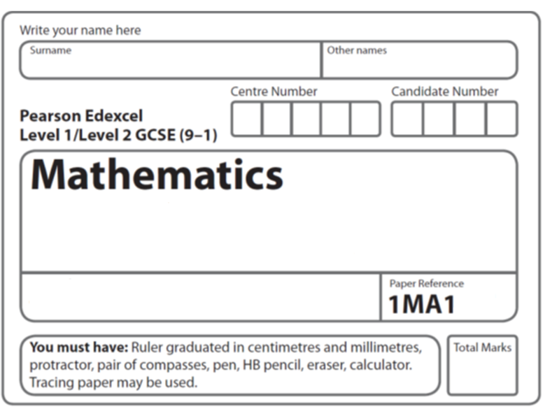
Estimate
Foundation Tier
Instructions
- Use black ink or ball-point pen.
  - Fill in the boxes at the top of this page with your name,
centre number and candidate number.
- Answer all questions.
- Answer the questions in the spaces provided
– there may be more space than you need.
- You must show all your working.
- Diagrams are NOT accurately drawn, unless otherwise indicated.
- If your calculator does not have a π button, take the value of π to be 3.142
unless the question instructs otherwise.

Information
- The total mark for this paper is 55. There are 16 questions.
- Questions have been arranged in an ascending order of mean difficulty, as found by all students in the June 2017–November 2019 examinations.
- The marks for each question are shown in brackets
– use this as a guide as to how much time to spend on each question.

Advice
- Read each question carefully before you start to answer it.
- Keep an eye on the time.
- Try to answer every question.
- Check your answers if you have time at the end.
1 The probability of an event is shown by the cross (×) on the probability scale.

Write down an estimate for the probability of the event.

.......................................................
(Total for Question 1 is 1 mark)
___________________________________________________________________________


2 The diagram shows a tree and a man.

The man is of average height.
The tree and the man are drawn to the same scale.
(a) Write down an estimate for the real height, in metres, of the man.

...................................................... metres
(1)
(b) Find an estimate for the real height, in metres, of the tree.

...................................................... metres
(2)
(Total for Question 2 is 3 marks)
___________________________________________________________________________
3

The picture shows a bus next to a building.
The bus has a length of 12 m.
The bus and the building are drawn to the same scale.
Work out an estimate for the height, in metres, of the building.

....................................................... m
(Total for Question 3 is 2 marks)
___________________________________________________________________________

4 The accurate scale diagram shows a telephone mast and a box.

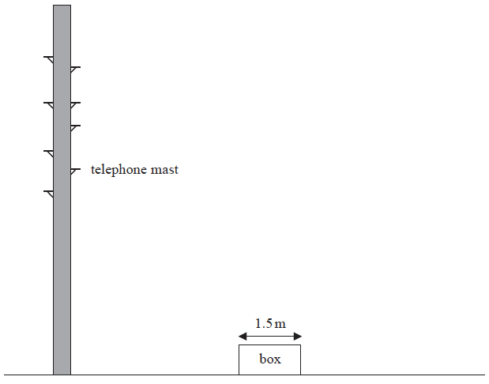

The box has a real width of 1.5 metres.
Find an estimate for the real height, in metres, of the telephone mast.

....................................................... metres
(Total for Question 4 is 2 marks)
___________________________________________________________________________
5 The accurate scale drawing shows a tree and a wall.

The tree is 15 feet tall.
The tree and the wall are drawn to the same scale.

Find an estimate for the height, in feet, of the wall.

....................................................... feet
(Total for Question 5 is 2 marks)
___________________________________________________________________________

6 An estimate of the height, H metres, of a tall building can be found using the formula
H = 4f + 12
where the building is f floors high.
A tall building is 110 floors high.
The real height of the building is 442 m.
Seb uses the formula to find an estimate of the height of this building.
He then finds the difference between his estimate and the real height.
Show that this difference is less than 5% of the real height.

(Total for Question 6 is 4 marks)
___________________________________________________________________________

7 Ami and Josh use a calculator to work out
Ami’s answer is 27.1115
Josh’s answer is 271.115
One of these answers is correct.
Use approximations to find out which answer is correct.

(Total for Question 7 is 3 marks)
___________________________________________________________________________

8 Balena has a garden in the shape of a circle of radius 10 m.
He is going to cover the garden with grass seed to make a lawn.
Grass seed is sold in boxes.
Each box of grass seed will cover 46 m² of garden.
Balena wants to cover all the garden with grass seed.

(a) Work out an estimate for the number of boxes of grass seed Balena needs.
You must show your working.

.......................................................
(4)
(b) Is your estimate for part (a) an underestimate or an overestimate?
Give a reason for your answer.

......................................................................................................................................................

......................................................................................................................................................

......................................................................................................................................................

......................................................................................................................................................
(1)
(Total for Question 8 is 5 marks)
___________________________________________________________________________

9 This shape is made from two rectangles.
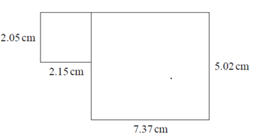

(a) Work out an estimate for the total area of the shape.

......................................... cm²
(3)
(b) Is your answer to (a) an overestimate or an underestimate?
Give a reason for your answer.

......................................................................................................................................................

......................................................................................................................................................
(1)
(Total for Question 9 is 4 marks)
___________________________________________________________________________

10 Jean records the maximum daily temperature each day for 10 days.
She also records the number of children going to a paddling pool for each of these days.
She draws this scatter graph for her information.

Jean’s information for one of these days is an outlier on the scatter graph.

(a) Give a possible reason for this.

......................................................................................................................................................

......................................................................................................................................................
(1)
(b) What type of correlation does the scatter graph show?

.......................................................
(1)
On the 11th day, the maximum daily temperature was 19 °C.

(c) Write down an estimate for the number of children going to the paddling pool on
the 11th day.

.......................................................
(1)
It would not be sensible to use the scatter graph to predict the number of children going
to the paddling pool on a day when the maximum daily temperature was 13 °C.

(d) Give a reason why.

......................................................................................................................................................

......................................................................................................................................................
(1)
(Total for Question 10 is 4 marks)
___________________________________________________________________________

11 Oliver records the distance from London to each of eight cities in the USA.
He also records the time taken to fly from London to each of these cities.
The scatter graph shows this information.

Chicago is a city in the USA.
Chicago is 4000 miles from London.
(a) (i) By drawing a line of best fit, find an estimate for the time taken to fly from
London to Chicago.

.......................................................minutes
(2)
(ii) Why is your answer to part (i) only an estimate?
......................................................................................................................................................
......................................................................................................................................................
(1)
(b) (i) Calculate the gradient of your line of best fit.

.......................................................
(2)
(ii) Give an interpretation of the gradient of your line of best fit.
......................................................................................................................................................
......................................................................................................................................................
(1)
(Total for Question 11 is 6 marks)
___________________________________________________________________________

12 Denise wants to give a pen set to every student in her school.
There are 799 students in the school.

Denise already has 102 pen sets.
She will need to buy more pen sets.
Each pen set costs 89 pence.

(a) Work out an estimate for the total cost of the pen sets Denise needs to buy.

.........................................
(3)

(b) Is your answer to (a) an underestimate or an overestimate?
Give a reason for your answer.

......................................................................................................................................................

......................................................................................................................................................
(1)
(Total for Question 12 is 4 marks)
___________________________________________________________________________

13 Here is the graph of y = x² – 2x – 4

(a) Write down estimates for the roots of x² – 2x – 4 = 0

.......................................................
(2)

(b) Write down the coordinates of the turning point of y = x² – 2x – 4

(............................ , ............................)
(1)
(Total for Question 13 is 3 marks)
___________________________________________________________________________

14 Mel drives a bus 39 weeks in a year.
She drives the bus an average of 298 miles each week.
(a) Work out an estimate for the total number of miles Mel drives the bus in one year.

......................................................miles
(2)
(b) Is your answer to part (a) an underestimate or an overestimate?
You must give a reason for your answer.
......................................................................................................................................................

......................................................................................................................................................
(1)
(Total for Question 14 is 3 marks)
___________________________________________________________________________

15 Linda recorded the temperature, in °C, at 9 am on each of 30 days.
The table shows information about her results.

Temperature  (T °C) | Number of days
10 < T ⩽ 12 | 3
12 < T ⩽ 14 | 8
14 < T ⩽ 16 | 14
16 < T ⩽ 18 | 4
18 < T ⩽ 20 | 1

Calculate an estimate for the mean temperature.
Give your answer correct to 1 decimal place.

.......................................................°C
(Total for Question 15 is 3 marks)
___________________________________________________________________________

16 There are only red counters, blue counters and green counters in a bag.
number of red counters : number of blue counters : number of green counters = 1 : 3 : 7
A counter is going to be taken at random from the bag.
(a) Complete the table below to show each of the probabilities that the counter will be
red or blue or green.

Colour | red | blue | green
Probability

(2)

Jamie takes at random a counter from the bag and records the colour of the counter.
He then puts the counter back in the bag.
Jamie does this a number of times.
He records a total of 68 blue counters.
(b) Work out an estimate for the total number of times Jamie takes a counter from the bag.

.......................................................
(2)
(Total for Question 16 is 4 marks)

TOTAL MARKS FOR PAPER: 55

