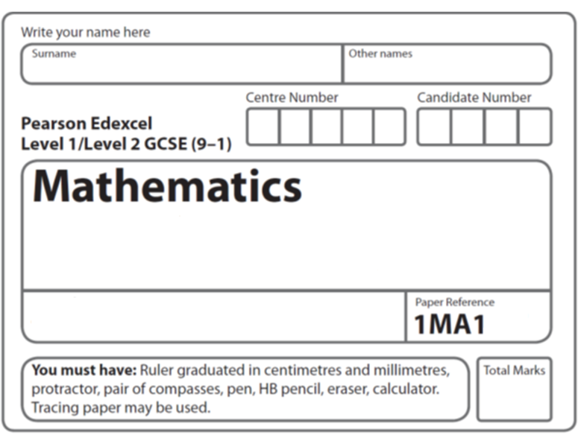
Inequalities
Foundation Tier
Instructions
- Use black ink or ball-point pen.
  - Fill in the boxes at the top of this page with your name,
centre number and candidate number.
- Answer all questions.
- Answer the questions in the spaces provided
– there may be more space than you need.
- You must show all your working.
- Diagrams are NOT accurately drawn, unless otherwise indicated.
- If your calculator does not have a π button, take the value of π to be 3.142
unless the question instructs otherwise.

Information
- The total mark for this paper is 26. There are 7 questions.
- Questions have been arranged in an ascending order of mean difficulty, as found by all students in the June 2017–November 2019 examinations.
- The marks for each question are shown in brackets
– use this as a guide as to how much time to spend on each question.

Advice
- Read each question carefully before you start to answer it.
- Keep an eye on the time.
- Try to answer every question.
- Check your answers if you have time at the end.
1 (a) On the number line, show the inequality x < 4

(2)

3 < y ⩽ 7 where y is an integer.
(b) Write down all the possible values of y.

.....................................................................................
(2)
(c) Solve 3x + 5 ⩾ x + 17

.......................................................
(3)
(Total for Question 1 is 7 marks)
___________________________________________________________________________


2 − 3 < t ⩽ 2
t is an integer.
(b) Write down all the possible values of t.

...............................................................................................

(Total for Question 2 is 2 marks)
___________________________________________________________________________

3 (a) Solve 14n > 11n + 6

.......................................................
(2)
(b) On the number line below, show the set of values of x for which –2 < x + 3 ⩽ 4

(3)
(Total for Question 3 is 5 marks)

4 Here is a number line.

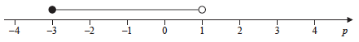

Write down the inequality shown on the number line.

..............................................................................................................
(Total for Question 4 is 2 marks)

5 (a) Show the inequality –2 ≤ x < 3 on the number line below.

(2)
(b) Solve the inequality 4y + 7 < 16

......................................................
(2)
(Total for Question 5 is 4 marks)

6 Solve 3(n − 1) < 21

.......................................................
(Total for Question 6 is 2 marks)
___________________________________________________________________________

7 Here is a number line.

(a) On this number line, show the inequality –2 ≤ x < 3
(2)
(b) Solve 5n + 3 > 27

.......................................................
(2)
(Total for Question 7 is 4 marks)
___________________________________________________________________________

TOTAL MARKS FOR PAPER: 26

