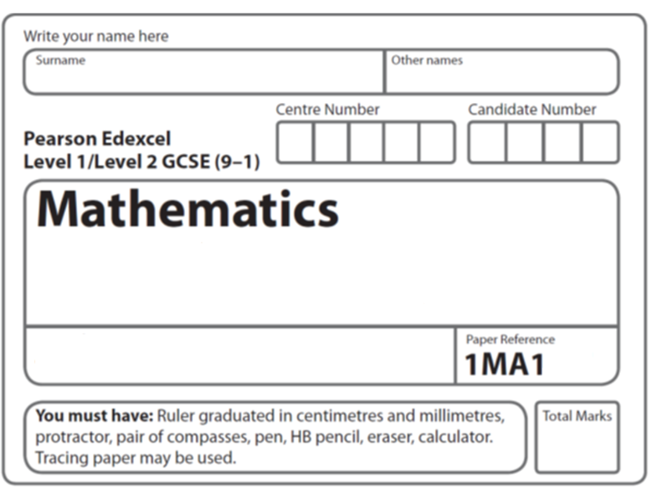
Foundation Tier
Simultaneous equations
Instructions
- Use black ink or ball-point pen.
  - Fill in the boxes at the top of this page with your name,
centre number and candidate number.
- Answer all questions.
- Answer the questions in the spaces provided
– there may be more space than you need.
- You must show all your working.
- Diagrams are NOT accurately drawn, unless otherwise indicated.
- If your calculator does not have a π button, take the value of π to be 3.142
unless the question instructs otherwise.

Information
- The total mark for this paper is 21. There are 7 questions.
- Questions have been arranged in an ascending order of mean difficulty, as found by all students in the June 2017–November 2019 examinations.
- The marks for each question are shown in brackets
– use this as a guide as to how much time to spend on each question.

Advice
- Read each question carefully before you start to answer it.
- Keep an eye on the time.
- Try to answer every question.
- Check your answers if you have time at the end.
1 Solve the simultaneous equations

3x − 4y = 11
9x + 2y = 5

x = .......................................................
y = .......................................................
(Total for Question 1 is 3 marks)
___________________________________________________________________________

2 Solve the simultaneous equations
3x + y = –4
3x – 4y = 6

x = .......................................................

y = .......................................................
(Total for Question 2 is 3 marks)
___________________________________________________________________________

3 Solve the simultaneous equations
x + 3y = 12
5x − y = 4

x = ............................
y = ............................
(Total for Question 3 is 3 marks)
___________________________________________________________________________


4 Solve the simultaneous equations
5x + y = 21
x − 3y = 9

x = ......................................................

y = ......................................................

(Total for Question 4 is 3 marks)
___________________________________________________________________________

5 Solve the simultaneous equations
3x – 2y = –5
2x – 4y = 2

x = .......................................................

y = .......................................................
(Total for Question 5 is 3 marks)
___________________________________________________________________________

6 Solve the simultaneous equations

2x + 3y = 10
4x – y = –1

x = .......................................................

y = .......................................................
(Total for Question 6 is 3 marks)

7 Solve the simultaneous equations

4x + y = 25
x – 3y = 16

x = ......................................... , y = .........................................
(Total for Question 7 is 3 marks)

TOTAL MARKS FOR PAPER: 21

