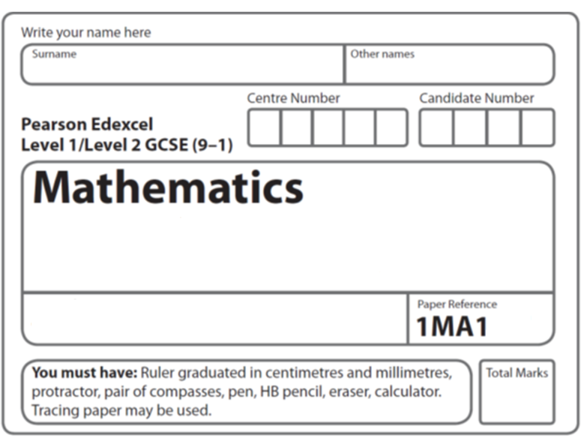
Statistical diagrams: Bar charts
Instructions
- Use black ink or ball-point pen.
  - Fill in the boxes at the top of this page with your name,
centre number and candidate number.
- Answer all questions.
- Answer the questions in the spaces provided
– there may be more space than you need.
- You must show all your working.
- Diagrams are NOT accurately drawn, unless otherwise indicated.
- If your calculator does not have a π button, take the value of π to be 3.142
unless the question instructs otherwise.

Information
- The total mark for this paper is 48. There are 9 questions.
- Questions have been arranged in an ascending order of mean difficulty, as found by all students in the June 2017–November 2019 examinations.
- The marks for each question are shown in brackets
– use this as a guide as to how much time to spend on each question.

Advice
- Read each question carefully before you start to answer it.
- Keep an eye on the time.
- Try to answer every question.
- Check your answers if you have time at the end.
1 Mrs Brown asked each child in her class which pet they liked best.
Here are her results.
dog | rabbit | cat | dog | dog | hamster
cat | dog | rabbit | hamster | cat | cat
dog | dog | cat | dog | rabbit | dog

(a) Complete the frequency table for this information.
Pet | Tally | Frequency
dog
rabbit
cat
hamster
(2)
(b) On the grid below, draw a bar chart for this information.
(3)
(c) Write down the most popular pet.
.......................................................
(1)
(Total for Question 3 is 1 marks)
___________________________________________________________________________

2 A teacher asks the students in Year 6 what type of transport they use to get to school.
The dual bar chart shows some of the results.

(a) What is the most popular type of transport used by the boys?

......................................................
(1)

7 girls walk to school.
(b) Show this information on the dual bar chart.
(1)

More of the students get to school by car than by bus.
(c) How many more?

......................................................
(1)

The number of students in Year 5 is the same as the number of students in Year 6.
(d) What is the total number of students in Years 5 and 6?

......................................................
(2)
(Total for Question 2 is 5 marks)
___________________________________________________________________________
3 The bar chart shows the number of hours of sunshine each day last week in Margate and
in Newquay.

(a) On how many days did Newquay have less than 5 hours of sunshine?

....................................................... days
(1)
In total, Margate had more hours of sunshine than Newquay last week.

(b) How many more?

....................................................... hours
(2)
(Total for Question 3 is 3 marks)
___________________________________________________________________________


4 The table shows the number of TVs sold in a shop on each of five days.

Day | Mon | Tue | Wed | Thu | Fri
Number of TVs sold | 8 | 12 | 9 | 6 | 8

David uses this information to draw the graph below.

Number of TVs sold
TVs sold

Write down three things wrong with this graph.

1 ...................................................................................................................................................

2 ...................................................................................................................................................

3 ...................................................................................................................................................
(Total for Question 4 is 3 marks)
___________________________________________________________________________

5 The bar chart shows some information about the number of letters in each word in a paragraph.

Number of letters
Number of words

(a) What is the modal number of letters in a word?

.......................................................
(1)

(b) Work out the range for the numbers of letters in a word.

.......................................................
(2)

(c) Work out the fraction of the words that have at least six letters.

.......................................................
(3)
(Total for Question 5 is 6 marks) ___________________________________________________________________________

6 A group of children and a group of adults gave an app a score.

1 was the lowest possible score.
5 was the highest possible score.

The incomplete bar chart shows some information about the scores.

Score | Number of children | Number of adults
4 | 14 | 6
5 | 10 | 9

(a) Complete the bar chart for this information.
(2)

(b) Work out the total number of adults who gave the app a score.

.......................................................
(2)
(c) Compare the scores given by the children with the scores given by the adults.

1....................................................................................................................................................

......................................................................................................................................................

2....................................................................................................................................................

......................................................................................................................................................
(2)
(Total for Question 6 is 6 marks)
___________________________________________________________________________

7 Bruna asked 20 students in each of Year 7 and Year 8 what pet they liked best.
The table gives information about her results.

 | Year 7 | Year 8
Cat | 7 | 4
Dog | 8 | 10
Rabbit | 5 | 6

Draw a suitable bar chart for this information.

(Total for Question 7 is 4 marks)
___________________________________________________________________________

8 A shop sells desktop computers, laptops and tablets.
The composite bar chart shows information about sales over the last three years.

(a) Write down the number of desktop computers sold in 2015

.......................................................
(1)
(b) Work out the total number of laptops sold in the 3 years.

.......................................................
(3)
(c) State the item that had the greatest increase in sales over the 3 years.
Give a reason for your answer.
......................................................................................................................................................
......................................................................................................................................................
......................................................................................................................................................
(2)
Alex says,
“In 2017, more tablets were sold than desktop computers. This means the shop makes
more profit from the sale of tablets than from the sale of desktop computers.”
(d) Is Alex correct?
You must justify your answer.
......................................................................................................................................................
......................................................................................................................................................
......................................................................................................................................................
(1)
(Total for Question 8 is 7 marks)
___________________________________________________________________________

9 Fran asks each of 40 students how many books they bought last year.
The chart below shows information about the number of books bought by each of the 40 students.

(a) Work out the percentage of these students who bought 20 or more books.

.......................................................%
(2)
(b) Show that an estimate for the mean number of books bought is 9.5
You must show all your working.

(4)
(Total for Question 9 is 6 marks)
___________________________________________________________________________
TOTAL MARKS FOR PAPER: 48

