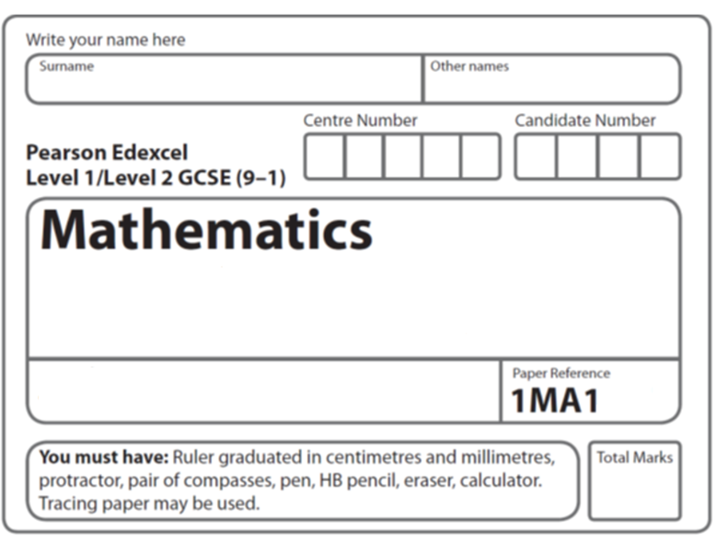
Foundation Tier
Which is better value for money?
Instructions
- Use black ink or ball-point pen.
  - Fill in the boxes at the top of this page with your name,
centre number and candidate number.
- Answer all questions.
- Answer the questions in the spaces provided
– there may be more space than you need.
- You must show all your working.
- Diagrams are NOT accurately drawn, unless otherwise indicated.
- If your calculator does not have a π button, take the value of π to be 3.142
unless the question instructs otherwise.

Information
- The total mark for this paper is 28. There are 8 questions.
- Questions have been arranged in an ascending order of mean difficulty, as found by all students in the June 2017–November 2019 examinations.
- The marks for each question are shown in brackets
– use this as a guide as to how much time to spend on each question.

Advice
- Read each question carefully before you start to answer it.
- Keep an eye on the time.
- Try to answer every question.
- Check your answers if you have time at the end.
1 The table shows the costs of sending a parcel by the Express service and by the Rapid service.

Type of service | Cost
Express | £15.25
Rapid | £35.38

Brendan has to send 12 parcels.
It will be cheaper to send the parcels by the Express service than by the Rapid service.
(a) How much cheaper?

£.......................................................
(3)

Luke wants to send 21 parcels by the Express service.
He does the calculation 20 × £15 = £300 to estimate the cost.
(b) Explain why Luke’s calculation shows the actual cost will be more than £300
......................................................................................................................................................
......................................................................................................................................................
......................................................................................................................................................
(1)
(Total for Question 1 is 4 marks)
___________________________________________________________________________

2 Jack’s driving school has two offers.

Offer 1 |  | Offer 2
First driving lesson free |  | All driving lessons
All other driving lessons normal price |  | 5% off the normal price

The normal price of a driving lesson is £24.
Douglas is going to have 12 driving lessons.
Which is the cheaper offer for 12 driving lessons, Offer 1 or Offer 2?
You must show how you get your answer.

(Total for Question 2 is 3 marks)
___________________________________________________________________________

3 Suha is going to buy 150 envelopes.
Here is some information about the cost of envelopes in two shops.

Letters2send |  | Stationery World
Pack of 25 envelopes for £3.49 |  | Pack of 10 envelopes for £2.10
 |  | Buy 2 packs get 1 pack free

Suha wants to buy the envelopes as cheaply as possible.
Which shop should Suha buy the 150 envelopes from?
You must show how you get your answer.

(Total for Question 3 is 4 marks)
___________________________________________________________________________

4 A shop sells compost in 20 litre bags and in 40 litre bags.
One day the shop had two special offers for the compost.

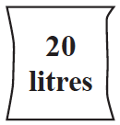 |  | 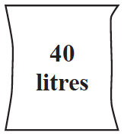
2 bags for £3.50 |  | 3 bags for £9

Which offer is the better value for money?
You must show how you get your answer.

(Total for Question 4 is 3 marks)
___________________________________________________________________________


5 Food Mart and Jan’s Store sell boxes of the same type of breakfast cereal.
Each shop has a special offer.

Which box of cereal is the better value for money?
You must show your working.

(Total for Question 5 is 4 marks)
___________________________________________________________________________
6 In London, 1 litre of petrol costs 108.9p
In New York, 1 US gallon of petrol costs $2.83.
1 US gallon = 3.785 litres
£1 = $1.46
In which city is petrol better value for money, London or New York?
You must show your working.

(Total for Question 6 is 3 marks)
___________________________________________________________________________

7 Three companies sell the same type of furniture.

The price of the furniture from Pooles of London is £1480
The price of the furniture from Jardins of Paris is €1980
The price of the furniture from Outways of New York is $2250

The exchange rates are

£1 = €1.34

£1 = $1.52

Which company sells this furniture at the lowest price?
You must show how you get your answer.

(Total for Question 7 is 3 marks)
___________________________________________________________________________

8 Shirley has a garage.
Here is a plan of her garage floor.

Shirley wants to buy enough paint to cover the garage floor as cheaply as possible.
She can buy her paint from Decor U or from Paint Store.

Decor U  Floor paint  £3.70 each tin  1 tin covers 12 m² |  | Paint Store  Floor paint  £3.00 each tin  1 tin covers 10 m²

From which of these two shops should Shirley buy her paint?
You must show all your working.

(Total for Question 8 is 4 marks)
___________________________________________________________________________
TOTAL MARKS FOR PAPER: 28

