GCSE Mathematics (1MA1)

Themed papers – Points Lines and Curves

Compiled from student-friendly mark schemes

Please note that this mark scheme is not the one used by examiners for making scripts. It is intended more as a guide to good practice, indicating where marks are given for correct answers. As such, it doesn’t show follow-through marks (marks that are awarded despite errors being made) or special cases.

It should also be noted that for many questions, there may be alternative methods of finding correct solutions that are not shown here – they will be covered in the formal mark scheme.

NOTES ON MARKING PRINCIPLES

Guidance on the use of codes within this mark scheme

M1 – method mark. This mark is generally given for an appropriate method in the context of the question. This mark is given for showing your working and may be awarded even if working is incorrect.

P1 – process mark. This mark is generally given for setting up an appropriate process to find a solution in the context of the question.

A1 – accuracy mark. This mark is generally given for a correct answer following correct working.

B1 – working mark. This mark is usually given when working and the answer cannot easily be separated.

C1 – communication mark. This mark is given for explaining your answer or giving a conclusion in context supported by your working.

Some questions require all working to be shown; in such questions, no marks will be given for an answer with no working (even if it is a correct answer).

Question 1 (Total 4 marks)
Part | Working or answer an examiner might expect to see | Mark | Notes
(a) | –10, –6, 2, 6 | B2 | These marks are given for four values correctly  (B1 is given for 2 or 3 values correct)
(b) |  | M1 | This mark is given for a at least five point correctly plotted
(b) |  | A1 | This mark is given for a correct graph from –1 to 4

Question 2 (Total 2 marks)
Part | Working or answer an examiner might expect to see | Mark | Notes
(a) | 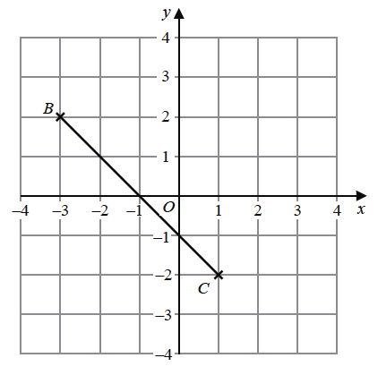  A  × | B1 | This mark is given for the point A correctly plotted
(b) | (–1, 0) | B1 | This mark is given for the correct answer only

Question 3 (Total 3 marks)
Part | Working or answer an examiner might expect to see | Mark | Notes
 |  | B3 | These marks are given for a correct straight line between the points (–2, –7) and (4, 5)  (B2 is given for a straight line segment through at least three of the points (–2, –7), (–1, 5), (0, –3), (1, –1) (2, 1), (3, 3) and (4, 5))  (B1 is give for at least two correct points stated or plotted or for a line drawn with gradient 2)

Question 4 (Total 2 marks)
Part | Working or answer an examiner might expect to see | Mark | Notes
 | D, F, A | C2 | These marks are given for all three graphs correct  (C1 is given for 1 or 2 graphs correct)
  Equation | Graph
  y = 2
  y = x
  x + y = 2

Question 5 (Total 4 marks)
Part | Working or answer an examiner might expect to see | Mark | Notes
(a) | 12, 4, 2, 1.2, 1 | B2 | These two marks are given for a fully correct table  (one mark is given for 3 values)
(b) | 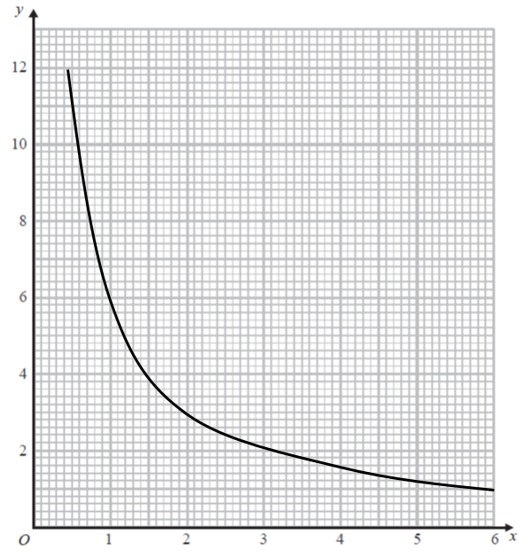 | M1 | This mark is given for plotting at least 6 points from their table correctly
(b) |  | A1 | This mark is given for a fully correct curve

Question 6 (Total 3 marks)
Part | Working or answer an examiner might expect to see | Mark | Notes
(a) | (–2, –1) | B1 | This mark is given for the correct answer only
(b) | B | B1 | This mark is given for the correct answer only
(c) |  | B1 | This mark is given for the line x = –4 drawn in the correct position

Question 7 (Total 5 marks)
Part | Working an or answer examiner might expect to see | Mark | Notes
(a) | 1.5, –1, –0.5, 0.5 | 2 | These marks are given for the correct values only  (1 mark is given for 1, 2 or 3 correct values seen)
(b) |  | 2 | These marks are given for the correct line drawn through (0, –1) and (2, 0)  (1 mark is given for any straight line with gradient or straight line through the point (0, –1))
(c) | 2.6 | 1 | This mark is given for the correct answer only

Question 8 (Total 4 marks)
Part | Working or answer an examiner might expect to see | Mark | Notes
(a) | (6, –2) | 1 | This mark is given for the correct answer only
(b)(i) | Point marked at (2, 9) | 1 | This mark is given for the correct answer only
(b)(ii) | (4 × 2) + 1 = 9  Yes, since when x = 2, y = 9 | 1 | This mark is given for a correct answer with a reason
(c) | Line drawn at x = –2 | 1 | This mark is given for the correct answer only

Question 9 (Total 1 mark)
Part | Working or answer an examiner might expect to see | Mark | Notes
 | A and D | C1

Question 10 (Total 5 marks)
Part | Working or answer an examiner might expect to see | Mark | Notes
 | width: 38 – 6 = 32  height: 36 – 7 = 29 | P1 | This mark is given for a process to find the width and height of the diagram
 | 32 ÷ 4 = 8 | P1 | This mark is given for a process to find the length of a side of a square
 | 6 + 8 + 8 = 22 | P1 | This mark is given for a process to find the x-coordinate
 | 36 – 8 – 8 = 20 | P1 | This mark is given for a process to find the y-coordinate
 | (22, 20) | A1 | This mark is given for the correct answer only

Question 11 (Total 3 marks)
Part | Working or answer an examiner might expect to see | Mark | Notes
 | 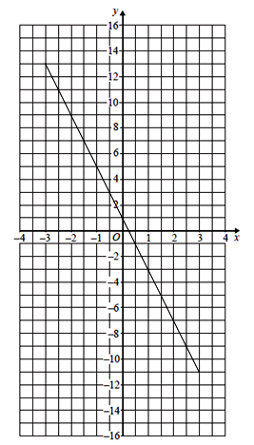 | B3 | These marks are given for a correct straight line between x = –3 and x = 3  (B2 is given for a line through at least three correct points)  (B1 is given for at least two correct points stated or plotted)

Question 12 (Total 2 marks)
Part | Working or answer an examiner might expect to see | Mark | Notes
(a) | (1, –4) | B1 | This mark is given for the correct answer only
(b) | –1, 3 | B2 | This mark is given for both correct answers only  (B1 is given for one correct solution seen)

Question 13 (Total 3 marks)
Part | Working or answer an examiner might expect to see | Mark | Notes
 | m = = 3 | M1 | This mark is given for a correct method to find the gradient of the line
 | Reading from the graph  c = –6 | M1 | This mark is given for finding –6 from the graph  or y = 3x + c  or 3x – 6
 | y = 3x – 6 | A1 | This mark is given for the correct answer only

Question 14 (Total 2 marks)
Part | Working or answer an examiner might expect to see | Mark | Notes
 | y = 3x – 2 so 3y = 9x – 6  3y – 9x + 5 = 0 so 3y = 9x − 5 | M1 | This mark is given for a method to start to form expressions which can be compared
 | Dividing rearranged equations by 3 gives y = 3x – 2 and y = 3x –  Gradient = 3 for both lines | A1 | This mark is given for comparing two equations and deducing that the gradients of the two lines are the same

Question 15 (Total 6 marks)
Part | Working or answer an examiner might expect to see | Mark | Notes
(a) | 0, –4, –6, –4, 0 | M1 | This mark is given for a correct method to find at least two values
(a) | 0, –4, –6, –4, 0 | A1 | This mark is given for finding all five values in the table
(b) |  | M1 | This mark is given for at least 5 points correctly plotted
(b) |  | A1 | This mark is given for a fully correct graph
(c) |  | M1 | This mark is given for the line y = –2 drawn
(c) | 2.6, –1.6 | A1 | This mark is given for answers in the range 2.5 to 2.7 and –1.5 to –1.7
Question 16 (Total 3 marks)
Part | Working or answer an examiner might expect to see | Mark | Notes
 | y = 3x + c  Using the coordinates for point A,  9 = (3 × 5) + c c = –6 | P1 | This mark is given for a process to use the gradient given
 | y = 3x – 6  Using the coordinates for point B,  15 = (3 × d) – 6  3d = 21 | P1 | This mark is given for a process to find a value for d
 | d = 7 | A1 | This mark is given for the correct answer only

Question 17 (Total 5 marks)
Part | Working or answer an examiner might expect to see | Mark | Notes
(a) | 2, –4, 2, 8 | B2 | These marks are given for all four values correct  (B1 is given for 2 or 3 values correct)
(b) |  | M1 | This mark is given for at least five points of (–3, 2), (–2, –2), (–1, –4), (0, –4), (1, –2), (2, 2) and (3, 8) plotted correctly
(b) |  | A1 | This mark is given for a fully correct curve drawn
(c) | –2.6 and 1.6 | B1 | This mark is given for two correct solutions read from the graph

Performance data:

Q | Taken from |  |  | Total Marks available | TOPIC | Spec Ref | AO | % Mean marks | Edexcel mean averages  Marks of candidates who achieved grade:
Q | Q | Series | Paper |  |  |  |  |  | ALL | 5 | 4 | 3 | 2 | 1 | U
1a | 17a | Nov 2019 | 3F | 2 | Algebra | A2 | 1 | 89 | 1.78 | 1.99 | 1.96 | 1.86 | 1.40 | 0.56 | 0.04
1b | 17b | Nov 2019 | 3F | 2 | Algebra | A9 | 2 | 82 | 1.64 | 1.94 | 1.88 | 1.71 | 1.17 | 0.41 | 0.01
2a | 10a | Nov 2019 | 1F | 1 | Algebra | A8 | 2 | 92 | 0.92 | 0.97 | 0.96 | 0.93 | 0.86 | 0.76 | 0.57
2b | 10b | Nov 2019 | 1F | 1 | Algebra | A8 | 1 | 62 | 0.62 | 0.84 | 0.72 | 0.62 | 0.48 | 0.39 | 0.34
3 | 21 | June 2019 | 2F | 3 | Algebra | A9 | 2 | 51 | 1.54 | 2.78 | 2.37 | 1.63 | 0.80 | 0.22 | 0.04
4 | 13 | June 2018 | 3F | 2 | Algebra | A12 | 2 | 50 | 1.00 | 1.37 | 1.17 | 1.02 | 0.87 | 0.68 | 0.37
5a | 22a | June 2017 | 3F | 2 | Algebra | A2 | 1 | 67 | 1.33 | 1.96 | 1.84 | 1.51 | 0.89 | 0.28 | 0.04
5b | 22b | June 2017 | 3F | 2 | Algebra | A14 | 2 | 48 | 0.96 | 1.68 | 1.43 | 1.04 | 0.50 | 0.10 | 0.01
6a | 8a | Nov 2018 | 1F | 1 | Algebra | A8 | 1 | 88 | 0.88 | 0.95 | 0.94 | 0.89 | 0.82 | 0.76 | 0.70
6b | 8b | Nov 2018 | 1F | 1 | Algebra | A8 | 2 | 96 | 0.96 | 0.99 | 0.99 | 0.97 | 0.93 | 0.85 | 0.77
6c | 8c | Nov 2018 | 1F | 1 | Algebra | A9 | 2 | 43 | 0.43 | 0.80 | 0.60 | 0.43 | 0.26 | 0.15 | 0.09
7a | 13a | Nov 2017 | 3F | 2 | Algebra | A2 | 1 | 76 | 1.52 | 1.96 | 1.86 | 1.62 | 1.11 | 0.36 | 0.10
7b | 13b | Nov 2017 | 3F | 2 | Algebra | A9 | 2 | 65 | 1.30 | 1.90 | 1.70 | 1.38 | 0.83 | 0.21 | 0.06
7c | 13c | Nov 2017 | 3F | 1 | Algebra | A17 | 2 | 28 | 0.28 | 0.65 | 0.44 | 0.28 | 0.12 | 0.02 | 0.02
8a | 7a | Nov 2017 | 1F | 1 | Algebra | A8 | 1 | 82 | 0.82 | 0.95 | 0.90 | 0.84 | 0.74 | 0.64 | 0.54
8bi | 7bi | Nov 2017 | 1F | 1 | Algebra | A8, A9 | 2 | 93 | 0.93 | 0.98 | 0.96 | 0.94 | 0.90 | 0.84 | 0.71
8bii | 7bii | Nov 2017 | 1F | 1 | Algebra | A8, A9 | 2 | 19 | 0.19 | 0.50 | 0.29 | 0.18 | 0.09 | 0.06 | 0.00
8c | 7c | Nov 2017 | 1F | 1 | Algebra | A9, A12 | 2 | 31 | 0.31 | 0.56 | 0.42 | 0.31 | 0.21 | 0.11 | 0.09
9 | 27 | Spec Set 1 | 3F | 1 | Geometry | − | − | − | − | − | − | − | − | − | −
10 | 24 | June 2018 | 1F | 5 | Geometry | G11, A8, A21 | 3 | 16 | 0.80 | 1.99 | 1.25 | 0.72 | 0.38 | 0.21 | 0.10
11 | 25 | June 2018 | 1F | 3 | Algebra | A9 | 2 | 16 | 0.49 | 1.84 | 0.93 | 0.32 | 0.07 | 0.02 | 0.01
12a | 29a | June 2019 | 1F | 1 | Algebra | A11, A12 | 2 | 51 | 0.51 | 0.89 | 0.75 | 0.53 | 0.32 | 0.16 | 0.05
12b | 29b | June 2019 | 1F | 2 | Algebra | A11, A18 | 2 | 9 | 0.18 | 0.65 | 0.29 | 0.12 | 0.07 | 0.05 | 0.04
13 | 22 | June 2018 | 2F | 3 | Algebra | A9 | 2 | 7 | 0.22 | 1.17 | 0.38 | 0.09 | 0.02 | 0.01 | 0.00
14 | 26 | June 2017 | 1F | 2 | Algebra | A9 | 2 | 6 | 0.11 | 0.42 | 0.15 | 0.05 | 0.02 | 0.00 | 0.00
15a | 24a | June 2018 | 2F | 2 | Algebra | A14 | 1 | 34 | 0.68 | 1.46 | 1.08 | 0.69 | 0.30 | 0.07 | 0.01
15b | 24b | June 2018 | 2F | 2 | Algebra | A14 | 2 | 25 | 0.50 | 1.22 | 0.83 | 0.49 | 0.19 | 0.04 | 0.00
15c | 24c | June 2018 | 2F | 2 | Algebra | A11 | 2 | 4 | 0.07 | 0.38 | 0.12 | 0.03 | 0.01 | 0.00 | 0.00
16 | 25 | Nov 2018 | 2F | 3 | Algebra | A10, A17 | 3 | 4 | 0.13 | 0.97 | 0.21 | 0.11 | 0.07 | 0.06 | 0.00
17a | 22a | Nov 2018 | 3F | 2 | Ratio | R10, R11, G14 | 3 | 47 | 0.94 | 1.74 | 1.30 | 0.94 | 0.52 | 0.18 | 0.01
17b | 22b | Nov 2018 | 3F | 2 | Ratio | R10, R11 | 3 | 25 | 0.50 | 1.39 | 0.83 | 0.46 | 0.15 | 0.03 | 0.00
17c | 22c | Nov 2018 | 3F | 1 | Algebra | A12 | 2 | 3 | 0.03 | 0.30 | 0.07 | 0.02 | 0.01 | 0.00 | 0.00
 |  |  |  | 58 |  |  |  |  | 22.57 | 38.19 | 29.62 | 22.73 | 15.11 | 8.23 | 4.72

