GCSE Mathematics (1MA1)

Themed papers – Transformations

Compiled from student-friendly mark schemes

Please note that this mark scheme is not the one used by examiners for making scripts. It is intended more as a guide to good practice, indicating where marks are given for correct answers. As such, it doesn’t show follow-through marks (marks that are awarded despite errors being made) or special cases.

It should also be noted that for many questions, there may be alternative methods of finding correct solutions that are not shown here – they will be covered in the formal mark scheme.

NOTES ON MARKING PRINCIPLES

Guidance on the use of codes within this mark scheme

M1 – method mark. This mark is generally given for an appropriate method in the context of the question. This mark is given for showing your working and may be awarded even if working is incorrect.

P1 – process mark. This mark is generally given for setting up an appropriate process to find a solution in the context of the question.

A1 – accuracy mark. This mark is generally given for a correct answer following correct working.

B1 – working mark. This mark is usually given when working and the answer cannot easily be separated.

C1 – communication mark. This mark is given for explaining your answer or giving a conclusion in context supported by your working.

Some questions require all working to be shown; in such questions, no marks will be given for an answer with no working (even if it is a correct answer).

Question 1 (Total 1 mark)
Part | Working or answer an examiner might expect to see | Mark | Notes
 |  | B1 | This mark is given for a correct reflection drawn

Question 2 (Total 2 marks)
Part | Working or answer an examiner might expect to see | Mark | Notes
 |  | B2 | These marks are given for a correct shape with vertices at (4, –3), (5, –4), (5, –5) and (4, –5)  (B1 is given for a rotation of 180° about the wrong centre)

Question 3 (Total 2 marks)
Part | Working an or answer examiner might expect to see | Mark | Notes
 |  | B2 | These marks are given for a correct enlargement  (B1 is given for any two sides correct or a correct enlargement with scale factor other than 1 or 3)
 |  | A1 | This mark is given for the correct answer only

Question 4 (Total 2 marks)
Part | Working or answer an examiner might expect to see | Mark | Notes
 | Reflection… | B1 | This mark is given for “reflection”
 | …in the x-axis | B1 | This mark is given for “x-axis”

Question 5 (Total 2 marks)
Part | Working or answer an examiner might expect to see | Mark | Notes
 | A reflection in the y-axis (or x = 0) | B1 | This mark is given for reflection
 | A reflection in the y-axis (or x = 0) | B1 | This mark is given for y-axis (or y = 0)

Question 6 (Total 2 marks)
Part | Working or answer an examiner might expect to see | Mark | Notes
 | y = 3 | B2 | These marks are given for a correctly drawn reflection  (B1 is given for a correct reflection in any line other than y = 3)

Question 7 (Total 2 marks)
Part | Working or answer an examiner might expect to see | Mark | Notes
 | Reflection… | 1 | This mark is given for identifying a reflection
 | …in the y-axis | 1 | This mark is given for identifying the line of reflection being the y-axis

Question 8 (Total 4 marks)
Part | Working or answer an examiner might expect to see | Mark | Notes
(a) | 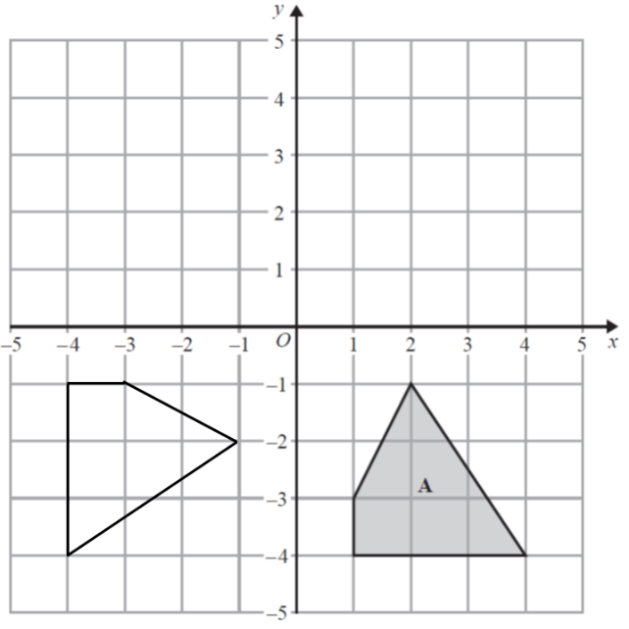 | B2 | These two marks are given for a fully correct rotation with vertices at (–4,–1), (–3,–1), (–4,–4), (–1,–2)  (One mark is given for the quadrilateral in correct orientation and size or rotated 90º anticlockwise about the origin)
(b) | Reflection in the y-axis | B1 | This mark is given for reflection
(b) | Reflection in the y-axis | B1 | This mark is given for y-axis (or x =0)

Question 9 (Total 2 marks)
Part | Working an or answer examiner might expect to see | Mark | Notes
 | A  B | 1 | This mark is given for a shape labelled A with coordinates (–2, 1), (–4, 1), (–2, 2) and (–5, 2)
 |  | 1 | This mark is given for a shape labelled B with coordinates (1, –4), (3, –4), (1, –5) and (4, –5)

Question 10 (Total 3 marks)
Part | Working or answer an examiner might expect to see | Mark | Notes
 |  | M1 | This mark is given for a correct reflection of A shown on the diagram
 | c = –6  d = –1 | A1 | This mark is given for a correct value for either c or d
 | c = –6  d = –1 | A1 | This mark is given for a correct value for both c and d

Performance data:

Q | Taken from |  |  | Total Marks available | TOPIC | Spec Ref | AO | % Mean marks | Edexcel mean averages  Marks of candidates who achieved grade:
Q | Q | Series | Paper |  |  |  |  |  | ALL | 5 | 4 | 3 | 2 | 1 | U
1 | 10 | Nov-18 | 3F | 1 | Geometry | G7 | 1 | 96 | 0.96 | 0.99 | 0.98 | 0.96 | 0.93 | 0.87 | 0.58
2 | 19 | Nov-18 | 1F | 2 | Geometry | G7 | 1 | 55 | 1.09 | 1.49 | 1.37 | 1.1 | 0.77 | 0.55 | 0.27
3 | 13 | Nov-19 | 2F | 2 | Geometry | G7 | 1 | 50 | 0.99 | 1.54 | 1.27 | 0.99 | 0.61 | 0.33 | 0.2
4 | 16 | Nov-18 | 2F | 2 | Geometry | G7 | 2 | 39 | 0.77 | 1.29 | 1.07 | 0.76 | 0.45 | 0.24 | 0.14
5 | 18 | Jun-18 | 2F | 2 | Geometry | G7 | 2 | 37 | 0.73 | 1.43 | 1.06 | 0.73 | 0.44 | 0.22 | 0.08
6 | 14 | Nov-17 | 3F | 2 | Geometry | G7 | 2 | 36 | 0.72 | 1.16 | 0.92 | 0.72 | 0.51 | 0.29 | 0.11
7a | 13a | Jun-17 | 2F | 2 | Geometry | G7 | 1 | 66 | 1.31 | 1.83 | 1.65 | 1.41 | 1.05 | 0.58 | 0.14
7b | 13b | Jun-17 | 2F | 2 | Geometry | G7, G24 | 2 | 36 | 0.72 | 1.35 | 1.02 | 0.69 | 0.42 | 0.2 | 0.06
8 | 18 | Nov-19 | 3F | 2 | Geometry | G7 | 1 | 33 | 0.66 | 1.34 | 0.97 | 0.62 | 0.31 | 0.16 | 0.08
9a | 20a | Nov-17 | 2F | 1 | Geometry | G7 | 1 | 50 | 0.5 | 0.72 | 0.64 | 0.52 | 0.37 | 0.17 | 0.04
9b | 20b | Nov-17 | 2F | 1 | Geometry | G7, G24 | 1 | 31 | 0.31 | 0.6 | 0.47 | 0.31 | 0.14 | 0.05 | 0.03
10 | 26 | Jun-19 | 1F | 3 | Geometry | G7, G24 | 2 | 20 | 0.59 | 1.78 | 1.03 | 0.46 | 0.18 | 0.08 | 0.04
 |  |  |  | 22 |  |  |  |  | 9.35 | 15.52 | 12.45 | 9.27 | 6.18 | 3.74 | 1.77

