GCSE Mathematics (1MA1)

Aiming for Grade 7 papers – Paper 1 – Non-Calculator

Compiled from student-friendly mark schemes

Please note that this mark scheme is not the one used by examiners for making scripts. It is intended more as a guide to good practice, indicating where marks are given for correct answers. As such, it doesn’t show follow-through marks (marks that are awarded despite errors being made) or special cases.

It should also be noted that for many questions, there may be alternative methods of finding correct solutions that are not shown here – they will be covered in the formal mark scheme.

NOTES ON MARKING PRINCIPLES

Guidance on the use of codes within this mark scheme

M1 – method mark. This mark is generally given for an appropriate method in the context of the question. This mark is given for showing your working and may be awarded even if working is incorrect.

P1 – process mark. This mark is generally given for setting up an appropriate process to find a solution in the context of the question.

A1 – accuracy mark. This mark is generally given for a correct answer following correct working.

B1 – working mark. This mark is usually given when working and the answer cannot easily be separated.

C1 – communication mark. This mark is given for explaining your answer or giving a conclusion in context supported by your working.

Some questions require all working to be shown; in such questions, no marks will be given for an answer with no working (even if it is a correct answer).

Question 1 (Total 4 mark)
Part | Working or answer an examiner might expect to see | Mark | Notes
 | $\frac{7}{9}$ × $\frac{2}{8}$ = $\frac{\text{14}}{\text{72}}$ | P1 | This mark is given for a process to find the probability of choosing a green counter followed by a blue counter
 | $\frac{2}{9}$ × $\frac{7}{8}$ = $\frac{\text{14}}{\text{72}}$ | P1 | This mark is given for a process to find the probability of choosing a blue counter followed by a green counter
 | $\frac{\text{14}}{\text{72}}$ + $\frac{\text{14}}{\text{72}}$ | P1 | This mark is given for a process to find the probability of choosing one counter of each colour
 | $\frac{\text{28}}{\text{72}}$ (=$\frac{7}{\text{18}}$) | A1 | This mark is given for the correct answer only

Question 2 (Total 3 mark)
Part | Working or answer an examiner might expect to see | Mark | Notes
(a) | 1 | B1 | This mark is given for the correct answer only
(b) | cos 60° = $\frac{4}{x}$  0.5 = $\frac{4}{x}$, x = $\frac{4}{0\text{.}5}$ | M1 | This mark is given for a method to find the value of x
(b) | 8 | A1 | This mark is given for the correct answer only

Question 3 (Total 2 mark)
Part | Working or answer an examiner might expect to see | Mark | Notes
 | ${\text{16}}^{\frac{1}{4}}$ = 2, ${\text{81}}^{\frac{1}{4}}$ = 3 | M1 | This mark is given for a method to find the fourth root of both 16 and 81
 | 2³ = 8, 3³ = 27  $$\frac{8}{\text{27}}$$ | A1 | This mark is given for the correct answer only

Question 4 (Total 4 mark)
Part | Working or answer an examiner might expect to see | Mark | Notes
 | ACB = 180 – 75 – 51 = 54 | M1 | This mark is given for a method to find the angle ACB
 | ACD = $\frac{\text{54}}{2+1}$ = 18  DCB = $\frac{\text{54}}{2+1}$ × 2 = 36 | M1 | This mark is given for a method to find the size of angles ACD and DCB
 | BDC = 180 – 51 – 36 | M1 | This mark is given for a method to find the angle BDC
 | BDC = 93 | A1 | This mark is given for the correct answer only

Question 5 (Total 4 mark)
Part | Working or answer an examiner might expect to see | Mark | Notes
 | 72 × $\frac{\text{18}}{\text{60}}$ | M1 | This mark is given for a method to find the distance travelled by the car
 | 21.6 | A1 | This mark is given for the correct answer only
 | 20 × $\frac{\text{3600}}{\text{1000}}$ = 72 | M1 | This mark is given for a method to convert 20 m/s to km/h
 | David is incorrect; 72 km/h is the same as 20 m/s, not faster | C1 | This mark is given for a valid conclusion supported by correct working

Question 6 (Total 3 marks)
Part | Working or answer an examiner might expect to see | Mark | Notes
 | √5(√8 + √18) = √5√8 + √5√18 | M1 | This mark is given for expanding brackets
 | = √40 + √90  = √4√10 + √9√10  = 2√10 + 3√10 | M1 | This mark is given for finding an expression in terms of √10
 | = (2 + 3)√10  = 5√10  a = 5 | A1 | This mark is given for the correct answer only

Question 7 (Total 3 marks)
Part | Working or answer an examiner might expect to see | Mark | Notes
 | 10x = 2.56256…  1000x = 256.256… | M1 | This mark is given for a method to eliminate recurring decimals
 | 990x = 254 | M1 | This mark is given for an expression with eliminates the recurring decimals
 | x = $\frac{\text{254}}{\text{990}}$;  divding top and bottom by 2 gives $\frac{\text{127}}{\text{495}}$ |  | This mark is given for a complete proof

Question 8 (Total 3 marks)
Part | Working or answer an examiner might expect to see | Mark | Notes
 | 30 × 60 (= 1800)  20 × 54 (= 1080) | P1 | This mark is given for a process to find the total mark of the whole class and the total mark of the girls
 | (1800 – 1080) = 720 | P1 | This mark is given for a process to find the total mark of the boys
 | 720 ÷ 10 = 72 | A1 | This mark is given for the correct answer only

Question 9 (Total 2 marks)
Part | Working or answer an examiner might expect to see | Mark | Notes
 | 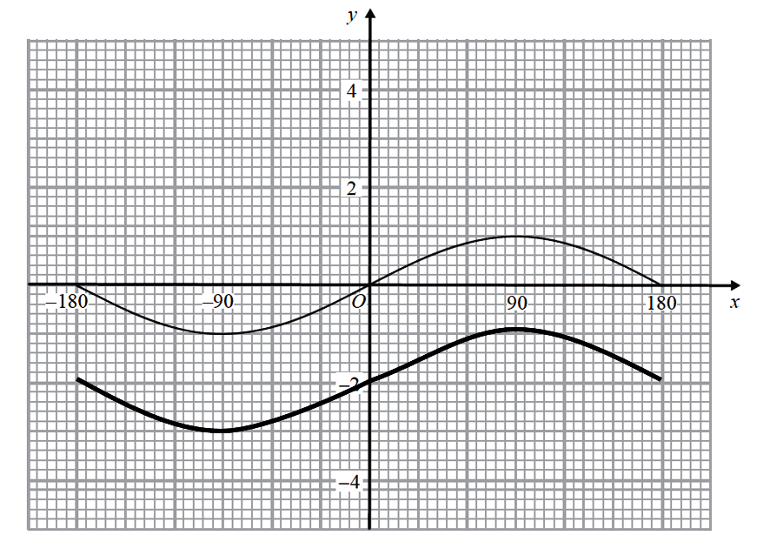 | C2 | These marks are given for a graph translated –2 in the y-direction  (One mark is given for a graph translated by another amount in the y-direction)

Question 10 (Total 3 marks)
Part | Working or answer an examiner might expect to see | Mark | Notes
(a) | 100 ≈ $\frac{1}{3}$ × 3 × 25h | M1 | This mark is given for substitution of suitable terms into the formula for the volume of a cone
(a) | h ≈ $\frac{\text{100}}{\text{25}}$ | M1 | This mark is given for a method to rearrange and solve
(a) | h ≈ 4 | A1 | This mark is given for a correct single value from estimate (accept answers in the range 3.5 to 4.5)

Question 11 (Total 4 marks)
Part | Working or answer an examiner might expect to see | Mark | Notes
(a) | (a + b)(a – b) | B1 | This mark is given for a correct answer only
(b) | (x² + 4 + x² – 2)(x² + 4 – x² + 2) | M1 | This mark is given for using a = x² + 4 and b = x² – 2
(b) | = (2x² + 2) × (6) | M1 | This mark is given for a method to multiply out the brackets to find an expression of the form cx² + d
(b) | = 12x² + 12  = 12(x² + 1) | A1 | This mark is given for a correct answer only

Question 12 (Total 4 marks)
Part | Working or answer an examiner might expect to see | Mark | Notes
 | $\frac{1}{2}$(x + 4)(x – 2) | P1 | This mark is given for a process to find the area of the triangle
 | $\frac{1}{2}$(x² + 2x – 8) = 27.5  x² + 2x – 8 = 55  x² + 2x – 63 = 0 | P1 | This mark is given for a process to expand brackets and find a quadratic equation to solve
 | (x – 7)(x + 9)  x = 7 | P1 | This mark is given for a process to factorise to find a value for x
 | Shortest side = 7 – 2 = 5 | A1 | This mark is given for the correct answer only

Question 13 (Total 3 marks)
Part | Working an or answer examiner might expect to see | Mark | Notes
 | 3x² – 8x – 3 = (3x + 1)(x – 3) | M1 | This mark is given for expanding the brackets of the numerator
 | 2x² – 6x = 2x(x – 3) | M1 | This mark is given for expanding the brackets of the denominator
 | $\frac{(3x+1)(x−3)}{2x(x−3)}$ = $\frac{3x+1}{2x}$ | A1 | This mark is given for cancelling (x – 3) for the correct answer

Question 14 (Total 5 marks)
Part |  | Working an or answer examiner might expect to see | Mark | Notes
(a) | fg(x) = 3(x² + 4) – 1 |  | M1 | This mark is given for a finding the angle BDC
(a) | gf(x) = (3x – 1)² + 4 |  | M1 | This mark is given for a an appropriate reason stated
(a) | 3x² + 11 = 2(9x² – 6x + 5) |  | M1 | This mark is for setting up the equation of fg(x) = 2gf(x)
(a) | 3x² + 11 = 18x² – 12x + 10 |  | M1 | This mark is given for multiplying out the expression for 2gf(x)
(a) | 15x² – 12x – 1 = 0 |  | C1 | This mark is given for a correct conclusion following from correct working
(b) |  | f^{–1}(x) = $\sqrt[3]{\frac{x+4}{2}}$ | C1 | This mark is given for finding an expression for f^{–1}(x)
 |  | f^{–1}(x) = $\sqrt[3]{\frac{\text{50}+4}{2}}$ = $\sqrt[3]{\text{27}}$ = 3 | C1 | This mark is given for correctly substituting 50 into f^{–1}(x)

Question 15 (Total 3 marks)
Part | Working or answer an examiner might expect to see | Mark | Notes
 | 3 + 17 represents 80% of the counters | P1 | This mark is given for using 1 – 0.2 = 0.8
 | 3 : 17 : 5 | P1 | This mark is given for a process to find the ratio of purple counters
 | $$\frac{3}{\text{25}}$$ | A1 | This mark is given for a correct answer only (or decimal equivalent)

Question 16 (Total 4 marks)
Part | Working or answer an examiner might expect to see | Mark | Notes
 | Let an odd number be 2n + 1 | B1 | This mark is given for finding an algebraic representation of an odd number
 | (2n + 1)² | M1 | This mark is given for an expression for the square of an odd number
 | 4n² + 4n + 1 | A1 | This mark is given for expanding brackets
 | Thus 4(n² + n) + 1 is 1 greater than a multiple of 4 | C1 | This mark is given for concluding statement

Question 17 (Total 5 marks)
Part | Working or answer an examiner might expect to see | Mark | Notes
 | y ∝ $\frac{1}{d^{2}}$ or y = $\frac{k}{d^{2}}$ | M1 | This mark is given for a process to set up a correct proportional relationship
 | 4 = $\frac{k}{{\text{10}}^{2}}$ = $\frac{k}{\text{100}}$, k = 400 | P1 | This mark is given for a process to find a value of k
 | d ∝ x² or d = kx²  24 = k × 4, k = 6 | P1 | This mark is given for a process to set up a second correct proportional relationship
 | y = $\frac{\text{400}}{d^{2}}$ = $\frac{\text{400}}{(6x^{2})^{2}}$ = $\frac{\text{400}}{\text{36}x^{4}}$ | P1 | This mark is given for a process to find y in terms of x
 | y = $\frac{\text{100}}{9x^{4}}$ | A1 | This mark is given for a correct and fully simplified answer only

Question 18 (Total 5 marks)
Part | Working or answer an examiner might expect to see | Mark | Notes
(a) |  | B1 | This mark is given for whiskers at 0 and 42
(a) |  | B1 | This mark is given for a median of 10 shown
(a) |  | B1 | This mark is given for ends of the box at 4 and 20
(b) |  | C1 | This mark is given for a correct comparison of medians
(b) |  | C1 | This mark is given for a correct comparison of measure of spread (range and/or IQR)

Question 19 (Total 2 marks)
Part | Working or answer an examiner might expect to see | Mark | Notes
 | y = f(x + 1) – 3 | C2 | These marks are given for a graph drawn translated by the vector $\left(\begin{matrix}−1 \\ −3\end{matrix}\right)$  (C1 is given for a translation of the graph by vector $\left(\begin{matrix}a \\ −3\end{matrix}\right)$ or $\left(\begin{matrix}−1 \\ b\end{matrix}\right)$ where a ≠ 1 or b ≠ –3)

Question 20 (Total 2 marks)
Part | Working or answer an examiner might expect to see | Mark | Notes
 | tan 30° = $\frac{1}{√3}$, sin 60° = $\frac{√3}{2}$ | M1 | This mark is given for find two exact values of tan 30° and sin 60°
 | $\frac{1}{√3}$ × $\frac{√3}{2}$ = $\frac{1}{2}$ | A1 | This mark is given for a correct answer only

Question 21 (Total 5 marks)
Part | Working or answer an examiner might expect to see | Mark | Notes
 | BAO = x  Base angles in an isosceles triangle are equal  AOB = 180 – 2x  Angles in a triangle add up to 180°  OBC = 90  A tangent to a circle is perpendicular to the radius | M1 | This mark is given for identifying at least one missing angle
 | 180 – x – x – 90  Angles in a triangle add up to 180° | M1 | This mark is given for a full method to find the required angle
 | 90 – 2x | A1 | This mark is given for the correct answer in its simplest form
 | Base angles in an isosceles triangle are equal, angles in a triangle add up to 180°, a tangent to a circle is perpendicular to the radius | C2 | These marks are given for a full set of reasons  (One mark is given for one correct reason included)

Question 22 (Total 4 marks)
Part | Working or answer an examiner might expect to see | Mark | Notes
 | (n – 2)² = n² – 4n + 4 | C1 | This mark is given for a correct expansion of (n – 2)²
 | n² – 2 − n² + 4n − 4 | C1 | This mark is given for a correct expansion of n – 2 – (n – 2)²
 | 2(2n − 3) | C1 | This mark is given for reducing the expression to (2n − 3)
 | 2(2n−3) always even since it has a factor of 2 for all values of n | C1 | This mark is given for a correct conclusion supported by working shown

Question 23 (Total 1 marks)
Part | Working or answer an examiner might expect to see | Mark | Notes
 | $\frac{x−1}{5(x−1)(x−1)}$ = $\frac{1}{5(x−1)}$ | B1 | This mark is given for the correct answer only

Q | Taken from Paper |  |  | Number of Marks | Edexcel averages: scores of candidates who achieved grade 7 | %
1 | 1H | June 17 | 17 | 4 | 3.30 | 83
2a | 1H | Nov 18 | 8a | 1 | 0.56 | 56
2b | 1H | Nov 18 | 8b | 2 | 1.66 | 83
3 | 1H | Nov 18 | 14a | 2 | 1.64 | 82
4 | 1H | Nov 19 | 5 | 4 | 3.29 | 82
5a | 1H | Nov 19 | 9a | 2 | 1.55 | 78
5b | 1H | Nov 19 | 9b | 2 | 1.16 | 58
6 | 1H | June 18 | 13 | 3 | 2.26 | 75
7 | 1H | Nov 18 | 16 | 3 | 2.20 | 73
8 | 1H | June 17 | 7 | 3 | 2.18 | 73
9 | 1H | June 18 | 18 | 2 | 1.44 | 72
10 | 1H | June 17 | 15a | 3 | 2.06 | 69
11a | 1H | June 18 | 15b | 3 | 1.47 | 49
11b | 1H | J49une 18 | 15a | 1 | 0.59 | 59
12 | 1H | Nov 19 | 14 | 4 | 2.71 | 68
13 | 1H | June 18 | 17 | 3 | 1.96 | 65
14a | 1H | June 19 | 21(b) | 5 | 3.19 | 64
14b | 1H | Nov 19 | 18a | 2 | 1.08 | 54
15 | 1H | June 18 | 16 | 3 | 1.88 | 63
16 | 1H | June 18 | 12 | 4 | 2.33 | 58
17 | 1H | June 18 | 14 | 5 | 2.92 | 58
18a | 1H | Nov 18 | 9a | 3 | 1.68 | 56
18b | 1H | Nov 18 | 9b | 2 | 0.73 | 37
19 | 1H | Nov 19 | 20a | 2 | 1.06 | 53
20 | 1H | June 19 | 14 | 2 | 0.94 | 47
21 | 1H | June 18 | 11 | 5 | 2.04 | 41
22 | 1H | June 17 | 16 | 4 | 1.56 | 39
23 | 1H | Nov 18 | 10a | 1 | 0.35 | 35

Suggested Grade Boundaries for Aiming for 7: Paper 1
Grade | 7 | 6 | 5 | 4
Mark | 50 | 36 | 23 | 11

For example:
A student aiming for Grade 7 would be expected to score at least 50 marks on this practice paper.

