GCSE Mathematics (1MA1) – Higher Tier Paper 3H

Aiming for Grade 9 – Spring 2020 student-friendly mark scheme

Please note that this mark scheme is not the one used by examiners for making scripts. It is intended more as a guide to good practice, indicating where marks are given for correct answers. As such, it doesn’t show follow-through marks (marks that are awarded despite errors being made) or special cases.

It should also be noted that for many questions, there may be alternative methods of finding correct solutions that are not shown here – they will be covered in the formal mark scheme.

NOTES ON MARKING PRINCIPLES

Guidance on the use of codes within this mark scheme

M1 – method mark. This mark is generally given for an appropriate method in the context of the question. This mark is given for showing your working and may be awarded even if working is incorrect.

P1 – process mark. This mark is generally given for setting up an appropriate process to find a solution in the context of the question.

A1 – accuracy mark. This mark is generally given for a correct answer following correct working.

B1 – working mark. This mark is usually given when working and the answer cannot easily be separated.

C1 – communication mark. This mark is given for explaining your answer or giving a conclusion in context supported by your working.

Some questions require all working to be shown; in such questions, no marks will be given for an answer with no working (even if it is a correct answer).

Question 1 (Total 5 marks)
Part | Working or answer an examiner might expect to see | Mark | Notes
 | y = $\frac{\text{17}}{2}$ – $\frac{3}{2}$x, gradient = –$\frac{3}{2}$ | P1 | This mark is given for a process to find the gradient of L
 | Gradient of M = $\frac{2}{3}$  Equation for M is y = $\frac{2}{3}$x + c  Point A on the line M at (0, 2) ⇒ c = 2 | P1 | This mark is given for a process to find an equation for the perpendicular M
 | B = (0, $\frac{\text{17}}{2}$) | B1 | This mark is given for identifying the coordinates of the point B
 | $\frac{\text{17}}{2}$ – $\frac{3}{2}$x = $\frac{2}{3}$x + 2  $\frac{\text{13}}{2}$ = $\frac{\text{13}}{6}$x,  x = 3, y = 4  C = (3, 4) | P1 | This mark is given finding the coordinates of the point C
 | Area ABC = $\frac{1}{2}$(8.5 – 2) × 3 = 9.75 | A1 | This mark is given for the correct answer only

Question 2 (Total 5 marks)
Part | Working or answer an examiner might expect to see | Mark | Notes
 | $\frac{p−5}{q−5}$ = $\frac{5}{1}$ ; $\frac{p+\text{20}}{q+\text{20}}$ = $\frac{5}{2}$ | P1 | This mark is given for a process to represent the ratios given
 | p – 5 = 5(q – 5) ; 2(p + 20) = 5(q + 20) | P1 | This mark is given for a method to find two simultaneous equations in p and q
 | 5q – p = 20  5q – 2p = –60  p = 80 | M1 | This mark is given for a method to rearrange to find a value for p
 | 5q = 100  q = 20 | M1 | This mark is given for a method to find a value for q
 | p : q = 80 : 20  = 4 : 1 | A1 | This mark is given for the correct answer only

Question 3 (Total 3 marks)
Part | Working an or answer examiner might expect to see | Mark | Notes
 | Area for Adley pie chart = π × 5² = 25π  Area of Bridford pie chart = π × 4² = 16π  Angle for 0–19 on Adley = 70° | 1 | This mark is given for finding areas for the two circles and an angle for 0–19
 | $\frac{\text{70}}{\text{360}}$ × $\frac{\text{25}π}{\text{41}π}$ | 1 | This mark is given for a method to find the proportion of 0–19 year olds in Bridford
 | 0.119 | 1 | This mark is given for the correct answer in the range 0.118 – 0.119

Question 4 (Total 3 marks)
Part | Working or answer an examiner might expect to see | Mark | Notes
 | 1 + 5 = 6 and 7 + 11 = 18 and 6 × 3 = 18 | P1 | This mark is given for a process to start to solve the problem using multipliers
 | (7 + 11) ÷ (1 + 5) = 3  and  1 × 3 : 7 − (3 × 1) : 11 | P1 | This mark is given for a complete process to find ratios
 | 3 : 4 : 11 | A1 | This mark is given for the correct answer only

Question 5 (Total 5 marks)
Part | Working or answer an examiner might expect to see | Mark | Notes
 | Area of triangle ADC = $\frac{1}{2}$ab sin C  = 0.5 × 11 × (CD × sin 105°) = 56 | 1 | This mark is given for finding an equation for the area of triangle ADC
 | CD = $\frac{\text{56}}{0\text{.}5×\text{11}×\text{sin}\text{105}°}$ = $\frac{\text{56}}{5\text{.}\text{312}\text{.}\text{.}\text{.}}$  = 10.54 | 1 | This mark is given for finding the length of CD
 | AC ² =  11² + (10.54)² – 2 × 11 × 10.54 × cos 105°  = 232.0916 + 60.01496  = 292.10656  AC = 17.091125 | 1 | This mark is given for using the cosine rule c² = a² + b² – 2ab cos C to find the length of AC
 | $\frac{\text{AB}}{\text{sin}\text{48}°}$ = $\frac{\text{AC}}{\text{sin}\text{118}°}$  $\frac{\text{AB}}{0\text{.}\text{743}}$ = $\frac{\text{17}\text{.}\text{09}}{0\text{.}\text{883}}$  AB = $\frac{\text{17}\text{.}\text{09}×0\text{.}\text{743}}{0\text{.}\text{883}}$ | 1 | This mark is given for a method to us the sine rule to find the length of AB
 | 14.38 | 1 | This mark is given for an answer in the range 14.3 – 14.4

Question 6 (Total 5 marks)
Part | Working or answer an examiner might expect to see | Mark | Notes
 | g(3) = 3a + b = 20 | 1 | This mark is given for finding an equation for g(3)
 | g(1) = a + b | 1 | This mark is given for finding g(1)
 | f ^{–1}(x) = $\frac{x−3}{5}$ | 1 | This mark is given for finding f ^{–1}(x)
 | f ^{–1}(33) = g(1) = a + b = $\frac{\text{33}−3}{5}$ = 6 | 1 | This mark is given for finding an the equation a + b = 6
 | 3a + b = 20  a + b = 6  2a = 14, so a = 7 and b = –1 | 1 | This mark is given for finding the values of a and b

Question 7 (Total 5 marks)
Part | Working or answer an examiner might expect to see | Mark |  | Notes
 | 3.4² = 6.1² + 6.2² – (2 × 6.1 × 6.2 × cos C) | B1 |  | This mark is given for the correct use of the cosine rule c² = a² + b² cos C
 | 11.56 = 37.21 + 38.44 – (75.64 × cos C)  cos C = $\frac{\text{64}\text{.}\text{09}}{\text{75}\text{.}\text{64}}$ = 0.8473…  ∠ BCA = 38.08° | P1 |  | This mark is given for a process to find the value of ∠ BCA
 | $\frac{\text{DC}}{\text{sin} (\text{32}\text{.}\text{08}×\frac{2}{5})}$ = $\frac{6\text{.}2}{\text{sin} (\text{180}−\text{32}\text{.}\text{08}−(\text{32}\text{.}\text{08}×\frac{2}{5}))}$  $\frac{\text{DC}}{0\text{.}\text{222}\text{.}\text{.}\text{.}}$ = $\frac{6\text{.}2}{0\text{.}\text{706}\text{.}\text{.}\text{.}}$ |  | P1 |  | This mark is given for a correct substitution using the sine rule
 | DC = $\frac{0\text{.}\text{222}\text{.}\text{.}\text{.}×6\text{.}2}{0\text{.}\text{706}\text{.}\text{.}\text{.}}$ | P1 |  | This mark is given for a process to find the length DC
 | 1.95 | A1 |  | This mark is given for a correct answer only (to 3 significant figures)

Question 8 (Total 5 marks)
Part | Working or answer an examiner might expect to see | Mark | Notes
 | F  G  S  2  8  4  0 | P1 | This mark is given for a process to show some of the information given
 | F  G  S  2  8  4  5  3  22  0 | P1 | This mark is given for a process to show at least three of the unknown amounts from the information given  5 people speak German and Spanish but not French  3 people speak French and German but not Spanish  22 people speak French but not German or Spanish
 | F  G  S  2  8  4  5  3  22  0  6 | P1 | This mark is given for a complete process to find the number of people who speak only Spanish (50 – 44 = 6)
 | $\frac{6}{\text{50}}$ × $\frac{6−1}{\text{50}−1}$ = $\frac{6}{\text{50}}$ × $\frac{5}{\text{49}}$ | P1 | This mark is given for a process to find the probability that two people chosen at random speak only Spanish
 | $$\frac{6}{\text{490}}$$ | A1 | This mark is given for the correct answer (or an equivalent fraction)

Question 9 (Total 3 marks)
Part | Working or answer an examiner might expect to see | Mark | Notes
 | Lengths ratio = $\sqrt[3]{\text{27}}$: $\sqrt[3]{8}$ = 3 : 2 | 1 | This mark is for finding a ratio of the lengths associated with the cone
 | Areas ratio = 3² : 2² = 9 : 4 | 1 | This mark is for finding a ratio of the areas associated with the cone
 | Thus the surface area of cone B  = $\frac{\text{297}}{9}$× 4 = 132 | 1 | This mark is given for the correct conclusion following correct arithmetic

Question 10 (Total 5 marks)
Part | Working or answer an examiner might expect to see | Mark | Notes
 | x = 10 + 2y  (10 + 2y)² + y² = 20 | 1 | This mark is given for a method to start the process by finding a value for x in terms of y and substituting
 | (100 + 20y + 20y + 4y²) + y² = 20  4y² + 20y + 20y = 100 | 1 | This mark is given for expanding brackets on the expression obtained
 | 5y² + 40y + 80 = 0 | 1 | This mark is given for forming a quadratic equation to be solved
 | (5y + 20) (y + 4) = 0  y = –4, x = 2 | 1 | This mark is given for solving the quadratic equation for y and so find the value of x
 | The line intersects the circle at only one point (2, –4), so must be a tangent | 1 | This mark is given for a fully correct statement to conclude the proof

Question 11 (Total 3 marks)
Part | Working or answer an examiner might expect to see | Mark | Notes
 | $\frac{5}{9}$ × $\frac{4}{8}$ = $\frac{\text{20}}{\text{72}}$ | P1 | This mark is given for a process to find the probability that the product is an odd number
 | 1 – $\frac{\text{20}}{\text{72}}$ | P1 | This mark is given for a process to find the probability that the product is an even number
 | $$\frac{\text{52}}{\text{72}}$$ | A1 | This mark is given for the correct answer only

Question 12 (Total 2 marks)
Part | Working or answer an examiner might expect to see | Mark | Notes
 | 8.3 ≤ y < 8.4 | B1 | This mark is given for either 8.3 or 8.4 seen in the correct position
 | 8.3 ≤ y < 8.4 | B1 | This mark is given for the correct answer only

Question 13 (Total 5 marks)
Part | Working or answer an examiner might expect to see | Mark | Notes
(a) | 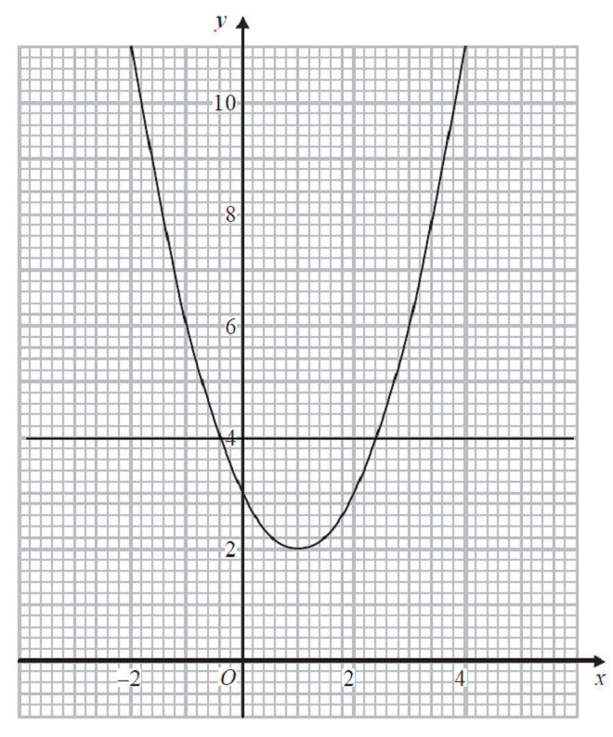 | M1 | This mark is given for the line y = x + 4 drawn
(a) | –0.3 and 3.3 | A1 | This mark is given for answers in the ranges –0.4 to –0.2 and 3.2 to 3.4
(b) | 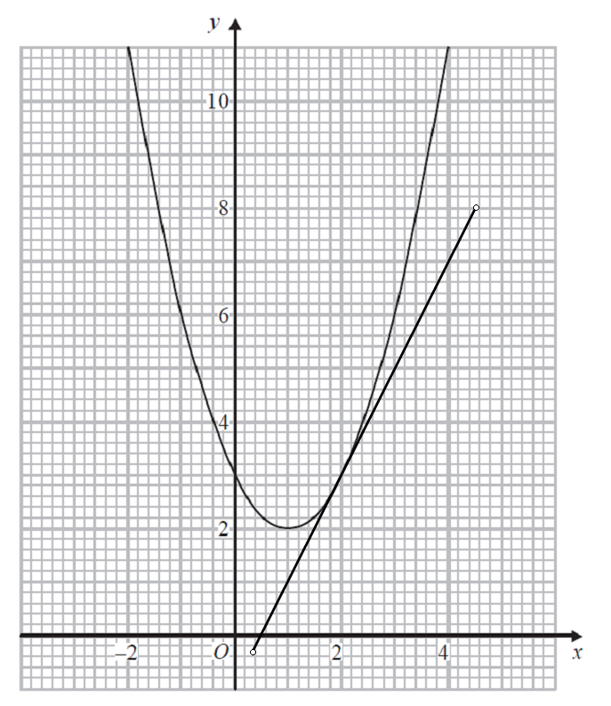 | M1 | This mark is given for drawing a tangent to the curve at x = 2
(b) | For example, measuring gradient between (2,3) and (4, 7) | M1 | This mark is given for a method to find gradient of their tangent
(b) | 2 | A1 | This mark is given for an answer in the range 1.6 to 2.5

Question 14 (Version 1) (Total 5 marks)
Part | Working an or answer examiner might expect to see | Mark | Notes
 | x = $\frac{7−4y}{3}$ | M1 | This mark is given for a method to find an expression for x to substitute into x² – 4y² = 9
 | ${\left(\frac{7−4y}{3}\right)}^{2}$ – 4y² = 9  $\left(\frac{\text{49}−\text{56}y+\text{16}y^{2}}{9}\right)$ – 4y² = 9  49 – 56y + 16y² – 36y² = 81 | M1 | This mark is given for a method to expand and simplify
 | 20y² +56y + 32 = 0  Dividing through by 4 gives  5y² + 14y = 8 = 0 | M1 | This mark is given for a method to form a quadratic equation to be solved
 | (5y + 4)(y + 2) = 0 | M1 | This mark is given factorising the quadratic to solve for y (and hence x)
 | x = 3$\frac{2}{5}$, y = –$\frac{4}{5}$  x = 5, y = –2 | A1 | This mark is given for the correct answers only

Question 14 (Version 2) (Total 5 marks)
Part | Working an or answer examiner might expect to see | Mark | Notes
 | y = $\frac{7−3x}{4}$ | M1 | This mark is given for a method to find an expression for y to substitute into x² – 4y² = 9
 | x² – 4 $\left(\frac{\text{49}−\text{42}x+9x^{2}}{\text{16}}\right)$ = 9  4x² – 49 + 42x – 9x² = 36 | M1 | This mark is given for a method to expand and simplify
 | 5x² – 42x + 85 = 0 | M1 | This mark is given for a method to form a quadratic equation to be solved
 | (5x – 17)(x – 5) = 0 | M1 | This mark is given factorising the quadratic to solve for x (and hence y)
 | x = 3$\frac{2}{5}$, y = –$\frac{4}{5}$  x = 5, y = –2 | A1 | This mark is given for the correct answers only

Question 15 (Total 5 marks)
Part | Working an or answer examiner might expect to see | Mark | Notes
 | $\vec{\text{AB}}$ = b – a | M1 | This mark is given for finding a vector expression for $\vec{\text{AB}}$
 | $\vec{\text{MN}}$ = –$\frac{1}{2}$b + a + 2a  = –$\frac{1}{2}$b + 3a | M1 | This mark is given for finding a vector expression for $\vec{\text{MN}}$
 | $\vec{\text{PN}}$ = –k(b – a) + 2a  = –kb + (2 + k)a | M1 | This mark is given for finding a vector expression for $\vec{\text{PN}}$
 | Since $\vec{\text{MN}}$ is a multiple of $\vec{\text{PN}}$  $\frac{−\frac{1}{2}}{−k}$ = $\frac{3}{(2+k)}$  –$\frac{1}{2}$(2 + k) = –3k | M1 | This mark is given for recognising that $\vec{\text{MN}}$ is a multiple of $\vec{\text{PN}}$and comparing coefficients of a and b
 | k = $\frac{2}{5}$ | A1 | This mark is given for the correct answer only

Question 16 (Total 5 marks)
Part | Working or answer an examiner might expect to see | Mark | Notes
(a) | AD = BC (opposite sides of a parallelogram are equal)  ∠ BAD = ∠ BCD (opposite angles of a parallelogram are equal)  ∠ ADP = ∠ CBQ = 90° (given on diagram) | C1 | This mark is given for identifying a pair of relevant equal sides or angles with reasons
(a) |  | C1 | This mark is given for a complete identification of all three aspects with reasons given
(a) | Two pairs of angles and one pair of sides are equal (ASA), so ADP is congruent to CBQ | C1 | This mark is given for a correct conclusion of congruency (with reference to ASA)
(b) | AP = QC since triangle ADP is congruent to triangle CBQ | C1 | This mark is given for identifying a pair of equal sides in APCQ with reasons
(b) | APCQ is a parallelogram and opposite sides of a parallelogram are equal | C1 | This mark is given for a complete explanation

Question 17 (Total 5 marks)
Part | Working or answer an examiner might expect to see | Mark | Notes
(a) | $\sqrt{x}$ + 1 = k × 1 | 1 | This mark is given for expressing the common ratio algebraically
(a) | $\frac{1}{\sqrt{x}−1}$ = $\frac{\sqrt{x}+1}{1}$ | 1 | This mark is given for setting up an appropriate equation in x
(a) | ($\sqrt{x}$ – 1) × ($\sqrt{x}$ + 1) = 1  x – 1 = 1  x = 2 | 1 | This mark is given for the correct answer only
(b) | (√2 + 1) × (√2 + 1)² | 1 | This mark s given for showing that the 5th term = 3rd term × (common ratio)²
(b) | = 2√2 + 4 +√2 + 2 + 2√2 + 1  = 7 + 5√2 | 1 | This mark is given for a correct conclusion supported by working

Question 18 (Total 2 marks)
Part | Working or answer an examiner might expect to see | Mark | Notes
 | 7 ≤ N < 8 | M1 | This mark is given for identifying the numbers 7 and 8
 | 7 ≤ N < 8 | A1 | This mark is given for the correct answer only

Question 19 (Total 4 marks)
Part | Working or answer an examiner might expect to see | Mark | Notes
 | If CAB = x, then CRO = 180 – x  Opposite angles of a cyclic quadrilateral add up to 180 | C1 | This mark is given for establishing a relationship between angles in a cyclic quadrilateral with a reason given
 | ORB = x  Angles on a straight line add up to 180 | C1 | This mark is given for finding the size of angle ORB with a reason given
 | RO = OB since both a radii of the same circle  ABC = x  Base angles of an isosceles triangle are equal | C1 | This mark is given for finding the size of angle ABC with a reason given
 | Thus ∠ CAB = ∠ ABC | C1 | This mark is given for a complete proof with all correct reasons given

 |  |  |  | Edexcel averages: scores of candidates who achieved grade:
Qn | Skill tested | Mean score | Max score | ALL | 9 | 8 | 7 | 6 | 5 | 4
1 | Gradients and intercepts of linear functions | 0.34 | 5 | 0.34 | 3.78 | 3.05 | 1.63 | 0.7 | 0.23 | 0.02
2 | Translate situations or procedures into algebraic expressions, formulae or equations | 0.48 | 5 | 0.48 | 4.30 | 3.18 | 1.56 | 0.77 | 0.56 | 0.28
3 | Pie charts | 0.33 | 3 | 0.33 | 2.25 | 1.32 | 0.87 | 0.70 | 0.51 | 0.31
4 | Multiplicative relationship between two quantities | 0.65 | 3 | 0.65 | 2.36 | 1.49 | 0.85 | 0.46 | 0.19 | 0.06
5 | Area of a triangle using the angle formula | 0.15 | 5 | 0.15 | 4.50 | 3.09 | 1.32 | 0.59 | 0.21 | 0.02
6 | Inverse and composite functions; formal function notation | 0.18 | 5 | 0.18 | 4.50 | 3.65 | 1.29 | 0.61 | 0.24 | 0.05
7 | Sine and cosine rule | 0.28 | 5 | 0.28 | 4.11 | 2.78 | 1.25 | 0.64 | 0.13 | 0.03
8 | Enumerate sets and combinations of sets systematically; two-way tables, Venn diagrams and tree diagrams | 0.94 | 5 | 0.94 | 3.39 | 2.05 | 1.20 | 0.68 | 0.35 | 0.16
9 | Relationships between lengths, areas and volumes in similar figures | 0.08 | 3 | 0.08 | 2.12 | 1.82 | 0.71 | 0.37 | 0.08 | 0.02
10 | Solve two simultaneous equations | 0.12 | 5 | 0.12 | 4.62 | 1.88 | 1.08 | 0.34 | 0.19 | 0.03
11 | Conditional probability | 0.19 | 3 | 0.19 | 1.78 | 1.22 | 0.61 | 0.4 | 0.17 | 0.05
12 | Rounding; Inequality notation to specify error interval | 0.39 | 2 | 0.39 | 1.10 | 0.60 | 0.37 | 0.28 | 0.27 | 0.28
13 | Solve quadratic equations / gradients and intercepts of linear functions | 0.74 | 5 | 0.74 | 3.32 | 1.89 | 0.86 | 0.35 | 0.16 | 0.08
14 | Solve two simultaneous equations | 0.60 | 5 | 0.60 | 2.92 | 1.39 | 0.66 | 0.27 | 0.09 | 0.03
15 | Vectors | 0.06 | 5 | 0.06 | 1.75 | 1.15 | 0.53 | 0.19 | 0.06 | 0.01
16 | Properties of 2D shapes | 0.34 | 5 | 0.34 | 1.40 | 0.71 | 0.42 | 0.23 | 0.11 | 0.07
17 | Sequences | 0.04 | 5 | 0.04 | 3.12 | 1.32 | 0.29 | 0.08 | 0.00 | 0.00
18 | Rounding; Inequality notation to specify error interval | 0.02 | 2 | 0.02 | 0.40 | 0.32 | 0.09 | 0.02 | 0.01 | 0.01
19 | Circle theorems | 0.00 | 4 | 0.00 | 0.30 | 0.06 | 0.00 | 0.00 | 0.00 | 0.00
 | TOTAL | 5.93 | 80 | 5.93 | 52.02 | 32.97 | 15.59 | 7.68 | 3.56 | 1.51

Grade 9 students averaged about 52 marks on this set of questions in examinations.

